###### **Cairo University**

**Faculty of Computers and Information Information Systems Department Database Systems 1**

**Lab 6**

**(Entity Relationship Diagram (ERD))**

# **Case Study 1: University System**

Every year at start of each semester a student enrolls on different which courses may have prerequisites, also student should have grade for each course separately.

Every student has a unique id, name and GPA. For each course there a unique Id, name and description.

Each course must be related to only one department, and is taught by only one professor. Every Professor has an id, name, email, address and multiple telephone numbers.

Each student has his/her own advisor “Professor” to help in identifying path of interest, but some advisors mayn't advise any students.

(Write any attributes you though it will be useful for system)

Requires

pID

es

Advises

Offers

Courses

Enrolls in

Teaches

Department

Professor

Students

N

N

N

N

N

N

N

1

1

1

1. Open power designer
2. Create new conceptual data model

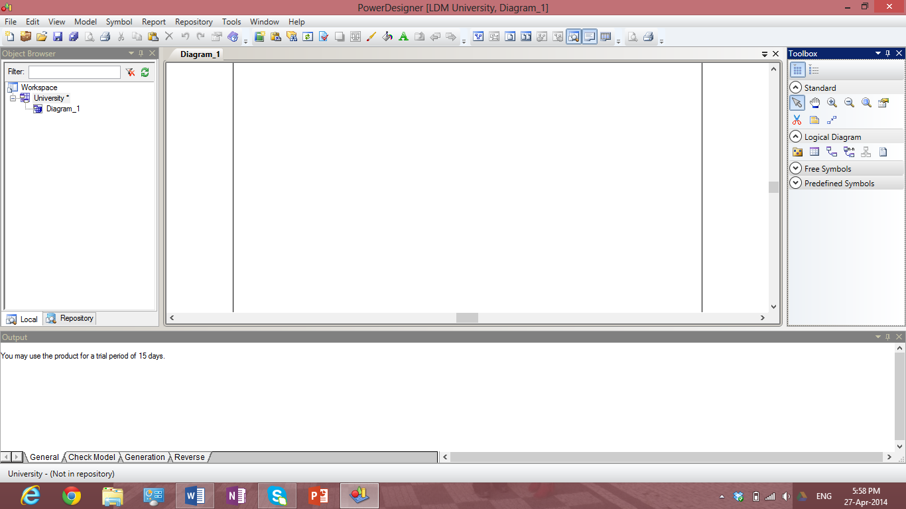

1. Add new entity [student entity]

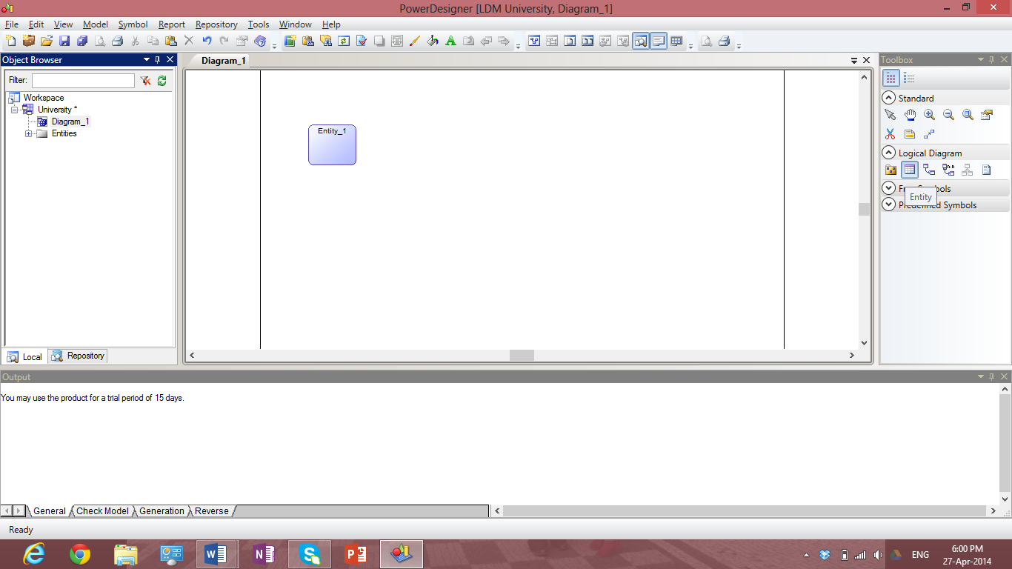

1. Double click on added entity, then set entity information

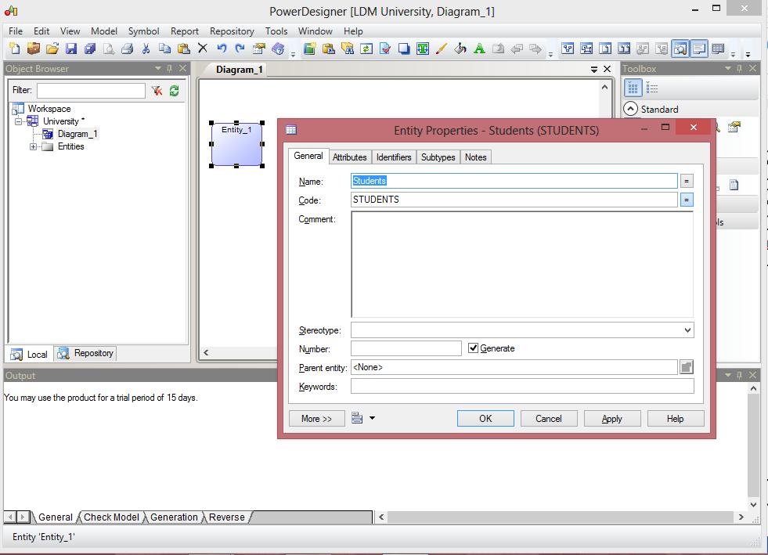

1. Set student entity attributes: go to attributes tab then specify each attribute type and name.

M 🡺 mandatory attribute

P 🡺 primary key

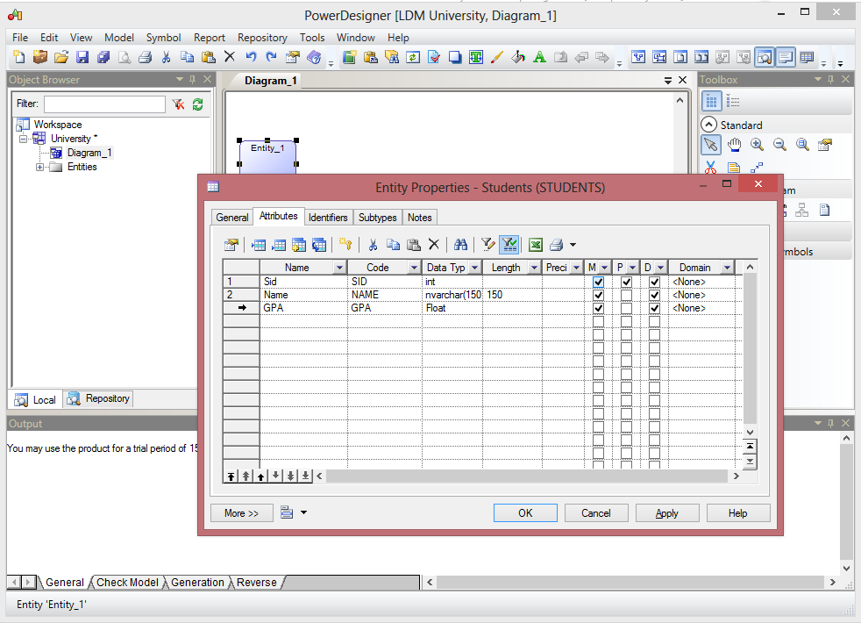

Press ok to save changes 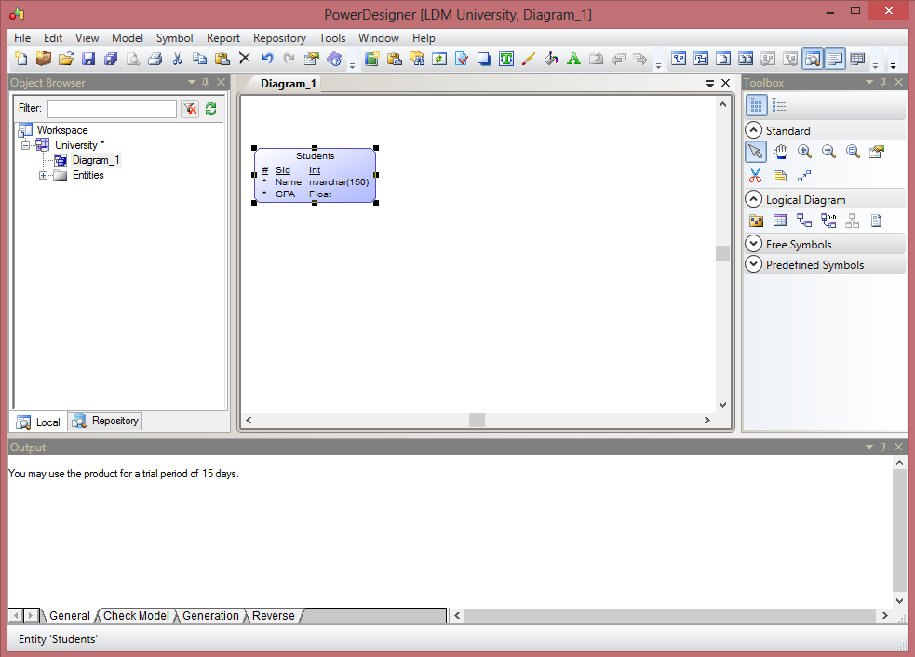

Repeat the previous steps for all entities

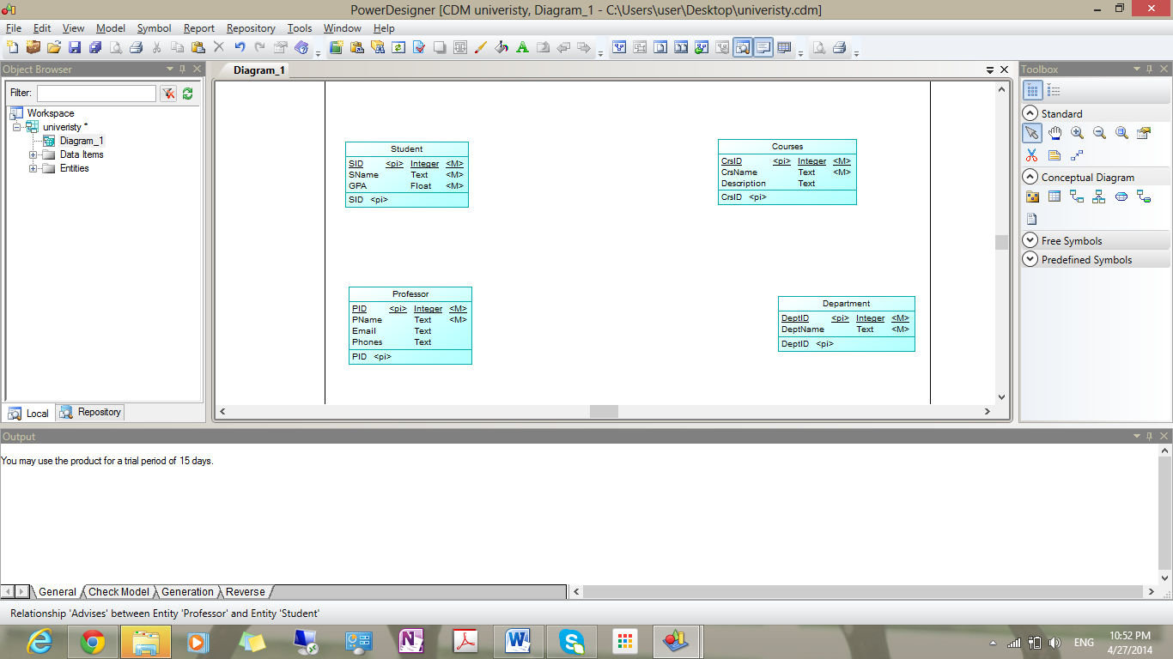

1. Declare relationship between tables

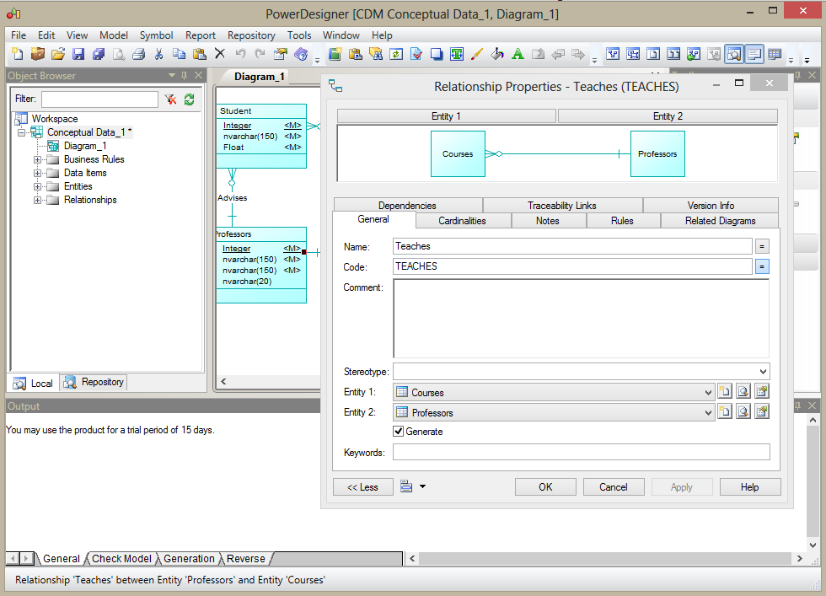

Association Relation, Association link in toolbox

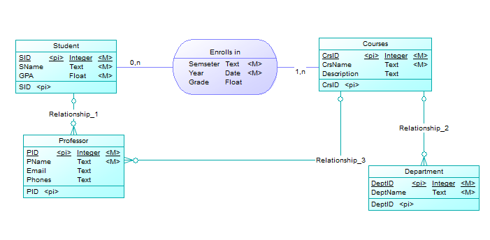

Final conceptual Data model

