**REGISTRATION METHOD**

1. Click on <http://agrosym2019.talkb2b.net>
2. Click on REGISTER



1. Fill in requested data about you (see below)

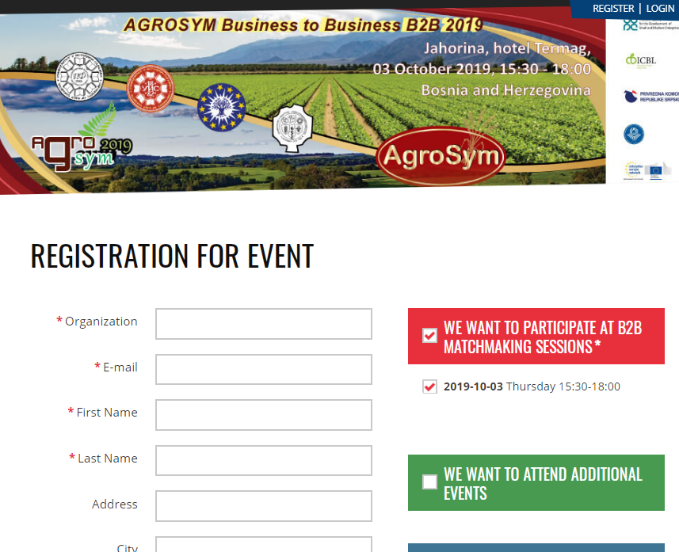

... and as obligatory check shown boxes in red square and below red, as it is shown in picture above.

The fields with red star are mandatory and need to be filled in.

If you like to attend also to additional events, please check green square box also.

1. After your click on REGISTRATION you need to continue with the rest of information.
2. Firstly, go to your inbox (and also please check SPAM or JUNK folder) and locate the email that was sent to confirm a successful registration. The email itself will contain a link which is shown in the screen capture below:



Just click on the activation link and continue with registration.

1. Then login on <http://agrosym2019.talkb2b.net> go on edit my data in the upper left corner. Clicking the link will bring up the following screen



Complete the Personal Data tab and click the “Update person” button. Once you have completed entering and/or updating the information on the Personal Data tab, please do the same with Organization Data and Participation Schedule tabs, which contain registration information, always ensuring to click the “Update person” button before moving to the next tab.

**THE FOURTH TAB, COOPERATION PROFILES, IS PERHAPS THE MOST IMPORTANT ONE.**



Clicking the “Create new cooperation profile” will bring up the following screen:



Please refer to the table below regarding the values that need to be entered on the screen above.

|  |  |
| --- | --- |
| **Field Name** | **Field data required** |
| Type | Select an option that best describes your  situation |
| Title | What are you offering? |
| Description | Describe what you offer or require |
| Image | Upload a logo |
| Offered/ Request | Select the offered/requested options |

Once all the information has been entered click the “Save new profile” button.

**ARRANGING MEETINGS**

After your log in <http://agrosym2019.talkb2b.net/> you will see on the right side REGISTERED PARTICIPANTS, and if you prefer any country you can click on that country and have a look of registered participants, and with clicking on certain participant you can REQUEST a MEETING with that participant.



There is a “Request a Meeting” option below each participant shown. Clicking this option will automatically send a meeting request. The organization to which you sent the meeting request will receive an email and will have the option of either accepting or declining the meeting request. The same rule applies if somebody sends you a request.

When you are logged in, under the Edit my Data option, you will find a Meetings option. The Meetings option gives you a summary of all the meeting requests sent and received, as well as an option to accept or reject a meeting request.