###### Cairo University

**Faculty of Computers and Information**

**Information Systems Department**

**Database Systems 1**

**Lab 7 (Accessing Data in C#)**

Most applications revolve around reading and updating information in databases. To enable data integration in distributed, scalable applications, Visual Studio provides support for integrating data into your applications.

**Example:**

Create the following windows form in visual studio containing the given labels, buttons and DataGridView.

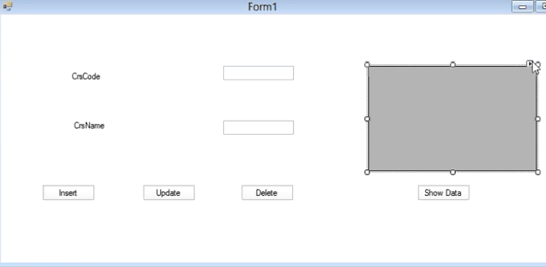

# Insert button: allows you to insert new records into a database.

# Update button: allows you to update records inside a database.

# Delete button: allows you to delete records inside a database.

# Show data button: allows you to view data inside a database.

**Please check this link:** [**http://scholar.cu.edu.eg/?q=mhafez/classes/is221database-systems-i-spring-2015/materials/connection-database-using-c-videos**](http://scholar.cu.edu.eg/?q=mhafez/classes/is221database-systems-i-spring-2015/materials/connection-database-using-c-videos) **to view the details of:**

* Inserting data into a database.
* Updating data inside a database.
* Deleting data inside a database.
* Viewing data from one or more tables inside a database.