###### Cairo University

**Faculty of Computers and Information Information Systems Department Database Systems 1**

**Section 8 (Normalization)**

* **Normalization** is a process for assigning attributes to entities. It reduces data redundancies and helps eliminate the data anomalies.
* Normalization works through a series of stages called normal forms:
  + **First normal form (1NF)**
  + **Second normal form (2NF)**
  + **Third normal form (3NF)**
* The highest level of normalization is not always desirable.

**Example: Suppose we have this table:**

**Employee (empno, ename, deptno, dname, addr)**

What is wrong with this table?

**1. Redundancy:** deptno&dname.

**2. Extra Work:** if we changed the name of a department, we will have to do it in multiple places**.**

**3. Anomalies:** could change deptno without changing dname or vice versa.

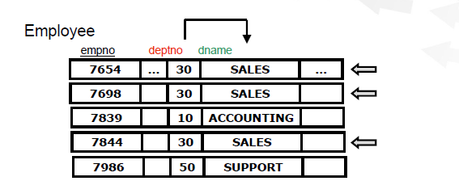

Entities with the same value for deptno have the same value for dname.

•Including dname in the entity class is redundant, since it can be derived from deptno.

**Redundancy causes duplicate work:** suppose that the company wants to change deptno 30 to be the Sales & Marketing department, this change must be made to multiple employees.

***Redundancy can cause anomalies (inconsistencies) if modifications are not done carefully.***

**• Update Anomaly:** updating a value in a single cell can make the database inconsistent.

**• Insertion Anomaly:** adding an entity can make the database inconsistent.

**• Deletion Anomaly:** deleting some information can make the database inconsistent or cause unintended loss of information.

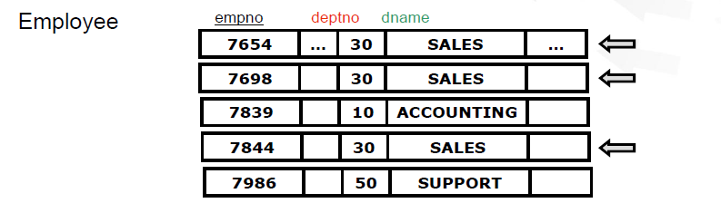

**Examples:**

**Modification Anomaly**: modify 7654's dname to 'SUPPORT' (without changing its deptno).

**Insert Anomaly**: insert a new employee with a deptno of 20, and a dname of 'SUPPORT'.

**Delete Anomaly**: delete employee 7986 (it’s the only employee in SUPPORT, and no other entity class keeps track that dept 50 is SUPPORT).

**Normalization:**

1. **First Normal Form (1NF) Definition:**
   * The term first normal form (1NF) describes the tabular format in which:
     + All the key attributes are defined.
     + There are no repeated groups in the table.
     + All attributes are dependent on the primary key.

**Conversion to First Normal Form**

* + A relational table must not contain repeated groups. That is each row/column intersection can contain only one value, not a set of values.
  + Repeated groups can be eliminated by adding the appropriate entry in at least the primary key column(s).

**Functional Dependencies:**

* A *Functional Dependency* describes a relationship between *attributes* in a single relation.
* An attribute is *functionally dependant* on another if we can use the value of one attribute to determine the value of another.
* We use the symbol ‘🡪' to indicate a functional dependency:   
  X 🡪 Y.
* Read "X functionally determines Y" or "Y functionally depends on X", more simply “*X* determines Y“or “Y depends on X".

**Examples:**

* Student_ID 🡪Saddress, SDoB
* Student_ID, Course# 🡪 Grade
* Model, Year 🡪CarPrice
* Course_No, Section 🡪 Professor, Classroom, Number of Students

1. **Second Normal Form**

* Conversion to Second Normal Form: starting with the 1NF format, the database can be converted into the 2NF format by:
* Writing each key component on a separate line, then
* Writing the original key on the last line and
* Writing the dependent attributes after each new key.

PROJECT (PROJ_NUM, PROJ_NAME)

EMPLOYEE (EMP_NUM, EMP_NAME, JOB_CLASS, CHG_HOUR)

ASSIGN (PROJ_NUM, EMP_NUM, HOURS)

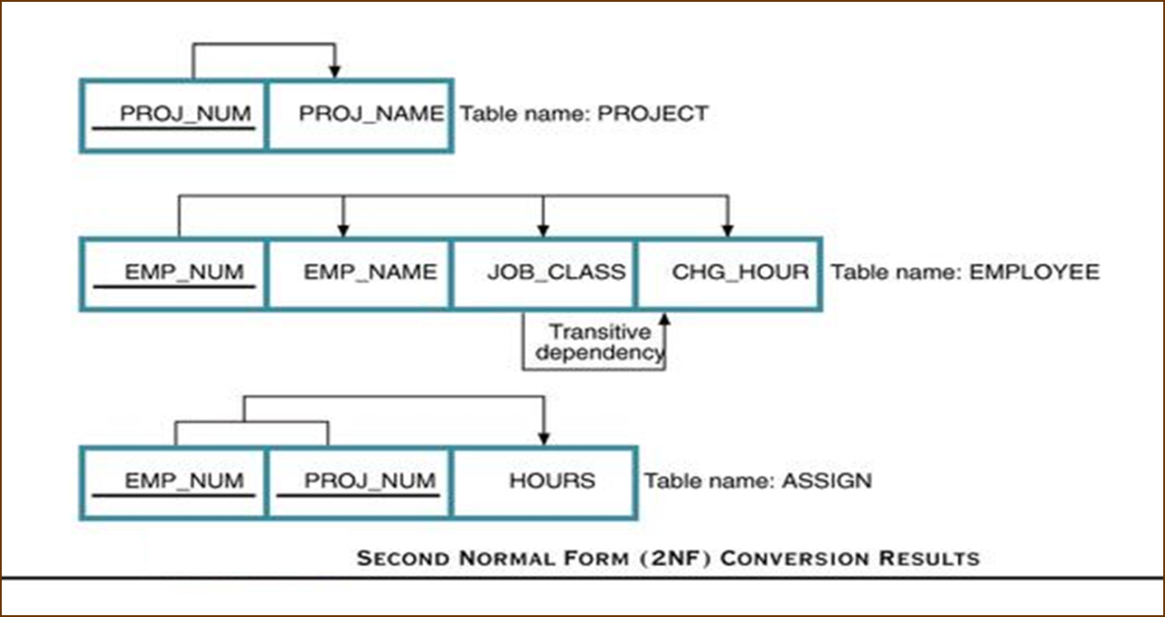

1. **Third Normal Form:**

A table is in 3NF if it is in 2NF and it contains no transitive dependencies.

* Conversion to third Normal Form:
* Create a separate table with attributes in a transitive functional dependence relationship.

PROJECT (PROJ_NUM, PROJ_NAME)

ASSIGN (PROJ_NUM, EMP_NUM, HOURS)

EMPLOYEE (EMP_NUM, EMP_NAME, JOB_CLASS)

JOB (JOB_CLASS, CHG_HOUR)

**Example:**

Construction Company manages many projects. Each project requires the services of many employees. An employee may be assigned to several different projects. Some employees are not assigned to a project and perform duties not specifically related to a project. Some employees are part of a labor pool, to be shared by all project teams. Each employee has a (single) primary job classification. This job classification determines the hourly billing rate. Many employees can have the same job classification.

1. **Two Initial Entities:**

PROJECT (PROJ_NUM, PROJ_NAME)

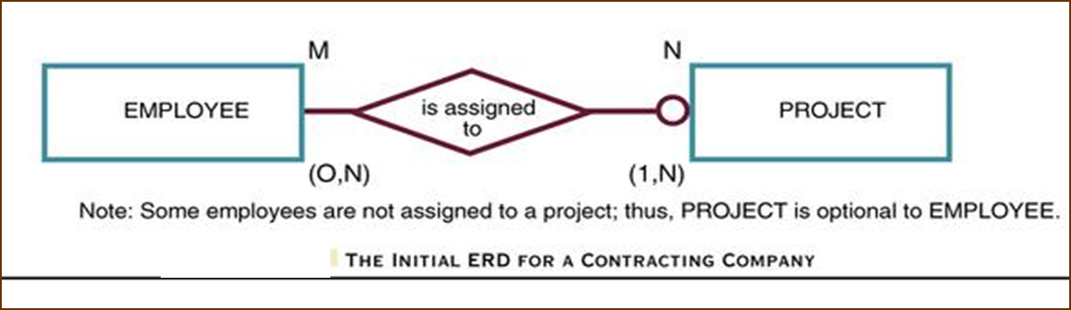EMPLOYEE(EMP_NUM,EMP_LNAME,EMP_FNAME,EMP_INITIAL, JOB_DESCRIPTION, JOB_CHG_HOUR)

1. **Three Entities After Transitive Dependency Removed**

PROJECT (PROJ_NUM, PROJ_NAME)

EMPLOYEE (EMP_NUM, EMP_LNAME, EMP_FNAME, EMP_INITIAL, JOB_CODE)

JOB (JOB_CODE, JOB_DESCRIPTION, JOB_CHG_HOUR)

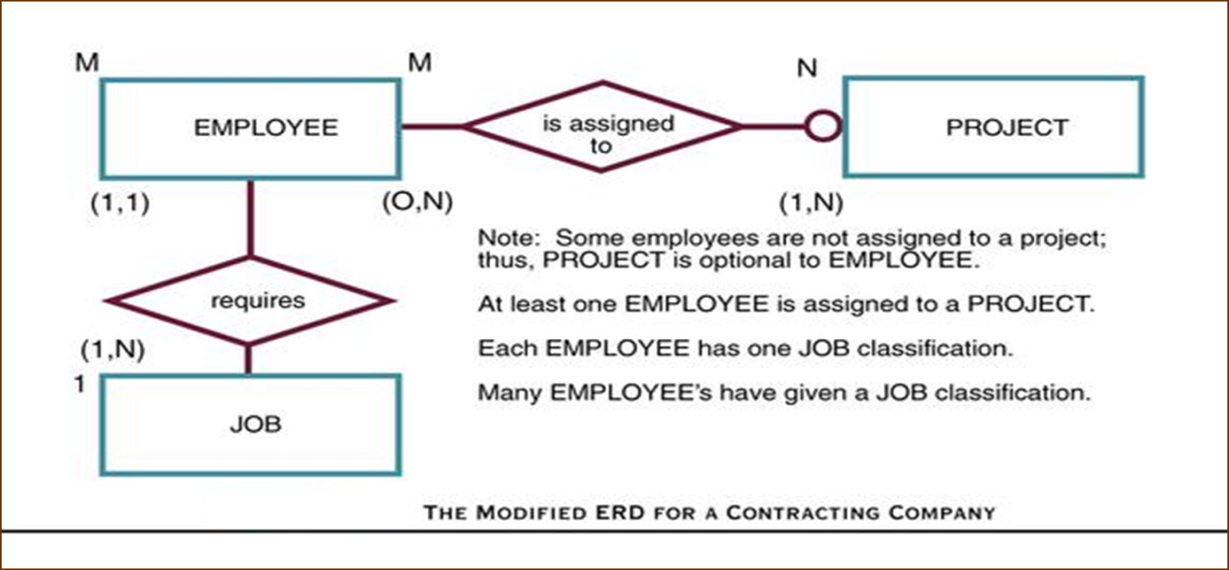

1. **Composite Entity Assign**

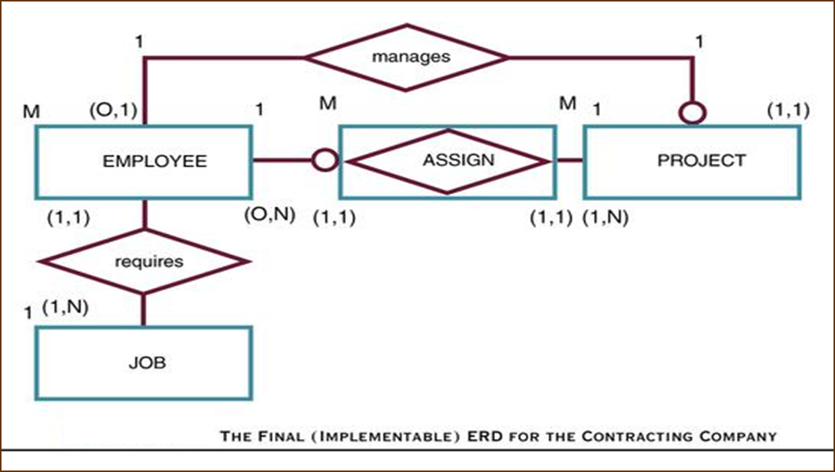

Attribute ASSIGN_HOUR is assigned to the composite entity ASSIGN.

“Manages” relationship is created between EMPLOYEE and PROJECT.

PROJECT (PROJ_NUM, PROJ_NAME, EMP_NUM)

EMPLOYEE (EMP_NUM, EMP_LNAME, EMP_FNAME, EMP_INITIAL, EMP_HIREDATE, JOB_CODE)

JOB (JOB_CODE, JOB_DESCRIPTION, JOB_CHG_HOUR)

ASSIGN (ASSIGN_NUM, ASSIGN_DATE, PROJ_NUM, EMP_NUM, ASSIGN_HOURS)