**Image classification**

**- Data clustering** is a mathematical process of classification of any type of data into classes; the data in each class are equal or close together in their value.

**- Image classification (spectral clustring)** is classifying pixels of a multispectral image into discrete classes based on the value of pixel reflectance or digital number (DN).

- Use **Unsupervised** classification to cluster pixels in a dataset (image) based on **statistics only**, without any user-defined training classes. Two unsupervised classification techniques are available:

1- ISODATA Classification.

2- K-Means ClassificAation.

- Use **Supervised** classification to cluster pixels in a dataset (image) into classes based on user-defined **training classes** **(region of interest, RIO )**. Following are some popular supervised classification methods available in ENVI:

1- Parallelepiped Classification.

2- Minimum Distance Classification.

3- Mahalanobis Distance Classification.

4- Maximum Likelihood Classification.

5- Binary Encoding Classification.

6- Spectral Angle Mapper Classification.

7- Spectral Information Divergence Classification.

- Some of these supervised classification methods (no.1, 2, 3, 4, 5) are based on the **training classes** **(region of interest, RIO)**. The difference between them is the algorithm used in the clustering calculation. Methods (6, 7) are based on what is known as **“spectral library”**. These libraries are available in ENVI and represent the reflectance of minerals, rocks or vegetation types that can be used for minerals, rocks, or vegetation detection and classification.

**Unsupervised Classification**

**A- Using ISODATA Classification**

1. From the ENVI main menu bar, open the original image to be classified.
2. From the ENVI main menu bar, select **Classification** → **Unsupervised** → **IsoData**. The Input File dialog appears.
3. Select an input file (the image to be classified), then click **OK**. The ISODATA Parameters dialog appears.
4. Enter the minimum and maximum **Number of Classes** you want. ENVI uses a range for the number of classes because the ISODATA algorithm splits and merges classes based on input thresholds and does not keep a fixed number of classes.

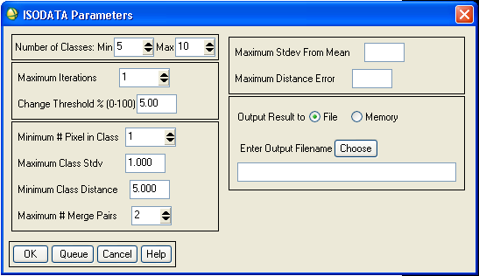

1. Enter the maximum number of iterations in the **Maximum Iterations** field and a change threshold (0-100%) in the **Change Threshold %** field.

**Iteration** is the repetition of the classification process to improve the mean value of each class and class limits. **Threshold** is the number of pixels (in percent) below which the classification process stops. It means that the clustering process ends when the number of pixels in each class changes by a percent less than the threshold value. ENVI uses the change threshold to end the iterative process when the number of pixels in each class changes by less than the threshold. The classification ends when either this threshold is met or the maximum number of iterations is reached.

1. Enter the minimum number of pixels needed to form a class in the **Minimum # Pixels in Class** field. If there are fewer than the minimum number of pixels in a class then ENVI deletes that class and the pixels placed in the class(es) nearest to them.
2. Enter the maximum class standard deviation (in DN) in the **Maximum Class Stdv** field. If the standard deviation of a class is larger than the defined standard deviation then the class is split into two classes.
3. Enter the **minimum class distance** (in DN) between class means and the **maximum number of merge pairs** in the fields provided.

If the distance between class means is less than the minimum value entered, then ENVI merges the classes. The maximum number of class pairs to merge is set by the maximum number of merge pairs parameter.

To set the optional standard deviation to use around the class mean and/or the maximum allowable distance error (in DN), enter the values in the **Maximum Stdev From Mean** or **Maximum Distance Error** fields, respectively.

If you enter values for both of these optional parameters, the classification uses the smaller of the two to determine which pixels to classify. If you do not enter a value for either parameter, then all pixels are classified.

1. Select output to **File** or **Memory**.
2. Click **OK**. The status bar cycles from 0 to 100% for each iteration of the classifier. ENVI adds the resulting output to the **Available Bands List**.
3. To display the resulted classification load the classification image in a new display using the “grey scale” option.

## B- Using K-Means Classification

Practically, the steps used to carry out the K-mean classification in ENVI are similar to the isodata classification. The only difference is that the number classes is given a fixed value determined by the user. The number of classes in the isodata classification is a range between a minimum and maximum values determined by the user.

**In both types of unsupervised**

**classification methods, do the**

**following:**

**1- use the maximum iteration = 1**

**(the default value), and get the**

**Classified image.**

**2- use the maximum iteration = 5**

**and get the classified image.**

**3- Notice the difference between the**

**Two cases.**

**Overlaying the classified classes on the original image, Edit class names and colors, and Merging classified classes:**

You can to interactively overlay classes on and off on the displayed image:

1. From the Available Bands List, load the **original image** as a gray scale image or multispectral image.

2. From the Display group menu bar, select **Overlay → Classification**. The Interactive Class Tool Input File dialog appears.

3. Select the **classified image** file within the “Select Input File section” of this dialog and click **OK**. The Interactive Class Tool appears with each class listed with its corresponding colors.

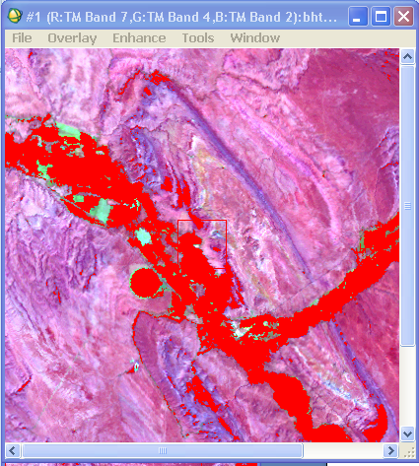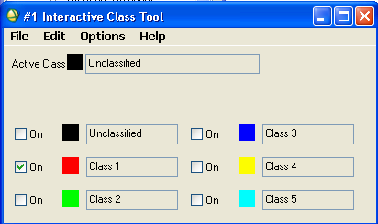

4. Click each **On** check box to change the display of each class as an overlay on the original image.

5- To edit the class name or color use Options **→ Edit class colors** **/** **names.**

6- To merge two classes or more useOptions **→ Merge classes.**

7. From the Display group menu bar, select **File → Save Image As → Image File** to burn in the classes and output to a new file.

8. From the Interactive Class Tool menu bar, select **File →** **Cancel** to exit the interactive tool.

**Improving and smoothing the classified image** (solve the problem of isolated pixels occurring in other larger classes.):

There are several methods to solve this problems. Some methods consider the isolated pixels as unclassified and others add them to the surrounding class. The most popular method is the **“majority/minority analysis” technique.**

1. From the ENVI main menu bar, select **Classification** → **Post Classification** → **Majority/Minority Analysis**. The Input File dialog appears.
2. 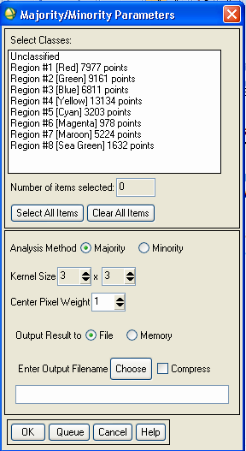Select the classification image file, then click **OK**. The Majority/Minority Parameters dialog appears.
3. In the list of classes, select the classes that you want to apply the analysis to. If the problem of isolated pixels is found in alll classes, choose all classes.
4. Select the analysis method, by clicking the corresponding toggle button. Choose **“majority”.**
5. Enter a kernel size. Larger kernel sizes produce more smoothing of the classification image.
6. Select output to **File** or **Memory**.
7. Click **OK**. ENVI adds the resulting output to the **Available Bands List**..
8. Notice if the smoothing process is ok. If not, repeat the process with a higher kernel value.

**Adding Classification Keys (legend) Using Annotation**

ENVI provides annotation tools to put classification keys (legend) on images and in map layouts. The classification keys are automatically generated.

1. From the Display group menu bar of the classified image, select **Overlay →**  **Annotation**.

2. From the Annotation menu bar, select **Object → Map Key** to start annotating the image. You can edit the legend characteristics by clicking the **Edit Map Key Items** button in the dialog and changing the desired characteristics.

3. Click once with the left mouse button in the Image window to place the legend in the image window.

4. Click and drag the legend using the left mouse button in the display to place the key.

5. Click in the display with the right mouse button to finalize the position of the legend.

