###### **Cairo University**

**Faculty of Computers and Information Information Systems Department Database Systems 1**

**Examples on converting ER Model to Relational Model**

**Example 1:**

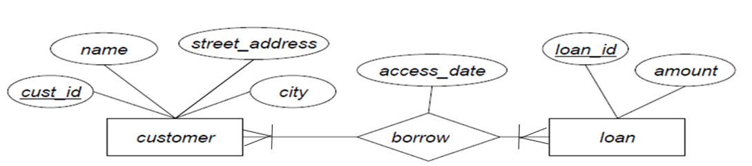

customer (cust_id, name, street_address, city)

loan (loan_id, amount)

borrow (cust_id, loan_id, access_date)

**Example 2:**

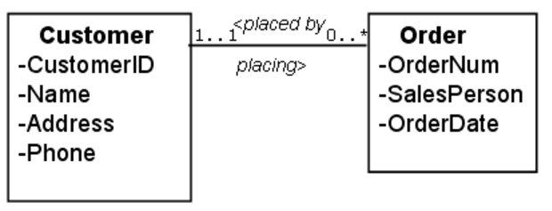

**Customer** (CustomerID, Name, Address, Phone)   
**Order** (OrderNumber, OrderDate, SalesPerson, CustomerID)

**Example 3:**

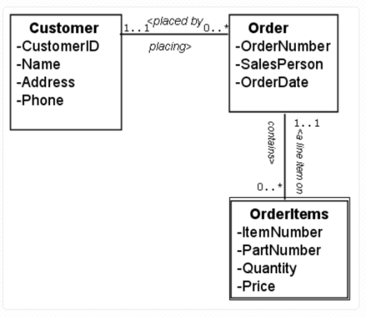

**Customer** (CustomerID, Name, Address, Phone)   
**Order** (OrderNumber, OrderDate, SalesPerson, CustomerID)   
**OrderItems**(OrderNumber, ItemNumber, PartNumber, Quantity, Price)

**Example 4:**

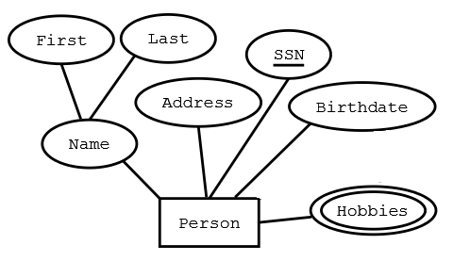

Person (SSN, FirstName, LastName, Address, Birthdate)  
Hobbies (SSN, Hobby)

**Example 5:**

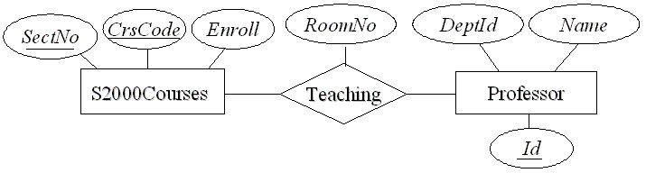

M

N

S2000Courses (CrsCode, SectNo, Enroll)   
Professor (Id, DeptId, Name)  
Teaching (CrsCode, SecNo, Id, RoomNo)