###### **Cairo University**

**Faculty of Computers and Information Information Systems Department Database Systems 1**

**Lab 7 (ERD Mapping to Relational Model (Physical Data Modeling))**

## Case Study 1: University System

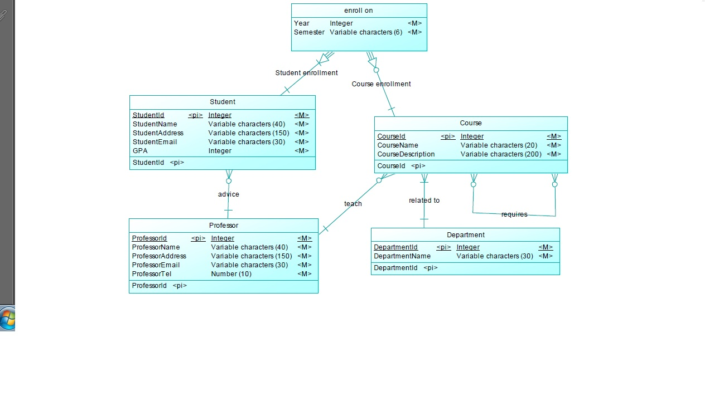

**Physical Model**

To get physical diagram that will be implemented as Database:

Steps:

Tools tab

1. Generate physical data model
2. Wizard:
3. Generate new physical data model:
4. Microsoft SQL server 2005
5. Share DBMS definition
6. Name: MiniUniversity_PhysicalModel
7. Check Model from same “Tools” tab.

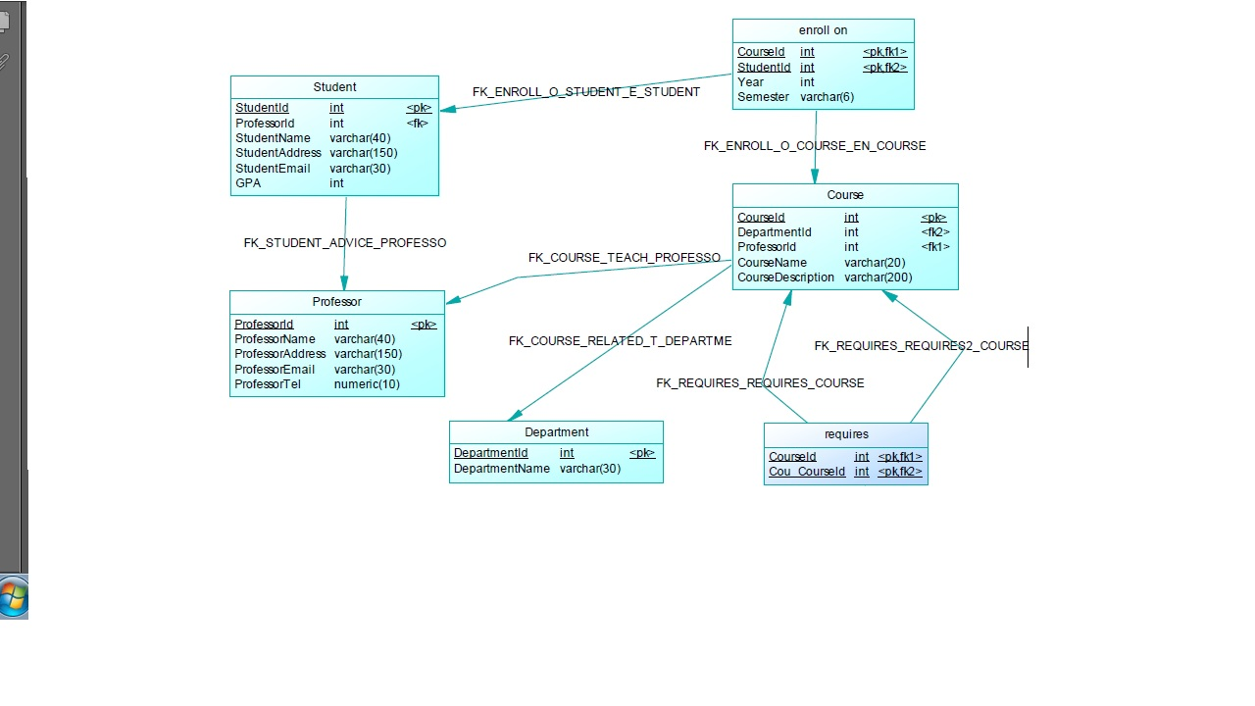

**Important notice about cardinality:**

Power Designer 12.5 is working on standards. (According to what mentioned in Help)

**Example**

The Cardinalities page below indicates that the subcontract relationship is optional from customer to project, and mandatory from project to customer. Each project must have a customer, while each customer does not have to have a project.

This means that the figure must be the same for both Power Designer and Book notations.

Check at Help> Index>cardinality, relationship

