###### **Cairo University**

**Faculty of Computers and Information Information Systems Department Database Systems 1**

**ERD Assignment (Model Answer)**

# Question 1

## Conceptual Model

Sport

Discipline

M

1

include

1

1

1

-------------

list

Schedule

M

Store

Continent

Judge

referee

participate

Competitor

Event

M

M

N

M

compete

M

N

1

Country

M

1

M

come

# Question 2

## Conceptual Model

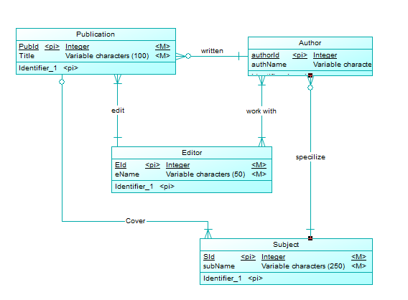

## Physical Model

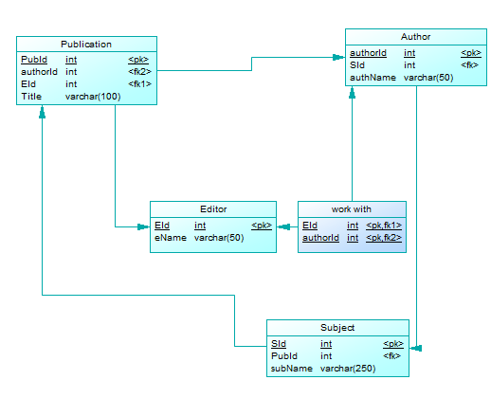

# Question 3

## Conceptual Model

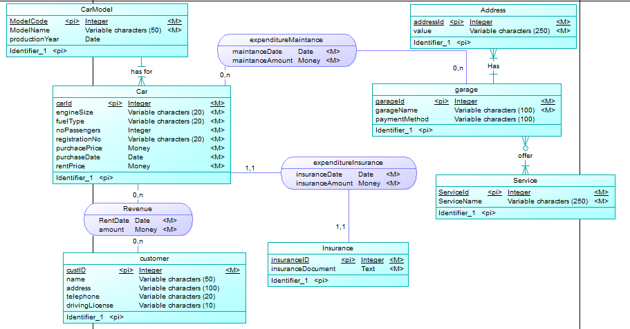

## Physical Model

# Question 4

## Conceptual Model

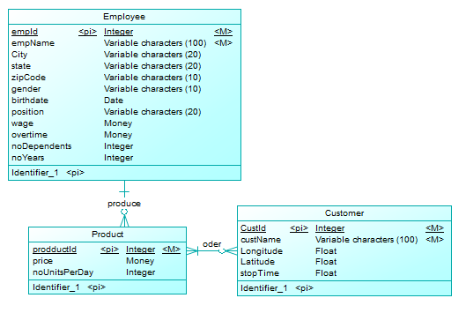

## Physical Model

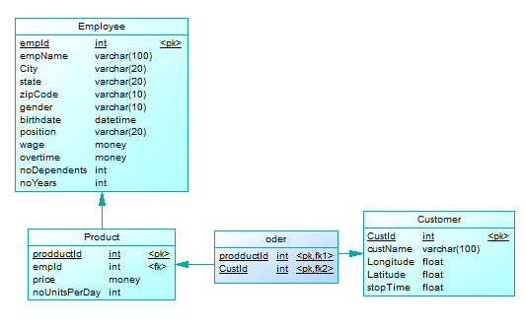

# Question 5

## Conceptual Model

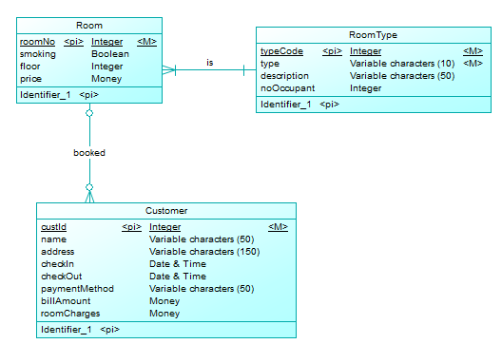

## Physical Model

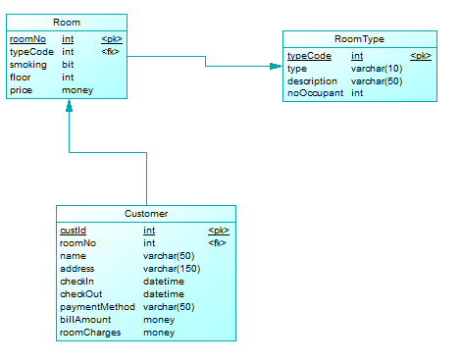

# Question 6

## Conceptual Model

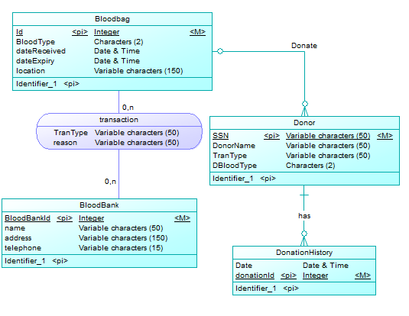

## Physical Model

