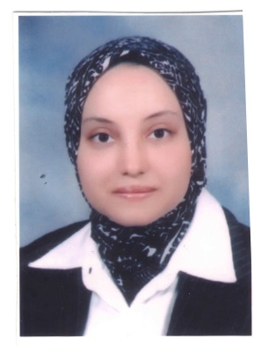

**Personal data**

|  |  |
| --- | --- |
| **Name** | **:** Rasha Sameh Eissa Hassan |
| **Nationality** | **:** Egyptian. |
| **Religious** | **:** Muslim. |
| **Home Address** | **:** 55 Ain Shames Street, Cairo, Egypt |
| **Home Tel. No.** | **:** 35828180 |
| **Mobile No.** | **:** 01146935139 |
| **E_mail Address** | :rasha_eco1 @yahoo.com |
|  |  |

**CAREER HISTORY**

**Current Position :**Teaching Assistant in Economics Department, Faculty of Economics & Political Sciences since 2001 until now

**Work Address:** FEPS, Cairo University, Giza , Cairo.

**Work Phone No.:** +202 570 80 94.

**Educational Background**

* **2011** : **Cairo University Cairo**

**Faculty of Economics and Political Sciences**

Proposal for Ph.D. Thesis on "The Effect of Foreign Loans and Grants on The Development of The Agricultural Sector in Egypt"

* **2009**  : **Cairo University Cairo**

**Faculty of Economics and Political Sciences**.

Preparation Courses for Ph.D. with an overall Grade ofExcellent.

* **2007**  : **Cairo University Cairo**

**Faculty of Economics and Political Sciences**.

M.Sc., Thesis on : " The Effect of The Credit Agricultural Policy On The Productivity Of Strategic Crops in Egypt" with an overall grade of Excellent.

* **1997-2001** : **Cairo University Cairo**

**Faculty of Economics and Political Sciences.**

Bachelor Degree (BA) In Economics.

**Major**: Economics **Minor**: Statistics.

An Excellent degree with Honor .

**Training Courses**

* **2004-2013: Faculty and Leadership Development Center, Cairo.**

Different Courses targeted to improve the tools and teaching techniques such as: "Academic Research Methods", "Using Technology in Teaching" , "Effective Communication Skills" , "Thinking Skills" ,"New Trends in Educations", " Research team Management" ,"Organizing Conferences"," Effective Presentation Skills ".

* **2002 : Institute of Educational Studies, Cairo University**.

Training Course on Teaching Skills.

**Experiences**

* Full-time professional work experience at Faculty of Economics and Political Sciences in Department of economics " Demonstrator in Microeconomics, Agricultural Economics, Economic Development, feasibility studies courses respectively in addition to being a research assistant to students in their researches''.
* Senior Organizer for the annual conferences in Economics Department, Faculty of Economics and Political Sciences.
* Regular Attend in ERF (Economic Research Forum) ,CEFRS (Center for Economic and Financial Research and Studies) and ECES (Egyptian Center for Economic Studies) annual Conferences (mainly attendance).
* Regular participant in the seminars and forums held at FEPS .

**Languages**

* **Arabic:** mother tongue
* **English:** very good reading and writing

**Computer literacy**

* Very well aquatinted with Microsoft Windows Application :(Ms Word, Ms Excel , PowerPoint)
* Extensive experience with Internet search for Academic researches and studies purposes.
* Working knowledge of SPSS (Data entry and analysis), E-views (Time Series Analysis), STATA (Cross-Sectional data).

**Personl Skills**

* Ability to work under pressure.
* Good presentation skills.
* Self-motivation, dependable and goal oriented.
* Ability to work individually and as co-operator team member.

**Favored Pastimes**

* Music
* Internet Surfing
* Traveling
* Reading