**Supervised classification**

Supervised classification is based on training classes (Regions of interest, ROI) defined by the user. You must prepare the Regions of interest (ROI) before performing supervised classification. Each training class (ROI) will represent a certain rock unit.

There are many methods for supervised classification. For training, you well apply two types ::

1- Parallelepiped Classification.

2- Mahalanobis Distance Classification.

Carryout both classifications and notice the difference in the produced classified images

**A- Defining Training Classes (Region of interest, ROI)**

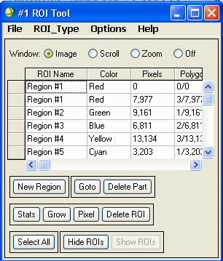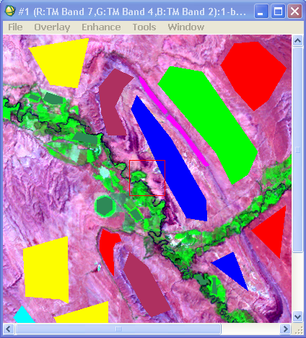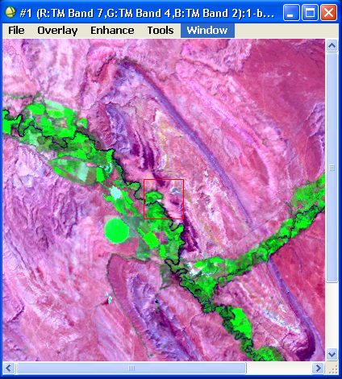

To draw an ROI:

1. Open the original image file in ENVI as usual.
2. Open the **ROI tool** from any of the following locations:
   * From the Display group menu bar, select **Overlay** → **Region of Interest**.
   * From the Display group menu bar, select **Tools** → **Region of Interest** → **ROI Tool**.
   * From the ENVI main menu bar, **Basic Tools** → **Region of Interest** → **ROI Tool**.

The ROI Tool dialog appears.

1. Select whether to use the **Image**, **Scroll**, or **Zoom** window to draw the ROIs.
2. From the ROI Tool dialog menu bar, select **ROI_Type** to choose the type of the shape you want to draw. Select one of the following options: **Polygon, Polyline, Point, Rectangle,** or **Ellipse.**
3. Move your mouse to the window you have chosen in step 3, and left click on the image to draw your shape. After drawing the shape right click once to close the shape, and right click a second time to fix the shape. You can draw several shapes in the same class. The class name and color are defined automatically, that can be changed later by editing as explained before in the previous lab..
4. To create a new class (region), press “**New Region”** button, and draw your new shapes. You can create new classes as many times as you want.
5. To delete a class (region), select that class in the classes list (in the ROI column) and press the button “**delete ROI**”.
6. To delete a part of the class, select the class in the classes list and press “**goto**” button several times to locate the shape you want to delete. In the image window, a rectangle appears on the shape to be deleted and moved to another shape each time you press “goto”. After locating the shape to be deleted press the “**delete part**.” Button.
7. To merge two or more classes (regions) into one class, select **Options** → **Merge Regions**. The Merge ROIs dialog appears with two lists of all defined regions.

a- Under **Choose Base ROI to Merge**, select the name of the base class (the class where other classes will be merged on).

b- Under the **Choose ROIs to Merge** list, select the names of the classes to merge into the base class.

1. To remove the original individual classes being merged after they are merged Click the **Delete Merged ROIs?.** The color of the other ROIs change to that of the base ROI and the other names are removed from the ROI Tools dialog table.

D- Click **OK**.

1. After you finished the plotting of classes, save the training classes into a ROI file from the RIO Tool menu File→ save RIOs.

**B- Applying Parallelepiped Classification**

1. From the ENVI main menu bar, select **Classification** → **Supervised** → **Parallelpiped**. The Input File dialog appears.
2. Select an image file to be classified then click **OK**. The Parallelepiped Parameters dialog appears.
3. If an error message appears “**there are no ROIs associated with this input file to classify with**”, this indicates that the ROI file is not recognized. Press the **open** button (at the lower part of the dialog box), → **ROI File,** and then select the ROI file you previously prepared, press open then ok. Now you can select the image file to be classified again and the Parallelepiped Parameters dialog appears.

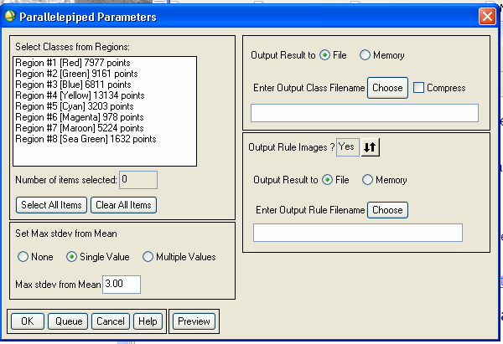

1. In the **Select Classes from Regions** list, select any number of classes or all classes as training classes. The ROIs listed are derived from the available ROIs in the ROI file.
2. Select one of the following thresholding options from the **Set Max stdev from Mean** area:
   * **None**: Use no standard deviation threshold.
   * **Single Value**: Use a single threshold for all classes. Enter a value in the **Max stdev from Mean** field to designate the number of standard deviations to use around the mean.
   * **Multiple Values**: Enter a different threshold for each class. **Do not use this option at the present time**.
3. Select classification output to **File** or **Memory**.
4. The **Output Rule Images?** option: if enabled an intermediate file (rule image file) is produced in the “available band list”. This file can be used in post classification processes. **Do not enable this option at the present time.**
5. Click **Preview** to see a classification image before getting a final product. You can change the parameters as needed and click **Preview** again to update the display.
6. Click **OK**. ENVI adds the resulting output classified image to the “Available Bands List”. To view the resulted image, view it in a new display on the “grey scale” option.

**C- Applying Mahalanobis Distance Classification**

1. From the ENVI main menu bar, select **Classification** → **Supervised** → **Mahalanobis Distance**.The Input File dialog appears.
2. Follow the same steps used in the previous classification. Do not put a value for the “**maximum distance error**”, unless you are not convinced with the resulting classified image.

