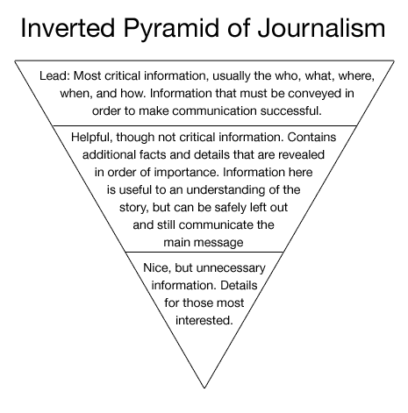

https://riptidereader.files.wordpress.com/2014/09/inverted-pyramid-journalism.png

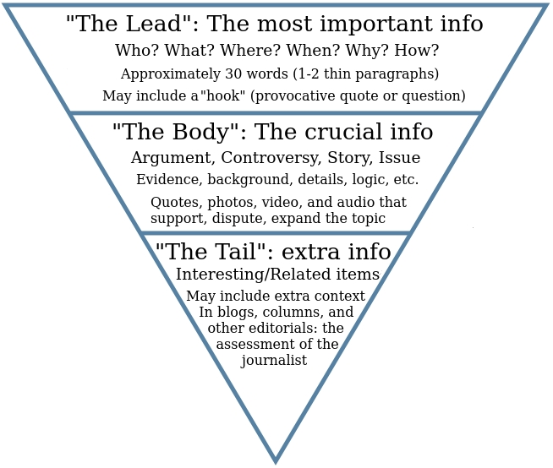https://upload.wikimedia.org/wikipedia/commons/0/09/Inverted_pyramid_in_comprehensive_form.jpg

Important Links

<http://www.wikihow.com/Use-the-Inverted-Pyramid-for-Writing-News>

<https://www.eduplace.com/graphicorganizer/pdf/5Ws.pdf>

<https://edis.ifas.ufl.edu/pdffiles/WC/WC19100.pdf>

<http://www.skilledup.com/articles/about-the-inverted-pyramid-writing-style>