###### **Cairo University**

**Faculty of Computers and Information Information Systems Department Database Systems 1**

**Section 8**

**Entity Relationship Diagram (ERD)**

**(Conceptual Data Model)**

**ERD Notations**

* + Entities names and attributes should be nouns.
  + Relationship names should be verbs.

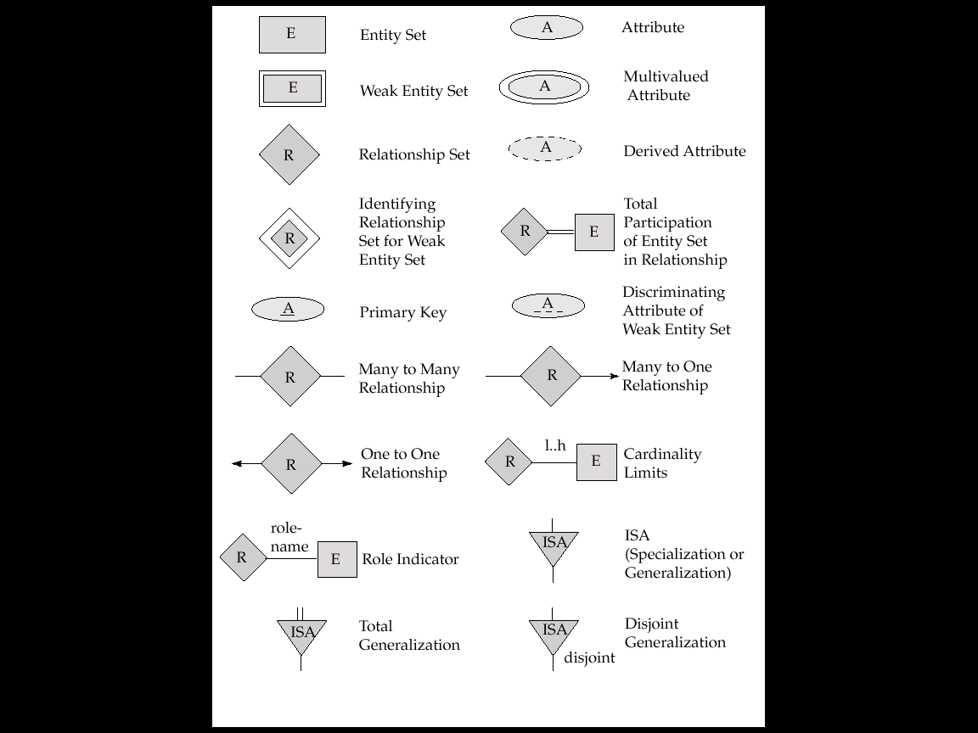

# **Case Study 1: University System**

Every year at the start of each semester, a student enrolls in different courses which may have prerequisites, also student should have grade for each course separately.

Every student has a unique id, name and GPA. For each course there is a unique id, name and description. Each course must be related to only one department, and is taught by only one professor. Every professor has an id, name, email, address and telephone number.

Each student has his/her own advisor professor to help in identifying path of interest, but some advisors mayn't advise any students.

(Write any attributes you think it will be useful for the system)

Requires

pID

es

Advises

Offers

Courses

Enrolls in

Teaches

Department

Professor

Students

N

N

N

N

N

N

N

1

1

1

# **Case Study 2: ABC Company**

ABC Company wants to create an information system for HR system. The COMPANY database keeps track of a company’s employees, departments, and projects. The requirements gathered are:

* The company is organized into departments. Each department has a unique name, a unique number, and a particular employee who manages the department. We keep track of the start date when that employee began managing the department. A department may have several locations.
* A department controls a number of projects, each of which has a unique name, a unique number, and a single location.
* We store each employee’s name, Social Security number, address, salary, sex (gender), and birth date. An employee is assigned to one department, but may work on several projects, which are not necessarily controlled by the same department. We keep track of the current number of hours per week that an employee works on each project. We also keep track of the direct supervisor of each employee (who is another employee).
* We want to keep track of the dependents of each employee for insurance purposes. We keep each dependent’s first name, sex, birth date, and relationship to the employee.

