###### Cairo University

**Faculty of Computers and Information Information Systems Department Database Systems 1**

**Lab 5**

1. Get the product name , its unit price , units of product currently in stock in addition to the product reorder level for all products having a unit price greater than 30 units and have a stock shortage (their Stock units are less than or equal the reorder level).

SELECT ProductName , UnitPrice , UnitsInStock , ReorderLevel

FROM Products

WHERE UnitsInStock <= ReorderLevel

AND UnitPrice >30

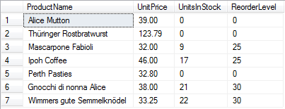

1. Get the last name, job title, city and phone number of all employees who live in either Seattle or Kirkland, and have a phone number that starts with (206) and works as Sales Representatives.

SELECT LastName , Title , City , HomePhone

FROM Employees

WHERE City IN ('Seattle','Kirkland')

AND HomePhone LIKE '(206)%'

AND Title = 'Sales Representative'



1. Get all cities in the UK that contain customers**.**

SELECT Distinct customers.City

FROM customers

WHERE customers.Country = 'UK'



1. Get the last name, title and the hiring year date of the top manager of employees (the one that doesn't report to anybody).

SELECT LastName , Title , YEAR (HireDate) AS HireYear

FROM Employees

WHERE ReportsTo IS NULL



1. Retrieve the last name, country, phone number and date of hiring of all employees between 1992 and 1998, and those employees should either live in USA or have phone number that starts with (71).

SELECT LastName , Country , HomePhone , HireDate

FROM Employees

WHERE (Country = 'USA'

OR HomePhone LIKE '(71)%')

AND YEAR(HireDate) BETWEEN 1992 AND 1998

