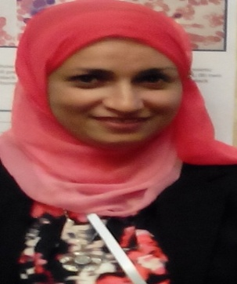 **Iman Gamal El Din Mahmoud ,M.D pediatrics.**

**Department of Pediatrics,pediatric neurology, Neurometabolic Unit, Cairo University Children Hospital.**

**Iman Gamal El Din Mahmoud (M.D) is an assistant consultant of pediatrics ,Cairo university . works at the inherited metabolic disorders unit (IMDU)since 2008 , in the centre of social and preventive medicine at Cairo university children hospital (CUCH) ,shared in  projects aiming for extended  newborn screening for metabolic diseases in Egypt e.g  phenylketonuria (PKU) and aminoacidopathies  , aminoacidurias , mitochondrial disorders,diagnosis of lysosomal storage diseases ,awareness and early diagnosis of Wolman disease and a multicenter natural history study of Farber disease led by (Enzyvant) as well as interest in research in many neurogenetic ,neuromuscular and neurometabolic  disorders .**

**Participated in the biomarker project for diagnosis of lysosomal storage disorders in collaboration with Rostock University and Centogene lab in Germany and currently starting with the centometabolic panel project with Centogene lab in Germany.**

**Has more than 20 national and international publications through collaboration with prof. Dr. Joseph Gleeson(Neurology and neurogenetics) at California and Rockfeller universities in U.S.A, Egyptian national research center and our unit in Cairo university Children hospital of which ,some were published in high impact scientific journals as Science and Nature.**

**Publications and projects of our unit led to the establishment of a national screening program for phenylketonuria in Egypt in 11/2015. She is a member and secretary  of the Egyptian metabolic  patients friend association , a member of the Egyptian neuropediatric society(ENPS), European pediatric neurology society(EPNS),international child neurology association (ICNA) and middle east metabolic group , orphanet (MEMG), the society for the study of inborn errors of metabolism (SSIEM) , the AAAS(American association for the advancement of science) ,the National association of rare disorders and the Egyptian national society of human genetics . Received international publications awards with certificate of appreciation from Cairo University in the years 2014 , 2015, 2016,2017,2018 and 2019.**