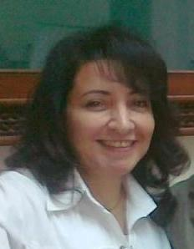**Amany AbdelMaqsod Sholkamy**

*Professor of Internal Medicine & Hepatology*

*Faculty of Medicine Cairo University*

*Senior consultant Hepatology & gastroenterology*

*Senior consultant liver transplantation.*

**email:** [amanymaqsod@kasralainy.edu.eg](mailto:amanymaqsod@kasralainy.edu.eg)

**Cairo university scholar:** <http://scholar.cu.edu.eg/amanymaqsod>

**LinkedIn:** <https://eg.linkedin.com/in/amany-sholkamy>

**Professor Amany Sholkamy Had MD in Internal Medicine from Cairo university in 1996. She was promoted to assistant Professor 2003 and then to professor in 2008.**

***Interested in the field of Hepatology and liver transplantation; she started working in the unit in Sep 2004. She was one of the pioneering staff that served a lot to assist in developing the unit as she also did in many fields of hepatology and gastroenterology in the faculty. In the same respect she get a certification and Master degree of Organ procurement, Donation and transplantation from DTI/Barcelona university. She is a member of the scientific committee of Higher council of Egyptian universities. She was a member of the Higher committee of organ transplantation in Cairo university French H.***

***Interested in the field of hepatic emergencies; being close to the field of liver transplantation; she was the founder of The Liver ICU in the French H of Cairo university. Professor Sholkamy was also the director of the medical ICU and assistant manager of Internal Medicine H (300beds).***

***In the academic field; she was the author of several sections of hepatology in several Faculty books. She participated in many national and international congresses in the field of liver transplantation and hepatology as speaker, chair, conference secretary and also through poster presentations. She is a member of European society of organ transplantation(ESOT), The International society of liver transplantation, the Egyptian society of study of gastrointestinal and liver diseases (ESGLD), and the Egyptian society of Internal Medicine (ESIM). She has also several distinguished researches and publications in the field of hepatology, liver transplantation, and emergency hepatology.***

***Professor Amany had a great role in supervising and developing the master exam. of Internal Medicine in Faculty of Medicine Cairo university through the years from 2002 to 2016 so as to meet the new international standards of assessment of postgraduate students.***

***She had got several discretionary awards through her academic career from the Internal Medicine Dep and also form Cairo university.***