###### **Cairo University**

**Faculty of Computers and Information Information Systems Department Database Systems 1**

**Lab 10**

**Entity Relationship Diagram (ERD) (Physical Data Model on Power Designer)**

# **Case Study**

A publishing company produces scientific books on various subjects. The books are written by authors who specialize in one particular subject. The company employs editors who, not necessarily being specialists in a particular area, each take sole responsibility for editing one or more publications. A publication covers essentially one of the specialist subjects and is normally written by a single author. When writing a particular book, each author works with one editor, but may submit another work for publication to be supervised by other editors. To improve their competitiveness, the company tries to employ a variety of authors, more than one author being a specialist in a particular subject.

**Create physical data model on Power Designer:**

1. Open power designer.
2. Create the conceptual data model first.
3. Click on the Tools tab.
4. Choose “Generate Physical Data Model”.

Wizard:

1. Generate new physical data model.
2. Microsoft SQL server 2005.
3. Share DBMS definition.
4. Name: PublishingCompany_PhysicalModel.
5. Click on “Check Model” from same “Tools” tab.

The conceptual data model will be as follows:

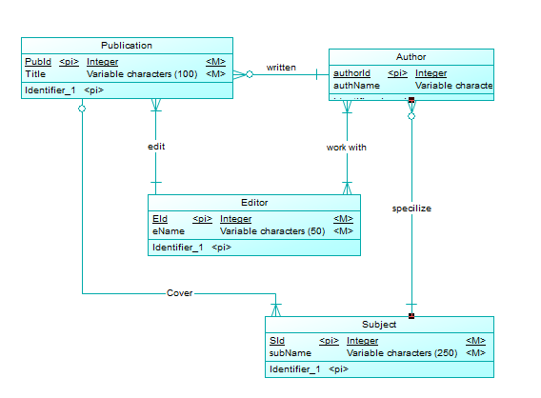

The physical data model will be as follows:

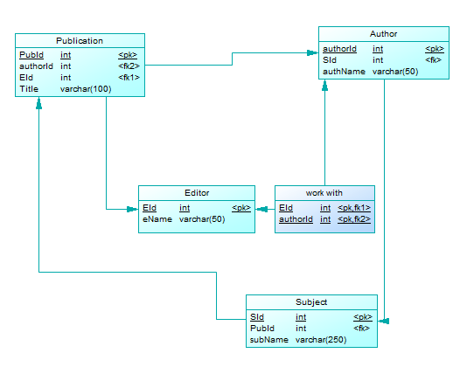

**Generate the script that will be implemented in SQL Server Management Studio:**

After generating the physical data model, click on Database tab then choose Generate Database.