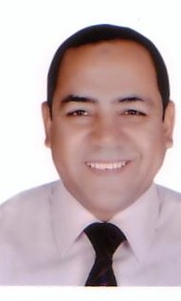

**Dr. Saleh Ahmed**

Saleh Ahmed is an associate professor of Public Administration at the Faculty of Economics and Political Science (FEPS), Cairo University (CU). He is also, the Director of the Public Administration Research & Consultation Center. He obtained his masters degree from Cairo University and his PhD degree from Western Michigan University.

He worked for several years as an Advisor for Minister of Local Development for capacity building and decentralization. He has intensive consultancy and training experience inside and outside Egypt with governmental agencies such as Ministry of Planning, Monitoring and Administrative Reform, Ministry of Youth, Ministry of Labor and Immigration, Central Agency for Administration and Organization, National Council for Women, National Council for Childhood and Motherhood, GIZ, UNWOMEN and UNICEF, and CARE.

Dr. Saleh, is currently the Ombudsman of FEPS, Member of several committees such as the High Committee for Administrative Reform in Egypt, Permanent Leadership Committee at Cairo University, Developing of Kasr Al-Ainy Hospital and Cairo University Digitalization Committee. Additionally he is the head of the Temporary employees Committee.

Moreover, Dr. Saleh has several publications in the areas of; public and local administration, state organization, gender, administrative reform and public policy. He also has lots of training manuals such as TOT, Local Election, and Women empowerment.