Ependymoma: prognostic factors and survival

Ebtessam M.Saad El Deen, M.D, Dalia O. Darwish, M.D, Hanan Selim, M.D, Noha Y. Ibrahim, M.D, Wael S. Makar, M.D

Oncology Department, NEMROCK, Faculty of medicine, Cairo University

Abstract
Background: Ependymoma is a rare disease accounting for 5-10% of brain tumors. Different prognostic factors affect the survival with a wide variation ranging from 10-87%. Patients and Methods: This clinical study is based on 30 patients diagnosed with intra-cranial ependymoma treated at NEMROCK between1998-2004 with a median follow up period of 8.5 years. The patient’s age ranged between 1.5 and 56 years with a median of 16.5 years. Data of the patients was studied as regards different prognostic factors in correlation to progression free and overall survival as well as treatment related events. Results: The 5 year overall survival and event free survival were 61.4% and 20.6% respectively. The median event free survival was 29 months (CI: 14.345-43.655 months). Male sex, age above 11years, low grade tumor and the use of radiotherapy achieved statistical significance for predicting long term survival. Pattern of relapse was mainly local recurrence. Conclusion: Despite the rarity of ependymoma and low number of patients, this retrospective study may add weight to the findings of others that suggest the importance of total surgical excision as well as the use of radiation therapy in the management of this group of patients. However prognostic factors change with time as better treatments are devised and more accurate imaging and histopathological techniques evolve
Key words: Ependymoma, prognostic factors, Survival

Corresponder
Dalia Omar Darwish
Adress: 9 Elmamaleek Elbaharia St. ElRoda, Cairo, Egypt
Home number: +202 26879077
Mobile number: +2 012 229 3408

Introduction

Ependymomas are relatively uncommon, accounting for 5-10% of brain tumors. It occurs in the pediatric age group; however, it is seen in adults at any age. (1)

They arise from the ependymal lining of the ventricular system. They can occur at any site within the ventricular system or within the spinal canal. Intracranial ependymomas present as intraventricular masses with frequent extension into the subarachnoid space, while spinal ependymomas present as intramedullary masses arising from the central canal or exophytic masses at the conus and cauda equine. (2)

The WHO grading system recognizes four tumor types: subepndymoma and myxopapillary ependymoma (grade I tumor), low grade ependymoma, with cellular, papillary and clear cell variants (grade II tumors), and anaplastic ependymoma (grade III tumors) (3).

Treatment of patients with ependymoma depends upon neurosurgical intervention to facilitate definitive diagnosis and decrease tumor burden (4). Treatment for all grades and types includes maximum surgical resection. For myxopapillary ependymoma, complete removal while maintaining capsule integrity may be curative. Some grade II ependymomas may be observed carefully after imaging confirms complete resection, but grade III tumors require adjuvant radiation treatment. Radiation commonly is given to the region of tumor, except in cases in which there is imaging or cerebrospinal fluid evidence of tumor dissemination. (3)

Children younger than 3 years are particularly susceptible to the adverse effect of radiation on brain development. (5)] Debilitating effects on growth and neurologic development have frequently been observed, especially in younger children.(6) For this reason, conformal radiation approaches that minimize damage to normal brain tissue are under evaluation for infants and children with ependymoma.(7) Long-term management of these patients is complex and requires a multidisciplinary approach.

In older children and adults, radiotherapy is the standard treatment following resection for most patients with WHO grade II ependymoma. The evidence for the benefit of post-operative radiotherapy compared with surgery alone has been demonstrated in several series. The 5 year progression free survival (PFS) was 51-70% versus 13%. (8)

Second-look surgery should be considered in patients with residual local tumor because patients who have complete resections have better disease control. The traditional post surgical treatment for children aged 3 years and older has been radiation therapy consisting of 54 Gy to 55.8 Gy to the tumor bed. It is not necessary to treat the entire CNS (whole brain and spine) because these tumors usually recur at the local site.(9)] In subtotally resected patients, treatment with radiation therapy results in 3-year to 5-year PFS in 30% to 50% of patients, (7,10) although the outcome of patients with residual tumor within the spinal canal may be better.(11) There is no evidence that adjuvant chemotherapy, including high-dose chemotherapy with stem cell rescue, is of any benefit.(12)

Treatment fields should cover the initial tumor bed with a 1- to 2-cm margin to avoid causing long-term radiation damage (13). For tumors in the posterior fossa, the recommended dose is 5400 cGy. Craniospinal–axis fields are used only when spinal seeding is radiologically or pathologically evident. Doses of approximately 36 Gy to the entire neuraxis (i.e., the whole brain and spine) should also be administered, but may be modulated depending on the age of the patient. Boosts between 41.4 Gy and 50.4 Gy to bulk areas of spinal disease should be administered, with doses depending on the age of the patient and the location of the tumor (14).

Recurrence is not uncommon in both benign and malignant childhood brain tumors and may develop many years after initial treatment. For ependymoma, delays beyond 10 to 15 years have been reported. (10) Disease generally recurs at the primary tumor site, even in children with malignant ependymomas (15).

Predictors of long-term survival included an estimate of the extent of resection made at surgery (total compared with less than total, P=0.0001) and the amount of residual tumor on postoperative imaging as verified by centralized radiologic review. Other factors, including tumor histopathologic type, site, metastasis, and tumor (M and T) stage, patient age, race, gender, and chemotherapy treatment regimen were not found to be significantly correlated with long-term survival (16).

Patients and methods
The current study is a retrospective analysis of patients diagnosed with ependymoma at Kasr El Aini Center of Clinical oncology.
Patients presented to NEMROCK from January 1998 till January 2004 were retrospectively studied, with a median follow up of 8.5 years.
Patients were studied as regards age, sex, surgical resection, residual tumor, histopathological type, site, CSF cytology, metastases, adjuvant treatment and its impact on treatment outcome.
Correlation between the previously mentioned factors and progression free and overall survival as well as treatment related events were done.
Tumor factors included site whether supra or infratentorial, size, histopathologic type according to WHO classification, CSF seedling.
Therapeutic factors included extent of surgical resection, residual tumor, adjuvant treatment whether chemotherapy and, or radiotherapy or both.
Treatment:
Children below 3 years of age received chemotherapy, either 6 cycles of cisplatin vepsid, or pediatric unit protocol for brain tumors (vincristine, cyclophosphamide, mesna, alternating with cisplatin, vepsid, for 69 weeks every 3 weeks). Assessment was done every 3 months for all patients by MRI brain or craniospinal, and CSF according to the patient initial condition whether metastatic or not.
Patients above 3 years of age received either localized field or craniospinal irradiation, depending on CSF cytology and post-operative MRI and whether there was seedling or not.
Craniospinal irradiation included Whole brain irradiation 36 Gy in18 fractions, Whole spine irradiation 24Gy in 12 fractions, Boost to post fossa 18 Gy in 10 fractions. Patients received localized field irradiation had a safety margin 2-3 cm of normal tissue all around the tumor to a total dose of 54 Gy in 27 fractions.
The overall and progression free survival were estimated in relation to different prognostic factors as well as treatment modalities.

Results
This clinical study is based on 30 patients diagnosed with intra-cranial ependymoma treated at Kasr el Aini center of oncology (NEMROCK) between1998-2004 with a median follow up period of 8.5 years.
The patient’s age ranged between 1.5 and 56 years with a median of 16.5 years. Sixteen patients were younger than 11 years old.
The most frequent site of tumor was infratentorial (17patients, 56.7%), and represented the dominant site in 90% of children less than 6 years old (p value 0.05). The majority of adult tumors (9 out of the 14 adult patients) 64.3% had a supratentorial location and were well differentiated type.
Six patients (20%) had low grade ependymoma grade I, while 24 patients (80%) had grade II (p 0.027).
Complete surgical resection associated with no gross residual tumor evidence on post operative CT or MRI images was achieved in 40% of patients. Supratentorial tumors had a greater chance of complete surgical resection 61.5% (8 patients) (p 0.013).
The baseline characteristics of study population are shown in table (1).
Twenty seven patients received post-operative radiotherapy. Only 8 (29.6%) out of the 27 irradiated patients, received craniospinal irradiation. The spinal subarachnoid space received doses between 18-24 Gy in 1.8-2 Gy per fraction. The radiation dose to the primary site ranged between 36-60 Gy. Twenty six patients (86.6%) received radiation dose more than or equal to 54 Gy.
Out of the 27 patients treated with post operative irradiation, five children (18.5%) received chemotherapy before irradiation with the intent of local tumor control and avoidance of radiation induced sequelae in the young children. Radiotherapy fields used in 27 patients is presented in table (2).
The 5 children treated with chemotherapy achieved partial remission more than 85%. The median interval from surgery to radiation treatment was 12 months for patients treated with chemotherapy compared with 1.4 months for those who did not receive chemotherapy. The response to treatment for patients treated by irradiation according to the site of primary tumor is shown in table (3).
More than half of our patients suffered from early radiation related complications mainly headache, nausea and vomiting, but the majority of these complications was successfully corrected by steroids and medical treatment. However, late sequelae was more evident with 50% of our patients had leukoencephalopathy which was evident in follow up MRI, and cognitive dysfunction that was associated with poor school performance.
The relation between different prognostic factors and the site of the disease is shown in table (4). Complete surgical excision and low grade pathology were significantly related to the site of the tumor (p 0.013 and 0.027 respectively).
The overall survival (OS) for all patients at 1, 3, and 5 years was 76%, 61.4% and 61.4% respectively. The mean OS was 41months (CI 32.891-50.110).The OS of all patients in relation to site are presented in figures 1 and 3. The event free survival (EFS) for all patients at 1, 3, and 5 years was 73.3%, 43.3%, and 20.6% respectively. The median EFS was 29 months (Cl of 14.345 - 43.655months). The event free survival of all patients and in relation to the site of the disease is presented in figures (2 and 4).
The EFS for Infratentorial tumors was superior to that of supratentorial, however the difference was not statistically significant (p 0.069). The median EFS for infratentorial ependymoma was 42months (CI 1.7-82months) versus 29months (CI 14.972-43.028) for the supratentorials with a wide range.
Relation between Patient characteristics OS is shown in table 5. The OS was affected significantly by sex, grade and radiotherapy (p 0.017, 0.010, 0.027 respectively), in favor of male sex, grade I, and whole brain irradiation.
CSF cytology was positive in 5 patients, 3 males and 2 females. All patients had infratentorial site and their age ranged from 19 months to 6 years. Three of the patients received craniospinal irradiation and the other 2 received chemotherapy followed by wide field irradiation as CSF turned negative after the third cycle of chemotherapy. Prognosis was not affected by positive CSF cytology.
Pattern of relapse was mainly local recurrence. Thirteen patients (43%) relapsed at a median of 29 months (14-43 months) after the start of treatment. Eleven of these patients had local recurrence at the primary tumor, while two patients had also CSF dissemination.

Statistical methods
Data were statistically described in terms of mean +/- standard deviation (+/- SD), frequencies (number of cases) and relative frequencies (percentages) when appropriate. Comparison of quantitative variables between the study groups was done using Mann Whitney U test for independent samples when not normally distributed. For comparing categorical data, Chi square (X²) test was performed. Exact test was used instead when the expected frequency is less than 5. Univariate and multivariate analysis models were used to test for the preferential effect of the independent variables on overall survival, disease free survival and final outcome. Survival analysis was done for the different outcome measures using Kaplan Maier statistics with the corresponding survival graphs. A probability value (p value) less than 0.05 was considered statistically significant. All statistical calculations were done using computer programs Microsoft Excel version 7 (Microsoft Corporation, NY, USA) and SPSS (Statistical Package for the Social Science; SPSS Inc., Chicago,IL, USA) version 13 for Microsoft Windows.

Discussion
Ependymoma is a rare disease accounting for 5-10% of brain tumors. More than 50% of the cases are usually younger than 11 years (1). Due to their rarity and the lack of awareness on their biological characteristics, ependymoma have escaped attempts of large cooperative prospective trials.

We approached this cohort of patients wondering whether different prognostic groups exist, based on clinical characteristics such as patient’s age, tumor site, histology, tumor resection, use of radiation therapy and Chemotherapy.

The 5 year overall survival for all patients was 61.4% and this was inferior to Van Veelen-Vincent et al 2002 who reported a 5 year overall survival of 68% with and 73% % without the perioperative deaths (16). This may be due to that the majority of the patients (60%) in our study were incompletely excised.
A gross-total resection seems to be the most important prognostic factor in the treatment of ependymoma (17). A complete resection was obtained in 40% of our patients. Surgery did not affect significantly the survival in our study (p 0.889 and 0.845 for the EFS and OS respectively). However this may be attributed to the fact that the number of completely resected tumors was relatively small in this study as compared to other studies.
Cognitive and focal neurological deficits may have a great impact on long term survivors of brain tumors. Memory loss, apathy, concentration difficulties and personality changes may have a profound effect (18). Surgery may also contribute to cognitive deficits. Radiation therapy is known to cause early somnolence syndrome, but may also cause late sequelae in particular delayed leukoencephalopathy with cognitive dysfunction and radiation necrosis (19). Radiation therapy may also induce endocrine dysfunction and seizures which may have a great impact on the quality of life in long term survivors of brain tumors. However chemotherapy may also induce late sequelae such as lymphoma, leukemia as well as lung fibrosis, infertility, renal impairment and signs of neurotoxicity of peripheral nervous system (20).
More than half of our patients suffered from early radiation related complications mainly headache, nausea and vomiting, but the majority of these complications was successfully corrected by steroids and medical treatment. However, late sequelae was more evident with 50% of our patients had cognitive dysfunction that was associated with poor school performance. Further concern about quality-of-life is needed especially in long-term survivors, to get a clear insight into the effects of various treatment modalities.
Different prognostic factors affect the survival with a wide variation ranging from 10-87%. In our study, the overall survival was markedly affected by the site of the disease accounting for 83% in supratentorial ependymoma versus 46% in infratentorial ependymoma at 5 years. The event free survival at 3 and 5 years in supra and infratentorial sites were 12%, 50% and 12%, 34% respectively (p 0.069). This was mainly due to better gross total resection in the supratentorial group. These results were close to the results of other investigators (Kawabata et al 2005) (21).

As regards pathology, the 5 year overall survival was affected significantly by grade. This is in coincidence with Kawabata et al 2005 and Lucio Palma 2006, who found that Tumor pathology and grade affected markedly the survival in favor of low grade (21, 17).

As regards age in our study, the best 5 years overall survival was seen in patients over 11 years 23.33 % versus 3.33 % in children below 3years (P 0.053). Younger age has been shown to be a negative prognostic factor in only half of the reported series which was reviewed by Van Veelen-Vincent MC et al, 2002 (16). This lack of conformity might, in part, be caused by the considerable variation in cut-off age between different studies. It is often assumed that the absence of radiotherapy in the younger group causes the difference in outcome, but other factors might also be important. Nazar, et al., (22) and Perilongo, et al. (23) reported an association of younger age with malignant lesions, infratentorial location, and subtotally resected lesions. On the other hand, Lyons and Kelly (24) and Pollack, et al., (10) found that younger age was a negative prognostic factor regardless of histological findings, extent of resection, and radiotherapy.
Male sex had a better 5 years overall survival 33.33% compared to the females 26.7% which was statistically significant (p 0.017). This is in contrary to Kawabata et al 2005, where male patients had 5 years OS of 77%, while female patients had 5 years OS of 88% (p 0.2376).

Patients receiving chemotherapy only faired the worse with 5 year overall survival 3.3% compared with 50% with those receiving radiotherapy alone and 6.7% with those receiving both chemotherapy and radiotherapy. These results were conflicting and may be due to some of the patients below 3 years had +ve CSF and received only chemotherapy at that time. Patients receiving radiotherapy had a lower survival than other studies (7) this may be attributed to the fact that only 40% of the patients had complete resection in our study.

Local recurrence was the major site of relapse in our study regardless of the treatment modality used. This was also reported in many other studies where the prominent pattern of relapse was local, even after gross total resection and postoperative radiotherapy (11, 21)

However this retrospective study was limited by the relatively small number of patients and the lack of genetic and molecular studies that could have an impact on optimization of treatment modalities.

Conclusion
Despite the rarity of ependymoma and low number of patients, this retrospective study may add weight to the findings of others that suggest the importance of total surgical excision as well as the use of radiation therapy in the management of this group of patients. However prognostic factors change with time as better treatments are devised and more accurate imaging and histopathological techniques evolve. These considerations call attention to the need for carefully designed treatment lines that would improve local control and minimize treatment related sequelae in long term survivors. It might be possible to enhance the benefit for radiotherapy by dose escalation with conventionally fractionated conformal radiotherapy.
It is evident that due to the rarity of this neoplasm, no single institution would be able to reach meaningful data in a reasonable time frame. This consideration call attention for the importance of cooperative clinical data gathered from different institutions and its importance on improving control of this rare but potentially devastating CNS tumor.

References

- Strother DR, Poplack IF, Fisher PG, et al (2002). Tumors of the central nervous system. Principles and practice of pediatric oncology. 4th edition, 751-824.

- Korshunov A, Golanov A, Sycheva R, et al (2004). The histologic grade is a main prognostic factor for patients with intracranial ependymomas treated in the microneurosurgical era: an analysis of 258 patients. Cancer 100 (6): 1230-7.

- Gilbert MR,Ruda R and Soffietti R (2010). Ependymoma in adults. Curr Neurol Neurosci Rep. May: 10 (3): 240-7.

- Merchant TE (2002). Current management of childhood ependymoma. Oncology. May; 16(5): 629-42, 644.

- Von Hoff K, Kieffer V, Habrand JL, et al (2008). Impairment of intellectual functions after surgery and posterior fossa irradiation in children with ependymoma is related to age and neurologic complications. BMC Cancer 8: 15.

- .Johnson DL, McCabe MA, Nicholson HS, et al (1994). Quality of long-term survival in young children with medulloblastoma. J Neurosurg 80 (6): 1004-10.

- Merchant TE, Mulhern RK, Krasin MJ, et al (2004). Preliminary results from a phase II trial of conformal radiation therapy and evaluation of radiation-related CNS effects for pediatric patients with localized ependymoma. J Clin Oncol 22 (15): 3156-62.

- Grundy R (2007). Primary radiotherapy for childhood ependymoma. The Lancet Oncology, vol 8 issue 9, 760-761.

9. Combs SE, Kelter V, Welzel T, et al (2008). Influence of radiotherapy treatment concept on the outcome of patients with localized ependymomas. Int J Radiat Oncol Biol Phys 71 (4): 972-8.

10.Pollack IF, Gerszten PC, Martinez AJ, et al (1995). Intracranial ependymomas of childhood: long-term outcome and prognostic factors. Neurosurgery 37 (4): 655-66; discussion 666-7.

11.Wahab SH, Simpson JR, Michalski JM, et al (2007). Long term outcome with post-operative radiation therapy for spinal canal ependymoma. J Neurooncol 83 (1): 85-9.

12.Grill J, Kalifa C, Doz F, et al (1996). A high-dose busulfan-thiotepa combination followed by autologous bone marrow transplantation in childhood recurrent ependymoma. A phase-II study. Pediatr Neurosurg 25 (1): 7-12.

13. Donahue B, Steinfeld A (1998). Intracranial ependymoma in the adult
patient: successful treatment with surgery and radiotherapy. J Neurooncol
37:131–133.

14. McLaughlin MP, Marcus RB, Buatti JM, et al (1998). Ependymoma: results, prognostic factors and treatment recommendations. Int J Radiat Oncol Biol Phys 40:845–850.

15. Merchant TE, Haida T, Wang MH, et al (1997). Anaplastic ependymoma: treatment of pediatric patients with or without craniospinal radiation therapy. J Neurosurg 86 (6): 943-9.

16.Van Veelen-Vincent ML, Pierre-Kahn A, Kalifa C, et al (2002). Ependymoma in childhood: prognostic factors, extent of surgery, and adjuvant therapy. Neurosurg. Oct, 97 (4): 827-35.
17.Lucio Palma (2006). Ependymoma. Journal of Neurosurgery: Sept. Volume 105, Number 3.
18. Muthern RK, Merchant TE, Gajjar A, et al (2004). Late neurocognitive sequelae in survivors of brain tumors in childhood. Lancet Oncol. 5: 399-408.
19. Spiegler BJ, Bouffet E, Greenberg ML, et al (2004). Change in neurocognitive functioning after treatment with cranial radiation in childhood. J Clin Oncol. 22: 706-13.
20. Duffner PK, Krischer JP, Horowitz ME, et al (1998). Second malignancies in young children with primary brain tumors following treatment with prolonged postoperative chemotherapy and delayed irradiation. Pediatric Oncology Group Study. Ann Neurol. 44: 313-16.
21. Kawabata Y, Takahashi JA, Arakawa Y and Hashimoto N (2005). Long-term outcome in patients harboring intracranial ependymoma. J Neurosurg 103:31–37, 31–37.

22.Nazar GB, Hoffman HJ, Becker LE, et al (1990). Infratentorial ependymomas in childhood: prognostic factors and treatment. J Neurosurg 72:408–417.

23.Perilongo G, Massimino M, Sotti G, et al (1997). Analyses of prognostic factors in a retrospective review of 92 children with ependymoma. Italian Pediatric Neuro-Oncology Group. Med Pediatr Oncol 29:79–85.

24.Lyons MK, Kelly PJ (1991). Posterior fossa ependymomas: report of 30 cases and review of the literature. Neurosurgery 28:659–665.

Table 1. Baseline characteristics of 30 patients with Ependymoma presented to NEMROCK from 1998-2004
 | No. of patients  No (%) | Supratent.  No. (%)  13 (43.3%) | Infratent.  No. (%)  17 (56.7%) | Age
 |  |  |  | <3yrs  No(%) | >3-5yrs  No (%) | >5-11yrs  No (%) | >11yrs  No (%)
Sex  Male  Female | 16 (53.3%)  14(46.7%) | 5 (38.5%)  8 (61.5%) | 11 (64.7%)  6 (35.3%) | 2 (40%)  3 (60%) | 4 (80%)  1 (20%) | 2 (33%)  4 (67%) | 8 (57.2%)  6 (48.8%)
Surgery  Complete  Incomplet | 12 (40%)  18 (60)% | 8 (61.5%)  5 (38.5%) | 4 (23.5%)  13 (76.5%) | --  5(100%) | --  5 (100%) | 2 (33%)  4 (67%) | 4(28.6%)  10(71.4%
Pathology  Grade I  Grade II | 6(20%)  24 (80%) | 5 (38.5%)  8 (61.5%) | 1 (5.9%)  16 (94.1%) | 4(80%)  1 (20%) | 4 (80%)  1 (20%) | 5 (83%)  1 (17%) | 9 (64.3%)  5 (35.7%)
Radioth. Alone | 22(73.3%) | 13 (100%) | 9 (52.9%) | -- | 2 (40%) | 6(100%) | 14(100%)
Chemoth. Alone | 3 (10%) | -- | 3 (17.6%) | 3(60%) | --- | --- | ---
Both chemo-radioth. | 5 (16.7%) | -- | 5 (29.5%) | 2(40%) | 3 (60%) | --- | ---

Table2. Radiotherapy fields used for the 27 cases of Ependymoma who received radiotherapy in NEMROCK 1998-2004
Site and type of ependymoma | No. of patients  27 | Loco-regional field  No. 19 (63.3%) | Cranio-spinal field  No.8 (22.2%)
Infratentorial (14)  Grade I  Grade II | 1  13 | 9 (64.2%) | 5 (35.7%)
Supratentorial (13)  Grade I  Grade II | 5 (38.5%)  8 (61.5%) | 10 (76.9) | 3 (23.1)

Table 3. Response of patients with Ependymoma treated by irradiation according to site of primary tumor in 27 patients treated in NEMROCK 1998-2004
Radiotherapy response | Infratentorial  No. (%) | Supratentorial  No. (%) | Total  No. (%) | P value
Partial remission | 10 (71.4%) | 7 (53.8%) | 17 (63%) | 0.193
Stationary disease | 3 (21.4%) | 6 (46.2%) | 9 (33.3) | 0.193
Disease progression | 1 (7.1%) | -- | 1 (3.7%) | 0.193
Total | 14 (100%) | 13 (100%) | 27(100%)

Table 4. Relation between different prognostic factors and the site of the disease in 30 patients with ependymoma treated in NEMROCK 1998-2004
 |  | site |  | Total  N=30 | P value
 |  | Supra n=13 | Infra n=17 | Total  N=30 | P value
Age | <3yrs | 0 (0%) | 5 (29.4%) | 5 (16.7%) | 0.056
Age | 3-5yrs | 1 (7.7%) | 4 (23.5%) | 5 (16.7%) | 0.056
Age | 6-11yrs | 3 (23.1%) | 3 (17.6%) | 6 (20%) | 0.056
Age | >11yrs | 9 (69.2%) | 5 (29.4%) | 14 (46.7%) | 0.056
Sex | Male | 5 (38.5%) | 11 (64.7%) | 16 (53.3%) | 0.269
Sex | Female | 8 (61.5%) | 6 (35.3%) | 14 (46.7%) | 0.269
Surgery  . | Excision | 8 (61.5%) | 3 (17.6%) | 11 (36.7%) | 0.013
Surgery  . | Biopsy | 5 (38.5%) | 14 (82.4%) | 19 (63.3%) | 0.013
Grade | I | 5 (38.5%) | 1 (5.9%) | 6 (20%) | 0.027
Grade | II | 8 (61.5%) | 16 (94.1%) | 24 (80%) | 0.027
Whole brain irradiation | Yes | 3 (23.1%) | 7 (41.2%) | 10 (33.3%) | 0.440
Wide field  Dose | <54Gy | 3 (17.65%) | 4(30.77%) | 7 (23.33%) | 0.039
Wide field  Dose | >54Gy | 3 (17.65%) | 7 (53.84%) | 10 (33.33%) | 0.039
Spinal dose | 18Gy |  | 3 (37.5%) | 3 (10%)
Spinal dose | 24Gy |  | 5 (62.5%) | 5 (16.66%)
Outcome. | Alive | 11 (84.6%) | 8 (47%) | 19 (63.3%) | 0.034
Outcome. | Dead | 2 (15.4%) | 9 (52.9%) | 11 (36.7%) | 0.034

Table5. Relation between Patient characteristics and overall survival in 30 patients treated at NEMROCK 1998-2004
 |  | Total n=30  N0 % | OS | P value
Age | <3yrs | 5 (16.7%) | 3.33%  13.33%  20%  23.3% | 0.053
Age | 3-5yrs | 5 (16.7%) | 3.33%  13.33%  20%  23.3% | 0.053
Age | 6-11yrs | 6 (20%) | 3.33%  13.33%  20%  23.3% | 0.053
Age | >11yrs | 14 (46.7%) | 3.33%  13.33%  20%  23.3% | 0.053
Sex | Male | 16 (53.3%) | 33.33%  26.7% | 0.017
Sex | Female | 14 (46.7%) | 33.33%  26.7% | 0.017
Site  . | Supra | 13 (43.3%) | 23.3%  36.7% | 0.093
Site  . | Infra | 17 (56.7) | 23.3%  36.7% | 0.093
Surgery | Excision | 12 (40%) | 6.7%  53.3% | 0.845
Surgery | Biopsy | 18 (60%) | 6.7%  53.3% | 0.845
Grade | I | 6 (20%) | 20%  33.33% | 0.010
Grade | II | 24 (80%) | 20%  33.33% | 0.010
Whole brain irradiation | Yes | 10 (33.3%) | 20% | 0.027
Wide field | Yes | 17 (56.66%) | 29.4% | 0.001
Spinal radiation | Yes | 8 (26.66%) | 62.5% | 0.7
OS: Overall survival
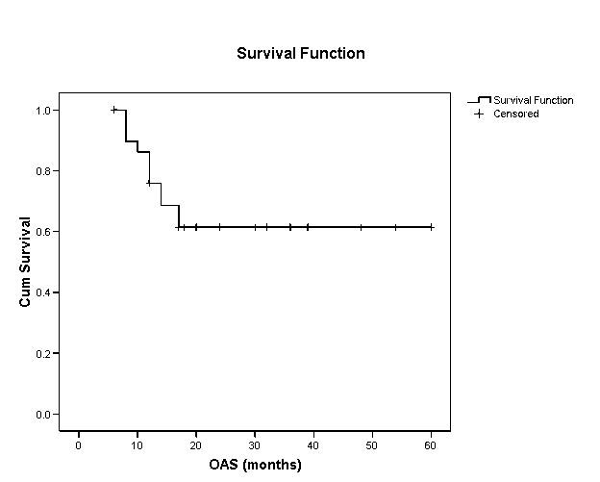

Fig. 1 Five years overall survival of 30 patients with ependymoma treated in NEMROCK 1998-2004

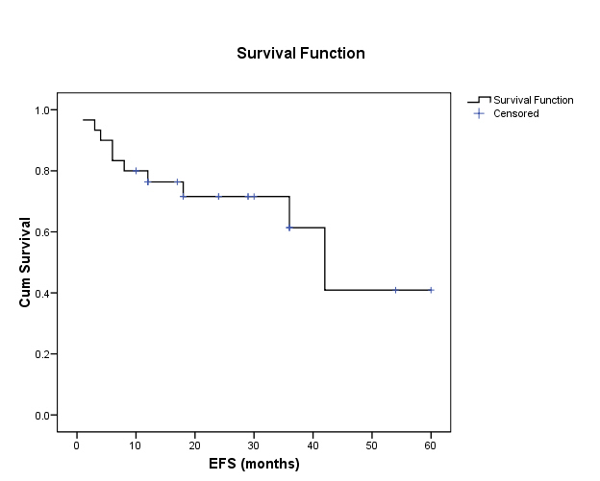

Fig. 2 Five years event free survival of 30 patients with ependymoma treated in NEMROCK 1998-2004
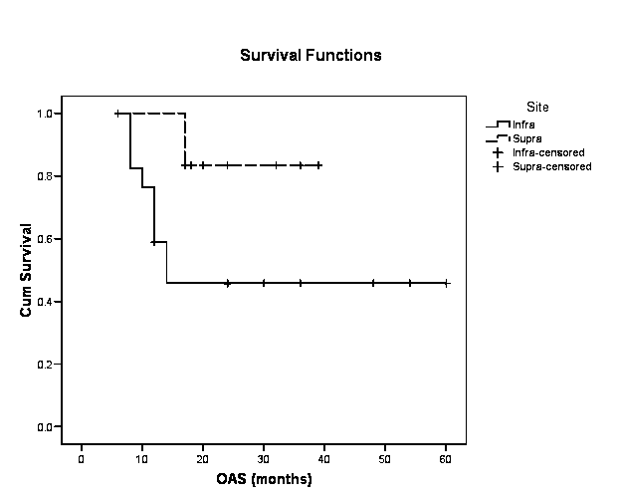

Fig. 3 Five years overall survival in relation to tumor site in 30 patients with ependymoma treated in NEMROCK 1998-2004

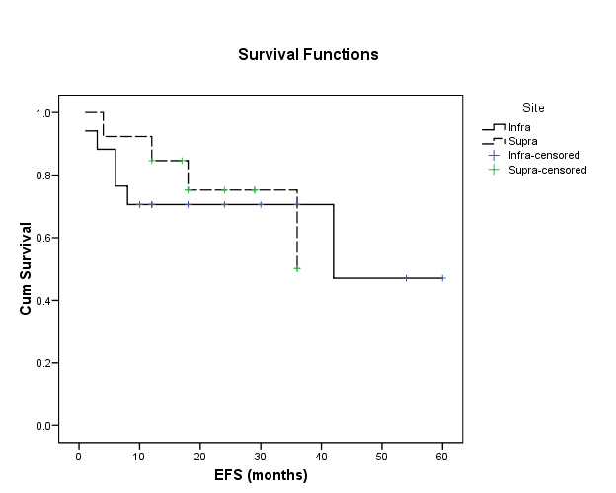

Fig. 4 Five years event free survival in relation to tumor site in 30 patients with ependymoma treated in NEMROCK 1998-2004

