
Cairo University
Faculty of Computers and Information
Information Systems Department

Reporting Services

Representing Cubes into Excel (Using Excel 2013)

- From the “DATA” menu, choose “From Other Sources”. Then, click on “From Analysis Services”.

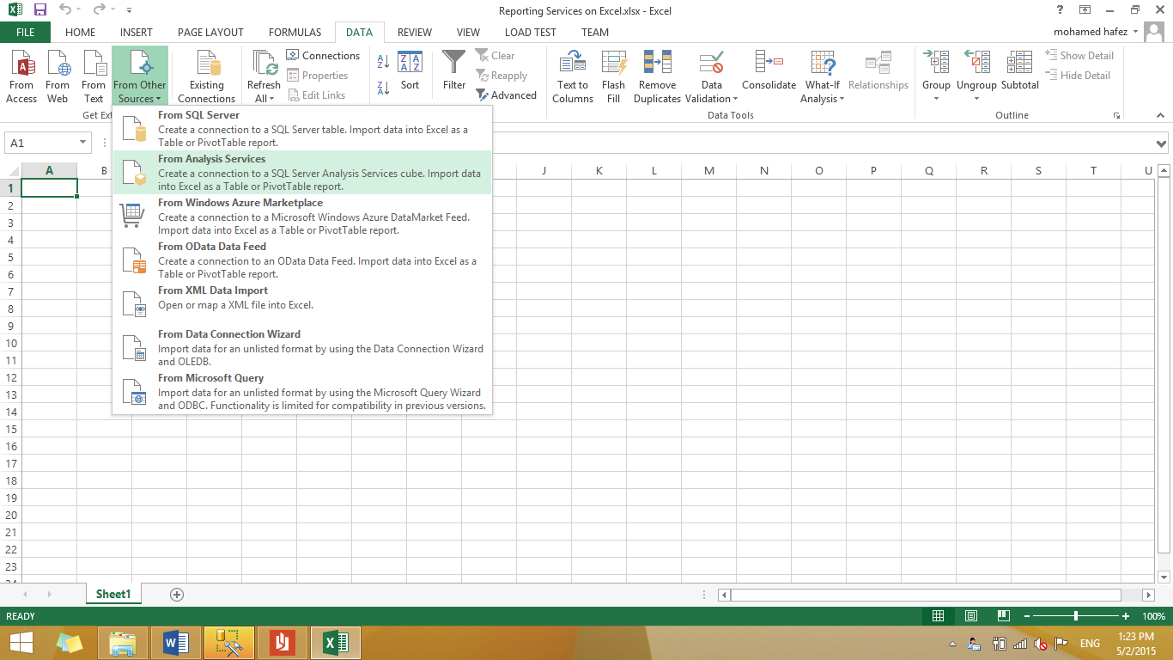

- Write the Server Name of your Analysis Services Instance, then click next.

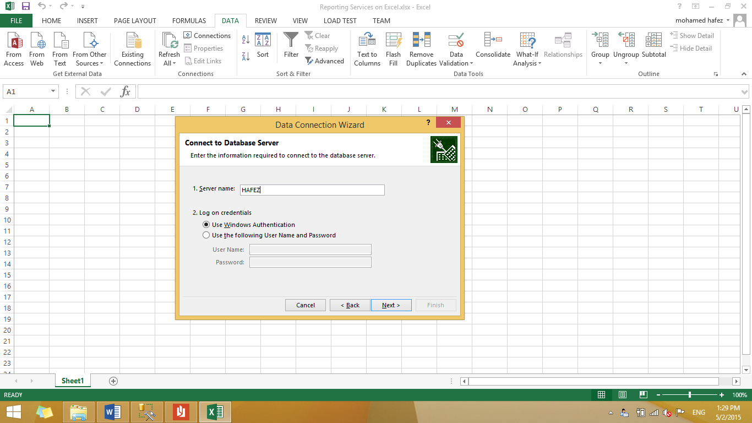

- Select the database (from the ComboBox) and the cube which contains the data you want, then click next.

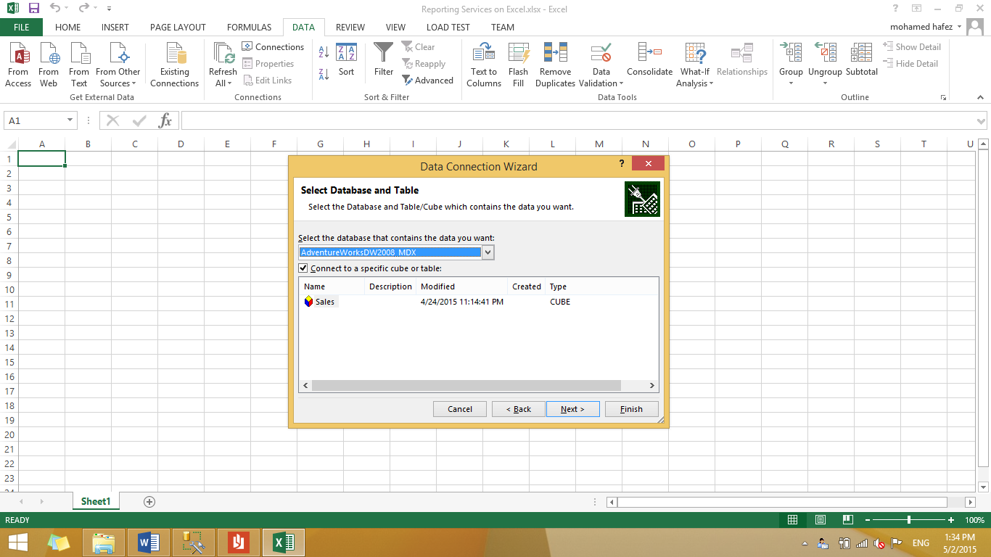

- Enter a name and a description for this data connection, then click finish.

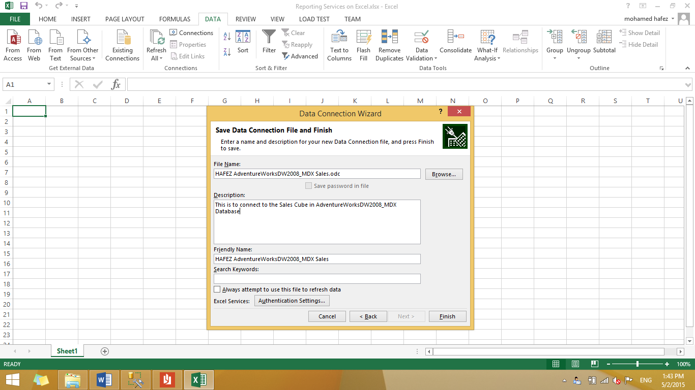

- Select how you want to view your cube’s data; either in a PivotTable Report or a PivotChart, and choose where do you want to put the data into the worksheet, then click OK.

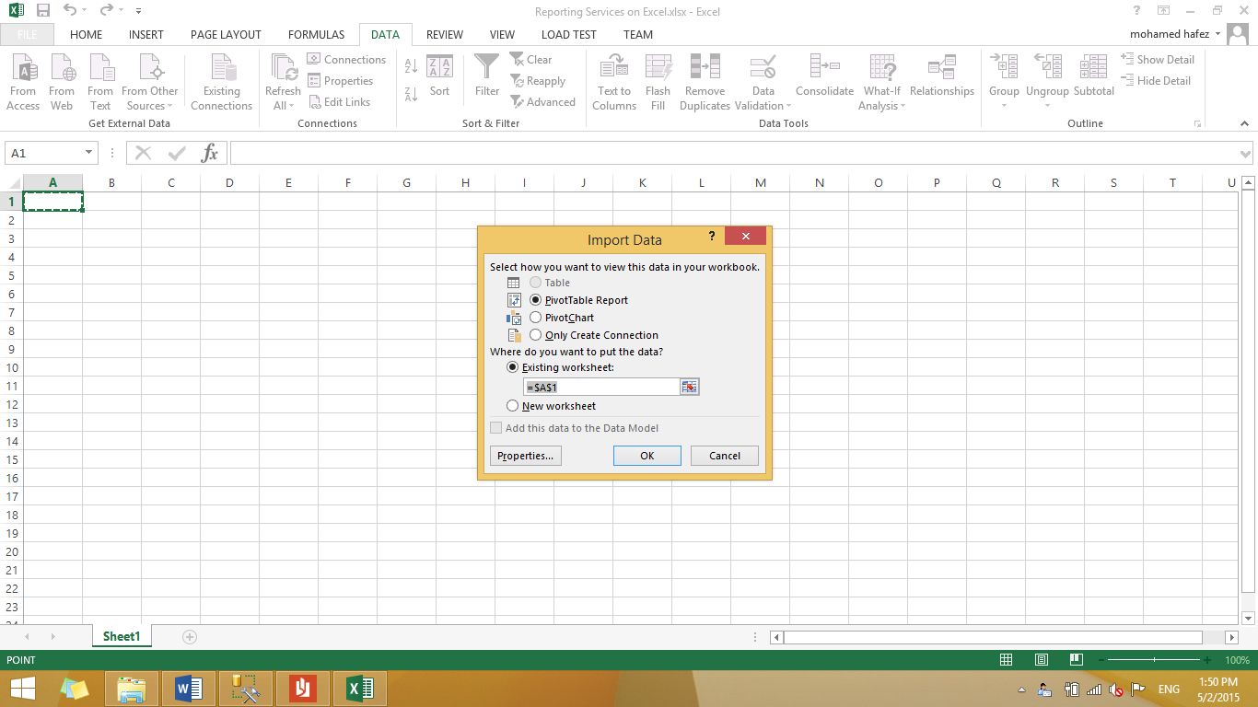
- Showing the two available options (PivotTable Report & PivotChart):
- The following will appear if you choose the PivotTable Report, then you click anywhere in the area shown on the left panel.

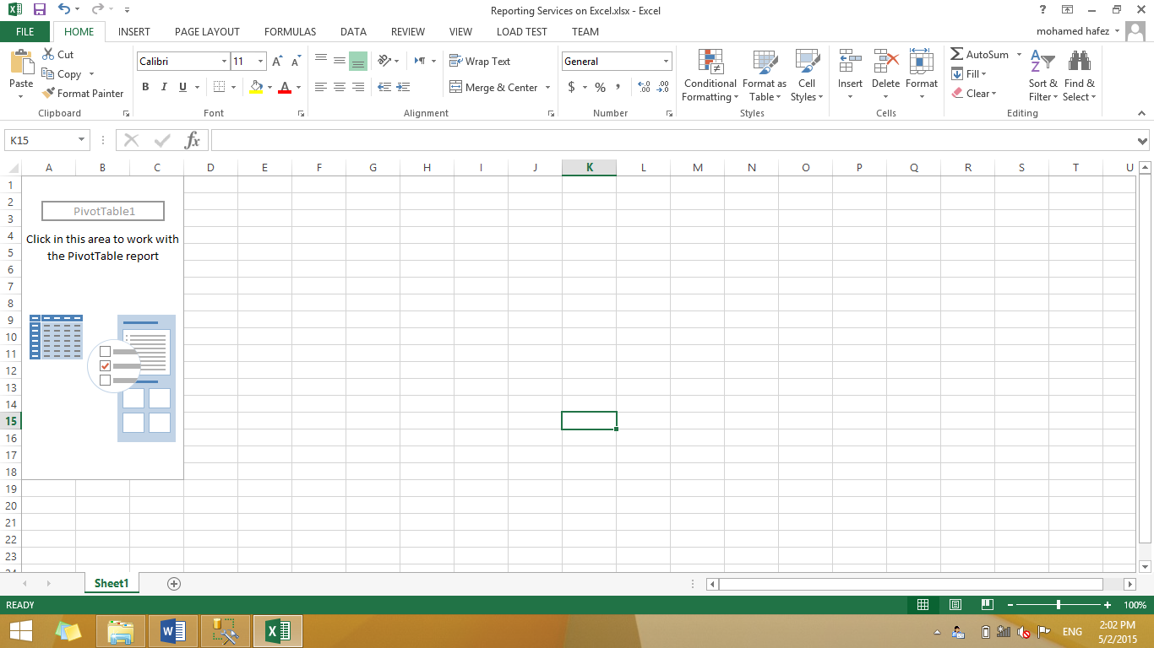

From the PivotTable Fields, you check or drag the fields into the bottom area. In other words, you will choose which fields to go into COLUMNS, ROWS, VALUES and FILTERS. In this example:
In COLUMNS, [Calendar Year] was chosen from the Hierarchy [Order Date.Calendar] under the [Order Date] Dimension Table.
In ROWS, [English Country Region Name] was chosen from the Hierarchy [Customers Geography] under the [Dim Customer] Dimension Table.
In VALUES, [Order Quantity] was chosen from the [Fact Internet Sales] Fact Table.

Note: You will see the report updated automatically when you check or drag a field into COLUMNS, ROWS, VALUES or FILTERS.

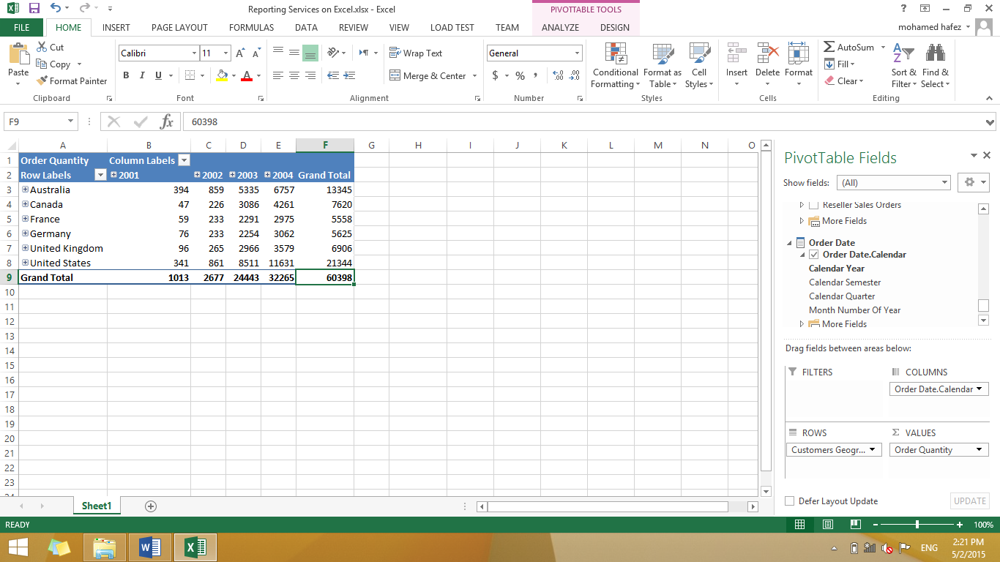

- The following will appear if you choose the PivotChart.

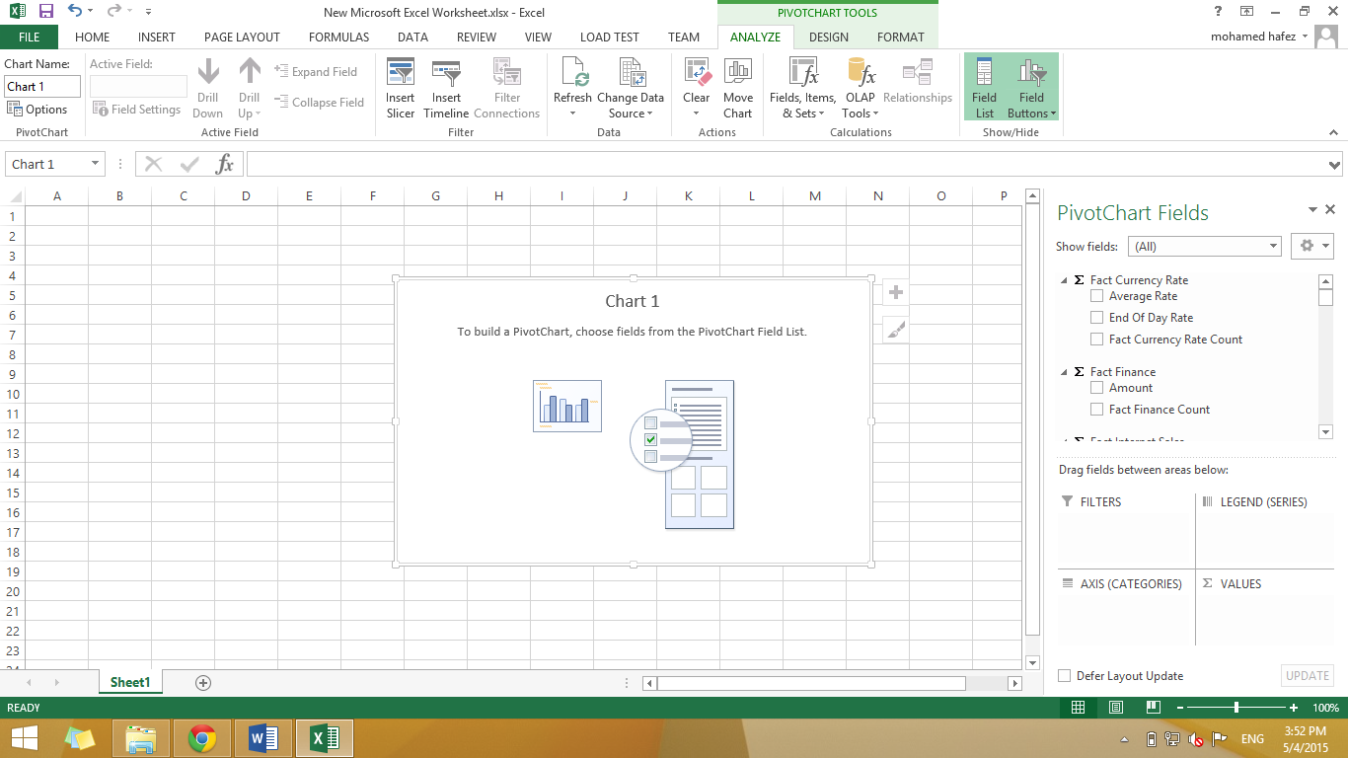

From the PivotChart Fields, you check or drag the fields into the bottom area. In other words, you will choose which fields to go into AXIS (CATEGORIES), LEGEND (SERIES), VALUES and FILTERS. In this example:
In AXIS (CATEGORIES), [Calendar Year] was chosen from the Hierarchy [Order Date.Calendar] under the [Order Date] Dimension Table.
In LEGEND (SERIES), [English Country Region Name] was chosen from the Hierarchy [Customers Geography] under the [Dim Customer] Dimension Table.
In VALUES, [Order Quantity] was chosen from the [Fact Internet Sales] Fact Table.

Note: You will see the chart updated automatically when you check or drag a field into AXIS (CATEGORIES), LEGEND (SERIES), VALUES and FILTERS.

