
Cairo University
Faculty of Computers and Information Information Systems Department Database Systems 1

Lab 5
(DML 3)
(Aggregations and Nested Select)

Exercises using Northwind Database

- Display the Customer Name (ContactName) and the number of orders ordered by this customer, for customers living in UK. Arrange the result based on the number of orders from the greatest to the lowest.
SELECT ContactName,COUNT(Orders.OrderID)
From Customers,Orders,[Order Details]
WHERE Customers.CustomerID = Orders.CustomerID
AND Orders.OrderID = [Order Details].OrderID
AND Customers.Country = 'UK'
GROUP BY ContactName
ORDER BY COUNT(Orders.OrderID) DESC

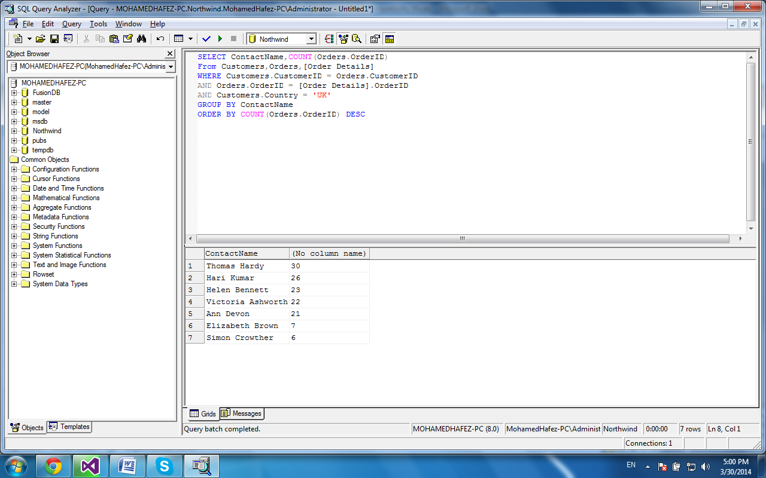
- Get the total quantity ordered for each displayed product name with unit price higher than 30. Restrict the result for those products having total ordered quantity in the range between 1000 and 1500. Label any un-named column(s) with a meaningful name(s).
SELECT Products.ProductName , Sum(Quantity) "Total Quantity Ordered"
FROM Products, [Order Details]
WHERE Products.ProductID = [Order Details].ProductID
AND Products.UnitPrice > 30
GROUP BY Products.ProductName
HAVING Sum (Quantity) BETWEEN 1000 AND 1500
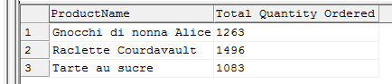

- For each displayed supplier name (ContactName), show how many products were supplied by suppliers who have got a home page. Sort the result by the number of products in an ascending order. Label any un-named column(s) by a meaningful name(s).
SELECT Suppliers.ContactName , Count(ProductID) "Number of Products"
FROM Suppliers,Products
WHERE Suppliers.SupplierID = Products.SupplierID
AND HomePage IS NOT NULL
GROUP BY Suppliers.ContactName
ORDER BY Count (ProductID)
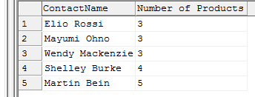

- Display the first name, job title and the country of all employees who are living in UK and have the same job title as the employees with first names: Janet or Steven. Sort the result by the first name of the employees in a descending order.
SELECT FirstName, Title, Country
FROM Employees
WHERE Country = 'UK'
AND Title IN (SELECT Title
FROM Employees
WHERE FirstName IN ('Janet', 'Steven'))
ORDER BY FirstName DESC
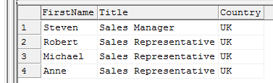

- Display the first name, job title and the city of all employees not working as Sales Managers and living in the same city as the employee with first name: Michael. Sort the result by the first name of the employees in an ascending order.
SELECT FirstName ,Title ,City
FROM Employees
WHERE Title <> 'Sales Manager'
AND City = (SELECT City
FROM Employees
WHERE FirstName = 'Michael')
ORDER BY FirstName

