
Cairo University
Faculty of Computers and Information
Information Systems Department
Database Systems 1

Section 9
(Enhanced ERD)
(Converting ER Model to Relational Model)

Basic concepts of ER modeling are not sufficient to represent requirements of complex applications.

- EER Model Concepts
  - Includes all basic ER modeling concepts
  - Additional concepts:
    - subclasses/superclasses
    - specialization/generalization
    - IS-A relationships
    - categories (Union types)
    - attribute and relationship inheritance
Example 1

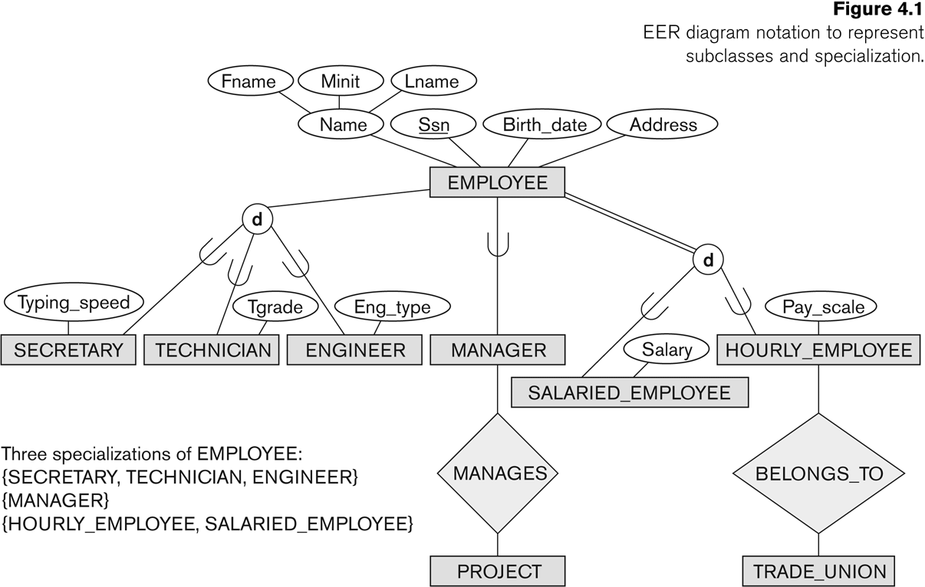

Subclasses and Superclasses

- Each of these subgroupings is a subset of EMPLOYEE entities
  - A secretary is an employee
  - A technician is an employee
  - A manager is an employee
- Each is called a subclass of EMPLOYEE
- EMPLOYEE is the superclass for each of these subclasses
- These are called superclass/subclass (or class/subclass) relationships:
  - EMPLOYEE/SECRETARY
  - EMPLOYEE/TECHNICIAN
  - EMPLOYEE/MANAGER

- The superclass/subclass relationship is also called an IS-A relationship
  - SECRETARY IS-A EMPLOYEE, TECHNICIAN IS-A EMPLOYEE, ….

Specialization

- Specialization is the process of defining a set of subclasses of a superclass
  - The set of subclasses is based upon some distinguishing characteristics of the entities in the superclass
  - Example: {SECRETARY, ENGINEER, TECHNICIAN} is a specialization of EMPLOYEE based upon job type
  - Example: Another specialization of EMPLOYEE based on method of pay is {SALARIED_EMPLOYEE, HOURLY_EMPLOYEE}.
  - Attributes of a subclass are called specific or local attributes
For example, the attribute TypingSpeed of SECRETARY
  - The subclass can also participate in specific relationship types
For example, a relationship BELONGS_TO of HOURLY_EMPLOYEE
- A subclass inherits attributes not only of its direct superclass, but also of all its predecessor superclasses
- A subclass with more than one superclass is called a shared subclass (multiple inheritance)

Generalization

- Generalization is the reverse of the specialization process

Constraints

Disjointness Constraint
  - Specifies that the subclasses of the specialization must be disjoint
  - An entity can be a member of at most one of the subclasses of the specialization
  - Specified by d in EER diagram

Overlapping Constraint
  - That is the same entity may be a member of more than one subclass of the specialization
  - Specified by o in EER diagram

Completeness Constraint:
  - Total (mandatory) specifies that every entity in the superclass must be a member of some subclass in the specialization/generalization
  - Shown in EER diagrams by a double line
  - Partial (optional) allows an entity not to belong to any of the subclasses
  - Shown in EER diagrams by a single line

Attribute Inheritance in Superclass / Subclass Relationships

- An entity that is member of a subclass inherits all attributes of the entity as a member of the superclass
- It also inherits all relationships

Example 2 University Database

Converting ER Model to Relational Model

Seven-step algorithm to convert the basic ER model constructs into relations

- Step 1: Mapping of Regular Entity Types

For each regular entity type, create a relation R that includes all the simple attributes of E.

Example:
Customer
CustomerID
Name
Address
Phone
Order
OrderNum
SalesPerson
OrderDate

1 M

Customer(CustomerID , Name, Address , Phone).
Order (OrderNum ,OrderDate , SalesPerson).

- Step 2: Mapping of Weak Entity Types

For each weak entity type:
- Create a relation R and include all simple attributes of the entity type as attributes of R.
- Include primary key attribute of owner as foreign key attributes of R

Example:
Order
OrderNum
SalesPerson
OrderDate

1
M
OrderItems
ItemNumber
PartNumber
Quantity
Price

ORDER (OrderNum, OrderDate, SalesPerson)
ORDERITEMS (OrderNum, ItemNumber, PartNumber, Quantity, Price).

- Step 3: Mapping of Binary 1:1 Relationship Types

Primary key on the mandatory side becomes a foreign key on the optional side

Example:
Nurse
NurseID
Name
DateofBirth
CareCenter
CenterID
CenterName
Location

1 1

Nurse(NurseID,Name,DateofBirth)
CareCenter(CenterID,CenterName,Loctaion, NurseID)

- Step 4: Mapping of Binary 1:N Relationship Types

Primary key on the one side becomes a foreign key on the many side.

Parent – Relation on the “1″ side.
Child – Relation on the “Many” side.

Represent each Entity as a relation. Copy the key of the parent into the child relation to be foreign key.

Example:
Student
SSN
Name
Age
City
Major

Department
DeptCode
Name

M 1

Student(SSN,Name,Age,City,Major)
Department (DeptCode, Name, SSN)

- Step 5: Mapping of Binary M:N Relationship Types

For each binary M:N relationship type:
- Create a new relation S.
- Include primary key of participating entity types as foreign key attributes in S.
- Include any simple attributes of M:N relationship type.
- Primary Key of the new relation S is the composition of all foreign keys.

Example:

Student
SSN
Name
Age
City
Major
Course
CrsCode
Name

M M

Student(SSN,Name,Age,City,Major)
Course(CrsCode,Name)
Course_Student(SSN , CrsCode)

- Step 6: Mapping of Multivalued Attributes

For each multivalued attribute A
- Create a new relation R.
- Relation R will include an attribute corresponding to A + primary Key attribute K (as a foreign key in R) of the relation that represents the relationship type that has A as multivalued attribute.
- Primary key of R is the combination of A and K.

Example:

Contact
ContactID
FirstName
LastName
Address
Phonenumber
Hobbies
ZipLocation
ZipCode
State
City

M 1

Hint : Hobbies à(Multivalued attribute)

Contact(ContactID,FirstName,LastName,Address,Phonenumber,ZipCode)
ZipLocation(ZipCode,State,City)
Hobbies(ContactID,Hoppy)

- Step 7: Mapping of N-ary Relationship Types

For each n-ary relationship type R
    - Create a new relation S to represent R
    - Include primary keys of participating entity types as foreign keys
    - Include any simple attributes as attributes
Example:

Quantity
Price
Part
Number
Name
Description

Project
ProjectNumber
Name
Budget

M M
Provide
Supplier
SupplierID
Name
Address

M

Part(Number,Name,Description).
Project(ProjectNumber,Name,Budget)
Supplier(SupplierID,Name,Address)
Provide(ProjectNumber,Number,SupplierID,Quantity,Price)

