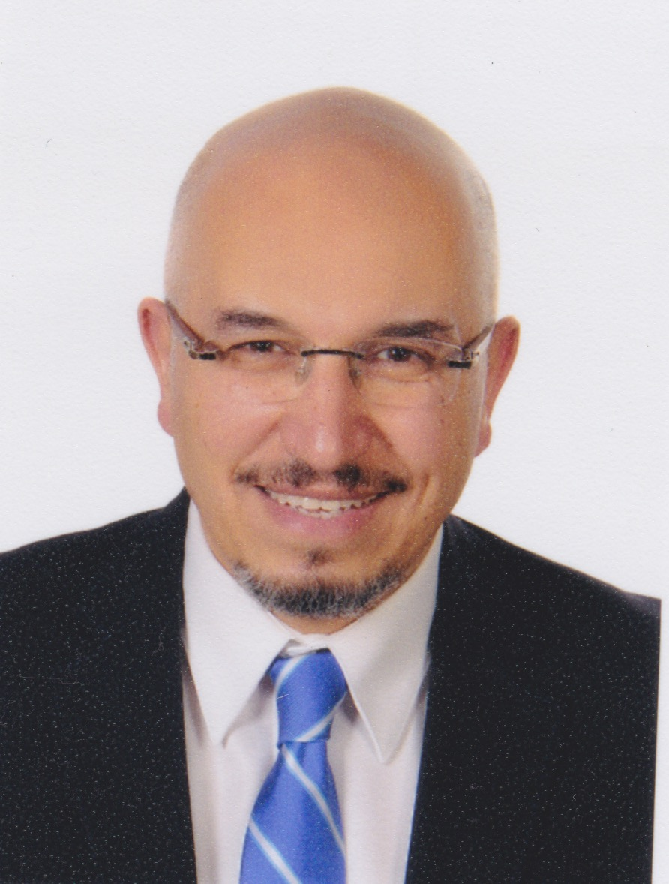
Ahmed Mostafa Hassan Abdelrahman
Ahmed Mostafa Abdelrahmn,MD, FRCSED, Born in Egypt 1966. Graduated from the Kasr Aini School of Medicine in 1990, excellent with honor, and achieved the first place over more than 1500 medical students. In 2008, I was appointed a professor of Ophthalmology, Cairo University, Egypt. I’m working in the academic and clinical fields; teaching undergraduate and postgraduate students, supervising MSc and MD theses, running a tertiary care glaucoma clinic and performing different glaucoma operations. I’m the medical director of Al Nour Eye Hospital (Nasr City Branch) ; the biggest Charity hospital in Egypt . I’m the owner of the Giza Specialized Eye Center and aboard member of Al Rowad Laser Correction Center; RCC. In 2012, I was elected a board member of the Egyptian Ophthalmological Society through which I initiated the Young Ophthalmologists activities in Egypt. Currently I’m the chairman of the Egyptian Society of Continuous Ophthalmic Education, EGSCOE. I’m Sub-Specialized in Glaucoma. In 2005, I introduced the technique of Trabeculotome- guided deep sclerectomy, and the sclera-preserving deep sclerectomy was introduced 3 years later, Prolene Canalostenting was published in 2015. Selective laser trabeculoplasty is one of the interesting fields of work with quite long experience and publications. Pediatric glaucoma is another field of interest.
Ahmed.mostafa@kasralainy.edu.eg

