Assessment of undergraduate nursing students' readiness for self-directed and E-learning
Enas Hassan Saad1, Magda Abd EL- Hamid2 and Enayat Abd El Wahab3
1,2Nursing Administration Department, Faculty of Nursing, Cairo University,
3 Psychiatric Mental Health Nursing, Faculty of Nursing, Cairo University.

ABSTRACT
Background: Technology is constantly changing and new technological developments can have profound effects on many industries especially higher education. Technology may have direct impact on self-directed learning because it has greatly facilitated access both to information resources and to online expertise. For the learners, being able to access a wide and unlimited range of information to serve their learning needs and interests are important to self-directed learning. Aim: The current study will be carried out to assess undergraduate nursing students' readiness for self-directed and e-learning. Subject and Methods: After approval from the ethical committee at the faculty of nursing Cairo University to conduct the study. Written consent was taken from 650 of nursing students from the four academic years at faculty of nursing. Design: A descriptive/ cross sectional study design was conducted to achieve the aim of present study by using modified Self-directed learning readiness scale and modified E-learning readiness questionnaire. Results: the result of the current study revealed that there that more than half of undergraduate nursing students have high readiness level for self-directed learning, while the major of undergraduate nursing students (40.7 %) have moderate readiness level for e-learning, and there were insignificant differences among the students readiness level, while, there were significant differences among the students readiness level for e-learning according to academic levels. Recommendations: the current study recommended that the importance of designing curriculums that can be taught using e-learning methods, and teaching scientific materials online – experimentally at first – to measure the response of the students and teachers to this modern technology.
Key words: Readiness, Self-directed learning, E-learning

INTRODUCTION
Technology is constantly changing and new technological developments can have profound effects on many industries especially higher education (1). Technology may have direct impact on self-directed learning because it has greatly facilitated access both to information resources and to online expertise. For the learners, being able to access a wide and unlimited range of information to serve their learning needs and interests are important to self-directed learning. These include capturing, storing, manipulating, displaying information, and making contact with fellow learners and experts around the globe without layers of formality and at the press of a button (2).
Self-directed learning defined as “a process in which individuals take the initiative, with or without the help of others,” to diagnose their learning needs, formulate learning goals, identify resources for learning, select and implement learning strategies, and evaluate learning outcomes (3). A self-directed learning approach differs from the traditional learning in that the locus of control is with the learner and not the instructor although the instructor can act as the person who facilitates the learning process. Both independent projects and e-learning are instructional methods that would complement the SDL. Self-directed learning begins with deciding what is to be learned. In the traditional approach, the faculty or a curriculum committee determines what is to be learned, while the self-directed learning approach allows this to be decided by the learner, either alone or with assistance (4).
Self-directed learners demonstrate a greater awareness of their responsibility in making learning meaningful and monitoring themselves, they view problems as challenges, desire change, and enjoy learning, and they are motivated and persistent, independent, self-disciplined, self-confident and goal-oriented. Moreover, the self-directed learner takes control and accepts the freedom to learn what they view as important for themselves. The degree of control the learner is willing to take over their own learning will depend on their attitude, abilities and personality characteristics (2).
Today, the development of the internet into a worldwide, high-speed, multimedia communication platform has enabled the development of e-learning as an effective teaching and learning mechanism. In education, e-learning offers significant advantages to students and teachers for research, training, and online learning on par with traditional instruction. In many countries, e-learning has become a “critical” component of lifelong learning and of long-term planning strategies (5).
E-learning has been significant in information and communications technology (ICT). It delivers knowledge to developing countries and it integrates many ICT capabilities in a noble cause. E-learning could dramatically increase access to education. It improves quality of education by accessing global academic resources and by offering training to academics. It also helps learners take an active role, work with their colleagues/instructors from a variety of locations (6).
E-learning could provide solutions to problems such as overcrowded classrooms and transportation. The higher education quality in Egypt has been declining due to the rapidly growing enrolment rate that started in the 1970s and 1980s, which lead to a large number of students per class. Thus, the adoption of e-learning in Egypt can provide an economic and more suitable solution to the higher education problem by filling in the gap between the number of university places available in Egypt and the growing demand for higher education. Although e-learning seems to be the dream that would solve the education hassle in Egypt, in order to make e-learning more popular in Egypt, and to successfully adopt this technology, it is important to understand the users', perception, and preferences (7).
E-learning provides the learner the chance to decide when to learn as well as how fast and how much to learn; and enables them to contact the teachers via e-mail or forums. Since there is no need to go to a campus, they have no expenses for accommodation or transportation. Therefore, e-learning terminates the limitation of time and place while providing learning environments with lower expenses. E-learning is particularly attractive to adult learners because of its flexibility. It provides opportunity for participants to reflect and translate learning out of their practical application of explicit knowledge (6).

SIGNIFICANCE OF THE STUDY
Changing demands on the nursing workforce have led to considerable changes in undergraduate nurse education. Nurse educators should strive to incorporate self-directed learning (SDL) into the curriculum to encourage student nurses to be proactive in their learning needs. Self-directed learning (SDL) can benefit students by giving them autonomy, motivation and the skills for lifelong learning. A clear strategy for introducing SDL into the nursing curriculum is required and SDL should be adopted in a systematic manner to address students’ variation of educational attainment at entry(8).
Furthermore, the remarkable progress in the field of information and communication technology (ICT) and the wide use of internet in the most daily life activities has led to radical changes in the traditional teaching process. Higher education sector must keep up with these technological changes through providing ideal learning environment. Moreover, the labor market began asking for new skills and qualifications which impose new trends and competencies to meet the needs of the new economy.
For the success of an e-learning implementation, there is a need to acknowledge the importance of assessing readiness of learners to adapt this learning style. An e-learning readiness evaluation can help an organization to identify potential aspects that are necessary to ensure that the design of e-learning strategies tailored to meet learners' needs and how teachers and learners come to accept and use an e-learning style as well.
AIM OF THE STUDY
The study aimed to assess undergraduate nursing students' readiness for self-directed and e-learning.
.
RESEARCH QUESTIONS
- What are undergraduate nursing students' degrees of readiness for self-directed and e-learning?
- To what extent is there a difference in undergraduate nursing students' degrees of readiness for self-directed and e- learning among the four academic years?
SUBJECT AND METHODS
Research design:
A descriptive/ cross sectional study design was conducted to achieve the aim of present study .
Setting:
This study will be conducted at Faculty of Nursing – Cairo University in which the building total area 5875.95m2, it consists of five floors .The faculty building is located inside the Campus of Cairo University Hospitals, as well as the faculty building contains expatriate extension garage for cars, cafeteria and mosque .
The faculty has seven scientific departments include Medical surgical department, Critical care nursing department, Administration nursing department, Maternity and Woman's health nursing department, Pediatric nursing department, Community health nursing department, and psychiatric nursing department

Subjects:
The total number of the nursing students from the four academic years at faculty of nursing were (759). The study sample (n=650) was selected according to random sample for this study.
Tools of data collection:
The study was collected by using the following tool as follows:-
1st Part: Socio-Demographic data sheet: It contains socio-demographic characteristics of undergraduate nursing students (11 items) such as age, gender, and marital status, academic status, academic year, previous certification in nursing field, place of residence during the study, Original place of residence, Previous system of education (precollege), Previous computer courses).
2nd Part: Modified Self-directed learning readiness scale that developed by (9) it contains three dimensions which include (40) items related to student perception of his/her individual levels of self-management (13 items), desire for learning (12 items), and characteristics of self-control (15 items).
3rd Part: Modified E-learning readiness questionnaire was developed by (10); It contains (8) dimensions that include (67) items related to readiness for e-learning success, which are grouped into:- 1) technology access (6 items), 2) Computer equipment capabilities (4 items), 3) readiness for using computer (11 items), 4) computer Skills (16 items), 5) internet skills (13 items), 6) learning preferences (5 items), 7) need for online learning (4 items), 8) academic skills (8 items).
Methods of data collection:
- Consent to conduct the study was taking from the vice dean of post graduate studies and research at the Faculty of Nursing, Cairo University, and the approval of ethical committee, and an approval letter from vice dean for education and student affairs
- The tools were translated into Arabic language and reviewed by jury consisted of five professors in nursing administration to be tested for its content validity.
- Internal consistency and reliability were determined using Cronbach’s alpha for self-directed learning and E-learning questionnaire. Internal consistency using Cronbach’s alpha was 0.95 for self-directed learning readiness scale and 0.96 for E-learning readiness questionnaire.
- A pilot study was carried out on (n = 77) nursing students which constituted (10%) of students from different academic levels at Faculty of Nursing – Cairo University to test the applicability and clarity of the questions, also to estimate the needed time to fill it, and to make sure that items are fully understood. All nursing students involved in the pilot study were excluded from the study sample later on.
- The researchers contacted to the nursing students to explain the purpose and procedure of the study and determine the available time to collect data.
- The questionnaires were distributed to the studied sample at the end of the theoretical lectures
- Data collection was completed in a period of one month, during February 2014.
Ethical Considerations
Before commencing the study, ethical approval was granted from the research ethics committee in which the study took place. The researchers ensured that the correct procedures were undertaken concerning informed consent, autonomy, anonymity and the maintenance of confidentiality.
Statistical analysis:-
The data collected from the self-directed and electronic learning readiness questionnaire were coded and entered into (SPSS), Version 20.0, for analysis.
The data were analyzed using the descriptive statistics in the form of Frequency distribution, percentage, mean and standard deviation. Inferential statistics in the form of Chi square test, as well as Multiple linear regression test which was used to test the most important predictors of self-directed and E- learning readiness. The significance level of all statistical analysis was at < 0.05 (P-value).
RESULTS:
Table (1) revealed that, the majority of the study sample were single freshmen females, between ages 18 and 21, and had the general secondary school degree, and that more than half of the study sample lived with their families in urban places, and that the majority were educated at government schools and did not received any computer courses.
Table (2) ,figure(1), represent that (51%) of the study sample have high readiness level of self-directed learning, while, (12.9%) have low readiness level of self-directed learning, and the highest percentage of readiness level was found regarding the desire for learning dimension .
Table (3)Figure (2) ,revealed that , (27.6%) of the study sample have high readiness level of electronic learning, while, (31.8%) have low readiness of self-directed learning.
Table (4), revealed that, there were insignificant differences among all of the study sample responses regarding readiness levels for self-directed learning according to academic levels.
Table (5), revealed that, there were significant differences among all the of study sample responses regarding readiness levels for electronic learning according to academic levels.
Table (6), revealed that, the highest percentage of students who have high levels of self-directed learning readiness (21.9 %) have moderate electronic learning readiness levels.

Table (1): Distribution of sample according to socio-demographic data (n=573)
socio-demographic data |  | No. | %
Age | 18 - 21 | 503 | 87.8
Age | 22 -25 | 70 | 12.2
Mean + SD=19.98 +1.31
Gender | Male | 169 | 29.5
Gender | Female | 404 | 70.5
Marital status | Single | 560 | 97.7
Marital status | Married | 13 | 2.3
Academic status | Freshmen | 536 | 93.5
Academic status | Repeater | 37 | 6.5
Academic level | First | 139 | 24.3
Academic level | Second | 222 | 38.7
Academic level | Third | 136 | 23.7
Academic level | Fourth | 76 | 13.3
Previous certification in  nursing field | Associate degree | 67 | 11.7
Previous certification in  nursing field | Secondary school | 506 | 88.3
Place of residence during study | Family | 341 | 59.5
Place of residence during study | University campus housing | 178 | 31.1
Place of residence during study | Private accommodation | 54 | 9.4
Original place of residence | Urban | 342 | 59.7
Original place of residence | Rural | 231 | 40.3
Previous system of education  (precollege) | Government schools | 539 | 94.1
Previous system of education  (precollege) | Private schools | 34 | 5.9
Previous computer courses | None | 521 | 90.9
Previous computer courses | ICDL | 39 | 6.8
Previous computer courses | Computer basics | 3 | 0.5
Previous computer courses | Microsoft office | 8 | 1.5
Previous computer courses | Photoshop | 2 | 0.3

Table (2): Levels of self-directed learning readiness (n=573)

Dimensions | Levels of Readiness |  |  |  |  |  | Total |  | χ2 | P value
Dimensions | Low |  | Moderate |  | High |  |  |  | χ2 | P value
Dimensions | No. | % | No. | % | No. | % | No. | % | χ2 | P value
Self-Management | 176 | 30.7 | 171 | 29.8 | 226 | 39.4 | 573 | 100 | 1.775 | <0.0001
Desire for learning | 50 | 8.7 | 111 | 19.4 | 412 | 71.9 | 573 | 100 | 39.33 | <0.0001
Self-control | 80 | 14.0 | 182 | 31.8 | 311 | 54.2 | 573 | 100 | 13.04 | <0.0001
Total | 74 | 12.9 | 207 | 36.1 | 292 | 51.0 | 573 | 100 | 12.64 | <0.0001

Figure (1) Levels of self-directed learning readiness
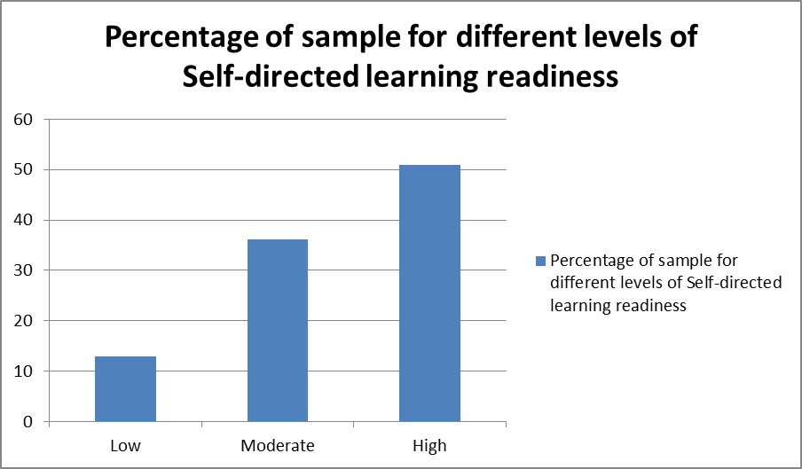
Table (3): Levels of self-directed learning readiness (n=573)

Dimensions | Levels of Readiness |  |  |  |  |  | Total |  | χ2 | P value
Dimensions | Low |  | Moderate |  | High |  |  |  | χ2 | P value
Dimensions | No. | % | No. | % | No. | % | No. | % | χ2 | P value
Technology access | 165 | 28.8 | 98 | 17.1 | 310 | 54.1 | 573 | 100 | 92.7 | <0.0001
Computer equipment capabilities | 185 | 32.3 | 132 | 23.0 | 256 | 44.6 | 573 | 100 | 32.48 | <0.0001
Readiness for using computer | 433 | 75.6 | 93 | 16.2 | 47 | 8.2 | 573 | 100 | 51.2 | <0.0001
Computer Skills | 171 | 29.8 | 89 | 15.5 | 313 | 54.6 | 573 | 100 | 54.12 | <0.0001
Internet Skills | 184 | 32.1 | 74 | 12.9 | 315 | 54.9 | 573 | 100 | 11.94 | <0.0001
Learning preferences | 312 | 54.5 | 176 | 30.7 | 85 | 14.8 | 573 | 100 | 13.67 | <0.0001
Need for Online Learning | 232 | 40.5 | 123 | 21.5 | 218 | 38 | 573 | 100 | 33.93 | <0.0001
Academic Skills | 116 | 20.2 | 124 | 21.6 | 333 | 58.1 | 573 | 100 | 12.89 | 0.002
Total | 182 | 31.8 | 233 | 40.7 | 158 | 27.6 | 573 | 100 | 15.36 | <0.0001

Figure (2) Levels of electronic learning readiness

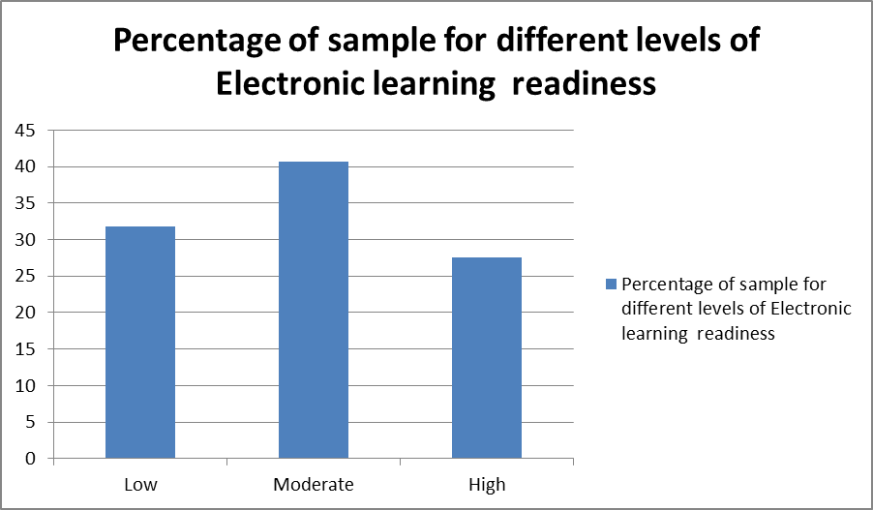

Table (4): Correlation between self-directed learning readiness levels according to academic levels

Academic levels | Levels of Readiness |  |  |  |  |  | Total |  | χ2 | P value
Academic levels | Low |  | Moderate |  | High |  |  |  | χ2 | P value
Academic levels | No. | % | No. | % | No. | % | No. | % | χ2 | P value
First level | 12 | 8.6 | 53 | 38.1 | 74 | 53.2 | 139 | 100 | 7.72 | 0.259
Second level | 39 | 17.6 | 76 | 34.2 | 107 | 48.2 | 222 | 100 | 7.72 | 0.259
Third level | 15 | 11.0 | 48 | 35.3 | 73 | 53.7 | 136 | 100 | 7.72 | 0.259
Fourth level | 8 | 10.5 | 30 | 39.5 | 38 | 50.0 | 76 | 100 | 7.72 | 0.259
Total | 74 | 12.9 | 207 | 36.1 | 292 | 51.0 | 573 | 100 | 12.64 | <0.0001

Table (5): Correlation between electronic learning readiness levels according to academic levels

Academic levels | Levels of Readiness |  |  |  |  |  | Total |  | χ2 | P value
Academic levels | Low |  | Moderate |  | High |  |  |  | χ2 | P value
Academic levels | No. | % | No. | % | No. | % | No. | % | χ2 | P value
First level | 50 | 36.0 | 56 | 40.3 | 23.7 | 33 | 139 | 100 | 14.89 | 0.021
Second level | 71 | 32.0 | 97 | 43.7 | 24.3 | 54 | 222 | 100 | 14.89 | 0.021
Third level | 30 | 22.1 | 55 | 40.4 | 37.5 | 51 | 136 | 100 | 14.89 | 0.021
Fourth level | 31 | 40.8 | 25 | 32.9 | 26.3 | 20 | 76 | 100 | 14.89 | 0.021
Total | 182 | 31.8 | 233 | 40.7 | 158 | 27.6 | 573 | 100 | 15.36 | <0.0001

Table (6): Correlation between self-directed learning readiness levels and electronic learning readiness levels for whole sample (n=573)

 |  | Electronic learning readiness levels |  |  |  | χ2 |  | Sig.
 |  | Low | Moderate | High | Total |  |  | Sig.
Self-directed  learning readiness levels | Low | 38 (6.6%) | 28 (4.8) | 8 (1.3%) | 74(12.9%) | 36.56 | <0.0001
Self-directed  learning readiness levels | Moderate | 80 (13.9%) | 79 (13.7%) | 48(8.3%) | 207(36.1%) | 36.56
Self-directed  learning readiness levels | High | 64 (11.1%) | 126(21.9%) | 102(17.8%) | 292(50.9%) | 36.56
Self-directed  learning readiness levels | Total | 182 (31.7%) | 233 (40.6%) | 158(27.5%) | 573(100%) | 36.56

DISCUSSION
Technology is constantly changing and new technological developments can have profound effects on many industries especially higher education. Technology may have direct impact on self-directed learning because it has greatly facilitated access both to information resources and to online expertise. For the learners, being able to access a wide and unlimited range of information to serve their learning needs and interests are important to self-directed learning.
The finding of the study revealed that the highest percentage of readiness level was found regarding the desire for learning dimension. The reason for this could be that the majority of students came from rural areas, and middle class. These students usually have a great desire to improve their social and economic statues through acquiring college degrees and higher academic skills which they think will allow them to get good jobs and join prestigious companies in order to achieve these goals. The results were in agreement with what (11), who stated that Learners with high levels of self-directed learning are active learners who have strong desires for learning, make use of problem-solving skills, have the capacity to engage in independent learning activities, and autonomously manage their own learning, and also agreed with what (12), whose stated that only students with a desire for learning can engage in learning using the available resources, and monitor and regulate the strategies they use to assist themselves in conscious learning.
The study results revealed that, more than half numbers of undergraduate nursing student have high level of self-directed learning. The results were in agreement with what (13), in Indonesia who indicated that 50% of the students had low to moderate scores for self-directed learning readiness. However these results contradicted with the study of (14), who found that the majority of nursing students have high level of self-directed learning readiness.

Finding of the present study denoted that the major of undergraduate nursing students (40.7 %) have moderate readiness level for e-learning, and that due to lack of attention to the development of these skills which needed in e-learning in the different stages of education
Regarding electronic learning dimensions which classified by readiness levels according to academic levels, the finding of the study revealed that the highest percentage of readiness level was found on the second level while the lowest level of readiness was found on the fourth level. For the second level, the reason could be that after the first year students start to look for methods of learning that are different from those which they have in the pre-university stages. As for the fourth level, the reason for that could be that the students are on the verge of graduation, which reduces their willingness to discover new ways of learning.
The finding of the current study indicated there were significant differences between self-directed learning readiness levels and electronic learning readiness levels, the highest percentage of students who have high levels of self-directed learning readiness have moderate electronic learning readiness levels. The reason behind this could be that e-learning in its foundation depends on the fact that the student must have high capabilities for self-directed learning, but it is not necessary that the student who has high capabilities for self-directed learning to be good at e-learning, because he might lack some electronic skills that need to be enhanced through training courses.
RECOMMENDATIONS
In the light of the findings of the present study, the following are recommended:
- Hold an acceptance exam to determine the computer skills of the student before enroll in the college.
- Training teachers on how to convert the lectures from the traditional form to various multimedia formats.
- The expansion in the use of e-learning applications.
- Modify the curriculum to suit the e-learning techniques.
- teaching scientific materials online – experimentally at first – to measure the response of the students and teachers to this modern technology.
REFERENCES
- Humaidi ,N., Syazwan, M., Asarani, N., & Annuar, A. ( 2012). Students’ Performance on the Implementation of Online Learning System. Centre of Applied Management, Faculty of Business & Management, UiTM Puncak Alam Campus, Malaysia.
- Teo, T., Tan, S., Lee, C., Chai, C., Koh, H., Chen, W., & Cheah, H. (2010). The self-directed learning with technology scale (SDLTS) for young students: An initial development and validation. Computers & Education International Journal , pp 1764-1771.
- Shaikh, R. (2012). Comparison of readiness for self-directed learning in students experiencing two different curricula in one medical school. Gulf Medical Journal, 2(1), pp 27-31.
- Daly, P., Gijbeles, D. (2012). Real Learning Opportunities at Business School and Beyond. New York: Springer-Verlag, LLC.
- Saekow, A. Samson, D. (2011). E-learning Readiness of Thailand’s Universities Comparing to the USA’s Cases. International Journal of e-Education, e-Business, e-Management and e-Learning, 1 (2), pp 126-127.
- Srichanyachon, N. (2010). Key Components of E-Learning Readiness. Accessed at June 5, 2013, Retrieved from: http:// www. bu.ac.th/knowledge center/ epopee r/Jan _June 2010 /puff/Page_56.pdf.
- El Gamal, S. Abd El Aziz, R. (2011). The Perception of Students Regarding E-Learning Implementation in Egyptian Universities. The Third International Conference on Mobile, Hybrid, and On-line Learning. 1(4), pp. 335 – 361.
- Miller, M. (2010). Are first year undergraduate student nurse prepared for self-directed learning?. Nursing Times, 106 (46), p 1.
- Fisher, M., King, J., Tague, G. (2001) Development of a self-directed learning readiness scale for nursing education. Nurse Education Today 21:516-52.
- Watkins, R., Leigh, D., and Triner, D. (2004). Assessing Readiness for E-learning. Performance Improvement Quarterly, 17(4), pp. 66-79.
- Guglielmino, L. M. (2010). Self-directed learning and teachers' professional development. In H. B. Long & Associates, Developing paradigms for self-directed learning (pp. 91-106). Norman, OK: Public Managers Center, College of Education, University of Oklahoma. Yang, GF. And Jiang, XY. (2014). Self-directed learning readiness and nursing competency among undergraduate nursing students in Fujian province of China. International Journal of Nursing Sciences. 1(3), 255–259
- Lestari, E., Widjajakusumah, D., 2009. Students' self-directed learning readiness, perception toward student-centered learning and predisposition towards student centered behavior. South East Asian Journal of Medical Education 3 (1), 52–56.
- El-Gilany, A.H., Abusaad, F.E.S. Self-directed learning readiness and learning styles among Saudi undergraduate nursing students. Nurse Educ. Today. 2013;33:1040–1044.

