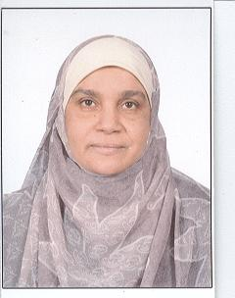
C.V.

Name: Hanaa Youssry Hashem Ibrahim
Address: 249N HADAEK AL-AHRAM Giza Egypt
Contact: 01153413458 dr.hanaa67@yahoo.com or dr.hanaa67@cu. edu.eg
url: http://scholar.cu.edu.eg/dr_hanaa
Date of Birth: 22-5-1967 Marital status: Married
Gender: Female No. of Dependents: 2
Nationality: Egyptian Religion: Moslem

Qualification: Degrees: Assistant prof. 13-10-2011, PhD. 20-9-2001, Master: 24-11- 1996, Bachelor: May 1989
Specialty: Medical-Surgical Nursing
University: Cairo University, Cairo, Egypt.
Professional Experience:
- August, 2014 to date: Professional Trainer, Faculty and Leadership Development Center, Cairo University, Egypt.
- July, 2014 to date: Member of the Quality Assurance and Accreditation Center Council, Cairo University, Egypt.
- Oct., 2012 to date: Member of the , Cairo University, Egypt.
- Oct., 2013 to date: Director of the Quality Assurance and Accreditation Unit, Faculty of Nursing, Cairo University, Egypt.
- Oct., 2012 to date: Member of the Faculty Council, Faculty of Nursing, Cairo University, Egypt.
- Oct., 2012 to date: Member of the Post graduate Studies and Scientific Researches Affairs Committee, Faculty of Nursing, Cairo University, Egypt.
- Oct., to date: Member of the Education and Undergraduate Students Affairs Committee, Faculty of Nursing, Cairo University, Egypt.

- Feb., to June 2013: Assigned to Teach Seminar in Nursing Specialty (critical care and emergency) course, doctorate Program, Faculty of Nursing, Cairo University, Egypt.

- Feb., 2013 to date: Assigned to Teach Seminar in Nursing Specialty (Medical-Surgical Nursing) course, doctorate Program, Faculty of Nursing, Cairo University, Egypt.

- Feb., 2013 to date: Coordinator of Medical Surgical Nursing Department (level 2). Faculty of Nursing, Cairo University, Egypt.

- Sep., 2013: Assigned to teach Medical Surgical Nursing course, Master Program, Faculty of Nursing, Suez Canal University, Egypt.
- Oct.,, 2012 to Oct., 2013: Head of the Scientific Research domain at the Quality Assurance and Accreditation Unit. Faculty of Nursing, Cairo University, Egypt.
- Sep., 2012 to date: Member of the Research Hearing Committee, Faculty of Nursing, Cairo University, Egypt.
- Sep., 2012 to date: Assigned to teach Medical Surgical Nursing course, Master Program, Faculty of Nursing, Cairo University, Egypt.
- Sep., 2012 to date: Assigned to teach Curriculum Development of Nursing course, Master Program, Faculty of Nursing, Cairo University, Egypt.
- Sep., 2012 to date: Assigned to teach Nursing Research course, Baccalaureate Program, Faculty of Nursing, Cairo University, Egypt.
- Sep., 2012 to date: Assigned to teach Medical- Surgical Nursing course, Baccalaureate Program, Faculty of Nursing, Cairo University, Egypt.
- July, 2012 to date: Assistant professor, Medical-surgical Nursing, Faculty of Nursing, Cairo University, Cairo, Egypt.
- Oct. 2010 to June 2012: Member of the Research Committee, College of Nursing, King Saud Bin Abdul-Aziz University for Health Sciences, Jeddah, Kingdom of Saudi Arabia.
- May, 2011: Member of the Scientific Committee, Research Day, Nursing Department, College of Nursing, King Saud Bin Abdul-Aziz University for Health Sciences, Riyadh, Kingdom of Saudi Arabia.
- Sep. 2010 to June 2012: Assistant professor, College of Nursing, King Saud Bin Abdul-Aziz University for Health Sciences, Jeddah, Kingdom of Saudi Arabia.
- Oct. 2010 to June 2012: Assigned to teach Critical Care Nursing course, College of Nursing, King Saud Bin Abdul-Aziz University for Health Sciences, Jeddah, Kingdom of Saudi Arabia.
- Oct. 2010 to June 2012: Assigned to teach Nursing Research course, College of Nursing, King Saud Bin Abdul-Aziz University for Health Sciences, Jeddah, Kingdom of Saudi Arabia.
- Oct. 2010 to June 2012: Assigned to teach Normal Growth and Development course, College of Nursing, King Saud Bin Abdulaziz University for Health Sciences, Jeddah, Kingdom of Saudi Arabia.
- Feb. 2010 to Sep., 2010: Acting head of the basic nursing unit, Medical-surgical Nursing Department, Faculty of Nursing, Cairo University, Cairo ,Egypt
- Feb. 2010 to June 2012: Assigned to teach critical care nursing course, Faculty of Nursing, Beni Sueif University, Beni Sueif, Egypt.
- Oct. 2009 to date: Head of the Education Appraisal System Domain at the Quality Assurance Unit. Faculty of Nursing, Cairo University, Egypt.
- Sep.2009 to Sep., 2010: Member of the research project team entitled (Monitoring Functional Status of Myocardium Infarction Patients at Al-Manial University Hospital). Funded by Cairo University Research Services, Cairo University, Egypt.
- Sept.2008 to Sept.2009 : Acting dean of the Princess Aisha bint Al-Hussein Faculty of Nursing, Al-Hussein bin Talal University, Ma;an, Jordan.
- Nov.2007 to Sept.2009: Associate Professor, Princess Aisha bint Al-Hussein Faculty of Nursing, Al-Hussein bin Talal University, Ma;an, Jordan.
- Feb. 2007 to June 2007: Visiting professor, College of Pharmacy & Nursing, University of Nizwa, Nizwa, Sultanate of Oman.
- March., 2005 to Feb. 2007: Member of management team of the Project entitled “Promoting Clinical Teaching Skills among Clinical Instructors at Faculties of Nursing, Arab Republic of Egypt” Funded by Higher Education Enhancement project HEEPF, Ministry of Higher Education Egypt.
- Jan.2004 to Jan. 2007: Member of the research project team entitled (Monitoring Functional Status of Hospitalized Patients Suffering from Chronic Liver Diseases). Funded by Cairo University Research Services, Cairo University, Cairo, Egypt.
- Sept. 2003 to Feb. 2007: Lecturer of method of teaching, Faculty of Nursing, Cairo University. Cairo, Egypt
- Sept., 2002 to Feb., 2007: Lecturer of Medical –Surgical Nursing . Kasr El-Ani, Technical Institute of Nursing, Mubarak- Kholl project, Cairo, Egypt.
- Sept. 2002 to Sept. 2003: Member of the team responsible for conducting the first self-study of the faculty of nursing Cairo University
- May 2002 to August 2002: Nursing Tutor, Nizwa Nursing Institute, Nizwa, Sultanate of Oman.
- November, 2001 to date: lecturer of Medical Surgical Nursing, Faculty of Nursing, Cairo University, Egypt.
- March 1996 to November, 2001: Assistant lecturer of Medical Surgical Nursing, Faculty of Nursing, Cairo University, Egypt.
- Feb., 1991 to March. 1996: Clinical instructor of Medical Surgical Nursing, Faculty of Nursing, Cairo University, Egypt.

Reference:
Dr. Samira El-Shakawy
Professor of Medical Surgical Nursing.
Work relation ship
Email:dr samira @yahoo.com
Contact: 01005388588

Dr. Khyria Abobaker El-Sawy
Professor of Medical Surgical Nursing.
Work relation ship
Email:
Contact: 01002572350

Publications:

- Okasha, T. & Ibrahim, H. (2014). Clinical Pathway for Postoperative Organ Transplants. LAP Lambert Academic Publishing. Publication date 13 September 2014. ISBN 13: 9783659589690. ISBN 10: 3659589691. http://www.bookdepository.com/Clinical-Pathway-For-Postoperative-Organ-Transplants-Tahsien-Okasha/9783659589690?b=-3&t=-26#Bibliographicdata-26.

- Hashem., H. & Ismail., L. (2014). Nursing Students’ Experience on Truthful Disclosure of Information to Cancer Patients. (2014). 2nd USM International Nursing Conference “Nursing Practice Transformation: Empowerment and Engagement’’ August 17-18. University of Sain, Malysia.
- Abd El-NabY., A., Hashem., H. & Ismail., G. (2014). Evaluation of a Designed Warfarin Educational program on Patients’ Knowledge and Incidence of Side Effects. Global Journal of Pharmacology 8 (4): 592-600, ISSN I992-0075. DOI: 10.5829/idosi.gip.2014.8.4.8525.
- Eswi, A., Radi, S. & Hashem., H. (2013). Stress/ Stressors as Perceived by Baccalaureate Saudi Nursing Students. Middle-East Journal of Scientific Research 14 (2): 193-202, 2013.
- Baiumy, H., & Hashem, H. (2013). Objective Structured Clinical Examination (OSCE) In Nursing: Students’ and Clinical Instructors’ Perception.
- Esmael,S., Esate, H. & Hashem, H.(2011). Fluid and Electrolyte Status among Patients Undergoing Intestinal Surgeries, at El Manial University Hospital. Egyptian Nursing Journal. Vol.1, No,2. June 2011.
- Esmael, S& Hashem, H.(2011). Impact of Scenario- Based Educational Intervention on Nurses’ Knowledge and Practice about Delirium Assessment among Critically Ill Patients. International publication in, The Journal of American Science.
- El-sayed,Y. & Hashem, H. ( 2009). Gender Differences in Quality of Life for Post Coronary Artery Bypass grafting Patients at El Manial University Hospital, The New Egyptian Journal Medicine, Vol.44, No,2
- Hashem, H., & Shaban, N. (2008) Nutritional Support Schedule among Acute Stroke Adult Patients' on Nasogastric Tube Feeding at Medical Departments Nizwa Hospital-Sultanate of Oman, The New Egyptian Journal Medicine, Vol.17, No,2.
- Soliman, M. El-sawy, Kh., Hashem, H., Abd El-kader, L. |& El- Sbaei, H (2006). Teaching /Training Sessions about clinical teaching For Clinical Nurse Instructors: Its Impact On Cognitive Development Of Their Clinical Roles. The 3rd Annual International Scientific Conference of Maternal Newborn Health Nursing Department (Environmental Factors: New Horizon for Women’s and Family Health)
- Hashem,H Abed, F. & Saad, E.(2006). Focused Critical Care Nursing Curriculum Leaning Experience: It’s Effect on the Quality of Nursing Care Provided by the Intern. The 3rd Annual International Scientific Conference of Maternal Newborn Health Nursing Department (Environmental Factors: New Horizon for Women’s and Family Health)
- Hashem, H , Attia, S. & Hussien, B. (2006). Patient’s Responses to Selected Invasive Procedures in Medical and Surgical Wards at El-Manial University Hospital. the 1st Scientific Nursing Conference of the Faculty of Nursing Zagazig University in titled (Quality Nursing Education and World Challenges).
- Essat, H. & Hashem, H. ( 2005). Patients –Health Care Provider Prioritization of Chemotherapeutic agents Side Effects among Patients Receiving Chemotherapy. The 1st National Scientific Nursing Conference Faculty of Nursing Mansours University.
- Hashem, H. & Helmy, N. (2005) A study of Physical and psychological responses of Women Undergoing Mammography, International Nursing Congress, Faculty of Nursing, Ain Shams University.
- Hashem, H. (2004). Effect of a Designed Teaching –Training Sessions about Diabetic Foot Care on Diabetic Knowledge and Self care Practice. The second Annual Scientific Conference of Maternal and Newborn Health Nursing Department Faculty of Nursing, Cairo University, pp.34-45.
- El-sawy, Kh., Soliman, M. & Hashem, H. (2004). Monitoring Functional Status of Hospitalized Patients Suffering from Chronic Liver Diseases. Funded by Cairo University Research Services, The second Annual Scientific Conference of Maternal and Newborn Health Nursing Department Faculty of Nursing, Cairo Unversity,pp.64-76.
- El-sawy, Kh., Soliman, M. & Hashem, H. ( 2001). The Effect of Two Pain Relieving Strategies on Post-operative pain Experience among Patients Undergoing Open Heart Surgeries, The New Egyptian Journal Medicine. Vol.34, No,2
- Omar. B, Yossief, W. |& Hashem, H. (1997). The Effect of Precardiac Catheterization Instruction on Patients Psycho-Physiologic Responses, The New Egyptian Journal Medicine, Vol.17, No, 2.

Scientific Activities:
Have participated in the following scientific events:

- 22nd -23rd Oct., (2014). Conducting a workshop entitled “Communication in disaster and emergency”. 4th Nursing Conference “Challenges Facing Nursing During Disaster”, National Authority for Health Insurance, Cairo, Egypt.
- 8thJune -26thJune, 2014: participate in delivering a training program to African Nursing Leaders about “Critical Care and Trauma Nursing”. Training and Research Counseling Center, Faculty of Nursing, Cairo University. Cairo, Egypt.
- 12thJan.-20thFeb., 2014: participate in delivering a training program to African Nursing Leaders about “Women’s Health”. Training and Research Counseling Center, Faculty of Nursing, Cairo University. Cairo, Egypt.
- 23rd April, 2013: Attended a Workshop entitled " Your Future in Science: Writing and Publishing a Scientific Paper". Held by Journal of Advanced Research, the Official Journal of Cairo University, at Cairo University Conference Center. Egypt.
- 19⁻ 21st Feb, 2013: Completed a course on "Test Construction and Clinical Evaluation". Faculty and Leadership Development Project (FLDC). Cairo University, Egypt.
- 10th March 2013: Attended symposium Entitled “Clinical Evaluation" Faculty of Nursing, Cairo University.
- 19⁻ 21st Feb, 2013: Completed a course on "Test Construction and Clinical Evaluation"., Faculty and Leadership Development Center (FLDC)., Cairo University, Egypt.
- 11th Feb., 2013: Attended a Workshop Entitled "Educational Institution Standers for: Self Study and Annual Report", Accreditation and Quality Assurance Center. Cairo University, Egypt.
- 11th Feb., 2013: Attended a Workshop Entitled "Educational Institution Standers for: Self Study and Annual Report", Accreditation and Quality Assurance Center. Cairo University, Egypt.
- 16th Dec., 2012: Attended a Symposium Entitled “Scientific Publication”., Education Development and Projects Management Center, Faculty of Nursing Cairo University. Cairo, Egypt.
- 10th Dec., 2012: Attended a Symposium Entitled “the Strategic Planning”., Education Development and Projects Management Center, Cairo University. Cairo, Egypt.
- 5th Dec., 2012: Participated in a Workshop Entitled “Grant Proposal Writing”., Education Development and Projects Management Center, Faculty of Nursing Cairo University. Cairo, Egypt.
- 2-9th Dec., 2012: Attended a Workshop Entitled “Scientific Writing”. Education Development and Projects Management Center, Faculty of Nursing Cairo University. Cairo, Egypt
- 18 - 19th Sep., 2012: Attended the First British Egyptian Society Conference, "Education: The Best Investment" London and Cairo, Cairo University, Egypt.
- 23-25th April, 2012: participate in "The 2012 International Nursing Research Conference" at the Royal College of Nursing London.
- 24-25th March, 2012: Attended a 16 CME hours Workshop Entitled “Contemporary Clinical Education in Nursing”. College of Nursing, Jeddah, King Saud Bin Abdul-Aziz University for Health Sciences, Riyadh, Kingdom of Saudi Arabia.
- 22nd -23rd Jan., 2012: Completed 8 CME hours of Professional Enhancement in “Item Analysis Course”. College of Nursing, King Saud Bin Abdul-Aziz University for Health Sciences, Jeddah, Kingdom of Saudi Arabia.
- 23rd April, 2012: Attended the Research Day, “Innovation in Nursing Practice and Education”,
- 20th Dec. 2011: Attended 9 CME hours “the International World Aids Day”. King Abdul-Aziz Medical City. Jeddah, Kingdom of Saudi Arabia.
- 17th Oct., 2011: Attended 4 CME hours Entitled “Prevent Infection..Save Lives”. King Abdul-Aziz Medical City. Jeddah, Kingdom of Saudi Arabia.
- 5th July, 2011: Attended 3 CME hours Entitled “Clean Hands Save Lives”. King Abdul-Aziz Medical City. Jeddah, Kingdom of Saudi Arabia.
- May, 2011: Member of the Scientific Committee, Research Day, College of Nursing, King Saud Bin Abdul-Aziz University for Health Sciences, Riyadh, Kingdom of Saudi Arabia.
- 10th May, 2011: Attended 7 CME hours “the Vaccination Day Program 2011”. King Abdul-Aziz Medical City. Jeddah, Kingdom of Saudi Arabia.
- 13th April, 2011: attendance of the workshop entitled “HOW TO GET PUBLISHED IN NATURE JOURNAL”., King Abdul-Aziz Medical City, Jeddah, Kingdom of Saudi Arabia.
- 10-11th April, 2011: attendance of the workshop entitled "Evidence Based Practice", College of Nursing, King Saud bin Abdul-Aziz University for Health Sciences, Jeddah, Kingdom of Saudi Arabia.
- 29th March, 2011: attendance of the World TB Day "On the Move Against Tuberculosis", King Abdul-Aziz Medical City, Jeddah, Kingdom of Saudi Arabia.
- 21-22nd, Dec., 2010: Planning and Conducting an OSCE for Intensive Care Diploma Students, Saudi Council, Riyadh, Kingdom of Saudi Arabia.
- 6-8th July 2010: Attended a Workshop Entitled “Aligning Higher Education with Private Sector Needs: A Market-Driven Approach for Program Development”. National Authority for Quality Assurance and Accreditation of Education (NQAAE), Cairo, Egypt.
- 21-23rd April, 2010: attendance of "The First International Nursing Conference Entitled (Nursing and Current Challenges), Faculty of Nursing, Minia University, Minia-Egypt.
- Oct., 2010-May, 2011: Conducted a Survey Study Entitled “ Alignment of the Educational Programs of the Faculty of Nursing, Cairo University to the needs of work Sector in the field of Nursing”. Faculty of Nursing, Cairo University, Egypt.
- 6-23rd June, 2010: participated in the Teaching-Training Program for the African Nursing Leaders about “Critical care and Emergency”. Faculty of Nursing Cairo University, Egypt.
- 13th April - 2010: Coordinate Symposium entitled credit hour system: Advantages versus Disadvantages. Medical surgical nursing department, Faculty of Nursing Cairo- Egypt.
- 7th April 2009: participate in the scientific day of faculty of nursing in collaboration with university of Goeteburg Siweden. Jordanian university- Aman- Jordan.
- 23rd-24th April – 2008: Attend the 2nd International Nursing Conference: 'The Less Traveled Road: Search for New Realities', Aman- Jordan.
- 9 th May 2006: participate in the 3rd Annual International Scientific Conference of Maternal Newborn Health Nursing Department (Environmental Factors: New Horizon for Women’s and Family Health).
- 3 rd April 2006: participate in the 1st Scientific Nursing Conference of the Faculty of Nursing Zagazig University in titled (Quality Nursing Education and World Challenges).
- 28th – 31th March 2006: Attend the workshop in titled Diabetic foot care (10th Pan Arab Conference on Diabetes).
- 28th – 31st March 2006: Attend of the 10th Pan Arab Conference on Diabetes.
- 4 – 5 th December 2005: participate in the 1st National Scientific Nursing Conference (Integration Initiative: Clinical Teaching Skills). HEEPF Funded Project Toward Future. Faculty of Nursing - Mansoura University.
- 4 – 5th September 2005: participate in the Eight International Nursing Congress (First Obstetric and Gynecological Nursing Congress) Reflection of Population Problems on women’s Health. Ain Shames University.
- 20th March 2005: participate in the 6th Conference of Faculty of Medicine, Beni-Suif University in titled Health Care in Egypt.
- 13, 14th October 2003: The first international Annual Congress of Maternal and Newborn Health Nursing Department, Faculty of Nursing, Cairo University.

Courses

- 10th -15th June, 2014: Completed a course on "Professional Trainer" Faculties Leadership Development Center (FLDC), Cairo University. Cairo, Egypt.

- 21st -22nd May, 2014: Completed a course on "Quality Standers in Teaching Process" Faculties Leadership Development Center (FLDC), Cairo University. Cairo, Egypt.
- 10th -11th Jan., 2014: Completed a course on "University Management" Faculties Leadership Development Center (FLDC), Cairo University. Cairo, Egypt.
- 19th -20th Feb., 2013: Completed a course on "Examination System and Student Evaluation" Faculties Leadership Development Center (FLDC), Cairo University. Cairo, Egypt.
- March, 2012: Completed a 16 CME hours Workshop Entitled “Contemporary Clinical Education in Nursing”. College of Nursing, Jeddah, King Saud Bin Abdul-Aziz University for Health Sciences, Riyadh, Kingdom of Saudi Arabia.
- 22nd -23rd Jan., 2012: Completed 8 CME hours of Professional Enhancement in “Item Analysis Course”. College of Nursing, King Saud Bin Abdul-Aziz University for Health Sciences, Jeddah, Kingdom of Saudi
- 26-30th Nov., 2011: Completed 30 CME hours of professional Enhancement in" Innovative Concept in Health Profession Education: Current Trends 2011", College of Medicine-Jeddah, King Saud bin Abdul-Aziz University for Health Sciences, Jeddah, Kingdom of Saudi Arabia.
- 26 to 28th June 2006: Completed a course on "Evaluation of Teaching" Faculties Leadership Development Project (FLDP), Faculty of Nursing, Cairo University.
- 14 to 20th June 2006: Completed a course on "Course Designing" Faculties Leadership Development Project (FLDP), Faculty of Nursing Cairo University.
- 24 to 28th June 2005: Completed a course on “Decision Making and Problem Solving, Faculties Leadership Development Project (FLDP), Faculty of Nursing Cairo University.
- 18to 21st /6 2005: Completed a course on “Effective Presentation, Faculties Leadership Development Project (FLDP). Cairo University.
- 14- to 16th /12/ 2004: Completed a course on “Research methodology” held on Faculty of Agriculture, Faculties Leadership Development Project (FLDP), Cairo University.
- 2005: Completed a one week teaching – Training course on” poison control course held on the national Egyptian Center of Clinical and Environmental Toxicological Research (NECTR), Faculty of Medicine Cairo University.
- 2004: Completed a one week course on “Scientific writing” held on Cairo University press center.

Awarded

- Oct., (2014). Certificate of Appreciation from National Authority for Health Insurance for conducting a workshop entitled “Communication in disaster and emergency”. 4th Nursing Conference “Challenges Facing Nursing During Disaster”, National Authority for Health Insurance, Cairo, Egypt.

- 2014: Certificate of Appreciation from Faculty of Nursing for Excellency as Director of the Quality Assurance and Accreditation Unit, Faculty of Nursing. Cairo University.

- 2013: Certificate of Appreciation from the Medical Surgical Nursing Department for the preparation and carrying out the Research Plan for the Medical Surgical Nursing Department 2012-2017, Faculty of Nursing. Cairo University.
- 2013: Certificate of Appreciation from the Medical Surgical Nursing Department for the participation in delivering a "Clinical Teaching Learning Program for the Novice Clinical Instructor" Medical Surgical Nursing, Faculty of Nursing. Cairo University.
- 2012: Certificate of Appreciation from the Faculty of Nursing for the participation in a Workshop Entitled “Cairo Investment Program” held by the United States of America International Development Agency. Ministry of Higher Education, Cairo Egypt.
- 2012: Certificate of Appreciation from King Saud Bin Abdul-Aziz University for Health Sciences, College of Nursing, Jeddah, for Efforts in Reviewing the Students Researches of the 3rd Scientific Conference for Students of Higher Education., Kingdom of Saudi Arabia.
- 2012: Certificate from King Saud Bin Abdul-Aziz University for Health Sciences, Jeddah, Kingdom of Saudi Arabia, for Participation in the problem based learning Program.
- 2012: Certificate of Participation in "The 2012 International Nursing Research Conference". Form the Royal College of Nursing, London, United Kingdom.
- 26-30th Nov., 2011: Certificate of Participation in the professional Enhancement in" Innovative Concept in Health Profession Education: Current Trends 2011", College of Medicine-Jeddah, King Saud bin Abdulaziz University for Health Sciences, Jeddah, Kingdom of Saudi Arabia. Oct. 2010 to date: Member of the research Committee, College of Nursing, King Saud Bin Abdulaziz University for Health Sciences, Jeddah, Kingdom of Saudi Arabia.
- 2005: Certificate from the National Egyptian Center and Environmental Toxicological Research (NECTR), Faculty of Medicine, Cairo University poison Control course.
- 2004: Certificate from Cairo University press Center for Scientific Writing.

Presentations
- 18th August, (2014). Nursing Students’ Experience on Truthful Disclosure of Information to Cancer Patients. 2nd USM International Nursing Conference “Nursing Practice Transformation: Empowerment and Engagement’’ August 17-18. University of Sain, Malysia.
- 7th May, (2014). Evaluation of a Designed Warfarin Educational program on Patients’ Knowledge and Incidence of Side Effects. 3rd international Scientific Nursing Conference entitled “nursing specialties based on community needs: challenges and opportunities. Cairo, Egypt.

- 22nd April, 2013: “Application of National Academic Reference Standards NARS in Medical Surgical Nursing Clinical Training”. The Annual Medical Surgical Nursing Department Conference, Faculty of Nursing, Cairo University, Cairo, Egypt
- 2012: “Impact of Scenario- Based Educational Intervention on Nurses’ Knowledge and Practice about Delirium Assessment among Critically Ill Patients”. The 2012 International Nursing Research Conference, Royal College of Nursing, London, United Kingdom.
- 10th June, 2010: “Credited Post Graduate Study Guide: Way to Quality Education”. The Annual Faculty Conference, Faculty of Nursing, Cairo University, Cairo, Egypt.
- 2006: Focused Critical Care Nursing Curriculum Leaning Experience: It’s Effect on the Quality of Nursing Care Provided by the Intern. The 3rd Annual International Scientific Conference of Maternal Newborn Health Nursing Department (Environmental Factors: New Horizon for Women’s.
- 2006: Patient’s Responses to Selected Invasive Procedures in Medical and Surgical Wards at El-Manial University Hospital. the 1st Scientific Nursing Conference of the Faculty of Nursing Zagazig University in titled (Quality Nursing Education and World Challenges).
- 2005: Patients –Health Care Provider Priotorization of Chemotherapeutic agents Side Effects among Patients Receiving Chemotherapy. The 1st National Scientific Nursing Conference Faculty of Nursing Al-Mansoura University
- 2004: Monitoring Functional Status of Hospitalized Patients Suffering from Chronic Liver Diseases. Funded by Cairo University Research Services, The second Annual Scientific Conference of Maternal and Newborn Health Nursing Department Faculty of Nursing, Cairo University.

Member Ship:

- Sep., 2012 to date: Head of the Scientific Research domain at the Quality Assurance Unit. Faculty of Nursing, Cairo University, Egypt.
- Sep., 2012 to date: Member of the Post Graduate Studies Committee, Faculty of Nursing, Cairo University, Egypt.
- Sep., 2012 to date: Member of the Research Hearing Committee, Faculty of Nursing, Cairo University, Egypt.
- May, 2011: Member of the Scientific Committee, Research Day, Nursing Department, College of Nursing, King Saud Bin Abdulaziz University for Health Sciences, Riyadh, Kingdom of Saudi Arabia.
- Oct. 2010 to date: Member of the research Committee, College of Nursing, King Saud Bin Abdulaziz University for Health Sciences, Jeddah, Kingdom of Saudi Arabia.
- Oct.2009 to date: Member of Library committee. Faculty of Nursing, Cairo University.
- Sept.2008 to August, 2009: Member of Al-Hussein bin Talal University Staff Punishment committee.
- Sept.2008 to August, 2009: Member of Al-Hussein bin Talal University council.
- Sept.2008 to August, 2009: Member of Al-Hussein bin Talal University graduation committee.
- Sept.2008 to August, 2009: Member of Al-Hussein bin Talal University Deans Council. Al-Hussein bin Talal University, Jordan.
- Sept.2008 to August, 2009: Head of the Princess Aisha bint Al-Hussein Faculty of Nursing Council, Al-Hussein bin Talal University, Jordan.
- Oct.2004 to Sept.2005 : library committee Faculty of Nursing, Cairo University
- Oct.2003 to Sept.2004: Repertoire of library committee Faculty of Nursing, Cairo University.
- Oct.2002 to Sept.2003: Board member at the Implementation council of Faculty of Nursing, Cairo University.
- Oct.2002 to Sept.2003: Repertoire and Board member at the Council of Medical Surgical Nursing ,Faculty of Nursing, Cairo university
- Oct.2002 to Sept.2003: Repertoire of Equipment and Apparatus committee, Faculty of Nursing, Cairo university.
- 2002-2003: Head of working group of performance Appraisal Committee, Faculty of Nursing , Cairo university.
- 1990 until now: member of Egyptian collective bargaining of nursing.

Significant photos:

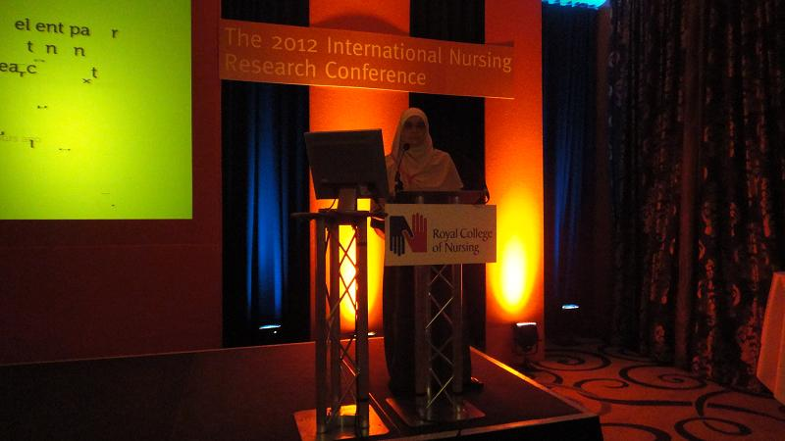

Dr. Hanaa Youssry during her research work presentation at "The 2012 International Nursing Research Conference" at the Royal College of Nursing London

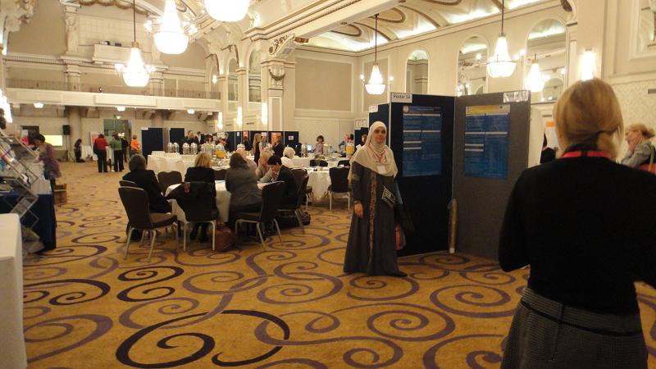

Dr. Hanaa Youssry during Evaluation of the Poster presentation in "The 2012 International Nursing Research Conference" at the Royal College of Nursing London

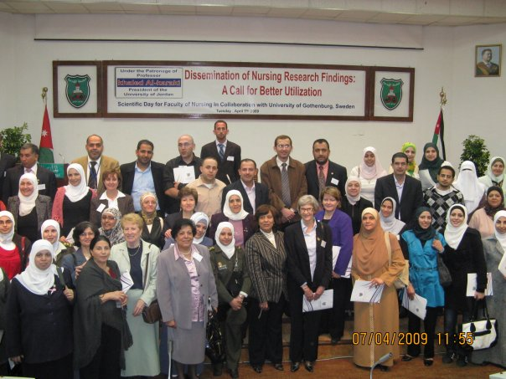

During opening ceremony of the princes Aisha bint AL-Hussein faculty of Nursing,
Al-Hussein bin Talal University, Ma'an, Jordan

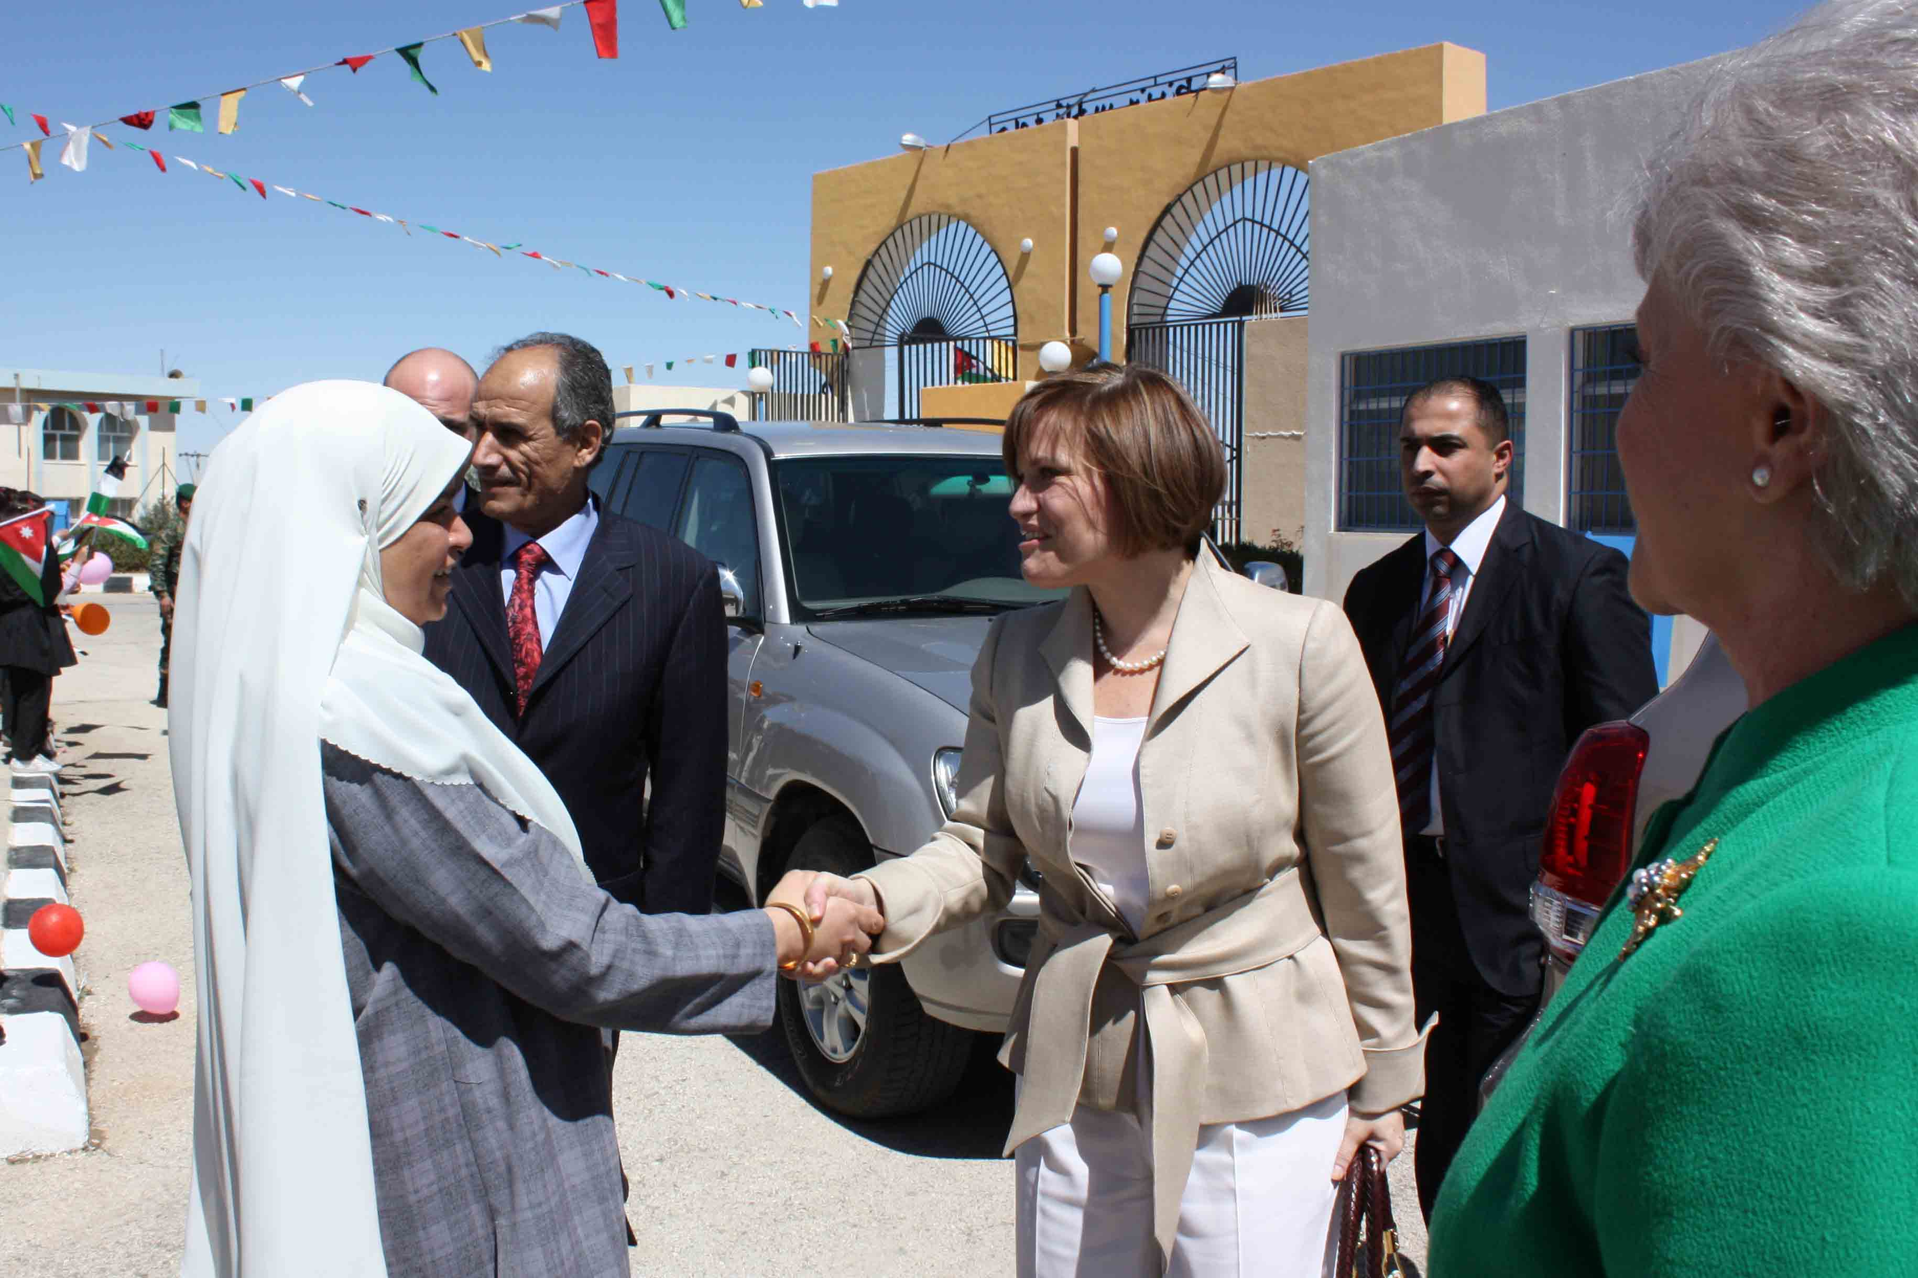
Dr. Hanaa with heightens Princess Aisha bint AL-Hussein

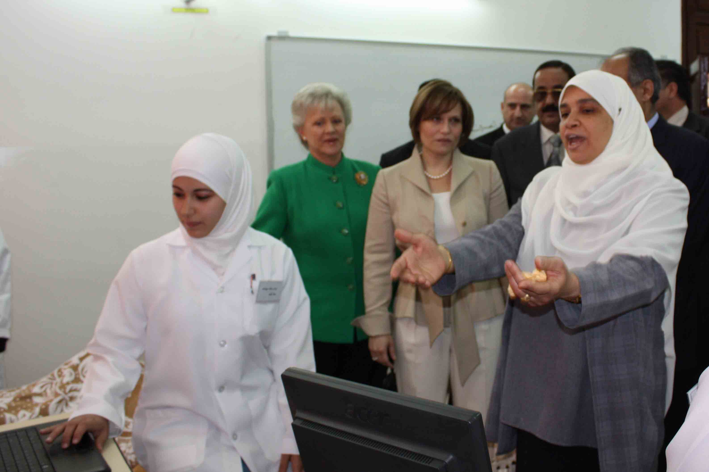

Dr. Hanaa with heightens princess Mona AL-Hussein and heightens princess Aisha bint AL-Hussein at the nursing lab.

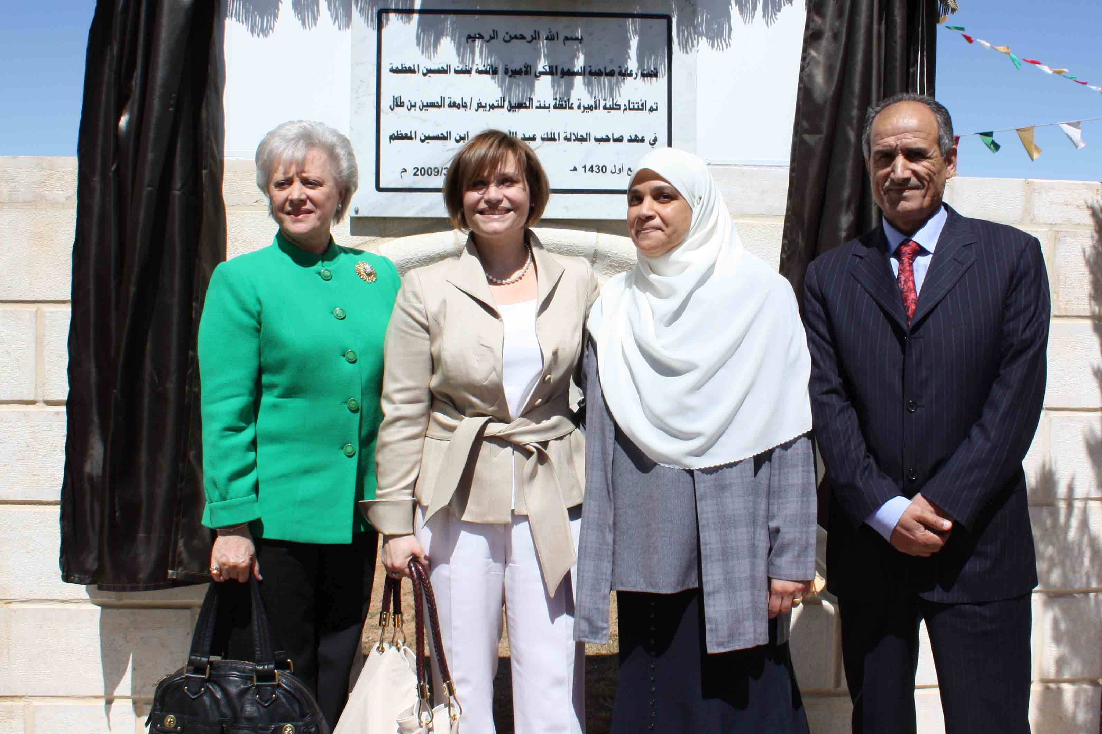

Dr. Hanaa with heightens princess Mona AL-Hussein , heightens princess Aisha bint AL-Hussein, and the president of AL-Hussein bin Talal university .

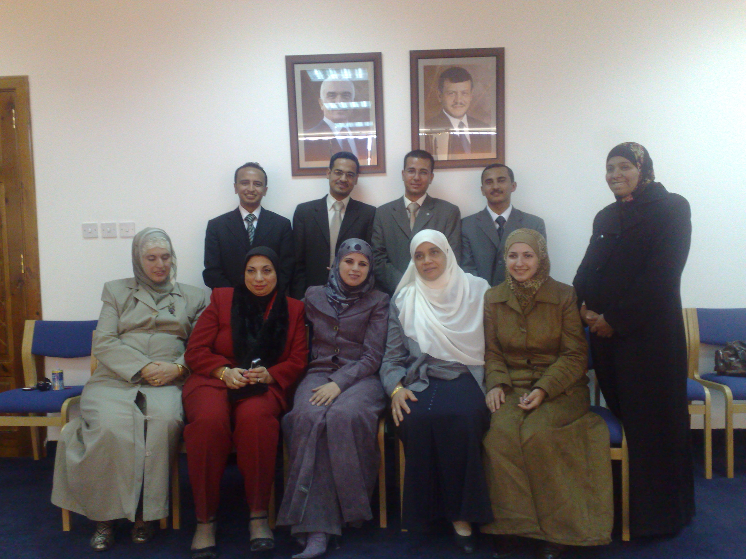

Dr. Hanaa with the faculty staff members at the dean's office.

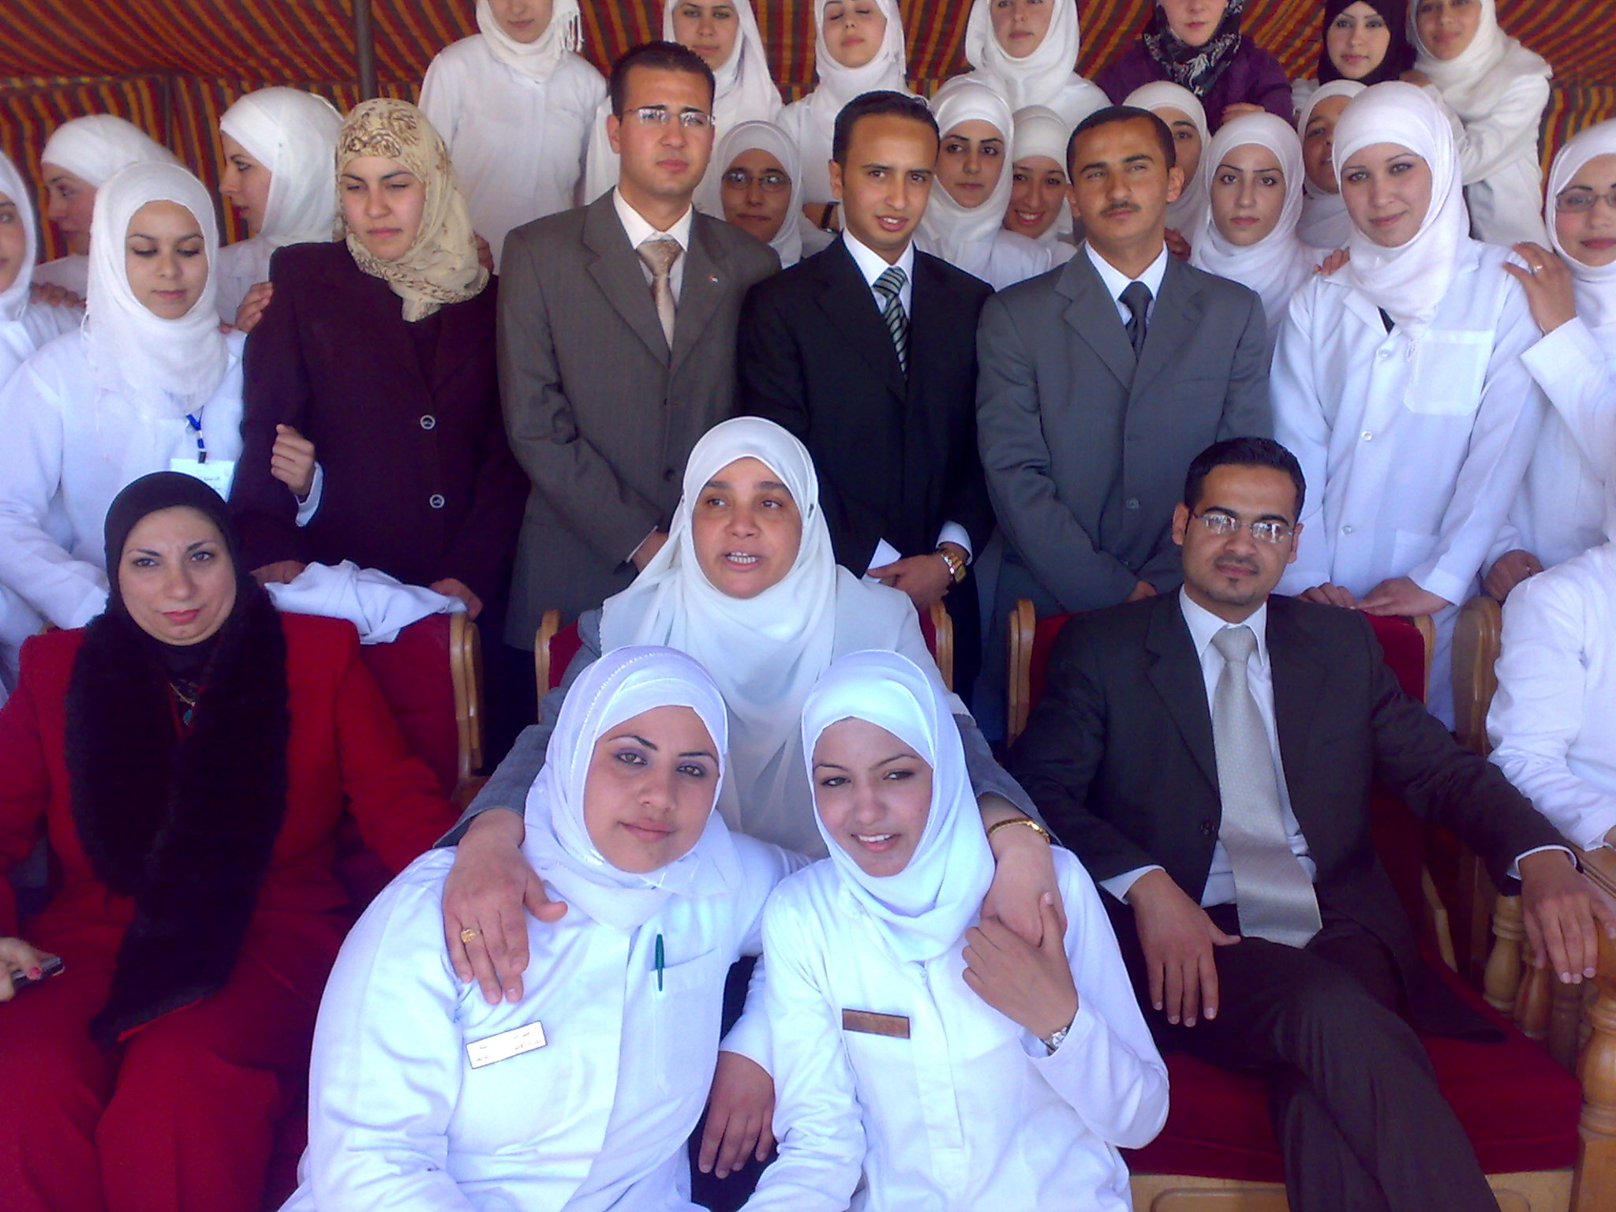

Dr. Hanaa with students of princess Aisha bint AL-Hussein faculty of nursing.

