G 210 Lab.
Relief Displacement of Vertical Features
An increase in the elevation of a feature causes its position on the photograph to be displaced radially outward from the principle point. Hence, when a vertical feature is photographed, relief displacement causes the top of the feature to lie farther from the photo center than its base. As a result, vertical features appear to lean away from the center of the photograph.
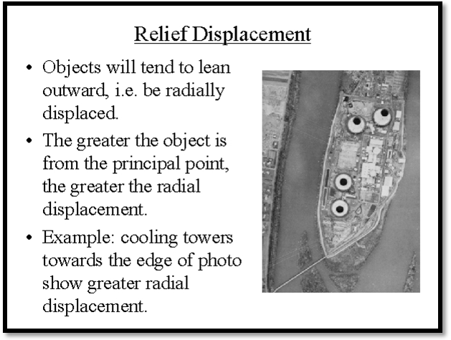
Fig. 1. Relief displacements on cooling towers.
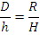
Expressing distances D and R at the scale of photograph we obtain:
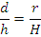
Rearranging the above equation we obtain:
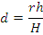
Where:
d = relief displacement.
r = radial distance on the photograph from the principle point to the displaced image point.
h = height above datum of the object point.
H = flying height above the same datum chosen to reference h.
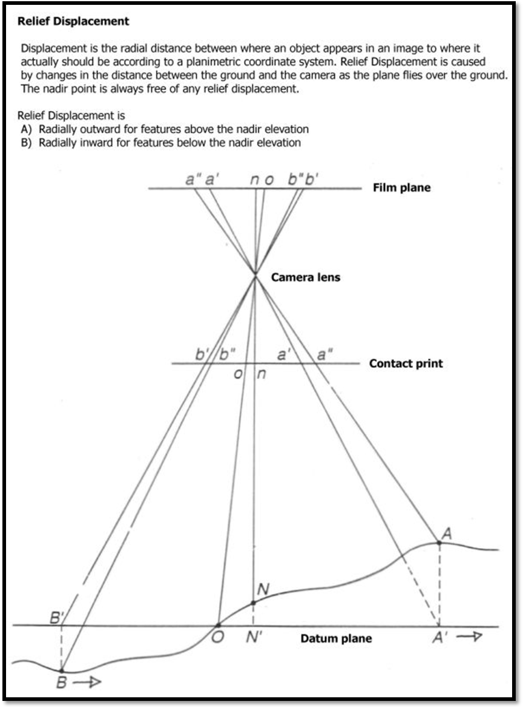
Fig. 2. Geometric components of relief displacement.

# Object Height Determination from Relief Displacement Measurement:
The above equation also indicates that relief displacement increases with the feature height h. this relationship makes it possible to indirectly measure heights of objects appearing on aerial photographs. By rearranging the above equation we obtain:
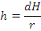
Q1: The relief displacement for a tower is 2.01 mm, and the radial distance from the center of the photo to the top of the tower is 56.43mm. If the flying height is 1220m above the base of the tower, find the height of the tower.

Answer:
h = 2.01 mm (1220 m) / 56.43 mm = 43.4 m

# Correction for Relief Displacement:
In addition to calculating object height, quantification of relief displacement can be used to correct the image positions of terrain points appearing in a photograph.
Keep in mind that terrain points in areas of varied relief exhibit relief displacement as do vertical objects.
Q2: For a vertical photograph assume that the radial distance for a point X is (r_{x}) = 64mm, and radial distance to the point Y is (r_{y}) = 63mm . Flying height H is 1200m, point X is 153m above datum and point Y is 169m below datum. Find the radial distance and direction one must lay off from point X and Y to plot x` and y`.

Answer:
d_{x} = r_{x} h_{x} / H = (36.84 mm X 152 mm) / 1220 m = 7.95 mm
correction = (plotted to the left or inward)

d_{y} = r_{y} h_{y} / H = (62.65 mm X -168 m ) / 1220 m = -8.63 mm
correction = (plotted to the right or outward)
N.B: negative sign because the point (y) is below the datum.

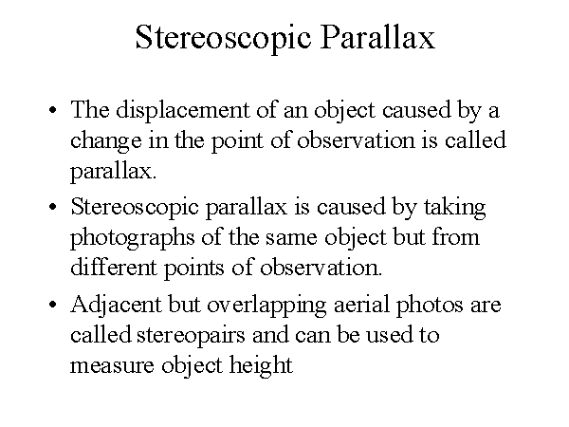
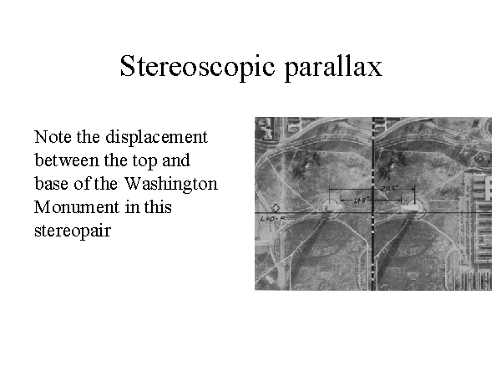
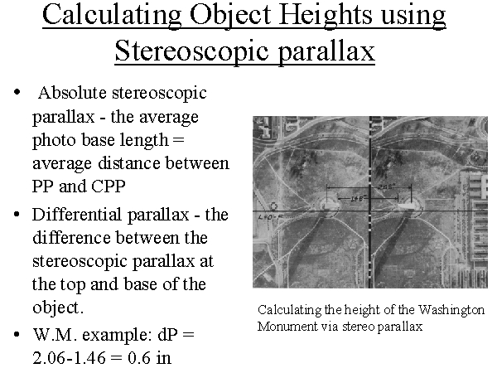

h = H x dP/ (P + dP)
Where h= object height,
H= flying height,
dP= differential parallax,
P= average photo base length.

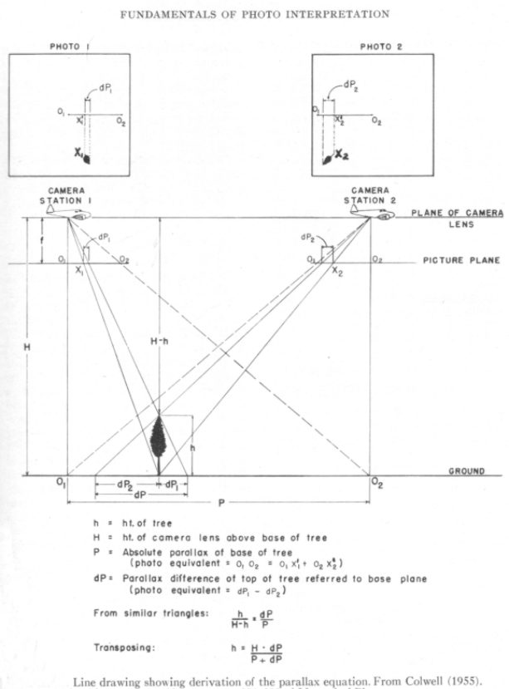

Q3: For a tower. The average photobase length (P) of the stereopair is calculated to be: 4.40 inches. Absolute stereo parallax at the base; and at the top of the monument is measured parallel to the line of flight with an engineers scale. The difference is: 2.06 in. - 1.46 in. This gives a dP of 0.60 in. So, 0.60 inches is the differential parallax of the displaced images. The nominal photo scale we are given is 1:4,800. We precisely measured the area of the monument and calculated that the scale is actually is 1:4,600 at the base. The camera focal length was 12 inches. So the flying height was ... 4,600 feet.
What is the actual height of the tower?

Answer:
h = H x dP/ (P + dP)
h = 4600 ft X 0.60 in / (4.40 in + 0.60 in)
h= 4600 ft X 0.05 ft / 0.42 ft = 547.6 ft

Photographic Scale:
S = photo scale = photo distance/ ground distance = d / D
The scale S is then computed as the ratio of the photo distance d to the ground distance D.
Q4: Assume that two road intersections shown on a photo graph can be located on a 1: 25.000 scale topographic map. The measured distance between the intersections is 47.2 mm on the map and 94.3 mm on the photograph. (a) what is the scale of the photograph ? (b) at that scale , what is the length of a fence line that measures 42.9 mm on the photograph.

Answer:
(a)The ground distance between intersections is determined from the map scale as
0.0472 m X 25000 = 1180 m
By direct ratio, the photo scale is
S = 0.0943 m / 1180 m = 1/ 12513 = 1: 12500
(b) The ground length of the 42.9 mm fence line is
D= d/S = 0.0429 m / (1/12500) = 536.25 m = 536 m

- For a vertical photograph taken over flat terrain , scale is a function of the focal length f of the camera and the flying height above the ground H from which the image was taken.
S = camera focal length/ flying height above terrain = f / H

Q5: A camera equipped with a 152 mm focal length lens is used to take a vertical photograph from a flying height of 2780 m above mean sea level. If the terrain is flat and located at an elevation of 500 m, what is the scale of photograph?

Answer:
S= f / (H-h) = 0.152 m / (2780 m – 500 m) = 1/15000 = 1 : 15000
So the photo scale is the function of terrain elevation h.
S = f / H – h
If an area has different terrain elevations h (irregular terrain surface) then h_{avg} (average h) is then calculated for the whole terrain.
S = f / H – h_{avg}

#Area Measurement:
By using the scale of aerial photograph, area within the photo can be calculated, Photo area can be converted to a ground area from the following relationship:
Ground area = A = photo area (a) x 1 / S²
Q6: A rectangular agricultural field measures 8.65 cm long and 5.13 cm wide on a vertical photograph having a scale of 1 : 20.000. Find the area of the field at ground level.
Answer:
Ground length = photo length X1/Scale = 0.0865 m X 20000 = 1730 m
Ground width = photo width X1/Scale = 0.0513 m X 20000 = 1026 m
Ground area = 1730 m X 1026 m = 1.774.980 m²

Q7: A flooded area is covered by 129 dots on a 25-dot/cm² grid on a 1 : 20.000 vertical aerial photograph. Find the ground area flooded.
Answer:
Dot density = (1 cm² / 25 dots) X 20000² = 16 000 000 cm²/dot
Ground area = 129 dots X 16 000 000 cm² / dot = 2064 X 10⁶ cm²

