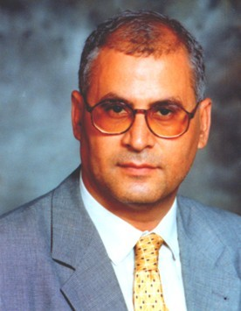

Ahmed S. Abutaleb: Currently a Professor at Cairo University, School of Engineering, Depts. Systems and Bioengineering, Giza, Egypt. From 1988-1991 he was a staff member at MIT/Lincoln Lab, Lexington, Mass, USA in Radar Data Analysis Division. From 1986-1988, he was an Assistant Professor at Temple University, School of Engineering, Philadelphia, Penn, USA. From 1984-1986, he was an Assistant Professor at the Medical University of South Carolina, School of Graduate Studies, Charleston, South Carolina, USA. He is Ph. D University of Pennsylvania, School of Engineering, 1984, MsC University of Pennsylvania, School of Engineering, 1980, Diploma in Electrical Engineering, MIT, School of Engineering, 1979, BsC Cairo Univeristy, School of Engineering, Dept. Electrical Engineering, 1976. His major areas of interest are statistical signal processing, Stochastic Control, Stochastic Calculus and its Applications in Economics, Communications, Applied Econometrics, Image Processing, Radar Data Analysis, and Number Theory and its applications. He has published over 100 papers in technical fields since 1980, and he is the coauthor with M. Papaioannou of the coming book "Introduction to the Stochastic Calculus and the Malliavin Calculus with Applications to Engineering and Finance” to be published by IDEA Group. He is consultant with several national and international organizations.

