**I- PERSONAL INFORMATION:**

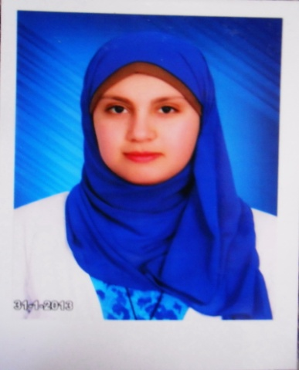- Name: **Sarah Said Sayed Nasr**

- Mobile NO. : **01008981516**

-E-Mail: **sarah.nasr@nci.cu.edu.eg**

- Address:  **Al-Sheikh Zayed City, Giza, Egypt**

**II- EDUCATIONAL BACKGROUND:**

- PhD/MD. Degree: - Date:

- MSC. Degree: - Date:

- MBBCH/Bachelor Degree: - Date: **12-2011**

**III-CURRENT EMPLOYMENT STATUS**

**Administrator**

**IV- PROFESSIONAL EXPERIENCE Department**

**Biostatistics and cancer epidemiology**

***Specialty Subspecialty***

***Activity within the department***

***Cancer registry***

1. **TEACHING EXPERIENCE:**

* Teaching/demonstrating experience

* Training, mentoring, facilitating
* What teaching materials have you designed or prepared (e.g. Lectures –Questions bank………)
* Supervised research students **(List)**:
* Marking of examinations Yes (Please specify with dates &role) No
* Membership of Examination committees Yes (Please specify with dates &role) No
* Supervision of Training programs Yes (Please specify with dates &role) No

**VI- ORGANIZATIONAL/MANAGERIAL EXPERIENCE:**

* Responsibility for planning conferences: Yes (Please specify with dates &role) No
* Committees Membership: Yes (Please specify with dates &role) No
* Quality control Unit: Yes (Please specify with dates &role) No
* Administration duties: Yes (Please specify with dates &role) No
* Established collaboration outside the institutionYes (Please specify with dates &role) No

**VII- RESEARCHEXPERIENCE:**

* Brief summary of current research + names of supervisors/collaborators
* Research Objective
* Publications , Abstracts , Book Chapter or Other Accomplishments: in the last 3 Years
* Conferences presentation and posters: in the last 3 Years
* Research Interest/s
  1. **Academic and scientific conferences, workshops, and presentations.**
  2. **Management and quality affairs.**
  3. **Infection control programs.**

**VIII- CONFERENCES and COURSES ATTENDED:**

**Monday NCI conference.**

**Department conference (NCI).**

**Hospital management course (NCI).**

**MSC. Degree courses**

**SPSS (kasr Al Aini)**

**ACLS (kasr Al Aini)**

**TOEFL (AMIDEAST)**

**ICDL (Ain Shams University)**

**IX- FUNDING and ACADEMIC AWARD/S:**

**X- PROFESSIONAL MEMBERSHIPS:**

**XI- REFEREES:**