**-2-**

**The Structure of Ceramic Materials**

**2.1 Atomic structure**

The atom of any element is known to consist of a positively charged nucleus surrounded by electrons moving into stationary orbits. The motion of an electron can be described by four **quantum numbers**:

The **principal quantum number *n*** represents the rank of the orbit in which the electron moves with respect to the nucleus. The closest orbit to the nucleus with *n* =1, is labeled K. The next orbit with *n* = 2 is the L orbit etc.

The **orbital quantum number *l*** is related to the shape of the orbit. An orbit with *l* = 0 is circular, while for *l* > 0, orbits are elliptical in shape, having higher eccentricities as the value of *l* increases. An orbit with principal quantum number possesses n values of *l*: 0, 1, 2, …, *n* – 1. These define **sub-orbits** designated: *s,* *p*, *d*, … respectively.

The **magnetic quantum number *m*,** represents the orientation of any orbit in space. For any value of *l*, there are 2*l* + 1 values of *m* that is 2.*l* + 1 different orientation of the orbits. For example, for an orbit with *n* = 2 and *l* = 1, there are 3 different space orientations (Figure 2.1) having the following values of *m*: -1, 0 and +1. Each value of *m* defines an **orbital**. In this particular case they are referred to as *pxx*, *pyy* and *pzz*.

Each orbital can accommodate a maximumof 2 electrons. They spin into two opposite directions about their axes. This defines the **spin quantum numbers** which takes the values + ½ or – ½ depending on the direction of rotation.

***m* = +1 *m* = -1**

***m* = 0**

**Fig (2.1) Magnetic quantum numbers**

This is in accordance with the **Pauli Exclusion Principle** according to which no two electrons have the same 4 quantum numbers. So, even if two electrons have the same values of n, *l* and m, their spins will be in opposite directions.

Details of atomic structure of different elements are not presented here since they are out of the scope of this work. Details can be found in the cited literature at the end of the chapter.

**2.2 Atomic bonding**

There are three main types of bonds of interest when dealing with ceramics: The ionic, covalent and the Van Der Waal bonds. They are dealt with very briefly in what follows:

**2.2.1 The ionic bond**

Some ceramic crystals consist of ions held in place by strong ionic attractive forces. Such materials are characterized by relatively high melting points and reasonable mechanical properties. They also display a degree of electrical conductivity even at low temperatures (For example KCl).

**2.2.2 The covalent bond**

When the atoms in a molecule share electrons to reach a stable configuration, a covalent bond is formed. Compounds having covalent bonds are also characterized by high melting points but they fail to conduct electricity. However, some of these compounds may exhibit polarity and short range movement ofthe polarized charges is possible, imparting some electric properties to these materials. The most celebrated example is SiO2.

It is to be noted, however, that most ceramic compounds display to various extents both types of bonding. For example, in CaSiO3, the oxygen atoms are linked to silicon atoms through a covalent bond, but the calcium ions are linked to the SiO3-- group by an ionic bond.

**2.2.3 Polarization bonds**

This represents a weak type of bonds that arises from the attraction between unlike polarized charges in some ceramic materials like clays. They are partly responsible for the phenomenon of plasticity, unique to clays. The most important type is the **hydrogen bond** present in water molecules. A relatively weaker bond is the **Van Der Waal bond**, usually arising from induced rather than genuine polarization.

**2.3 Crystal structure**

**2.3.1 The coordination number**

In a crystal, the different ions or atoms are located in specific positions. The number of nearest neighbors of any ion (or atom) is **the coordination number C.N.** The value of this number regulates to a great extent the crystal structure of any species.

Consider Figure (2.2) where a cation, shown in black, is surrounded by three anions B, shown in white. The C.N. of the cation is therefore 3. It was proved that among the three schemes shown in the figure, a minimum stability is reached in case (2), that is if the atoms barely touch each other. The case (1) is unstable and the case (3) is highly stable. Therefore it is possible from simple geometrical calculations to calculate the minimum cation to anion radius necessary to confer equilibrium to this structure.

(1) Unstable configuration (2) Marginally stable (3) Stable

**Fig (2.2) Stability of a threefold coordination number of a cation**

Consider Figure (2.3) showing a marginally stable situation. Let *r* be the cation radius and *R* the anion radius. Then *r* + *R* is equal to two third the height of the equilateral triangle joining the centers of the anions. The length of a side of this triangle is 2*R*.

Hence: *r* + *R* = = 1.155*R*,

Hence: = 0.155

**Fig (2.3) Three-fold coordination**

**Fig (2.4) Fig (2.5) Fig (2.6)**

**4-fold tetrahedral 6-fold octahedral 8-fold cubic coordination coordination coordination**

This represents the minimum *r*/*R* ratio for this type of coordination.

For a C.N. of 4, the cation is surrounded by 4 anions in a **tetrahedral** configuration (Figure 2.4). In this case, the minimum *r*/*R* ratio can be proved to equal 0.225.

For a C.N. of 6, the arrangement is said to be **octahedral** (Figure 2.5) with a minimum *r*/*R* ratio of 0.414.

For a C.N. of 8, it is **cubic** (Fig. 2.6) with a minimum *r*/*R* ratio of 0.732.

In Table (2.1) are shown, in pm (10-12m), the ionic radii of some ions

**Table (2.1) Ionic radii (in pm) of some common ceramic ions**

|  |  |  |  |  |  |  |  |  |  |  |  |
| --- | --- | --- | --- | --- | --- | --- | --- | --- | --- | --- | --- |
| **Element** | Li + | Na + | K + | Mg2+ | Ca 2+ | Al 3+ | Fe 3+ | Si 4+ | C 4+ | Cl - | O 2- |
| **Radius** | 78 | 98 | 133 | 78 | 120 | 68 | 69 | 40 | 29 | 167 | 132 |

Let us now consider the probable C.N. of Si4+ in a silicate. The bond between Si 4+ and O 2- ions is covalent and, from the above table: *r*/*R* = 40/132 = 0.3. This value lies within the stability region of C.N.= 4 and hence the Si – O configuration will be tetrahedral.

On the other hand, Al3+ ions in presence of O2- ions will have a C.N.=6 since r/R = 68/132 = 0.515 which is a value in the stability region of that C.N. Hence, the Al – O configuration will be octahedral.

Finally, K+ ions in a KCl molecule will show a 8-fold coordination since r/R = 133/167 = 0.796, which is within the stability range of C.N. = 8.

**2.3.2 Ceramic crystal structures**

1. **The Cesium Chloride structure**

**Fig (2.7) The Cesium chloride structure**

**Fig (2.8) Rock salt structure**

This is the simplest structure in which the cation occupies the center of a cube whereas 8 anions are positioned at its vertices as in Figure (2.7). It is clear that compounds having that structure will show a low atomic packing density per unit cell and will therefore have a relatively low density. This is an example of an **open structure**.

**(b) Closed packed structures**

Most ceramic materials fall in this category. The most classical example is the **rock salt** structure (NaCl) shown in Figure (2.8).

In the previous figure, it is clear that all cations (Na+) have octahedral coordination. Their sites are therefore called octahedral sites. On the other hand, anions (Cl-) also have octahedral coordination. In some more complex rock salt – like structures (such as **CaF2**), anions have a coordination number of 4 and their sites are consequently called tetrahedral sites.

Actual structures of a large portion of ceramic materials are similar to rock salt structures except that not all octahedral or tetrahedral sites are filled. For example, ceramic materials having the **Rutile structure (TiO2)** have only half of their octahedral sites filled, whereas materials having the **Zinc blende structure (ZnS)** have only half their tetragonal sites filled. That is why most ceramic structures are open, that is, show a lower atomic packing per unit cell than metal.

Some materials have much more complex structures although essentially derived from the previous arrangements. One important class consists of mixed oxide compounds having the general formula MO.XO2 or MXO3, like BaTiO3 having the **perovskite structure**. Another important class is the **spinel structure** named after the magnesium aluminate material MgAl2O4. These compounds have the general formula MO.X2O3 or MX2O4. The crystal structure of such materials is also derived from the cubic closed packed structure.

**(c) Silicates structure**

A large portion of ceramic raw materials and products belong to that category. The basic unit of any silicate material is the SiO4 tetrahedron shown in Fig.(2.4) where each silicon ion is surrounded by 4 oxygen ions in covalent bonding. Such tetrahedra are not electrically neutral since they possess a (– 4) net charge. These charges, in the simplest case can be neutralized by positive ions attached to a SiO4-4 unit through ionic bonding, like in Ca2SiO4. This class of silicates is called **orthosilicates**.

Another possibility is that two or more tetrahedral units join at their vertices by sharing oxygen atoms in covalent bonding. One situation is shown in Figure (2.9) where three units join together to give a (SiO3-2)3 unit as in CaSiO3, which is an example of **metasilicates**. This category also comprises compounds where a single linear chain is formed (Figure 2.9). Asbestos falls in this class. The fibrous nature of this compound is due to its chain structure. In this structure, each unit cell shares 2 oxygen ions with neighboring units corresponding to a SiO3-2 unit.

**Fig (2.9) Structure of metasilicates**

**Fig (2.10) The sheet structure**

If now, every Si – O tetrahedron shares three oxygen ions, we reach a **sheet structure** as shown in Figure (2.10). In this case, the unit cell is SiO2.5-1 or Si2O5-2, which means that the ionic character has greatly diminished since there is only one negative charge to be neutralized for each silicon ion in the unit cell.

Compounds like Na2Si2O5 do have that structure, but perhaps the most important ceramic raw materials to possess that structure are clays. In the case of clays, the structure is more complex owing to the presence of hydroxyl groups. For example, the mineral **kaolinite** has the formula Al2O3.2SiO2.2H2O which can also be written in the form: Al2Si2O5.(OH)4.

**(d) Three dimensional networks**

If now all O--ions are linked to silicon ions, a three dimensional network will be formed as in the case of **silica** where the bonds are purely covalent.

**2.4 Defects in ceramic lattices**

In the previous section, when dealing with ceramic structures, it was assumed that these structures were ideal. This means that all ions are in their “theoretical” positions. In practice, this is never the case and there are always crystalimperfections. There are generally five types of lattice imperfections which are summarized in what follows.

**2.4.1 Point imperfections**

**(a) Frenkel defects**

Above absolute zero temperature all atoms (or ions) in a crystal lattice show thermal vibration about their equilibrium positions. So, some atoms will acquire enough energy to leave their position and go interstitial (Figure 2.11a). This causes the formation of vacancies. This defect is known as a Frenkel defect.

**Fig (2.11) (a) Frenkel defect (b) Schottky defect**

**(b) Schottky defects**

If the atom (or ion) acquires enough energy to leave its equilibrium position and migrate to the surface, then the defect is known as a Schottky defect as is shown in Figure (2.11b). In an ionic lattice, as a cation leaves to the surface, an anion has to leave as well, as a result of charge neutrality. In that case, two vacancies are formed, known as a **Schottky pair**. This defect is particularly found in ionic compounds with high coordination numbers and where the difference in size between cations and anions is small.

**(c) Interstitial solid solutions**

If the material under consideration contains a small fraction of foreign impurities, then the impurity atoms will generally go into the interstices of the crystal (Figure 2.12a). In that case, there is a maximum amount of foreign atoms that can be allowed into the lattice without impairing its stability. If more atoms are forced, the impurity species will show as a separate phase.

**(d) Substitutional solid solutions**

Under some conditions, the host lattice can accommodate a large fraction of foreign atoms. In that case, the guest atoms can substitute those of thehost atoms as shown in Figure (2.12b). Generally, the probability of formation of a substitutional solid solution is higher when both the guest and host atoms are close in size and have the same valence (For example FeO and NiO). In some cases, the substitutional solid solution can exist over the whole range of compositions of the two oxides, as in the case of NiO and CoO.

**Fig (2.12) (a) Interstitial solid solution (b) Substitutional solid solution**

**(e) Non – stoichiometry**

Some compounds do not obey the law of constant proportions. For example, the mole ratio of Fe:O in wüstite (FeO) is not 1:1. There are vacancies in the Fe positions due to the fact that some Fe ions are trivalent rather than divalent so that this oxide should rather be written as Fe1-*x*O. Vacancies can also be formed in the anion positions as in TiO2-*x*. In some rarer instances, there is an excess in either the cations or anions. These extra ions introduce themselves interstitially. This is the case of UO2+*x*.

For example, consider the non-stoichiometric form of wüstite Fe0.9O in which *x* ions of Fe are divalent (Fe+2) and 1 – *x* ions are trivalent (Fe+3). A total charge balance yields:

0.9×[2*x* + 3(1 – *x*)] = 2

Accordingly: *x* = 0.78.

This means that 78% of the iron ions have a valence = 2 while 28% are of valence = 3.

**2.4.2 Line defects**

By line defect, is meant the defect known as **dislocations**. These are formed as some planes slide over other planes in what is known as a slip mechanism. Different materials show different slip directions and the slip mechanism is very close to the same phenomenon in metals. There are actually two types of dislocations: the **edge** type and the **screw** type illustrated in Figure (2.13).

These figures show that edge dislocations move in a perpendicular direction to that of the applied shear stress, while screw dislocations move parallel to that stress.

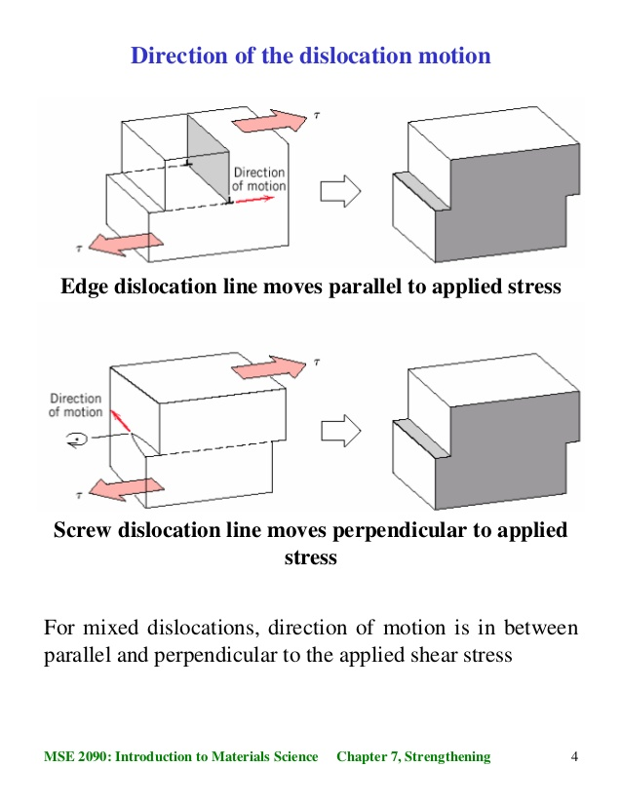

**Fig (2.13) (a) Edge dislocation (b) Screw dislocation**

**2.4.3 Planar defects**

The main planar defect consists of **grain boundaries**. As crystallization takes place, for example from a melt, atomic planes are formed. These atomic planes have different orientations. Sets of planes having the same orientation intersect with other planes of different orientation in boundaries. The set of atomic planes having the same orientation form a grain (Figure 2.14). As will be explained later, the grains tend to increase in size onfiring. This affects negatively the mechanical properties of the material.

**Fig (2.14) Grain boundaries**

**Suggested additional reading**

1. J.C. Anderson, K.D. Leaver, R.D. Rawlings, J.M. Alexander, *Materials Science,* 3rd ed., ELBS, UK, 1985
2. M.W. Barsoum, *Fundamental of Ceramics,* 1st ed., McGraw-Hill, Singapore, 1997

3. J. William, J.R. Callister, *Material Science and Engineering, an Introduction,* 1st edition, J. Wiley, N.Y., 2003

4- M.F. Abadir, A.N.Mahdy and H.A.Sibak, *Inorganic Chemistry for* *Chemical Engineers,* 4th ed., Cairo Univ., Fac. of Eng., 2014

5. C.B. Carter and M.G. Norton, *Ceramic Materials,* 1st ed., Springer science, 2007