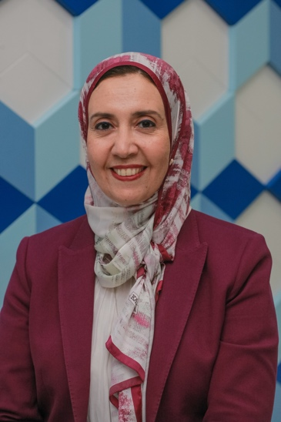

**Prof. Dr. Mona Salah Fayed**

**BDS, MSc, PhD, (Cairo), DrMedDent (Bern), FDS(RCDEd)**

**Mona.fayed@dentistry.cu.edu.eg**

Professor Dr. Mona Fayed, Professor of Orthodontics, Faculty of Dentistry, Cairo University, has obtained her graduate degree, masters and PhD in Orthodontics from Cairo University, Egypt. She has also had the opportunity to work as a visiting researcher at the University of Bern, Switzerland, where she was awarded a Doctorate degree in Orthodontics. She is currently the program director for the Masters degree, the head of the International Orthodontic Program (Morth Program) at Cairo University, and the Head of Department at MSA University in Egypt, and was recently appointed as the head of the quality assurance unit at the Faculty of dentistry, Cairo University. She has worked as an international professor at University Malaya, Malaysia. In 2020, she has graduated from an executive program in healthcare leadership from Harvard Medical school. She has practiced orthodontics since 1995. Prof. Fayed has published more than 80 national and international publications with special interests in tooth movement, functional appliances , temporomandibular disorders and cleft lip and palate management. She has presented her research work in many national and international conferences.