**-3-**

**CERAMIC RAW MATERIALS**

**3.1 Introduction**

Generally speaking, traditional ceramic industries use three main types of raw materials:

**- Clays** which give the main body of the product and ensure enough plasticity for the body to be shaped.

**- Feldspars** which represent fluxing components since they melt at relatively low temperatures.

**- Silica** which is the main glass forming raw material.

In addition, other raw materials are often used, including limestone, magnesite (MgCO3), soda ash (Na2CO3), bauxite (Al2O3.xH2O), borax (Na2B4O7.10H2O) etc. …

A recurrent problem when dealing with ceramic raw materials in general is that their composition is rarely kept constant over long periods of time even if they are quarried from the same location. That is why it is important to have the following properties monitored so as to ensure that the final product abides by the standard requirements in a continuous way:

Chemical and mineralogical composition – Particle size distribution – Plasticity for clays and kaolin – Drying shrinkage for clays and kaolin – water absorption - color, etc. …

**3.2 Plastic raw materials**

These may constitute more than 50% of the composition of ceramic bodies and are necessary for the formation of the main body of the prodcut. Besides, they impart workability to the plastic mix formed by adding other materials such as feldspars and quartz. They are usually related to the mineral kaolinite of chemical composition Al2O3.2SiO2.2H2O and to a lesser extent to the mineral pyrophyllite of chemical composition Al2O3.4SiO2.H2O.

**3.2.1 Structure of clay minerals**

Both aforementioned minerals possess a sheet structure where Si – O tetrahedral and Al – O – OH octahedral are the main building units. Actually, both are characterized by the presence of a Si2O5 unit characteristic of sheet structures; the formulas of kaolinite and pyrophyllite minerals can be written as Al2Si2O5(OH)4 and Al2Si4O10(OH)2 respectively.

Kaolinite mineral possesses a sheet structure in which the unit cell consists of one Si – O and one Al – O – OH layers (Figure 3.1). That is why it is sometimes called a two layered type of clay. Adjacent groups of Si – O and Al – O – OH in adjacent sheets are bonded by moderately strong hydrogen bonds. That is why; water molecules insert themselves between the sheets with relative difficulty, which accounts for the limited plasticity of kaolinite based clays. Figure (3.2) details kaolinite structure.

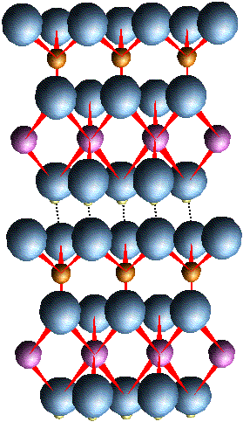

Si – O

Al – O – OH

Si - O

Si – O

Al – O – OH

Si - O

Si – O

Al – O – OH

Si - O

**Fig (3.1) 3 Unit cells of kaolinite Fig (3.2) Two unit cells of kaolinite**

On the other hand, pyrophyllite possesses a three layered structure where Al – O – OH octahedra are sandwiched between two layers of Si – O tetrahedra. This results in the absence of hydrogen bonds between adjacent unit cells. The only bonds between these unit cells will be of the weak Van Der Waal type. This allows for much more water molecules to insert themselves between the sheets causing swelling of the clay – water mix. Clay ores constituted out of that mineral are highly expandable and are added in small amounts in conventional ceramic mixes to enhance plasticity, a typical example being bentonite. Figures (3.3) and (3.4) illustrate the structure of this three layered mineral.

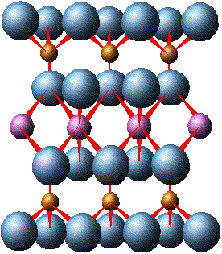

Si – O

Al – O – OH

Si – O

Si – O

Al – O – OH

Si – O

**Fig (3.3) 2 Unit cells of pyrophyllite Fig (3.4) One unit cell of pyrophyllite**

**3.2.2 Properties of clays**

Clays possess certain basic properties that are essential for proper processing in the production of ceramic ware in general and tiles in particular. This is since these properties are of direct impact on the manufacturing process.

**(a) Base exchange Capacity**

The previously mentioned clay minerals chemical formulas are only approximate. This is since clays usually contain cations held on its surface by attraction to negative surface charges. The presence of these negative charges is attributed to two factors.

First, owing to extremely slow ion exchange over eons, some aluminum (III) ions have been substituted by divalent ions, like Mg++, resulting in a deficiency in positive charge, a process known as isomorphous substitution. This results in negative charges that concentrate on the external surface of the clay sheet. Second, the valences of oxygen ions at crystal edges are not satisfied and consequently, have to bind to some positive ion.

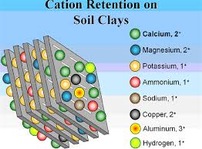 These surface negative charges are neutralized by positive cations present in the vicinity of the surface. (Figure 3.5). Common such cations are Mg++, Ca++ and H+. As can be seen from Figure (3.6) forces of attraction between cations and negative charges are competitive with forces of repulsion between like charges.

**Fig (3.5) Adsorption of cations on clay surface**

**Repulsion**

**Attraction**

**Repulsion**

**Fig (3.6) Attractive and repulsive forces Fig (3.7) Alkali ions go into solution**

In general, attractive forces overcome repulsive ones so that clay particles tend to attract each other forming bigger agglomerations that readily settle down in clay – water suspensions. This phenomenon known as **flocculation** causes severe problems in many ceramic manufacturing processes.

If now, alkali ions such as Na+, are added to the suspension an exchange takes place between the adsorbed ions and sodium ions. This can be simplified into the following equation:

. + 2 Na++ = . +

Sodium ions, however, do not remain on the clay surface, but rather go into solution leaving bare surfaces with residual negative charges. The resulting repulsion causes deflocculation of the particles that imparts stability to the suspension. (Figure3.7).This phenomenon is of use in the tile industry to guarantee stability of the mix suspension prior to introduction to the spray dryer.

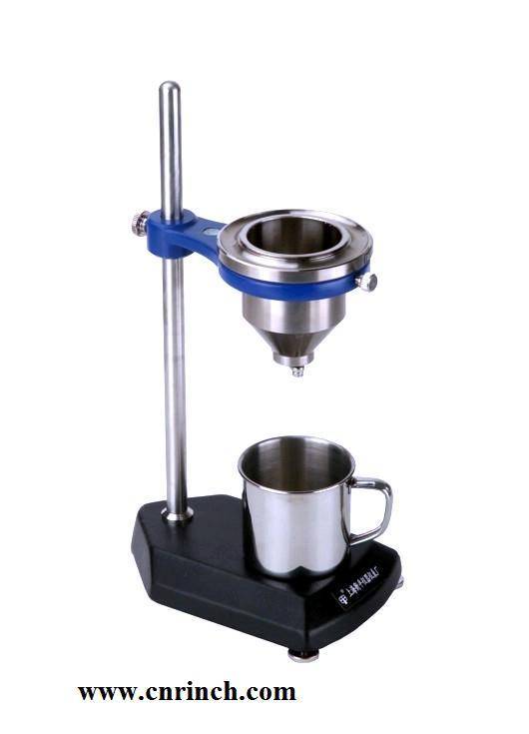 The most common method of assessing the deflocculation of a suspension is achieved by a simple experiment using the **Ford viscometer cup**. This consists of a standard cup with a hole at its bottom closed by a stopper. The suspension is poured into the cup up to a specified height and the hole opened. The time required for the suspension to drain from the cup is a measure of its viscosity (Figure 3.8). For example, typical values of time for ceramic tile suspensions range from 15 to 20 seconds.

**Fig (3.8) Ford cup viscometer**

**(b) Plasticity of clay – water mixes**

Plasticity is a general term indicating the ability of clay – water masses to be worked out properly. Two contradictory requirements have to be met in that respect. First, the paste should not be too stiff so as to facilitate its shaping. Second, it should show some resistance to applied stresses so as not to display excessive flowability.

Many methods have been suggested to asses quantitatively the plasticity of ceramic pastes. One early method is the Atterberg plasticity limits proposed in 1911 and described by ASTM D4318-10e1 mainly intended for determining the plasticity of soils. In this method, The Atterberg plastic limit is the lowest water content (expressed in mass percent of the clay dried at 120 °C) at which the body can be rolled into threads without breaking. On the other hand, The Atterberg liquid limit is the water content at which the body begins to flow. The difference between these two limits has been designated by Atterberg as the **plasticity index**. Despite the simplicity of this method, it is time consuming and of low reproducibility.

A more reliable method, known as the Pfefferkorn plasticity index offers higher reproducibility although it is slow in getting results. In this method, a clay–water paste is rammed into a steel cylinder of standard dimensions. The mold is removed, and a standard ram allowed dropping over the cylindrical paste. Let the original height of the cylinder be *h*0 and the final height after being compressed under the ram, *hf*. The ratio (*h*0/*hf*) is plotted for different water to clay ratios. The percent water content corresponding to a ratio of 3.3, is called the **Pfefferkorn plasticity number**. Figure (3.9) illustrates the experimental setup.

***h*0**

***h*0/*hf***

**% Water**

**3.3**

***hf***

**Fig (3.9) Determination of clay – water plasticity by the Pfefferkorn method**

Methods based on stress – strain curves rely on subjecting the tested specimen to mechanical loading and record the corresponding strain. In the tensile loading method, the plasticity is calculated as the product of the yield stress by the maximum tensile strain. Higher percentages of water produce an elevated strain but a low yield stress while low water levels result in a low strain corresponding to a high value of yield stress (Figure 3.10). The plasticity is equivalent to the area of the shown rectangular surfaces. This method can optimize the amount of water to be added to clay to obtain a maximum plasticity. Its results are very reliable despite the procedure being lengthy and costly.

Another set of methods relies on identifying the rheological behavior of the paste. In general clay – water pastes exhibit non – Newtonian flow characteristics described by the Herschell – Bulkley equation:

(3.1)

Where, is the strain rate (s–1), is the shear stress (Pa), is the yield stress and *k* , *n* constants.

A torsion viscometer can be used to obtain the relation between shear stress and shear rate and the curve extrapolated to zero shear rate to obtain the yield stress .

**Fig (3.10) Stress – strain diagrams of clay – water mixtures**

A plot of ln ( against ln yields a straight line of slope = *n*. The plasticity of the mixture can be calculated through a dimensionless group, the Hedstrom number defined by:

*He* = (3.2)

Where, *D* is the diameter of the viscometer cup (m), *ρ* is the density of the mix (kgm-3) and *μ* the viscosity of the mix at a prefixed strain rate (Pa.s). This method yields highly reproducible results in a relatively short time although the apparatus needed is expensive.

The plasticity of clay – water mixtures is affected by several factors: First, there is an optimum amount of water added corresponding to a maximum plasticity. Second, a lower particle size usually favors higher plasticity. Third, the presence of a substantial amount of non – plastic material like quartz as impurity in clays decreases plasticity. Fourth, the presence of organic impurities enhances plasticity. This is since the decomposition of such impurities ultimately yields substances that facilitate sliding of clay sheets over each other thus promoting plasticity. Finally, aging for long time periods increases plasticity due to the action of special bacteria.

It is worth mentioning that an increase in plasticity is associated with an increase in drying shrinkage which can cause deformation of the dried article. However, an increased shrinkage enhances dry strength, an essential requisite for proper handling of unfired ware without undue losses. That is why; it is necessary to reach a compromise between these two conflicting requirements, namely, low drying shrinkage and elevated dry strength.

**(c) Effect of heat on clays**

As clay is heated a series of physico – chemical changes take place. In case of kaolinite based clays, adsorbed moisture is eliminated round 100oC (Physical water). Organic impurities usually oxidize in the temperature range 300 – 500oC. Next, chemical water is eliminated from kaolinite molecules in the temperature range 500 – 700oC:

Al2O3.2SiO2.2H2O = Al2O3.2SiO2 (meta-kaolinite) + 2 H2O

This reaction is associated with a theoretical weight loss of about 13.95%. In practice, this loss ranges from 7 to 13% depending on the type of clay mineral involved. At about 900oC, meta-kaolinite decomposes to mullite (3Al2O3.2SiO2) and cristobalite (SiO2) according to the reaction:

3 (Al2O3.2SiO2) = 3Al2O3.2SiO2 + 4 SiO2

Actually, there is much controversy regarding this reaction since γ – Al2O3 is formed at that temperature which suggests first a decomposition of meta-kaolinite to alumina and silica followed by a solid state reaction between part of the silica formed with alumina to form mullite. In theory, on further heating a liquid will be formed around 1600oC. Final melting will take place at about 1900oC. n practice owing to the presence of fluxing impurities like sodium, potassium , calcium and iron compounds, melting takes place at much lower temperatures.

**3.2.3 Clay ores**

In traditional ceramic industries, two main types of clays are used, namely, kaolin clay and ball clay. Occasionally, bentonite clay is added in minute amounts to promote plasticity.

**(a) Kaolin clays**

This type of clays is of metamorphic origin. It originated from the weathering of igneous rocks over hundreds of millions of years. Consequently, it does not contain much organic impurity and is usually white colored. However, owing to the absence of organic impurities, it suffers from a relatively low plasticity. One factor that adds to that problem is the possible presence of non – plastic sand in levels that may reach 40%. Also, the percent alumina in kaolin clay determines its refractoriness ranging from 25 to 35% according to the level of sand impurities present. Kaolin clays are usually quarried in open pits quarries.

**(b) Ball clays**

This is a sedimentary type of kaolinitic clays that has been transported over very long distances, usually by water, to form deposits of often impure clays. The main impurities are of organic origin owing to vegetable and animal debris that have been collected by the material. This imparts high plasticity to the sedimentary mass that makes it often necessary to blend it with other types to promote workability. Also, the long distance travelled by that clay type causes a gradual reduction in the size of its particles due to their crumbling. Increased plasticity as well as reduced particle size confers a high drying shrinkage of the wet products from the forming step. This, in turns, produces dried articles with elevated dry strength although often of deformed shape. Most ball clays are quarried from open pits although being sometimes obtained from tunneled mines. The latter types are generally of higher purity than the former.

**(c) Bentonite clays**

This type is a pyrophyllitic type clay that is related to the mineral montmorillonite of chemical structure (Na,Ca)0.33.(Al,Mg)2.Si4O10. Bentonites are usually named after the dominant cations present. Common types are sodium bentonite, potassium bentonite and calcium bentonite. It is added in small amounts (< 1%), to ceramic mixes to promote plasticity. The main uses of bentonite are in drilling mud and as a powerful adsorbent owing to the fineness of its particles. Bentonite clay is known to swell in spectacular way in presence of water. This property is made use by adding it in minute amounts to concrete mixes exposed to running water to decrease their porosity as it swells in contact with water. The same property finds application in foundry sand castings where small amount of bentonite are blended with the sand molds.

**(d) Shale clays**

This is a type of low purity sedimentary clay in which the percent of clay minerals can be as low as 60%. The main impurities present are quartz (about 30%), feldspars (about 5%) and iron oxides (about 1%) besides organic matter with variable levels. Its mineralogical constitution is usually of the kaolinite type although some sediment can also contain montmorillonite type minerals. Its use is restricted to low cost articles in which whiteness is not a prime prerequisite like pots and building bricks.

**(e) Flint clays**

This is a type of sedimentary clay of kaolinitic nature that is usually found in conjunction with coal layers, often in coastal areas. It does not slake in water and is often associated with high levels of silica. This type of clay has a low content of fluxing oxides making it a suitable raw material for refractory brick making. Deposits of high purity constitute a category known as **refractory clays** that possess elevated melting points.

**3.2.4 Impurities present in clay ores**

Clays are more often than not of low purity, particularly the sedimentary types. These impurities strongly affect their properties in positive or negative ways. The main impurities usually associated with clay ores are discussed in what follows:

**(a) Silica**

Silica is by far the most common impurity associated with clay ores where it normally exists in the form of quartz. Its presence imparts less plasticity to clay making it less workable besides causing severe abrasion to metallic parts in the shaping equipment. It also reduces the drying shrinkage thus producing dry articles with low mechanical strength. The percent silica in clays depends also on the clay origin. Desert clays tend to contain high levels of quartz sometimes exceeding 40%. The percentage silica present in a clay ore can be evaluated by a test known as determination of free silica and described by Trobstl et al (2006).

**(b**) **Iron impurities**

Iron is present in some clay deposits, particularly of the sedimentary type in the form of goethite (FeO.OH) or hematite (Fe2O3). The percent iron oxides can constitute up to 7% of the clay composition. Its presence has a fluxing effect on the clay, decreasing the temperature for melt formation. It also imparts a yellowish to reddish color to the fired products shifting even to brown if the level of iron oxides is very high. In fired articles that require a high level of whiteness, Fe (III) reddish compounds are reduced to the almost colorless Fe (II) state by lowering the partial pressure of oxygen in the firing kiln.

**(c) Alkali compounds**

Residual clays were formed, as stated before, by the weathering action of igneous rocks. These rocks are constituted of granite, feldspars and mica. Incomplete weathering can result in a clay ore containing sodium or potassium ions due to the presence of feldspathic compounds. The effect of alkalis is to exert a strong fluxing action that reduces the melting point of clay by values that depend on the extent to which they are present.

**(d) Limestone**

Limestone, mainly consisting of calcium carbonate, is sometimes present in clay deposits as large veins. Its level does not usually exceed a few percent. Its presence is beneficial in case the clay is to be used in wall tiles making as its presence is essential to prevent remote crazing of tile glazed face. Otherwise, it lowers the plasticity and slightly decreases the melting point owing to its moderate fluxing effect.

**(e) Titania**

Titania (TiO2) is essentially present as impurity in sedimentary clays where its content can reach values as high as 4% while it does not usually exceed 1% in residual clays. It confers a greyish color to the raw material and produces a slight fluxing action. Clays containing large amounts of such impurity cannot be used whenever whiteness of the end product is a prime prerequisite.

**(f) Organic matter**

Theorganic matter present in clays, particularly those of the sedimentary type, usually consists of a number of substances such as humic acid and fulvic acid. Both are not a single acid, but rather a complex mixture of several acids produced by the biodegradation of dead organisms. They both contain carboxyl and phenolic groups to different extents. They have been known to increase clay plasticity since several millennia. The effect of humic acid on clay plasticity has been studied by many researchers who proved that the presence of humic acid in percentages exceeding 3% caused cracking of the clay sheets, decreasing their resistance to applied loads and hence increasing their workability.

**3.3 Non – plastic raw materials**

**3.3.1 Silica**

**(a) Allotropic forms of crystalline silica**

Silica occurs in three main allotropic forms. The form that is abundant in nature is α-quartz, simply known as quartz. It consists of trigonal crystals that transform to hexagonal (β-quartz) when heated above 573oC. This type of transition is very rapid and reversible. It does not however involve much change in the crystals dimensions: For α-quartz, *a* = 49.13 nm and *c* = 54.05 nm while for β-quartz, *a* = 50.1 nm and *c* = 54.7 nm. That type of allotropic change is known as a **displacive transition**. When slowly heated in presence of some oxide impurities β-quartz converts to another polymorph: High tridymite. This transformation is sluggish and irreversible. It involves a complete breakdown of the structure and is therefore termed **reconstructive.** High tridymite forms as hexagonal crystals that convert to orthorhombic on cooling down below 160oC (Medium tridymite). On further cooling below 105oC, a third monoclinic polymorph is formed: Low tridymite.. These transitions are of the displacive type and hence occur rapidly and reversibly. When slowly heated above 1470oC, tridymite converts irreversibly to a cubic form, known as β-cristobalite. This form can directly be obtained from pure β-quartz when heated above 1490oC. β-cristobalite when cooled below about 200oC transforms reversibly to a low temperature tetragonal form: α-cristobalite. These polymorphic transformations are illustrated in Figure (3.11).

The different forms of silica undergo volume changes upon occurrence of the aforementioned transformations. These are illustrated in Figure (3.12). This figure shows that the displacive transitions are accompanied by relatively large expansion values. Quartz transition is accompanied by about 1.4% increase in length while the corresponding values for tridymite and cristobalite are 0.95% and 1.75% respectively. Such dimensional changes have a direct impact on the operating conditions of firing kilns in the manufacture of ceramic articles.

**(b) The role of silica in the manufacture of ceramic products**

Silica plays a dual role in the manufacture of ceramic products and tiles in particular. First, being of non – plastic nature, it decreases the drying shrinkage of unfired articles. Too much silica, however, decreases the dry strength besides causing severe abrasion to metallic parts of the forming equipment. Besides, during firing and in presence of fluxing oxides, silica assists the formation of a highly viscous liquid that slowly diffuses into the pores of the body. On cooling, this liquid transforms into a glassy phase that pulls the particles together causing a firing shrinkage that imparts high strength to the fired body. This bond formed between the particles is called the **ceramic bond**.



**Fig (3.11) Polymorphic forms of silica**

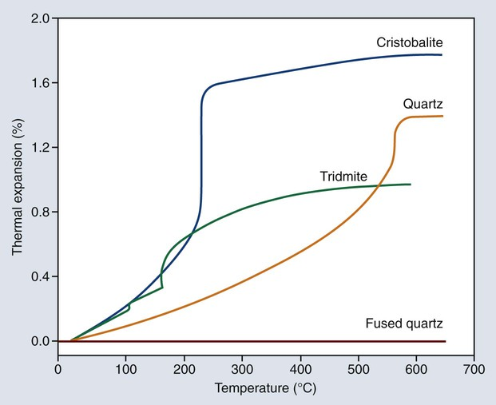

**Fig (3.12) Volumetric changes accompanying allotropic transitions of silica**

**(c) Silica ores**

**(i) Quartz crystals:** The purest type of silica can be found in the form of well-shaped crystals. This is used in the manufacture of quartz type watches and in piezoelectric applications. Smaller bonded pure grains, called **quartzite**, are used in the manufacture production of refractory bricks. If these bricks made of pure silica, they are used in the roofs of glass melting furnaces, their commercial name being Dinas bricks.

**(ii) Quartz sand:** This consists of lightly bonded quartz grains, usually of high purity and relatively low particle size. It is essentially used in glass manufacture.

**(iii) Flint:** This is a microcrystalline variety of silica, usually found in the neighbor-hood of sea shores. It is used in the manufacture of whiteware products.

**(iv) Diatomite:** Also called diatomic earth or kiezelguhr, this variety has evolved over millions of years through the decarbonization of primitive living organisms constituted of two cells. Over the millenia, there occurred a slow replacement of carbon atoms by silicon atoms finally yielding an extremely porous type of silica. That is why it is mainly used as an adsorbing material, as filter aid, in packaging and in a lot of other applications.

**(v) Common sand:** This is usually contaminated with iron oxides, giving it its yellowish colorr. It is used in the manufacture of concrete and foundries.

**(vi) Silica fume (flour):** This is an amorphous form of silica obtained as by-product of the ferrro-silicon industry. It is composed of very fine particles of few microns size and usually possesses a narrow particle size distribution. It is mainly used as an addition to concrete since it reacts with calcium hydroxide present in its pores forming hydrates of calcium silicates that impart elevated strength. Its addition to ceramic tiles has proved to be deleterious as it crystallizes to cristobalite followed by rapid grain growth.

**3.3.2 Feldspars**

Feldspars are alkali or alkaline earth aluminum silicates. They are used as fluxing agents in the ceramic industry. They are non-plastic and their addition decreases the drying shrinkage of the body. They are of moderate grindability, being easier to grind than quartz but more difficult than clays. There are three main types of feldspars:

Albite or soda feldspar: Na2O. Al2O3.6SiO2,

Orthoclase or potash feldspar: K2O. Al2O3.6SiO2

Anorthite: CaO. Al2O3.2SiO2

Their fluxing power decreases in the order: K > Na > Ca, that is why; anorthite is seldom used as flux in ceramic industries.

Their presence in a ceramic body allows lowering the firing temperatures and in presence of silica, a viscous melt can be partly formed at a relatively low temperature. This will form the ceramic bond upon cooling the fired body.

More often than not, the quarried feldspars are not purely sodic or potassic; rather they are formed of a solid solution of both. Sometimes, feldspars are present in solid solution with nepheline (K, Na) Al SiO4, in which case it is considered to be a feldspar – like material (feldspathoid) known as **nepheline syenite.**

**3.3.3 Carbonates**

The carbonate that is mostly used in ceramic industries is calcium carbonate present in high proportions in limestone, where its percentage can reach 99%. This is a major ingredient used in wall tiles recipes where it is added in levels reaching 20%. Since it decomposes at temperatures in the range 800 – 900oC, the evolution of carbon dioxide may cause troubles in the production line, which requires careful monitoring of operating conditions in firing kilns.

Dolomite, a solid solution of calcium and magnesium carbonate is rarely used instead of limestone only if this latter is not readily available.

**3.3.4 Talc**

It is a magnesium silicate mineral of formula Mg3Si4O10(OH)2. It is one of the softest known materials and can therefore be easily ground. Although its main uses are in the pulp and paper industry and pharmaceutical industries, it finds application in the ceramic industry as fluxing material.

**3.3.5 Alumina**

Aluminum oxide occurs naturally as **corundum**, a very pure oxide ore, **gibbsite**, essentially Al(OH)3, but more commonly as **bauxite**, a hydrated oxide often contaminated with iron oxides. Alumina is extracted from bauxite through a process known as the Bayer process. It is used as a refractory material for making crucibles, bricks, blocks, spark plugs etc…It has not been possible to detect any bauxite on the Egyptian territory.

**3.3.6 Zirconia**

The chief source of zirconia (ZrO2), is zircon (ZrSiO4). It is locally found in black sand, in the Rashid region, in north Egypt. The pure ore is used as an electrical insulator. The oxide, on the other hand, is extremely refractory (M.P.= 2700oC) and is used alone or in association with other oxides, to manufacture the refractory lining of glass melting tanks. It suffers, however, from a main drawback, as it undergoes an allotropic inversion at about 1170oC, accompanied with a large volume change. Stabilized zirconia is obtained by adding CaO, in levels from 10 – 20%, which forms a solid solution of reasonable volume stability. Zirconia is also used in the manufacture of piezoelectric ceramics.

**3.3.7 Grog**

Grog is a synthetic raw material obtained by calcining kaolin above 800oC. This way, the non-plastic meta-kaolinite is formed. This is used as an addition to conventional mixes to reduce shrinkage. Its merit over sand is that, being soft, it does not cause any abrasion of metallic machinery used in the manufacturing processes. On the other hand, it is an essential ingredient in the manufacture of aluminum silicate refractory materials.

**3.4 Characterization of ceramic raw materials**

Ceramic raw materials are not easily characterized and one has to use more than one method of identification to ensure proper assessment. One reason is that they are seldom of high purity as they are usually contaminated with various impurities the level of which can be as high as 50%. A second reason is their poor crystallinity and fine particle size that makes the use of some techniques like X – ray diffraction a difficult task. In the following is an outlook of the main methods used for identifying these raw materials.

**3.4.1 Light Microscopy**

Reflected light microscopy is often used as a preliminary tool for characterization. The magnification of that type of microscopes does not usually exceed 1000×. If monochromatic light is used, then it is sometimes possible to identify the crystal structure of one or more component of the material. This is done by spreading the powdered material over a transparent slide and observing the different colors appearing as the monochromatic rays hit their targets. Upon rotation of the microscope disk, the colors will start shifting to other shades until their original state is restored. The angle of rotation of the disk can be an indication of the probable crystal structure. If colored pattern repeat at 90o, then the crystals are cubic; whereas a recurrence of the color pattern every 180o will correspond to a tetragonal or rhombohedral structure. A recurrence of the pattern every 60o will indicate the presence of hexagonal crystals. The presence of species of low crystallinity of amorphous nature will not facilitate characterization using that simple technique.

**3.4.2 Electron microscopy**

An electron microscope is a microscope that uses a beam of accelerated [electrons](https://en.wikipedia.org/wiki/Electron) as a source of illumination. Electron microscopes have a much higher [resolving power](https://en.wikipedia.org/wiki/Angular_resolution) than [light microscopes](https://en.wikipedia.org/wiki/Optical_microscope) and can reveal the structure of smaller objects because of the extremely short wavelength of cathode rays. The magnification of a transmission electron microscope can be as high as 10,000,000× compared to a maximum of 2000× for light microscopes. Electron microscopes use [electrostatic](https://en.wikipedia.org/wiki/Electrostatic_lens) and [electromagnetic](https://en.wikipedia.org/wiki/Electromagnetism) lenses to control the electron beam and focus it to form an image. These [electron optical lenses](https://en.wikipedia.org/wiki/Electron_optics) are analogous to the glass lenses of an optical light microscope. Modern electron microscopes produce electron [micrographs](https://en.wikipedia.org/wiki/Micrograph) using specialized digital cameras and [frame grabbers](https://en.wikipedia.org/wiki/Frame_grabber) to capture the image. The two common types of electron microscopes used are reviewed is what follows.

**(a) The Scan Electron Microscope (SEM)**

The SEM produces images by probing the specimen with a focused electron beam that is scanned across a rectangular area of the specimen. When the electron beam interacts with the specimen, energy is lost that is converted into alternative forms such as heat, emission of low-energy secondary electrons and high-energy backscattered electrons, light emission or X-ray emission. all of these forms provide signals carrying information about the topography and morphology of the specimen surface. The image displayed by an SEM maps the varying intensity of any of these signals into the image in a position corresponding to the position of the beam on the specimen when the signal was generated

Figure (3.13) shows the SEM micrograph of a clay specimen, while Figure (3.14) illustrates the principle of operation of the scanning electron microscope.

**(b) The transmission electron microscope (TEM)**

The transmission electron microscope (TEM) uses a high voltage electron beam to illuminate the specimen and create an image. The electron beam is accelerated by an anode focused by electrostatic and electromagnetic lenses, and transmitted through the specimen that is in part transparent to electrons and in part scatters them out of the beam. When it emerges from the specimen, the electron beam carries information about the structure of the specimen that is magnified by the objective lens system of the microscope. The spatial variation in this information (the "image") may be viewed by projecting the magnified electron image onto a fluorescent viewing screen coated with a phosphor or scintillator material. The image detected by the digital camera may be displayed on a monitor or computer.

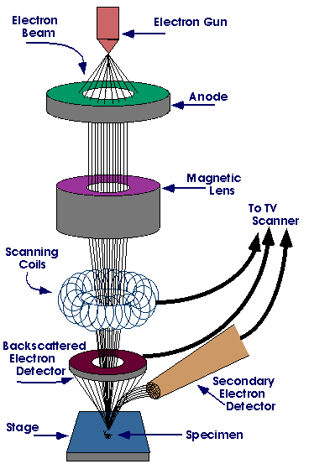

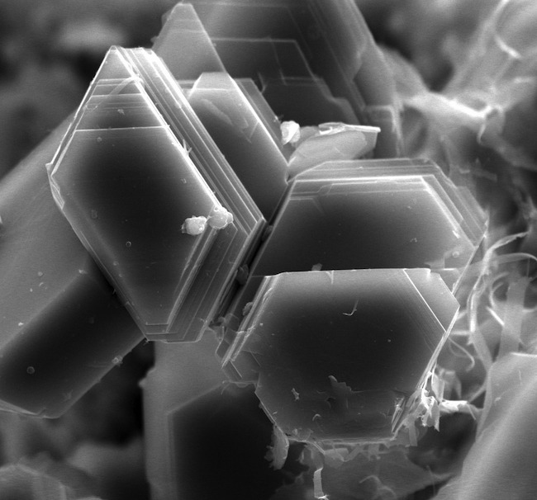

***Fig (3.13) SEM of kaolin specimen Fig (3.14) SEM diagrammatic principle***

The resolution of that type of electron microscope can be ten times higher than SEM as it can reach 10,000,000× in extreme cases, although normally confined to lesser magnification ratios. Figure (4.15) shows a TEM micrograph (106×) of the boundary between alumina and carbon nanotubes in a ceramic nanocomposite.

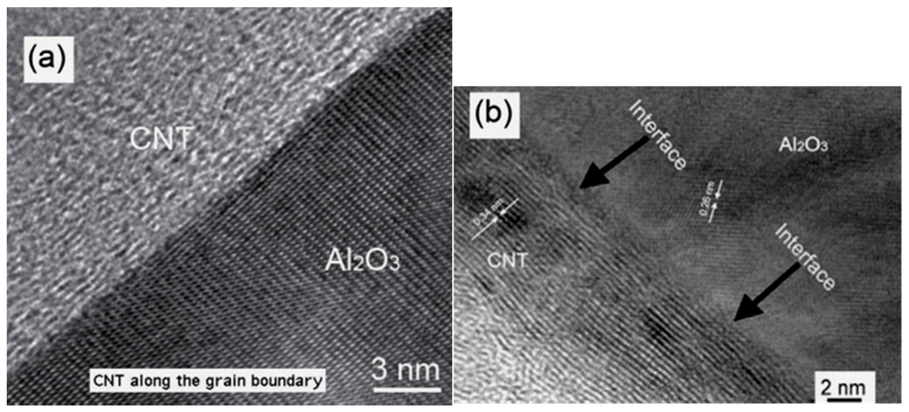

***Fig (3.15) TEM micrograph of Al2O3 – CNT interface***

The main difference between SEM and TEM is that the electron beam in the former reflects on the specimen surface which is normally coated with a high atomic mass material, like gold, to increase the proportion of reflected rays. The latter type, on the other hand, relies on maximizing penetration of cathode rays through the specimen. In both types, an inert gas is used during the scanning process.

**3.4.3 X – ray analyses**

There are three types of analyses commonly used in the characterization of ceramic materials that rely on using X – rays in material assessment.

1. **X – ray Diffractometric analysis (XRD)**

The principle on which XRD is based is the following: When electron rays (cathode tube rays) collide with a metallic target (usually copper), low frequency X-rays are emitted. These rays are then directed to a crystalline powder where they diffract yielding intensities that depend on the distance between the atomic planes on which they fell (*d*) or the angle of incidence (*θ*). These two parameters are related by Bragg’s law:

*n.λ* = 2*d*.sin *θ* (3.3)

Where: *n* is an integer, normally taken as 1 and *λ* is the wave length of the X-ray that is related to the type of metallic target (for copper, λ = 15.39 nm).

The emitted intensities are usually plotted against 2*θ* in what is known as a XRD pattern, as the one shown in Figure (3.16) which displays the XRD pattern of a type of clay quarried in Upper Egypt.

Every crystalline element or compound has its characteristic XRD pattern. Patterns are either available in ASTM catalogues or are loaded on the hard disk of the equipment. By comparing the obtained pattern with standard patterns, one is able to detect the presence of any crystalline phase present at > 5% level.

Through proper manipulation of an XRD pattern, we can also assess the presence of solid solutions, degree of crystallinity, crystallite size, presence of internal strains, atomic arrangement etc…It is to be noted, however, that XRD does not lend itself easily for quantitative analysis. The heights of peaks are not proportional to the content of the phase, but rather with its degree of crystallinity.

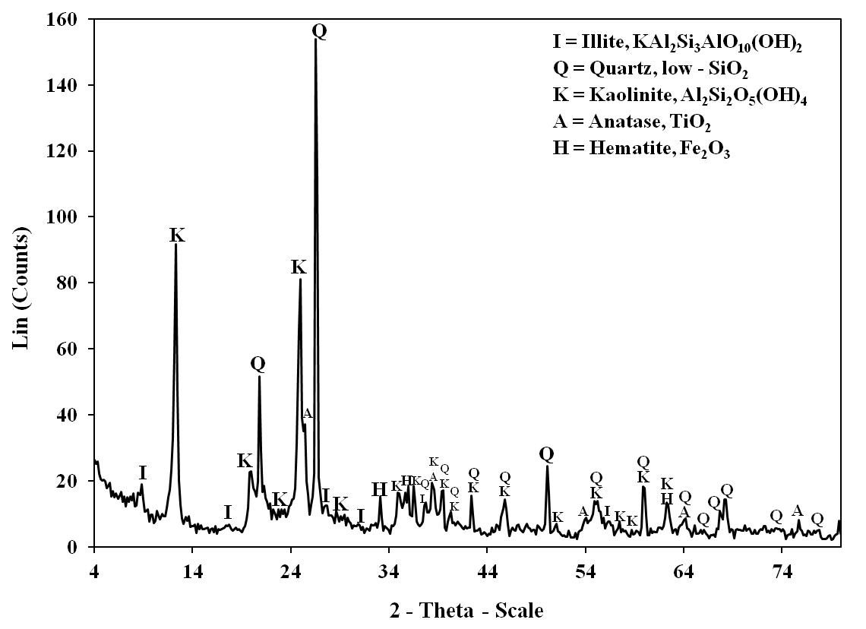

***Fig (3.16) XRD pattern of an Egyptian type of clay***

1. **X – Ray Fluorescence analysis (XRF)**

In this method, an X-ray beam is used to irradiate a specimen, causing this specimen, in turns, to emit X-rays of his own. The wave lengths of the emitted rays are characteristic for each element, and hence this method, unlike XRD does not identify phases but rather elements or oxides. Also, the concentration of each element (or oxide) present is obtained from the peak intensity. This method has now replaced the conventional chemical methods for elemental analysis. It can detect elements present in levels as low as 0.01%. However, due to instrumental limitations and low X-ray yields for the light elements, it is often difficult to quantify elements lighter than [sodium](https://en.wikipedia.org/wiki/Sodium).

A suitable coupling of the results of XRD and XRF analyses can sometimes be used to obtain a quantitative phase composition of a material to a reasonable degree of accuracy. This is done by performing a material balance on the elements detected by XRF in their compounds as detected by XRD.

1. **Energy dispersive X- Ray analysis (EDX)**

This is an analytical technique used for the [elemental analysis](https://en.wikipedia.org/wiki/Elemental_analysis) or [chemical characterization](https://en.wikipedia.org/wiki/Characterization_(materials_science)) of a sample. It relies on an interaction of some [source](https://en.wikipedia.org/wiki/X-ray_source) of [X-ray](https://en.wikipedia.org/wiki/X-ray) excitation and a [sample](https://en.wikipedia.org/wiki/Sample_(material)). To stimulate the emission of characteristic X-rays from a specimen, a high-energy beam of charged particles such as [electrons](https://en.wikipedia.org/wiki/Electron) or [protons](https://en.wikipedia.org/wiki/Proton) or a beam of X-rays, is focused into the sample being studied. At rest, an atom within the sample contains [ground state](https://en.wikipedia.org/wiki/Ground_state) (or unexcited) electrons in discrete energy levels or [electron shells](https://en.wikipedia.org/wiki/Electron_shell) bound to the nucleus. The incident beam may excite an electron in an inner shell, ejecting it from the shell while creating an [electron hole](https://en.wikipedia.org/wiki/Electron_hole) where the electron was. An electron from an outer, higher-energy shell then fills the hole, and the difference in energy between the higher energy shell and the lower energy shell may be released in the form of an X-ray. The number and energy of the X-rays emitted from a specimen can be measured by an energy-dispersive spectrometer. As the energies of the X-rays are characteristic of the difference in energy between the two shells and of the atomic structure of the emitting element, EDX allows the elemental composition of the specimen to be measured.

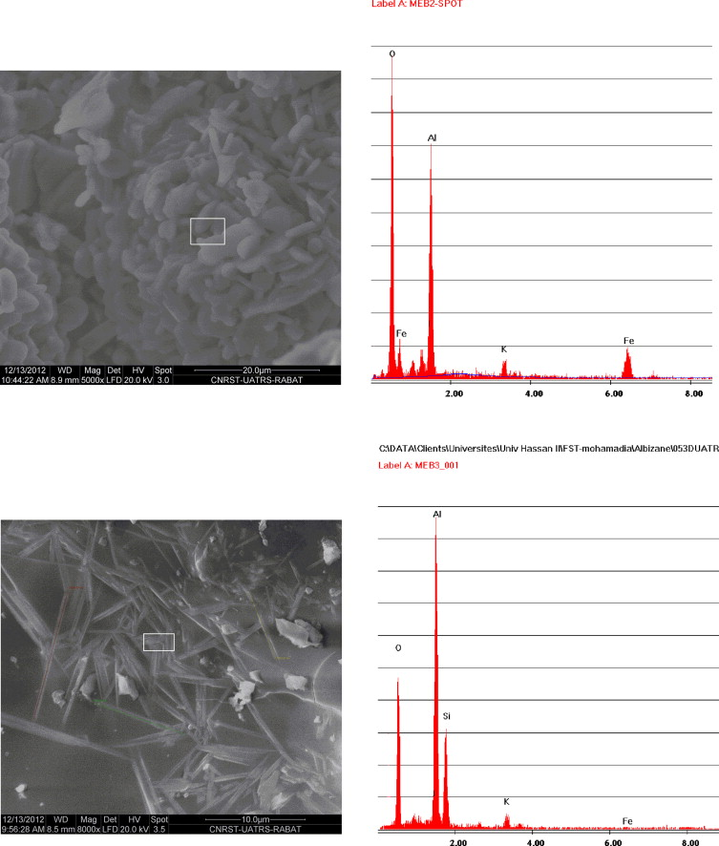

***Fig (3.17) SEM – EDX micrograph for mullite specimen***

One merit of EDX is that it can disclose the percentage of elements present in a very limited portion of the specimen as can be seen from Figure (3.17) depicting a dual SEM – EDX micrograph – analysis in a minuscule area (2.5×1 μm2) selected from the SEM micrograph of a mullite specimen.

**3.4.4 Thermal Analysis methods**

These methods rely upon following up some properties of the material as it is heated, usually under constant heating rate, typically from 2 to 20oC/min. Heating is performed in a confined space often, but not always, in nitrogen atmosphere. There are several thermal analysis techniques used in the characterization of ceramic materials, the most commonly used being Differential Thermal Analysis (DTA), Differential Scanning Calorimetry (DSC), Thermogravimetric analysis (TGA) and Differential Thermogravimetric Analysis (DTG).

**(a) Differential Thermal Analysis (DTA)**

This is a [thermo-analytic](https://en.wikipedia.org/wiki/Thermal_analysis) technique where the material under study and an inert reference are made to undergo identical thermal cycles, while recording any temperature difference between sample and reference. This differential temperature is then plotted against time, or against temperature (DTA curve, or thermogram). Changes in the sample, either exothermic or endothermic, can be detected relative to the inert reference. Thus, a DTA curve provides data on the transformations that have occurred, such as glass transitions, crystallization, melting and sublimation. The area under a DTA peak is approximately proportional to the enthalpy change and is not affected by the heat capacity of the sample.

The apparatus used comprises a furnace containing two crucibles that are connected to two thermocouples (Figure 3.18). A calibrated voltmeter indicates the difference in potential between the two thermocouples which is proportional to the difference in temperature Δ*T*.

**Δ*Τ***

.

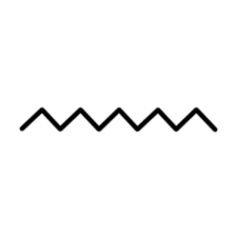

***Fig (3.18) Sketch of DTA apparatus***

The specimen to be tested is placed in one of them while the other is filled with an equal weight of a reference inert material, commonly alumina. As the furnace is heated, the difference in temperatures between the two materials is continuously recorded and a pattern like the one shown in Figure (3.19) obtained, that corresponds to the thermal decomposition of a kaolin ore. The pattern display two peaks, the first peak occurring in the range 500 – 650oC corresponds to the transformation of kaolinite to meta-kaolinite, while the second in the 1000 – 1020oC range corresponds to the formation of γ-Alumina or possibly mullite.



***Fig (3.19) Typical TG-DTA pattern for kaolin***

**(b) Differential Scanning Calorimetry (DSC)**

This technique which bears strong resemblance to DTA, is a [thermo-analytical](https://en.wikipedia.org/wiki/Thermal_analysis) technique in which the difference in the amount of [heat](https://en.wikipedia.org/wiki/Heat) required to increase the [temperature](https://en.wikipedia.org/wiki/Temperature) of a sample and reference is measured as a function of temperature. Both the sample and reference are maintained at nearly the same temperature throughout the experiment. Generally, the temperature program for a DSC analysis is designed such that the sample holder temperature increases linearly as a function of time. The reference sample should have a well-defined [heat capacity](https://en.wikipedia.org/wiki/Heat_capacity) over the range of temperatures to be scanned. The trace obtained in a DSC run has practically the same shape as the DTA curve.

**(c) Thermogravimetric Analysis (TGA)**

This is simply a record of the weight of the specimen as function of time or temperature. It can detect weight losses due to loss of gaseous components like water vapor or CO2, weight gain due to oxidation of a solid and the occurrence of solid state reactions involving loss or gain in weight. However, it cannot detect transformations unaccompanied by weight change such as melting, allotropic transitions.

Coupling TGA with DTA can disclose the nature of transformations occurring on heating a material. This nature will depend on whether the TGA curve at temperatures of occurrence of DTA peaks will yield a change in weight or not.

**Differential Thermogravimetric analysis (DTG)**

The DTG pattern obtained is always associated with a TGA curve. Actually, it represents the rate of change of weight with respect to time . It can be useful in disclosing the occurrence of consecutive transformations otherwise undetected by TGA. Also, since is proportional to the rate of transformation or reaction taking place, it can be used in calculating the kinetic parameters of the reaction. (Sabry et al, 1986)

Fig.(3.20) shows a combined TGA – DTG curve for the decomposition of potassium borate, often used in glaze making, glass lenses and enamels (Ceyhan et al, 2009).

**(e) Other methods of thermal analysis**

There are other methods often used in ceramic materials characterization, like dilatometric analysis, which involves continuously recording dimensional changes of a specimen with time or temperature and evolved gas analysis which often couples a chromatographic analysis equipment to a thermal analyzer.

***Fig (3.20) TGA – DTG pattern for the decomposition of potassium borate hydrate***

**Suggested additional reading**

1. F.H. Norton, *Elements of Ceramics,* Mc Graw-Hill ed., 1968
2. W.E. Worrall, *Ceramic Raw Materials,* 2nd ed., Pergamon Press, 1982
3. D.A. Payne and L.E. Cross, *Microstructure and Properties of Ceramic Materials,* Science Press, 1984
4. B.V.S. Subba Rao, *High Performance Ceramics,* Proceedings of the seminar on high performance ceramics, Hyderabad, 1987
5. R.E. Loehman, *Characterization of Ceramics,* 1st ed., Butterworth-Heinemann, Boston, 1993
6. C.B. Carter and M.G. Norton, *ceramic Materials,* 1st ed., Springer science, 2007