**Laser safety**

**AMR ELDIB**

**Laser safety Topics**

**Lecture**1-Introduction

**Lecture** 2-Fundamentals of lasers

**Lecture** 3-Laser operation and applications

**Lecture** 4-Hazards laser and non beam

**Lecture** 5-Bioeffects and Accidents

Midterm exam

**Lecture** 6-Laser standards

**Lecture** 7-ANSIZ136.1 standards

**Lecture** 8-Control measures

**Lecture** 9-Laser safety rules

**Lecture** 10- MPE,OD&NHZ examples

**4-** LASER HAZARDS

1- **Laser beam hazards Non beam radiation hazards**

**Skin Eye**

**Chapter**

4

LASER HAZARDS

**Laser beam hazards Non beam radiation hazards**

**Skin Eye**

**1-Skin**

200-315 nm actinic UV range from erythema to blistering , possible carcinogenic effects 315nm – 1mm Thermal effects range from mild reddening (erythema) to blistering, charring depends upon exposure time , exposure dose, rate and conduction of heat away from site of absorption

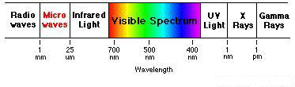

[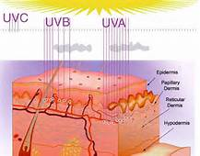](https://images.search.yahoo.com/images/view;_ylt=AwrB8pXhiixWxzwAft.JzbkF;_ylu=X3oDMTIzNjMxM28xBHNlYwNzcgRzbGsDaW1nBG9pZANkZTE4MDM3YjMwOGQzMDg2ZWIxY2U2NWY0NWQxMDNhZgRncG9zAzk0BGl0A2Jpbmc-?.origin=&back=https://images.search.yahoo.com/search/images?p=laser+damage+to+the+skin&fr=vmn-s&fr2=piv-web&nost=1&tab=organic&ri=94&w=589&h=461&imgurl=biotechinasia.files.wordpress.com/2015/05/skin2.jpg&rurl=http://biotechin.asia/2015/05/25/nono-says-yes-for-repairing-dna-damage-induced-by-uv-radiation/&size=69.8KB&name=NONO%E2%80%99+says+yes+for+repairing+DNA+%3cb%3edamage%3c/b%3e+induced+by+UV+radiation+...&p=laser+damage+to+the+skin&oid=de18037b308d3086eb1ce65f45d103af&fr2=piv-web&fr=vmn-s&tt=NONO%E2%80%99+says+yes+for+repairing+DNA+%3cb%3edamage%3c/b%3e+induced+by+UV+radiation+...&b=61&ni=21&no=94&ts=&tab=organic&sigr=130fek3mp&sigb=13m596me2&sigi=11jtvc4b3&sigt=12cbpftre&sign=12cbpftre&.crumb=awT.HMVCIH8&fr=vmn-s&fr2=piv-web) [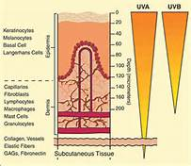](https://images.search.yahoo.com/images/view;_ylt=AwrB8pXhiixWxzwAgt.JzbkF;_ylu=X3oDMTIzbjBvaG80BHNlYwNzcgRzbGsDaW1nBG9pZAM5OWJmNzRmMmZiMmY2ZTZmYzgzMzA0ZDIxNWJlNmRlNQRncG9zAzk4BGl0A2Jpbmc-?.origin=&back=https://images.search.yahoo.com/search/images?p=laser+damage+to+the+skin&fr=vmn-s&fr2=piv-web&nost=1&tab=organic&ri=98&w=356&h=309&imgurl=www.dermatology.ucsf.edu/skincancer/images/UV.gif&rurl=http://www.skincaretalk.com/t/21393/do-skin-peels-undo-dna-damage/40&size=33.5KB&name=do+%3cb%3eskin%3c/b%3e+peels+undo+DNA+%3cb%3eDamage%3c/b%3e?+-+Page+3&p=laser+damage+to+the+skin&oid=99bf74f2fb2f6e6fc83304d215be6de5&fr2=piv-web&fr=vmn-s&tt=do+%3cb%3eskin%3c/b%3e+peels+undo+DNA+%3cb%3eDamage%3c/b%3e?+-+Page+3&b=61&ni=21&no=98&ts=&tab=organic&sigr=124afoqph&sigb=13m5tv8fa&sigi=11h9c7cp3&sigt=11l3nkfco&sign=11l3nkfco&.crumb=awT.HMVCIH8&fr=vmn-s&fr2=piv-web)

**2- Eye**

UV-A affects the lens very high dose may produce opacity UV-B and UV-C affects the cornea similar to the effects produced by arc welders . Acute inflammation of conjunctiva as well.

|  |  |
| --- | --- |
| 315-400nm | UV-A |
| 280 -315 nm | UV-B |
| 180-280nm | UV-C |

IR-B and IR-C (far IR) affects the cornea and lens ,heat effect on ornea and lens .

|  |  |
| --- | --- |
| IR- A (NEAR-IR0 | 740-1400 nm |
| IR-B | 1400-3000 nm |
| IR-C (FAR- IR) | More than 3000 nm |

VISIBLE and NEAR-IR Passes through the transparent media of the eye ( cornea ,lens, & vitreous) and affects the Retina effects may be temporary or permanent ,lesion ranging from edema to charring with hemorrhage and tissue reaction around the lesion. With very high radiant energy tissue photodisruption of the physical structure of the eye can happen,

[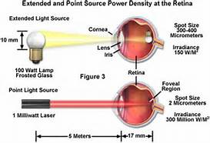](https://images.search.yahoo.com/images/view;_ylt=AwrB8pKviyxWMWQAP0GJzbkF;_ylu=X3oDMTIzcGMzaGJrBHNlYwNzcgRzbGsDaW1nBG9pZAMwYmFlYmNmYTkyNDRiNGFjNTQzOTdkZGRlZjBiNjc4YgRncG9zAzMwBGl0A2Jpbmc-?.origin=&back=https://images.search.yahoo.com/search/images?p=laser+damage+to+the+eye&n=60&ei=UTF-8&fr=vmn-s&fr2=sb-top-images.search.yahoo.com&tab=organic&ri=30&w=456&h=311&imgurl=www.microscopyu.com/articles/fluorescence/images/lasersafetyfigure3.jpg&rurl=http://www.microscopyu.com/articles/fluorescence/lasersafety.html&size=34.7KB&name=the+band+of+wavelengths+that+pass+through+the+outer+%3cb%3eeye%3c/b%3e&p=laser+damage+to+the+eye&oid=0baebcfa9244b4ac54397dddef0b678b&fr2=sb-top-images.search.yahoo.com&fr=vmn-s&tt=the+band+of+wavelengths+that+pass+through+the+outer+%3cb%3eeye%3c/b%3e&b=0&ni=108&no=30&ts=&tab=organic&sigr=121agl85o&sigb=14jg17s77&sigi=127hn8dvv&sigt=11u7ljlbh&sign=11u7ljlbh&.crumb=awT.HMVCIH8&fr=vmn-s&fr2=sb-top-images.search.yahoo.com) 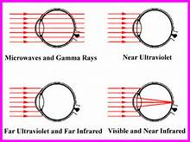 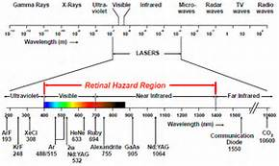

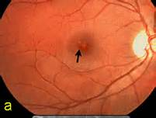

[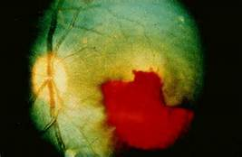](https://images.search.yahoo.com/images/view;_ylt=AwrB8pKviyxWMWQAIkGJzbkF;_ylu=X3oDMTIydmRnbmcyBHNlYwNzcgRzbGsDaW1nBG9pZANhODU0NTgxMzBjZTQyZGNjNmZkNmQxNjhkY2I1OThiYwRncG9zAzEEaXQDYmluZw--?.origin=&back=https://images.search.yahoo.com/search/images?p=laser+damage+to+the+eye&n=60&ei=UTF-8&fr=vmn-s&fr2=sb-top-images.search.yahoo.com&tab=organic&ri=1&w=427&h=278&imgurl=images.defensetech.org/wp-content/uploads/2012/10/laser-eye-damage.jpg&rurl=http://defensetech.org/2012/10/26/lasing-airplanes-aint-cool-kids/&size=30.3KB&name=Lasing+Airplanes+Ain&#39;t+Cool,+Kids+|+Defense+Tech&p=laser+damage+to+the+eye&oid=a85458130ce42dcc6fd6d168dcb598bc&fr2=sb-top-images.search.yahoo.com&fr=vmn-s&tt=Lasing+Airplanes+Ain&#39;t+Cool,+Kids+|+Defense+Tech&b=0&ni=108&no=1&ts=&tab=organic&sigr=12221khj9&sigb=14ic4nm3d&sigi=126ab84df&sigt=11k6cudl3&sign=11k6cudl3&.crumb=awT.HMVCIH8&fr=vmn-s&fr2=sb-top-images.search.yahoo.com)

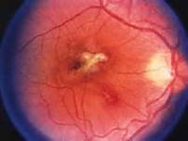

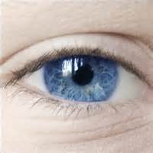

Non beam radiation hazards

Electric shock and electrocution

Air contamination ( laser gas or tissue vaporized particles)

Collateral and plasma generation

X ray radiation generation

UV & Visible plume radiation

Radiofrequencies (RF)

Fire hazards

Explosion hazards

Compressed gases

Laser dyes and cryogenic materials

Mechanical accidents

Noise levels

Waste disposal

Visibility issues / confined space

Human factors /Ergonomics

Notes