**Title Page**

**A comparative study of implant–tooth connected prostheses with rigid and non-rigid connectors**

Author #1(corresponding author):

Dr. Gihan Omar

Assistant professor of oral and maxillofacial radiology, Cairo University

[gihanomar2012@hotmail.com](mailto:gihanomar2012@hotmail.com)

Author #2:

Dr. Lamia Sherif

Assistant professor of fixed prosthodontics, Cairo University

[lamiasherif@hotmail.com](mailto:lamiasherif@hotmail.com)

Author #3:

Dr. Naglaa Abdelwahed

Assistant professor of oral and maxillofacial radiology, Cairo University

Word count of abstract: 185

Word count of manuscript: 2379

Number of tables: 4

Number of figures: 2

**Abstract**

***Aim:*** A comparative clinical study incorporating implant-tooth supported FPDs with either rigid or non-rigid connectors, using cone beam computed tomography scans for evaluation. ***Materials and Methods:*** 10 titanium cylindrical implants were inserted in the position of the distal abutments, in ten edentulous patients. 3-units implant-tooth supported FPDs were constructed. Half of the patients (n=5), received 3 units FPD with rigid connection, while the other half (n=5), received 3 units FPD with non-rigid connector. CBCT scans were taken immediately following prosthesis loading and after 6 months of loading.

***Results:*** Regarding bone loss, non-rigid group showed significantly higher mean bone loss than rigid group around implant abutments (6.5±1.2 and 2±0.5). While around natural teeth abutments, rigid group showed statistically higher bone loss than non-rigid group (-8.1±1.6 and 9.2±2, respectively). Regarding change in density profile, non-rigid group showed more decrease in density profile than rigid group (-322± 75.3 and -95.3± 21.6) around implant abutments. While around natural teeth abutments, rigid group showed more decrease in density profile than non-rigid group (-12.2±3.5 and 7.3±2.5).

***Conclusions:*** Non-rigid connectors cause increases bone resorption and decreases bone density around the implant system.

**Introduction**

Implant-supported FPD have been shown to be a predictable treatment modality (Lindh T G. J., 1998). However, in clinical practice this restoration may not be possible due to inadequate bone volume, bone resorption and anatomical limitations of space for implants, which might necessitate the use of teeth in combination with implants to support FPDs (Clarh DF, 2006)

.

The main problem of tooth-implant supported prostheses is that dental implants are rigidly fixed to bone by osseointegration, while the periodontal ligament provides a resilient attachment and affords some movement of the tooth in the alveolar socket (Lindh T G. J., 1998). This difference in union between implants and teeth means that they behave very differently in response to the different masticatory forces, both natural and pathological (Carillo C, 2010).

The amount of tooth movement with healthy periodontal ligament against that of an osseointegrated dental implant can be 5-10 times greater (Nyman S, 2000). The physiologic movement of the tooth causes the prosthesis to act as a cantilever, resulting in implant overload (Wylie RS, 1991) and (Yang HS, 1999). A potential consequence of such overloading may be peri-implant marginal bone resorption, which may eventually cause failure of the osseointegration. Another problem associated with tooth-implant supported prosthesis is the raised incidence of tooth intrusion (Gross M, 1997) and (Naert I D. J., 2001) .

To stabilize the dissimilar mobility between natural teeth and implant system, several methods have been suggested. These include a stress breaker application either in the implant system, which is supplied with resilient elements, or incorporation of a non-rigid connector in the FPD (Steen D, 1990) . The resilient element was expected to act as a stress absorbing device to distribute the force around the implant and compensate for the mobility of the implant. However, various analytical studies have actually casted doubts on its effectiveness (Laufer B, 1998). On the other hand, a non-rigid connector was stated to provide the ability to separate the splinted units; thus compensating for the different degrees of mobility between the implant and the tooth (Russell D, 1999) and (Becker C, 2000).

A strong correlation between bone density and alveolar bone level around implants and their stability and rate of success was approved (Kei I, 2011). While radiographic two dimensional imaging modalities suffer from superimpositions, projection geometry and completely lack the third dimension of bone depth such that diagnostic value is inaccurate and unreliable (Angelopoulos C, 2008 ), CBCT was approved to be a reliable diagnostic tool for bone density evaluation around implants using the HU (Rodrigues R, 2011), especially since the reported radiation dose required is minimal (Aranyarachkul PCaruso J, 2005).

So the purpose of this study was to compare clinical outcomes of connecting teeth to implants either by rigid or non-rigid connection, to support an implant-tooth supported prosthesis, using cone beam computed tomography scans. The hypothesis of the present study was that implant-tooth borne prosthesis constructed with non-rigid connection will show better results compared with rigid connection.

**Materials and methods**

The present study included ten patients with two missing mandibular molars, selected from out-patient clinic. All patients were free from any systemic diseases and any local pathologic lesions that may contraindicate the surgery. Patients had good oral hygiene and an opposing natural dentition. Clinical and digital radiographic preoperative data were gathered and the available jawbone quantity and bone quality were registered.

All patients received an implant distally; to support an implant-tooth supported FPD, using a natural tooth as a mesial abutment and the implant as a distal abutment.

A total of 10 titanium cylindrical implants (Pitteasy, Sybron implants, Oraltronic-Germany), were inserted in the position of the distal abutments. Implants with 3.75-4 mm wide and 12-14 mm length, were inserted following a conventional 2-stage surgical technique.

Surgical stents were used to guide implant s' insertion, then implants were inserted according to manufacturer instructions, followed by cover screws insertion and site suturing.

An integration/healing phase of three months was provided. Then implants were exposed and gingival formers were inserted for two weeks. Natural premolar teeth abutments were prepared to receive a full veneered retainer, then impressions were taken using closed tray impression technique. Then 3-units implant-tooth supported FPDs were constructed using Ni Cr alloy and fully porcelain veneered restorations. Two layers of die spacer coat were applied on the implants and teeth abutments to insure a passive framework fit.

Half of the patients (n=5), received 3 units FPD with rigid connection, supported by natural tooth abutment mesially and supported by an implant distally. While, the other half (n=5), received 3 units FPD with non-rigid connector between the mesial surface of the pontic and the distal surface of the second premolar in the form of an occlusal rest and a deep spoon shaped rest seat.

The spoon shaped rest seats were prepared on the distal marginal ridges of the natural teeth retainers (mesial abutment), directed towards their central fossae, and the corresponding occlusal rests were attached to the mesial part of the pontic. Each rest seat provided a space of 1.5 mm depth and 2.5 mm width, and all walls of the rest seats were rounded to allow freedom of movement for tooth-pontic connection.

The FPDs had a modified ridge lap pontic design, with fixed connectors’ dimensions of 3x3 mm.

Prior to cementation, each framework was evaluated for its adaptation, fitness and lack of premature contacts during centric and eccentric movements. Then FPDs were cemented with glass ionomer cement (Medicem, Promedica-Germany).

Following prosthetic treatment, the patients were seen for follow-up every 3 months. Implant survival was based on the following criteria: absence of mobility, absence of painful symptoms or paresthesia, absence of peri-implant radiolucency, and absence of progressive marginal bone loss (Adell R, 1990).

Cone beam computed tomography (CBCT) scans were taken immediately following prosthesis loading and after 6 months of loading to evaluate the crestal bone level around both implants and abutments by measuring the distance from the crest of the ridge to a point perpendicular on the tangent of the most apical end of implant or tooth apex at the mesial, distal, buccal, and lingual surfaces.Also Bone density profile around implants and natural teeth was recorded at the four surfaces as well as the apical area (Figure 1 and Figure 2)

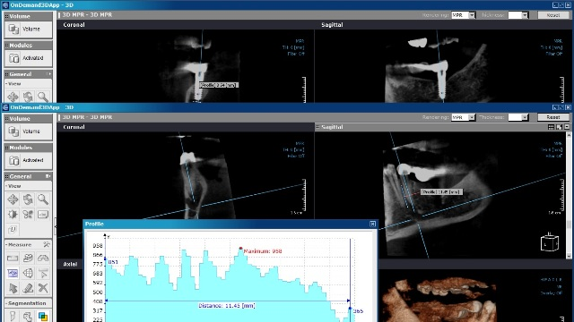

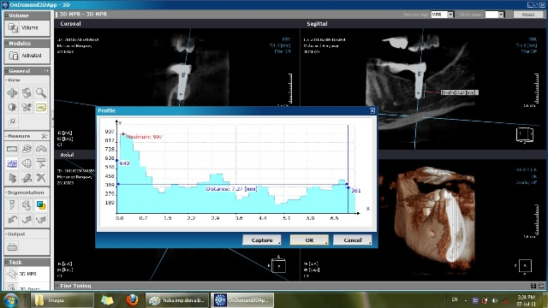

*Fig (1): measure of alveolar bone level and density profile in rigid group, around abutment (above) and around implant (below)*

CBCT scans were obtained by Scanora 3D scanner, (Sorredex , Finland) at (M. Ekram radiology center). Exposure parameters were 15 mA, 85 kV, 0.1 mm thickness. The acquired data was viewed and measurements were performed by 3D multiplanar radiography provided with the scanner (On demand 3D project viewer limited) software version 1.0.9 (Cyber med, Korea)

Data were presented as mean and standard deviation (SD) values. Mann-Whitney *U* test was used to compare between the two groups. The significance level was set at *P ≤ 0.05*. Statistical analysis was performed with PASW Statistics 18.0[1]® (Predictive Analytics Software) for Windows.

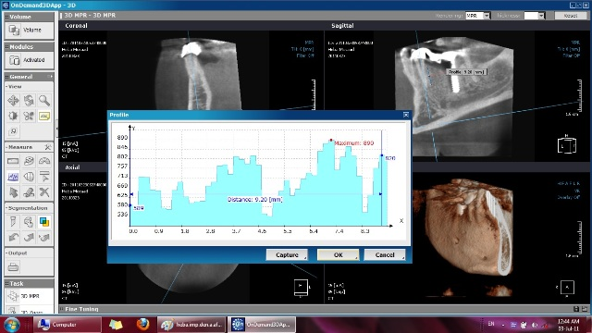

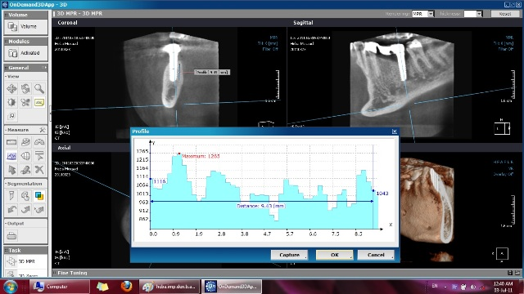

*Fig (2): measure of alveolar bone level and density profile in non- rigid group, around abutment (above) and around implant (below)*

**Results**

***Bone height***

Regarding bone height around implants, results revealed that there was no statistically significant difference between bone height measurements in the two groups, immediately and after 6 months (*P*-value = 0.075 and 0.112, respectively). Regarding percentage of bone loss, non-rigid group showed significantly higher bone loss than rigid group (6.5±1.2 and 2±0.5, respectively), yet it was statistically non significant (*P*-value =0.087).

Regarding bone height around natural abutments, results revealed that there was no statistically significant difference between bone height measurements in the two groups immediately and after 6 months (*P*-value = 0.055 and 0.051, respectively). Regarding percentage of bone loss, rigid group showed statistically significantly higher mean bone loss than non-rigid group which showed bone deposition (-8.1±1.6 and 9.2±2, respectively, P-value =0.01).

***Density profile***

Regarding density profile around implants, results revealed that non-rigid group showed statistically significantly higher mean density profile than rigid group immediately and after 6 months (*P*-value = 0.021 and 0.050, respectively). Regarding percentage of change in density profile, non-rigid group showed statistically significantly more decrease in density profile than rigid group (-322±75.3 and -95.3±21.6 respectively) (*P*-value < 0.001).

Regarding density profile around natural teeth abutments, results revealed that there was no statistically significant difference between density profile measurements in the two groups immediately and after 6 months (*P-*value = 0.095 and 0.001 respectively). Regarding percentage of change in density profile, rigid group showed statistically significantly higher mean % decrease in density profile than non-rigid group which showed an increase in density profile (-12.2±3.5 and 7.3±2.5 respectively, *P*-value = 0.006).

**Discussion**

Due to the dissimilar mobility between natural teeth and implant system; the connection of implants to natural teeth is a point of controversy. So based on the fact that using different connectors affects the stresses found in each component of the prosthesis and consequently on the supporting bone, this study was conducted to clinically compare the effect of using different types of connectors, in implant/tooth supported prostheses, on the quality and quantity of the supporting bone around different components of the prostheses.

The hypothesis of this study was partially accepted, since non-rigid connectors were found to be beneficial to bone quality around natural teeth abutments, yet they caused an increased bone resorption and a decrease in bone density around implant abutments, as it might drastically affect Implant survival which is directly related to bone density.

Non-rigid connection was achieved in tooth/implant-supported prosthesis in the form of deep spoon shaped rest seat as advocated by Winston, 2010 (Winston, 2010).

CBCT was used for evaluation, as it was proven to capture 3D images with high contrast, have excellent image acquisition of vital structures as the inferior alveolar nerve canal, and has proven more reliable than medical CT (Guerrero ME, 2006). In addition, CBCT exposes the patient to less radiation than medical CT. (Kobayashi K, 2004) concluded that the average distance measurement error for CBCT was found to be significantly less than that for CT. Moreover, the maximum error associated with measuring the distance was 0.65 mm in CBCT, which was significantly less than that of CT at 1.11mm. Considering that the measurement error should be less than 1 mm on images for implant treatment (Wyatt CC, 1998), CBCT appears to be a more accurate tool for distance measurement with regards to implant planning. (Aranyarachkul PCaruso J, 2005) concluded that CBCT was a suitable alternative to CT for measurement of bone density. Additionally, CBCT provided a good reproducibility of bone density measure.

**Regarding cases that used non-rigid connectors;** results revealed that using them resulted in an increase in percentage bone loss, accompanied with a significant decrease in bone density around implant abutments compared with cases that used rigid connectors. These results might indicate that non-rigid connectors result in an excessively applied dynamic loading which caused a decreased percentage of mineralized bone tissue in the cortex; a decrease in bone density, thus leading to increased bone resorption and crater-like defects around the implant collar (Duyck J, 2001) and (Hoshaw SJ, 1994)

That was in approval with Li-Lin C, who reported that stresses falling on implants using non-rigid connectors were found to be increased compared with those using rigid connectors, which was attributed to the increased occlusal forces transferred from the prosthesis to alveolar bone by only one abutment (implant) as a result of the non-rigid connector that was used as a stress breaker and broke the stress transfer from the implant-side to the natural tooth (Lin CL, 2006)

Yet, contradicting results were reported by(Naert I D. J., 2001) , (Winston, 2010), and (Carillo C, 2010) who stated that there was 3 times greater bone loss rate for the rigid tooth-implant connected prostheses, than the freestanding prostheses or the non-rigid tooth implant connections, although it was suggested that rigid connection achieves better outcomes with regard to avoiding dental intrusion.

Meanwhile, using non-rigid connectors resulted in healthy bone stimulation; yielding bone deposition and slight increase in bone density around natural teeth abutments. That was attributed to the fact that due to the non-rigid connector, most of the stresses were transferred to the implant abutment; leading to the decrease in stresses falling on natural teeth abutments. That was in approval with (Russell D, 1999) and (Becker C, 2000) who stated that a non-rigid connector provides the ability to separate the splinted units; thus compensating for the different degrees of mobility between the implant and the tooth, together with decreasing stresses on the restoration and decrease marginal bone loss (Russell D, 1999)

**Regarding cases that used rigid connectors;** results revealed that using them resulted in an increase in percentage bone loss, accompanied with a significant decrease in bone density around natural teeth abutments compared with cases that used non-rigid connectors. This was attributed to the face that rigid connectors result in distributing occlusal forces and stresses equally on both abutments, thus resulting in increased stresses on natural teeth abutments on in comparison with cases that used non-rigid connectors.

Meanwhile, the stresses falling on implants decreased when the occlusal force was transferred from prosthesis to alveolar bone by two abutments when rigid connector was used, which was in approval with Lin CL et al (Lin CL, 2006).

That was in approval with others who advocated rigid implant-tooth connections based on the inherent flexibility of the prosthesis and implant to accommodate dissimilar mobility characteristics (Naert I Q. M., 1992), (Gross M, 1997), and (Menicucci G, 2002) which was stated to have an excellent long term follow up results by (Kindberg H, 2001).

It was also reported that the use of keyway attachments was associated with teeth intrusion, which occurred in 20% of the cases when natural teeth were connected to implants (Steen D, 1990) and (Richter, 1995) , so combining implants and teeth using rigid forms of connection to prevent tooth intrusion was advocated by (Lindh T D. S., 2001) and(Akca K, 2006)

However, many authors found no significant difference on using either rigid or non-rigid connectors, as (Russell D, 1999) who stated that loading of abutment in rigid and in non-rigid implant-tooth connection generates similar stresses apical to the tooth and to the implant, similar to that found with normal teeth; indicating adequate distribution of stresses for both rigid and non-rigid connections. In addition, there was no statistical significant difference between mean percentage changes in bone density around implant or the natural abutment connected either with rigid or non-rigid connection with implants.

**Conclusions**

It was concluded that non-rigid connector should be used with caution since it breaks the stress transfer and increases the unfavorable Stress values in the implant system and prosthesis. Results also implied that a non-rigid connector may not be necessary to accommodate dissimilar mobility characteristics when occlusal forces act on the entire splinting system, since a rigid connection seems to possess this ability, in addition it distributes occlusal forces equally between different prosthesis components; thus preventing overloading on one of its components.

**References:**

Adell R, E. B. (1990). long-term follow up study of osseointegrated implants in the treatment of totally edentulous jaws. *Int J Oral and Maxillofac Implants* *, 5*, 347-59.

Akca K, U. S. (2006). Implant-tooth supported fixed partial prostheses: correlations between in vivo occlusal bite forces and marginal bone reactions. *Clin Oral Implants res* *, 17*, 331-336.

Angelopoulos C, T. S. (2008 ). Comparison between digital panoramic radiography and cone‐beam computed tomography for the identification of the mandibular canal as part of presurgical dental implant assessment. *J Oral and Maxillofac Surg* *, 66(10)*, 2130‐5.

Aranyarachkul P, C. J. (2005). Bone density assessments of dental implant sites: 2. Quantitative cone‐beam computerized tomography. *Int J Oral and Maxillofac Implants* *, 20(3)*, 416‐24.

Aranyarachkul PCaruso J, G. B. (2005). Bone density assessments of dental implant sites: 2. Quantitative cone-beam computerized tomography. *International J Oral and Maxillofac Implants* *, 20(3)*, 416-24.

Becker C, K. D. (2000). Guidelines for splinting implants. *J Prosthet Dent* *, 84*, 210-214.

Carillo C, A. M. (2010). Tooth implant connection: Abibliographic review. . *Med Oral Patol Oral Cir Bucal* *, 15*, 387-394.

Clarh DF, C. S. (2006). The use of a dental implant as an abutment in three units implant-tooth supported fixed partial denture: a case report and 32 months follow up. *Aust Dent J , 3*, 263-276.

Duyck J, N. I. (2001). The influence of static and dynamic loading on marginal bone reactions around osseointegrated implants: an animal experimental study. *Clin Oral Implants res* *, 12*, 207-18.

Gross M, L. B. (1997). Splinting osseointegrated implants and natural teeth in rehabilitation of partially edentulous patient. Part I: laboratory and clinical studies. *J Oral Rehabil* *, 24*, 863-870.

Guerrero ME, J. R. (2006). State‐of‐the‐art on cone beam CT imaging for preoperative planning of implant placement. *Clin Oral Investig* *, 10(1)*, 1‐7.

Hoshaw SJ, B. J. (1994). Mechanical loading of Branemark implants affects interfacial bone modeling and remodeling. *Int J Oral and Maxillofac Implants* *, 9*, 345-60.

Kei I, Y. A. (2011). Relationship between the bone density estimated by cone-beam computed tomography and the primary stability of dental implants. *Clin oral implants res* *, 23*, 1-5.

Kindberg H, G. J. (2001). Tooth-implant supported prostheses: A retrospective clinical follow up to 8 years. *Int J Prosthodont* *, 14*, 575-581.

Kobayashi K, S. S. (2004). Accuracy in measurement of distance using limited cone‐beam computerized tomography. *Int J Oral and Maxillofac Implants* *, 19(2)*, 228‐31.

Laufer B, G. M. (1998). Splinting osseointegrated implants and natural teeth in rehabilitation of partially edentulous patients. Part II: principle and applications. *J Oral Rehabil* *, 25*, 69-80.

Lin CL, C. S. (2006). Mechanical interactions of an implant/tooth-supported system under different periodontal supports and number of splinted teeth with rigid and non-rigid connections. *J Dent* *, 34*, 682-91.

Lindh T, D. S. (2001). Tooth-implant supported fixed prostheses: A retrospective multicenter study. *Int J Prosthodont* *, 14*, 321-328.

Lindh T, G. J. (1998). Meta-analysis of implants in partial edentulism. *Clin Oral implants res* *, 9*, 80-90.

Menicucci G, M. A. (2002). Tooth-implant connection: Some biomechanical aspects based on finite elements analysis. *Clin Oral Implants res* *, 13*, 334-344.

Naert I, D. J. (2001). Free standing and tooth-implant connected prostheses in the treatment of partially edentulous patients. Part II: An up to 15 years radiographic evaluation. *Clin Oral Implants res* *, 12*, 245-251.

Naert I, Q. M. (1992). A six years prosthodontic study of 50 consecutively inserted implants for the treatment of partial edentulism. *J Prosthet Dent* *, 67*, 236-245.

Nyman S, L. N. (2000). Tooth mobility and the biological rationale for splinting teeth. *J Periodontol* *, 4*, 15-22.

Richter, E. (1995). In vivo vertical forces on implants. *Int J Oral and Maxillofac Implantology* *, 10*, 99-108.

Rodrigues R, L. A. (2011). Can Cone Beam Computer Tomography predict the bone density expected at the implant surgical site? Exploratory study. *the 20th Annual Scientific Meeting of the European Association of Osseointegration* .

Russell D, K. T. (1999). Photoelastic stress analysis of load transfer to implants and natural teeth comparing rigid semirigid connectors. *J Prosthet Dent* *, 81*, 699-703.

Steen D, L. V. (1990). The applicability to osseointegrated oral implants in the rehabilitation of partially edentulism: a prospective multicenter study on 558 fixtures. *Int J Oral and Maxillofac Implants* *, 5*, 272-282.

Winston, W. (2010). Tooth-to-implant connection: A systemic review of the literature and a case report utilizing a new connection design. *ClinImplant Dent and related res* *, 12*, 122-133.

Wyatt CC, P. M. (1998). Imaging techniques and image interpretation for dental implant treatment. *Int J Prosthodont* *, 11(5)*, 442‐52.

Wylie RS, C. A. (1991). Fixed cantilever splints on teeth with normal and reduced periodontal support. *J Prosthet Dent* *, 66*, 737-42.

Yang HS, L. L. (1999). Finite element stress analysis on the effect of splinting in fixed partial dentures. *J Prosthet Dent* *, 81*, 721-8.

*Table (1):* *The mean, standard deviation (SD) values and results of Mann-Whitney U test for the comparison between bone height and its changes around the implants in the two groups*

|  |  |  |  |  |  |
| --- | --- | --- | --- | --- | --- |
| Group  Period | Rigid | | Non-rigid | | P-value |
| Mean | SD | Mean | SD |
| Immediate | 3.57 | 0.56 | 2.31 | 0.38 | 0.075 |
| 6 months | 3.50 | 0.67 | 2.16 | 0.33 | 0.112 |
| Bone loss | 0.07 | 0.02 | 0.15 | 0.03 | 0.060 |
| % loss | 2 | 0.5 | 6.5 | 1.2 | 0.087 |

*\*: Significant at P ≤ 0.05*



*Figure ( ): Mean % change in bone height around implants in the two groups*

*Table (2): The mean, standard deviation (SD) values and results of Mann-Whitney U test for the comparison between bone height and its changes around natural teeth abutments in the two groups*

|  |  |  |  |  |  |
| --- | --- | --- | --- | --- | --- |
| Group  Period | Rigid | | Non-rigid | | P-value |
| Mean | SD | Mean | SD |
| Immediate | 2.41 | 0.42 | 1.18 | 0.11 | 0.055 |
| 6 months | 2.21 | 0.39 | 1.30 | 0.34 | 0.051 |
| Bone loss | -0.20 | 0.08 | 0.12 | 0.04 | 0.008* |
| % loss | -8.1 | 1.6 | 9.2 | 2 | 0.010* |

*\*: Significant at P ≤ 0.05*



*Figure ( ): Mean % change around abutments in the two groups*

*Table (3): The mean, standard deviation (SD) values and results of Mann-Whitney U test for the comparison between density profile and its changes around the implants in the two groups*

|  |  |  |  |  |  |
| --- | --- | --- | --- | --- | --- |
| Group  Period | Rigid | | Non-rigid | | *P*-value |
| Mean | SD | Mean | SD |
| Immediate | 768 | 89.5 | 1129.3 | 77.8 | 0.021* |
| 6 months | 708.7 | 68.1 | 807.3 | 15.6 | 0.050* |
| % change | -95.3 | 21.6 | -322 | 75.3 | <0.001* |

*\*: Significant at P ≤ 0.05*



*Figure ( ): Mean % change in bone density around implants in the two groups*

Table ( ): The mean, standard deviation (SD) values and results of Mann-Whitney U test for the comparison between bone density and its changes around the abutments in the two groups

|  |  |  |  |  |  |
| --- | --- | --- | --- | --- | --- |
| Group  Period | Rigid | | Non-rigid | | *P*-value |
| Mean | SD | Mean | SD |
| Immediate | 572.6 | 131.3 | 813.7 | 149.5 | 0.050* |
| 6 months | 584.1 | 236.5 | 464 | 54.1 | 0.513 |
| % change | 4.4 | 9.6 | -41.9 | 11.3 | 0.033* |

*\*: Significant at P ≤ 0.05*

*\*: Significant at P ≤ 0.05*

*Table (4): The mean, standard deviation (SD) values and results of Mann-Whitney U test for the comparison between density profile and its changes around the natural teeth abutments in the two groups*

|  |  |  |  |  |  |
| --- | --- | --- | --- | --- | --- |
| Group  Period | Rigid | | Non-rigid | | P-value |
| Mean | SD | Mean | SD |
| Immediate | 1110 | 184.5 | 757 | 112.6 | 0.095 |
| 6 months | 975 | 145.4 | 764.3 | 84.7 | 0.001* |
| % change | -12.2 | 3.5 | 7.3 | 2.5 | 0.006* |

*\*: Significant at P ≤ 0.05*



*Figure ( ): Mean % change in bone density around abutments in the two groups*

1.