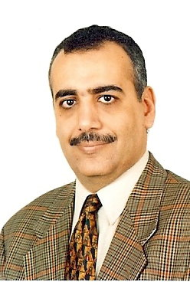

**Khaled T. Wassif** received his B.Sc. in Accounting with an honorary degree from Faculty of Commerce, Cairo University in 1983. He received his Post G. Diploma in Computer and Information Sciences from Institute of Statistical Studies & Research, Cairo University in 1986. He received his Master and Ph.D. degrees from Cairo University in the field of Artificial Intelligence in 1991 and 1998 respectively.

**Dr. Wassif** is currently a Professor in Faculty of Computers and Artificial Intelligence, Cairo University. His main research topics include Machine learning, Data mining, Web mining, Case-based reasoning, Big data, and Cloud computing. He has supervised or co-supervised twelve students on their Ph.D. dissertations and M.S. theses. He has published thirty research papers in international journals and conference proceedings. He is a reviewer in the international Egyptian Informatics Journal and the Egyptian Computer Journal.