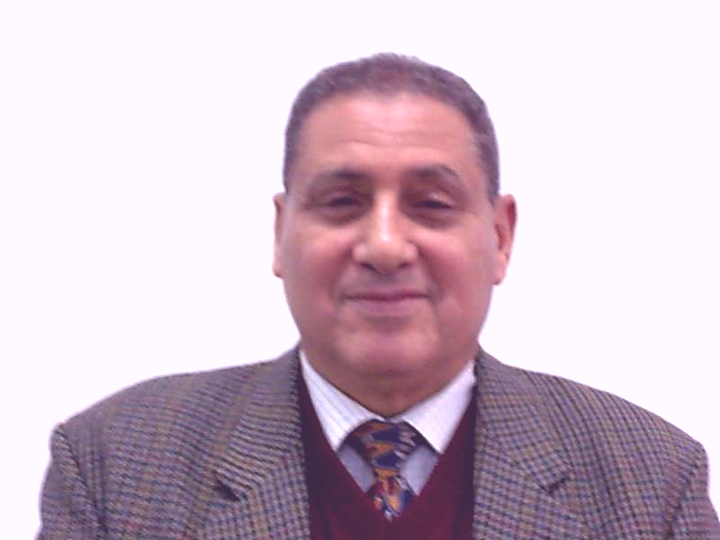**BIOGRAPHY OF Prof. Dr. Mohamed Abd El- Hameed Shalaby**

## 

* **Dr.Shalaby graduated from Cairo University,Faculty of Veyerinary Medicine And attained his Ph.D in virology,1972.**
* **He has obtained a fellowship to study immunology at Val De-Marn University.Paris ,France,1976.-1977.Then obtained Alexander Humboldt Foundation fellowship at the institute of microbiology ,Ludwig Mxmalian Unversity.Munch,Germamy till the end of 1978 working on Parapoxviruses.**
* **He establish and become the directot of the Center of analysis and vet. Applied studies ,cairo university since1989 till 1997**
* **Dr Shalaby seconded to king Faisal university at the Fac. Of Vet. Medicine he is appointed as head Of Dept. of Microbiology (1981-1986).**
* **Obtained Fulbright fellowship for 6 months and work on establishment of techniques for evaluation of cell mediated immunity to some immunostimulants with Prof Ian Tizard, at patho biology Dept.,Texas A&M University (1990-1991)**
* **Head of Department of Virology from 1997-2003 during that period he got 2 project from the Academy of science and technology with about 1.5 Million LE and act as Pi of Monoclonal Antibodies and The Genetic Engineered - Proteins in the diagnosis and production of diagnostic Kits to Infectious Bronchitis and Reo Virus infection in Chickens , the second project was on: “Production of a combined engineered bovine rotavirus/corona virus subunit vaccine (2002-2006).**
* **Principal Investigator of the bilateral project between faculty of Veterinary Medicine, Cairo University and Institute of Virology, Gottingen University Germany entitled:**

**"Application of mobile recombinase polymerase amplification (RPA) for the rapid diagnosis of relevant viruses in veterinary medicine" with the cooperation with Prof. Frank Huferet ,Director of Virology institute ,UMG,Goettingen,Germany.The project is financed by Alexander Von Humboldt foundation ,Germany with A total Sum of 65,ooo Euros. (2012-2014)**

* **Dr Shalaby supervised 120 MSC and Ph.D thesis in Diagnostic and Molecular Virology, Viral immunology, development of many local produced vaccines. He also published more than 100 papers in various aspects of virology and immunology published in local and int. journals**
* **Dr Shalaby is a member of many scientific societies and he is now the president of the Egyptian Society of Virology**
* **- Member in the National Committee for Promotion Of Univ. Staff – of Microbiology.(Supreme council of universities)**
* **Member of the Committee for the Promotion of Scientific Staff at the Institute for Animal health Institute ,Agriculture Research Center, Ministry of Agriculture. Egypt.**
* **- Member of The National Committee of biological Science, 2014 Academy of Science and Technology/Egypt.**
* **Dr Shalaby awarded the National Encouragement Award in Agricultural Sciences from the National Academy of Sciences and Technology(2002)**
* **He awarded The Merit Prize of Cairo University in Basic Sciences (2006).**

**Awarded an extension to Alexander von Humboldt foundation at the Dept. of Microbiology ,Goettingen University( August6-October,30,2018) The plan Foccus on:** Serotyping of foot-and-mouth disease virus using oxford nanopore

sequencing

* **Organize with Prof. Dr.Czerny and Dr Ahmed Abd elwahed the int. Summer School on imported and neglected infectious diseases Between Cairo University And Goettingen University (Sept.16-27, 2018 ,Cairo Egypt)**
* **Supervised the 7th Int.Virology Conference Organized by the Egyptian society of Virology,Hurghada ,Egypt (November,27 –December 1St,2018)**