Sheet Two
Processes Synchronization and Deadlock
- What is the race condition problem?
- What are the sections of a process?
- What are the conditions that a solution to the critical-section problem must satisfy?
- If a process has the form:
do {
flag[i] = TRUE;
turn = j;
while (flag[j] && turn == j);
critical section
flag[i] = FALSE;
remainder section
} while (TRUE);
How the critical-section problem will be solved.
- If a process has the form:
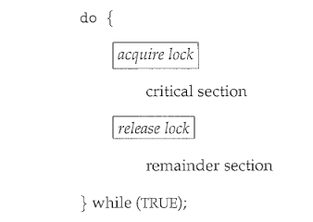
How the critical-section problem will be solved.
- If a process has the form
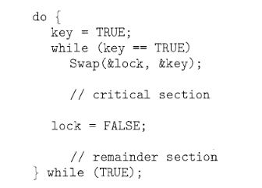
How the critical-section problem will be solved.
- Considering a system with five processes p0…p4 and three resources types A,B and C. A has 10 instances, B has 5 instances and C has 7 instances. Suppose at t0 following snapshot of the system has been taken:
process | Allocation | Max | Available
process | A B C | A B C | A B C
P0 | 0 1 0 | 7 5 3 | 3 3 2
P1 | 2 0 0 | 3 2 2
P2 | 3 0 2 | 9 0 2
P3 | 2 1 1 | 2 2 2
P4 | 0 0 2 | 4 3 3

i-what will be the content of need matrix?
ii-Is the system in a safe state? If yes, then what is the safe sequence?

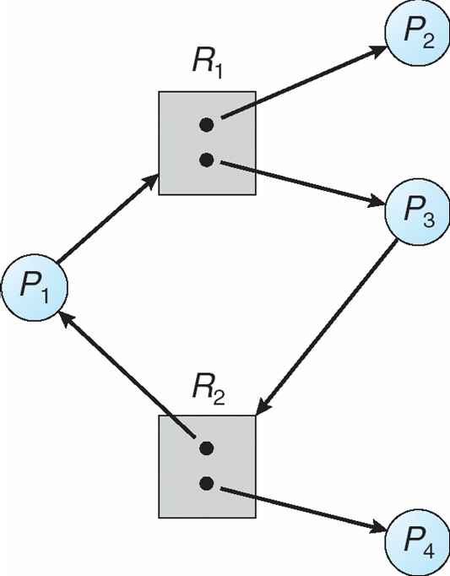
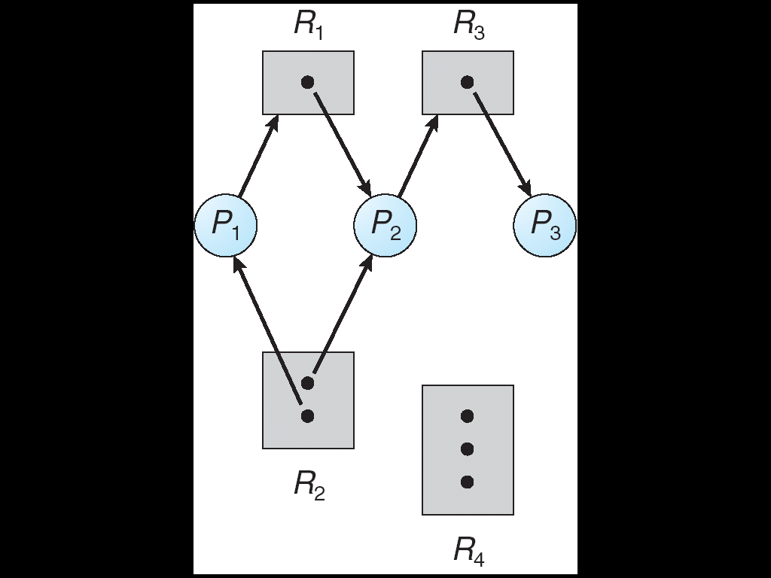
Which is the graph that has a deadlock? And why?

With my best wishes
Dr. Abd El-Aziz Ahmed

