Cairo University
Department of Computer and Information Sciences
Dr. Abd El-Aziz Ahmed
Java Programming
Spring term 2015
Practice Lab 3 (Arrays)
One dimensional array

- Write a java program that accepts an array of 20 elements then apply the following operations :
- Reverse the order of the array and display it.
- Display the sum and the average of the array.
- Allow user to input a number and search for this number in the array.

- Write a java program to read 20 values from the user, ask the user about a number N, and display how many numbers of N in this array.

- Write a java program that accepts an array of ten elements and an integer value then find scalar multiplication.

- Write a java program to find the intersection between array of 10 elements and array o3 elements. For example: if A[10] = { 1,2,3,4,5,6,7,8,9,10 }and B [3] = {2, 5, 11}, result is 2, 5.

- Write a java program to find the union between array of 10 elements and array o3 elements. For example: if A[10] = { 1,2,3,4,5,6,7,8,9,10 }and B [3] = {2, 5, 11}, result is 1,2,3,4,5,6,7,8,9,10, 11.

- Write a java program to find the complement of an array of 3 elements from an array of 10 elements. For example: if A[10] = { 1,2,3,4,5,6,7,8,9,10 }and B [3] = {2, 5, 11}, result is 1,3,4,6,7,8,9,10.

- Write a java program to ask the user to input 5 numbers in an array, ask the user for a number A, and calculate how many numbers in the array = absolute value of A.

Two dimensional array

- Write a java program to read 2-D array from the user of size 3x3, replace all odd numbers by 0, display the positions of odd numbers and the odd number, and display the array after replacement. For example
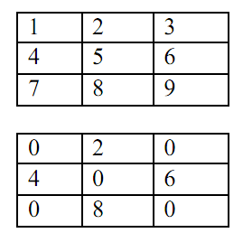
- Write a java program that ask user to enter values of two matrices 2x3 and display the summation and subtraction them.

- Write a java program that accepts two matrices first 2x3 and the second 3x4 and calculate the multiplication of the two matrices then display result.

- Write a java program to read a matrix (3x3) and ask the user to chose a number and then display the position of the select number if found, otherwise display “number not found”

- Write a java program to read a matrix (4x4) form the user, ask the user about a specific column, and swap this column with its next.

- Write a java program to check if a set of numbers can form the magic square or not. The magic square is a matrix of natural numbers in which the sums of all the rows, columns, and the two major diagonals are equal. Assume the size of the matrix is 4x4. Write a function to get the natural numbers from the user and write a function to check these numbers can form the magic square or not.

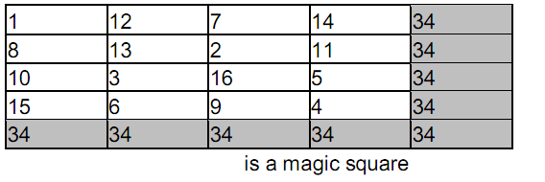

- Write a java program to check if a matrix is a mirror or not (a matrix is mirror if the sum of the first half of the matrix is equal to the total of the second half of matrix).

