Institute of Statistical Studies and Research
Cairo University

Department of Computer and Information Sciences  Course Title: Selected Topics in Computer Science  Course Code: CS 638 | Examination Date: 08/01/2015  Examination time: 3 hours  Total Marks: 70 marks

The Examination consists of fifteen Questions in three Pages

Answer all the following questions
PART A- (10 x 2 = 20 marks)
- What is the difference between security and integrity?
- When are the two parts of recovery algorithms and basic steps in query processing?
- What is the difference between static and dynamic hashing?
- Define the deadlock, schedule, starvation, and lock.
- What are the cascadeless schedules?
- What is the difference between exclusive and shared modes?
- What are advantages of B⁺-tree index files?
- What is the difference between Conflict and view serializability?
- What are the ACID properties?
- What are the DBA’s responsibilities?

PART B - (5x10 = 50 marks)
- (a) Explain two techniques for executing the selection operation.
Or
(b) Suppose that the DBA creates four accounts A1, A2, A3, A4, write SQL for the
following cases:
1- DBA wants only A1 to be able to create base relations.
2- A1 wants to grant A2 the privilege to insert and delete tuples in the relations created
by him, but A1 does not want A2 to be able to propagate these privileges.
3- Suppose that A1 wants to allow A3 to retrieve information from the created relations
and also to be able to propagate the SELECT privilege to other accounts.
- (a) Construct a B+ -tree for the following set of key values:
(2, 3, 5, 7, 11, 17, 19, 23, 29, 31)

Assume that the tree is initially empty and values are added in ascending order, where
the number of pointers that will fit in one node is 4:
Or
(b) Suppose that we are using extendable hashing on a file that contains records with the
following search-key values: 2, 3, 5, 7, 11, 17, 19, 23, 29, and 31. Show the extendable
hash structure for this file if the hash function is h(x) = x mod8 and bucket scan hold
tree records.

- (a) Convert the following serial schedule to a conﬂict serializable schedule: (4 marks)

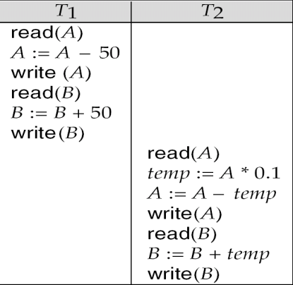

(b) Consider the precedence graph of the following figure. Is the corresponding schedule
conﬂict serializable? Explain your answer. (4 marks)
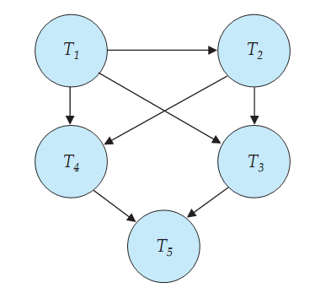
(c) Is the following schedule is serializable? And why? (2 marks)
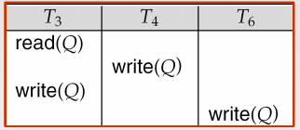

- (a) Explain the two phase locking protocol and explain its enhanced versions. (5 marks)
(b) Explain the timestamp-based protocol. (5 marks)
Or
(c) Explain the deadlock prevention strategies. (5 marks)

(d) Why is the tree protocol deadlock free? Explain your answer. (5 marks)

- (a) Explain the deferred database modification and immediate database modification.
Or
(b) Explain the checkpoint technique for concurrency transactions.

With my best wishes
Dr. Abd El-Aziz Ahmed

