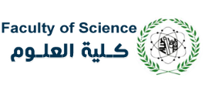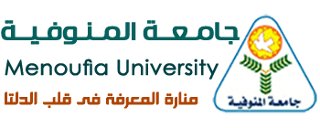
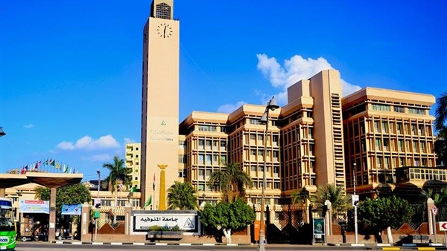
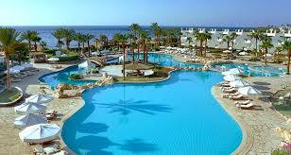
Sharm El-Sheikh

The First International Conference on Materials Science & Applications (ICMSA 2019)
Sharm El-Sheikh, Egypt, 10-12 September 2019

ORGANIZED UNDER THE PATRONAGE OF:

PROFESSOR DR. Adel E. Mubark

President of Menoufia University, Sheben El-Koom, Egypt.

PROFESSOR DR. Ahmed F. AlKased

Vice-President of Menoufia University for Post Graduate Studies and Research Sector, Egypt

PROFESSOR DR. MOHMED TAWFIEK SHAABAN

Dean of Faculty of Science, Menoufia University, Egypt

Prof. Dr. Amin Eladawy
Vice-Dean of Faculty of Science for post graduate studies and research sector

CONFERENCE CHAIRMAN
Prof. Dr. Magdy Said Abo Ghazala
Head of the Physics Department, Faculty of Science, Menoufia University, Egypt
Mobile: (002) 01028553445
Email: magdyaboghazala@gmail.com

IMPORTANT DATES
Abstract submission deadline 1 June 2019
Notification of abstract acceptance 1 July 2019
Full Paper submission dead line 1Agust 2019
Opening of the registration 10 September 2019

CONFERENCE VENUE
Physics Department, Faculty of science, Menoufia University will organize the 1st International Conference on Material Science and Applications (ICMSA 2019) that will be held on September 10 -12, 2019 in 4 stars hotel, Sharm El-Shaeikh. Sharm El- Sheikh is an Egyptian city on the southern tip of the Sinai Peninsula, in South Sinai Governorate, on the coastal strip along the Red Sea. Sharm El- Sheikh is the administrative hub of Egypt's South Sinai Governorate, which includes the smaller coastal towns of Dahab and Nuweiba as well as the mountainous interior, St. Catherine and Mount Sinai. The city and holiday resort is a significant center for tourism in Egypt, while also attracting many international conferences and diplomatic meetings.
Objective: The ICMSA (2019) conference aims to promote research in material science. It is an opportunity to exchange experiences and present research results in the fields of theoretical, experimental, and applied physics and engineering. It will give the opportunity for the international material science community to meet in Egypt for scientific and technological exchanges. Also, it will be a link between institutions of higher education and industries to share their creative ideas and products that can be commercialized.
Topics:
Semiconductor materials
Glasses and Ceramics
Magnetic Materials
Metals and Alloys
Nanoscience and Nanotechnology
Optical and Dielectric Materials
Polymers and Composites
Superconductors
Thin Films
Biomedical materials
Laser and Optoelectronics
Radiation Shielding, Energy Conversion Technology Solar Energy, Luminescence
Theory, Simulation, Modeling and Other Related Areas.
Earth Materials

Conference Chairs:
Conference Chair: Prof. Magdy Abo Ghazala
Conference Vice-Chair: Prof. Raouf El Malowany
Organizing Committee Chair: Prof. Ibrahim Hagar
Organizing Committee Co-Chair: Prof. Lobna Sharf Eldeen
Scientific Committee Chair: Prof. Mohamed El Zaidia
Scientific Committee Co-Chair: Prof. Mawad El Kholly
Conference Secretary General: Dr. Yaser Ramah
Technical Program Chair: Dr. Hosam Awad

CONFERENCE REGISTRATION
CONFERENCE REGISTRATION SHOULD BE MADE ON LINE USING THE CONFERENCE REGISTRATION FORM.
CONFERENCE LANGUAGE: English is the official Conference Language.
VISA APPLICATION
All visas should be obtained from the Egyptian Consulates at the home country of the participant. One should submit the application in a reasonable time.
Registration Fees

Fees will be paid after the final acceptance of the submitted papers. The registration fees cover a full board accommodation in a 4 star hotel and a copy of the proceedings; attending sessions, and coffee breaks according to the following rates:

Registration | Egyptian | Foreign | Egyptian student | Egyptian  listener
Early bird  (before June 30, 2019) | 3000 EGP* | $350 | 2500 EGP | 2300 EGP
Onsite | 3500 EGP | $380 | 2800 EGP | 2500 EGP

You can pay your registration fees either via bank transfer or on site
- For international registration fees transfer, you can use the following bank details and send us a scanned copy of the transfer slip to the following email: registration.icmsa@men.edu.eg
Bank Name: NATIONAL BANK OF EGYPT
Branch Name: Shebin EL Kom
Address:Gamal Abdel Nasser Str., inside Menoufia University
ACCOUNT NAME: Teaching Services
Account Number:4/082/17754/6
Swift Code: NBEGEGCX412 NBEGEGCX 412

- For local registration fees transfer through any post office, you can use the following details and send us a scanned copy of the transfer slip to the following email: registration.icmsa@men.edu.eg
Account Name: post account MAMN
Account Number: 0707612000238818

For More Information, Enquiries, and Registration Please Contact:
Prof. R. El-Mallawany, Conference Vice- chair
r.el-mallawany@science.menofia.edu.eg
Prof. Dr. Magdy Abo Ghazala, Chairman of the conference. magdyaboghazala@gmail.com
More details will be given in the second call.

