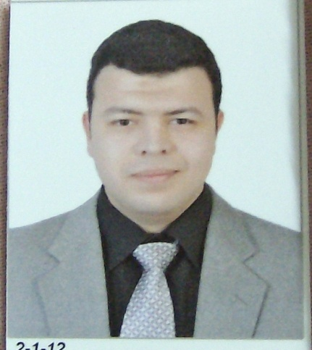
Mohammed Omar Mohammed
Osman

Address: 20 Youssif Edrees st., El-Mohandeseen,
Giza, EGYPT
Tel /Mobile: 002/ 33022948 01005018417
E-Mail: m.omarosman@yahoo.com

PROFILE / OBJECTIVE:
Nuclear Medicine resident in EL KASR ALAINY Cairo University (since 2012), seeking a challenging position in the Nuclear Medicine field in which my knowledge & skills are applied.
PERSONAL STATEMENT
- ID number: 28608100105016
- Date of birth: 10/8/1986
- Nationality: Egyptian
- Marital Status: Single
- Religion: Muslim
LANGUAGES:
- Arabic: Mother Tongue
- English: Fluent
- French: fair

EDUCATION / WORK
- Start nuclear medicine residency in Cairo University-EL KASR ALAINY since 1/12/2012
- Worked in El-Dokki health office from 1/5/2011 to 30/11/2012
- Appointed as house officer in EL KASR ALAINY hospitals from 1/3/2011 to 29/2/2012
- Obtained degree of MBBS with EXCELENT grade and degree of honor (2010)
- University: Cairo University-EL KASR ALAINY (2004-2010)
- High school: Gamal Abd El-Nasser Language School (2004).

ACHIEVEMENTS/ Skills

- Passed the first examination for fellowship of Royal College of Radiologists in clinical radiology (FRCR part 1) in June 2015
- Participate in the Fifthteen Nuclear Medicine Egyptian meeting 4-7 March 2015.
- Complete the Advanced life support course provided by Resuscitation Council (UK) in March 2014
- Finishing the military force service in the nuclear medicine department in El Galaa military hospital from 1/3/2013 to 28/2/2014
- Passed all modules required for the granting of the International Computer Driving License (ICDL) in 8/2/2012
- Completed the Radiosonography course in KASR ALAINY from Dec 19th 2011 to Feb 6th 2012
- Completed the European Resuscitation Council immediate life support provider course on 23rd May 2011
- Accomplished Basic Emergency & Surgical Skills on 5th May 2011
- Attended the concepts and application of communications skills, patient safety, infection control, medico-legal aspects of health care and Ethics in medical practice

