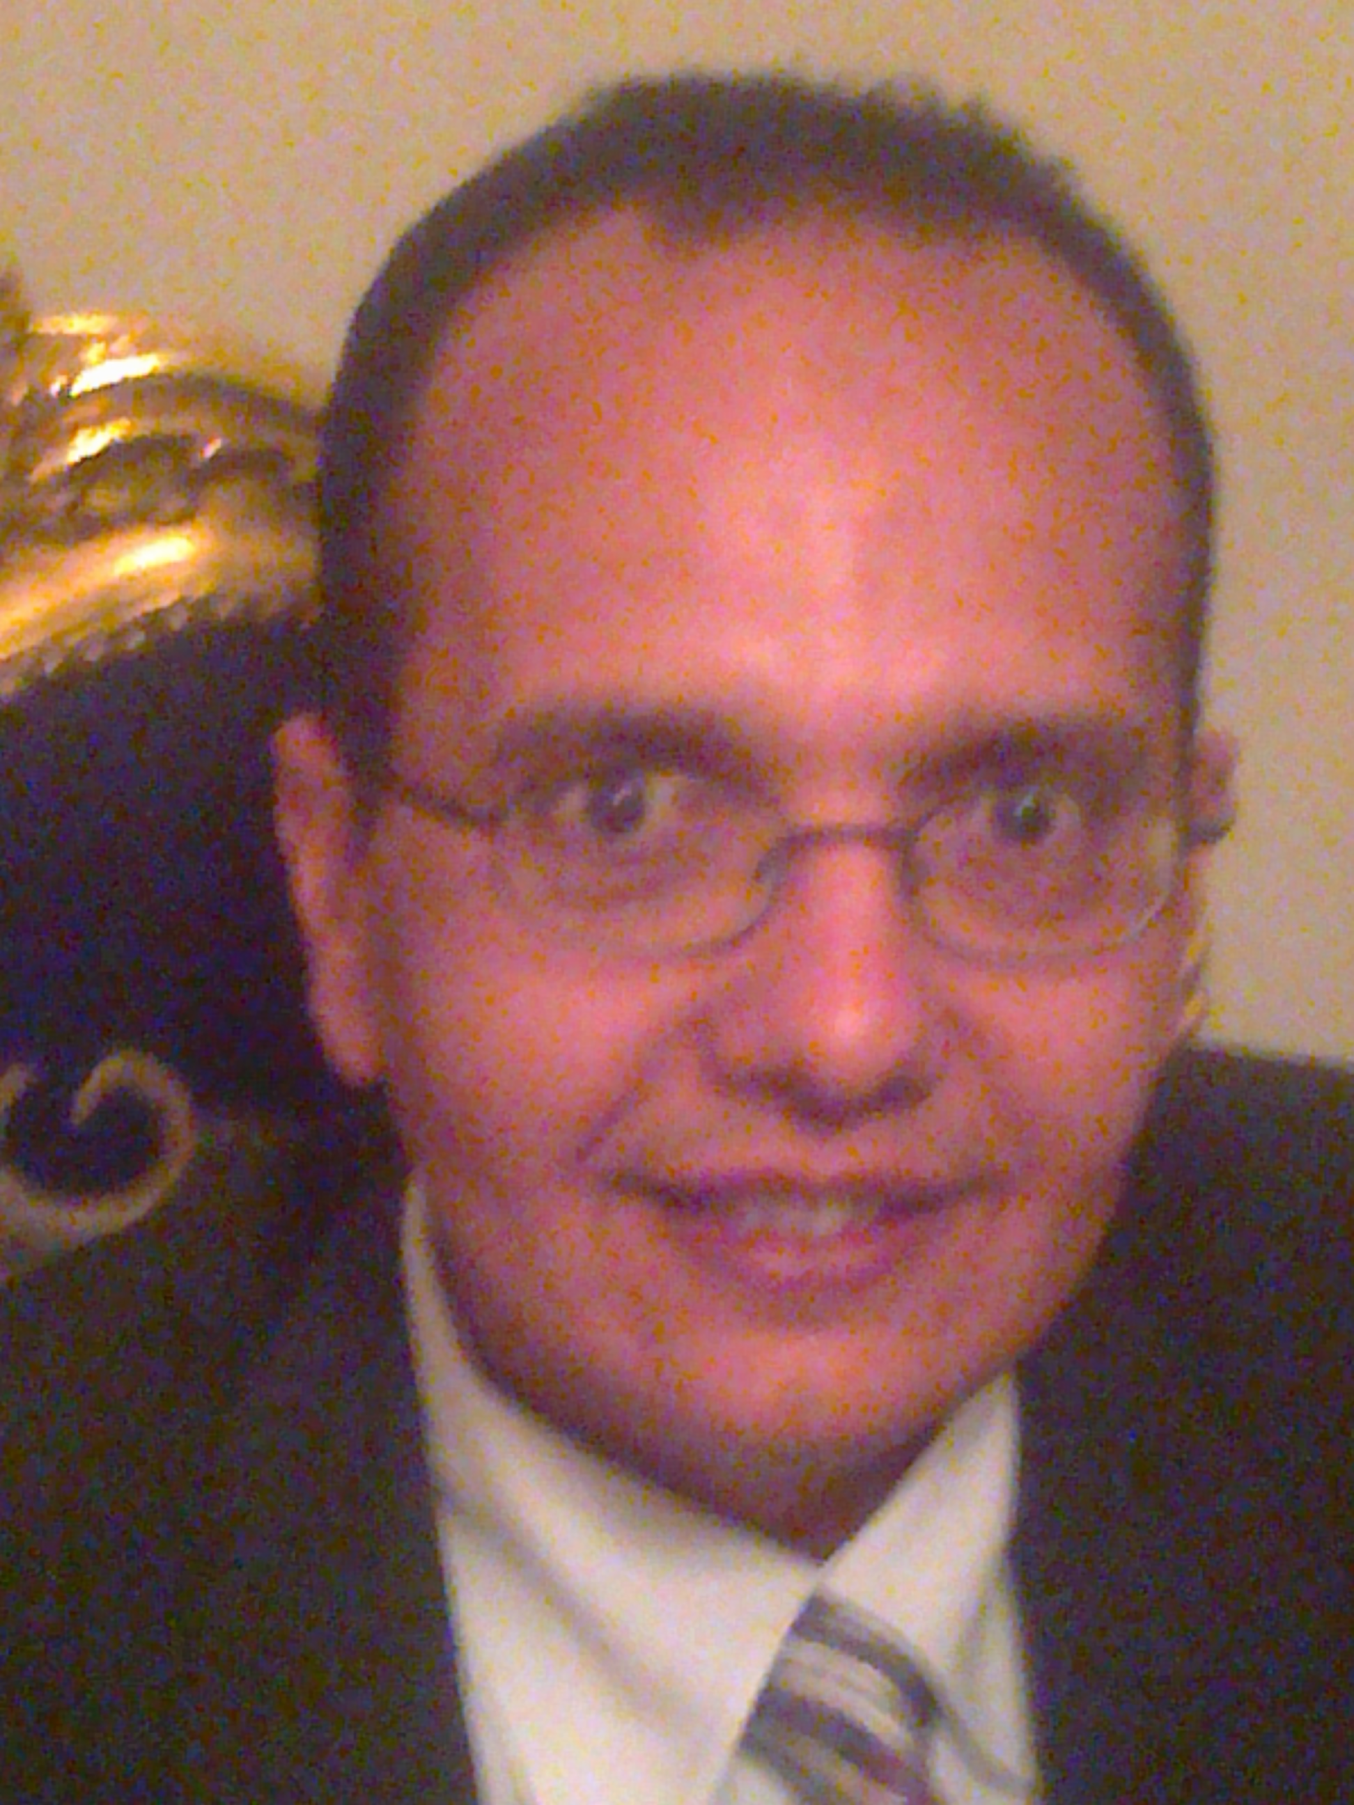

Curriculum Vitae

PERSONAL

Name: Nagy EL.Sayed EL.Mashad
Date of birth: Julie 1, 1968
Address: 6 EL.Batal Ahmad Abdelaziz ST,
Tala, AL.Monfeya,
Egypt.
Home Phone: +20483794530
Cell Phone: +20192309418
E-mail: nagy_elmashad@yahoo.com

EDUCATION

Ph.D in vet. Med. Science, University of Veterinary Medicine Vienna, Austria 2003 – 2009.
Thesis Title: The use of anionic salts in diets withe high potassium for the prevention of parturient paresis in dairy cows.
M. V. Sc Master in Internal medicine, Faculty of Veterinary Medicine, Cairo University 1996.
Thesis Title: Some studies on canine and feline skin affections

B. V. Sc Bachelor in Vet. Med. With grade very good, Faculty of Veterinary Medicine, Cairo University 1990.

EMPLOYMENT
1991 – 2003
Demonstrator and Lecturer Assistant, Dept. Of Medicine and Infectious diseases, Faculty of Veterinary Medicine, Cairo University.
I work as a part of the team of animals research hospital, Faculty of Veterinary Medicine, Cairo University in the same period. My work involved equine, cattle, sheep, goat, dogs and cat .
2004 – 2010
I work in a project for prevention of milk fever in Klinisches Department für Nutztiere und Bestandsbetreuung. Klinik für Wiederkäuer. Der Veterinärmedizinischen Universität Wien. Univ. Prof. Dr. Baumgartner Walter; Dr. Gelfert C.C., also i work for 2 semester in pets hospital, Medizine zwei, Prof. Dr. Tallhamer.
2011-2016
Scientific and applied activity

Teaching work
1. Participation in teaching of Internal Medicine for the students of fourth-year students and the fifth band.
2. Participation in teaching of Internal Medicine for postgraduate students.
3. Participation in and put a note material of Internal Medicine for students of the fourth and fifth band.
4. Participate in the preparation of teaching aids for Internal Medicine material assistance.
Acts of exams
1. participate in the work process and theory exams and oral for students of the fourth and fifth band.
2. participate in the work CONTROL.
Scientific supervision
1. contribute to the scientific supervision of the scientific messages for a master's and PhD degrees.
2. help graduate students from both inside and outside the department in the operation parts of their messages for master's degrees and doctorates.

Participation in the labor Veterinary Teaching Hospital
To participate in the diagnosis and treatment of the animals that come to the Veterinary Teaching Hospital, Faculty of Veterinary Medicine - Cairo University diseases.
Second, outside the university
Community service and development environment
Participation in convoys therapeutic veterinary center in the villages and Giza governorate in the period from 2012 to 2016
Associations and scientific projects:
• Member of the Egyptian Society for Animal Welfare.
• Member of the Egyptian veterinarians union.
• Member of the Egyptian Society of life on planet Earth

Training courses and workshops

• * Workshop on "systems and programs for the care of horses" - the Arab Center for Training in the period from 29-30 / 4/2016
• * Workshop on "use of educational alternatives in veterinary medicine" - Cairo University from 9-10 / 3/2013
• * seminar How To Pass personal interviews and CV writing - Egyptian Society for the Life Sciences on May 2012 m -3 planet Earth
• * symposium foot and mouth disease in humans the Egyptian Society of animal Life Sciences hate Alordah- April 12, 2012 AD
• * "Internet and communication skills in the service of scientific research," Agricultural Research Center for Agricultural Library-Egyptian Ministry of Agriculture on February 23, 2003.
• * course on "clinical diagnosis of veterinary clinics work" for his brother veterinarians Saudis - PSI vet in the period from 03.08.2014 for a period of four weeks.
• * role for "Sheep and goats disease" analyzes and studies Center for Applied vet - Faculty of Veterinary Medicine - Cairo University from 5-6 / 2/2014.
• * course on "diagnosis and treatment of animal diseases household" Analysis Center of Applied Studies Vet - College of Veterinary Medicine - Cairo University from 10-14 / 2/2012.
• * training course on diagnosis and treatment of animal diseases, domestic: Clinical examination of the skin and non-communicable diseases in the skin, "the Department of Internal Medicine and Infectious - College of Veterinary Medicine - Cairo University from 30-4 / 12/2005 g
• * "training course veterinarians in the field of internal medicine and infectious diseases to domestic animals: respiratory device in domestic animals." . "At the Department of Gastroenterology at the Faculty of Veterinary Medicine. Cairo University on 14/7/2005.
• * teaching Decisions of Internal Medicine in the years 2012-2016 for Arab students (Qatari - Omani)
The capacity of faculty members and Leadership Development Center - Cairo University courses:
"Crisis management" in the period from 28/6/2006 to 30/6/2006.
"Teaching for the large and small" in the period from 4/9/2006 to 6/9/2006
"Effective teaching." In the period from 4/12/2006 to 7/12/2006.
"Effective communication skills" in the period from 11/12/2006 to 12/13/2006.
"The use of technology in teaching" in the period from 10/3/2008 to 12/3/2008.
"Behaviors Occupation" in the period from 3/3/2008 to 5/3/2008
"Time management and meetings" in the period from 23/11/2009 to 25/11/2009
"The ethics of scientific research" in the period from 18-20 / 10/2010
"Scientific Publications" in the period from 18-20 / 1/2011
"Almutmrat scientific organization" in the period from 23-25 ​​/ 5/2011
"Competitiveness research projects" in the period from 19-21 / 9/2011
"Recent trends in teaching" in the period of 2-4 / 1/2012
"Titrated Jawdhvi process of teaching" in the period of 4-6 / 12/2012
"The financial and legal aspects of the Undergraduate Business" in the period of 2-3 / 12/2013
"Creative thinking" in the period from 12-13 / 11/2014
"" Ntm Alamtkhanat and evaluate students "in the period from 13-14 / 1/2016
Credit Hours systems "in the period from 25-26 / 5/2016

Scientific conferences

Sixth Congress of the Egyptian Society for Animal Welfare in the period between August 27 to 31, 2013 at the Faculty of Veterinary Medicine, Cairo University and completed the conference in Hurghada for four days (three nights) under the auspices of Dr. Ahmed Algizawy Minister of Agriculture, Prof. Dr. Fathi Farouk Dean of the Faculty of Veterinary Medicine at Cairo University

Seventh Scientific Conference of the Egyptian Society for Animal Welfare in 2016 the Egyptian Society for Animal Welfare, Faculty of Veterinary Medicine, Cairo University organizes the seventh scientific conference of risk reduction in livestock production poultry and fish under the auspices of Dr. / Salah al-Helal, Minister of agriculture and land reclamation, and Dr. / Ghada wali the Minister of Alajtmai24-27 August Solidarity 2016 Sharm el-Sheikh conference chairman Prof. / spring Hassan Fayed

The second regional forum for the development of livestock in the period from 21-22 / 11/2012

Seminar on "The use of educational alternatives in veterinary medicine" - Cairo University from 9-10 / 3/2013
Seminar How To Pass personal interviews and CV writing - Egyptian Society for the Life Sciences on May 2012 m -3 planet Earth

What symposium foot and mouth disease in humans and of Animal Collective

Skills

Computing Skills: Microsoft Office Suite, Animal hospital control system.

Teaching Skills: Supervise practical's for undergraduate students and have supervised the undergraduate research projects of 2 final year students.

Time Management and Teamwork: were important to complete my Ph.D and this I did successfully. I have also good knowledge of research methodologies, Bio Statistic, Data and information collection, Writing and presenting reports and I have a reasonable understanding of written germane

References:
References available upon request

Nagy El.Mashad

