Conservative Management of Extradural Hematoma: Experience with 70 Cases
Mohamed Mamdouh Salama M.D., Ehab Mohamed Eissa M.D.
Department of Neurosurgery, Faculty of Medicine, Cairo University
Abstract
Objective: to evaluate safety and efficiency of conservative treatment of extradural hematoma (EDH) in selected patients. We aimed at detecting time interval during which most of these lesions tend to enlarge, as well as percentage of patients requiring surgical evacuation.
Methods: Patients with Glasgow coma scale (GCS) > 8, without focal neurological deficits, with EDH < 30 cc in volume and < 15 mm in thickness, with midline shift (MLS) < 5mm on their initial computed tomography (CT) were managed conservatively. Close monitoring of conscious level as well as regular follow up CTs were performed in all patients. Time interval between onset of trauma and time of initial CT, as well as intervals between subsequent CTs were documented. Hospital stay for at least 6 days after trauma was mandatory.
Results: None of our seventy patients showed clinical deterioration in the follow up period. Seven patients had increase in size (more than 30cc volume and/or 15 mm thickness) in their follow up CTs thus requiring surgical evacuation in all but one patient who refused surgery. The increase in size was detected in the first follow up CT in six patients, and in a later CT in one patient.
Conclusion: Conservative management of EDH can be adopted safely in patients fulfilling the inclusion criteria, with close monitoring of conscious level and regular follow up CTs. A group of these patients will need surgical evacuation mostly in the first 24 hours following trauma, however delayed asymptomatic increase in volume may uncommonly occur.
Key words: conservative - non-operative – epidural hematoma - extradural hematoma - traumatic brain injury
Abbreviations: CT: computerized tomography - EDH: extradural hematoma - GCS: Glasgow coma scale – MLS: midline shift

Introduction:
The possibility of managing patients with extradural hematoma (EDH) safely without surgery has been documented in several reports.¹⁻¹¹ There was no agreement on the hematoma volume or thickness above which surgery is indicated. Hematoma volume which has been considered safe for conservative management has ranged from 10 ml to 55 ml in various reports.^{5,6,8,10} Patients who were treated either surgically or non-operatively were compared in some studies, and statistics were used to determine factors associated with each treatment.^{11,12} Some investigators reviewed patient series that were initially all treated conservatively and analyzed the factors associated with subsequent delayed surgery.^{5,7,12,13}
Regarding the guidelines for the surgical management of traumatic brain injury, Bullock and his co-workers ¹⁴ recommended that patients who were not comatose, without focal neurological deficits, and with an acute EDH with a thickness of less than 15 mm, volume less than 30 cc and MLS less than 5 mm, may be managed non-operatively with serial CT scanning and close neurological evaluation in a neurosurgical center.
Clinical patients and methods:
During two years period, a selected group of patients with EDH were initially managed conservatively in the neurotrauma unit at Cairo University Hospitals. Neurological examination of all patients was performed and initial CT scans of these patients were accurately viewed. The selection of patients to be managed non-operatively followed the guidelines for the surgical management of traumatic brain injury.¹⁴
Inclusion criteria (all criteria must be fulfilled in every patient):
- Patients with GCS > 8 ¹⁵ having no focal neurological deficits
- EDH thickness < 15 mm
- MLS (measured at level of septum pellucidum) < 5 mm
- EDH volume < 30 cc
(The volume of the EDH was calculated using the Petersen and Espersen equation:¹⁶ 0.5 x height x length x depth)
Patients with GCS less than 9, patients with focal neurological deficits, as well as patients with hematoma volume equal to or exceeding 30 cc and/or thickness equal to or exceeding 15 mm or MLS equal to or exceeding 5 mm were not included in this study as they were operated upon immediately.

Other associated intracranial lesions as well as presence or absence of overlying fissure fracture were documented. Patients with associated significant intracranial lesions were excluded from the study. Association of fracture base, depressed fractures not requiring surgery, or small contusions less than 2 cm in diameter were not considered as exclusion criteria.
The interval between the time of trauma and the initial CT was documented. Conscious level was closely observed and CT was planned in case of deterioration and as routine follow up. First follow up CT was scheduled within 12 hours from the initial CT for all patients having their initial CT performed within 6 hours of trauma, and within 24 hours from initial CT for patients having their initial CT later than 6 hours from trauma. Second follow up CT was scheduled one day after the first follow up CT, and then subsequent follow up CTs were ordered every other day in the first six days after trauma.
Criteria for hospital discharge included fully conscious patients, with hematoma thickness and volume less than 15 mm and 30 cc respectively, after duration of at least 6 days since the time of trauma. On discharge, all patients and their caregivers were instructed to come back immediately if they experience repeated vomiting, persistent headache or any conscious level deterioration.
Results:
Our study included 53 males and 17 females with age ranging between 5 months and 57 years (mean age 24 years). Mode of trauma included road traffic accidents in 37 patients, fall from height in 24 patients, and assault by heavy object in 9 patients. The majority of patients were GCS 14 and 15 on admission, with the exception of three patients with GCS 13, 11, and 9. All the patients had no focal neurological deficits on examination.
The time interval between the onset of trauma and the time of the initial CT was variable and ranged between 45 minutes and 2 days, with most of the patients having their initial CT performed within 6 hours following trauma. Table 1 shows the time interval between the onset of trauma and the initial CT.
Time interval between onset of trauma & initial CT | Number of patients
Less than 6 hours | 54
6-24 hours | 11
More than 24 hours | 5

Table 1: time interval between onset of trauma and initial CT
Hematoma thickness on the initial CT ranged between 3 mm and 14 mm with mean thickness of 9 mm. Hematoma volume ranged between 1.5 cc and 25.7 cc with mean volume of 11.7 cc on the initial CT. Midline shift ranged between 0 mm and 3 mm, with 57 patients having no midline shift.
The sites of hematomas are shown in table 2. An overlying fissure fracture was detected on bone window CT in 38 patients. Associated lesions were present in 18 patients, and included cerebral contusions less than 2cm in diameter in 7 patients, depressed fractures not requiring surgical intervention in 2 patients, and fracture base in 13 patients.
Site of hematoma | Number of patients
Frontal | 24
Parietal | 13
Temporal | 6
Occipital | 4
Tempro-parietal | 21
Bifrontal | 2

Table 2: sites of hematoma
Comparing the initial CT & the first follow up CT revealed that hematoma thickness increased in 27 patients, with thickness exceeding 15 mm in 2 patients, remained stationary in 26 patients, and decreased in 17 patients. Hematoma volume increased in 33 patients, exceeding 30 cc in 5 patients, remained stationary in 14 patients, and decreased in 23 patients. The subsequent CT scans showed hematoma enlargement reaching more than 30 cc in volume in only one patient on the CT performed 4 days after trauma.
Only seven of our patients showed significant increase in hematoma volume and/or thickness above 30 cc and 15 mm respectively. Six of these showed hematoma enlargement within the first 24 hours following the initial CT (five patients within the first 12 hours), with only one patient showing delayed enlargement 4 days after initial CT. None of these patients showed clinical deterioration.
Five of these patients were operated upon after the first follow up CT, within 24 hours from the onset of trauma. The patient with delayed enlargement was operated upon on the fourth day. The last patient refused surgery and he was closely monitored clinically and with serial CTs till he was discharged from hospital six days later with no further increase in hematoma size.
The number of CT scans performed for each patient ranged between 4 and 7 (except for operated patients), with most patients having 5 CT scans. Hospital stay ranged between 6 days and 13 days, with most patients discharged after 6 days. We had no mortality and all patients had good recovery according to Glasgow outcome scale.
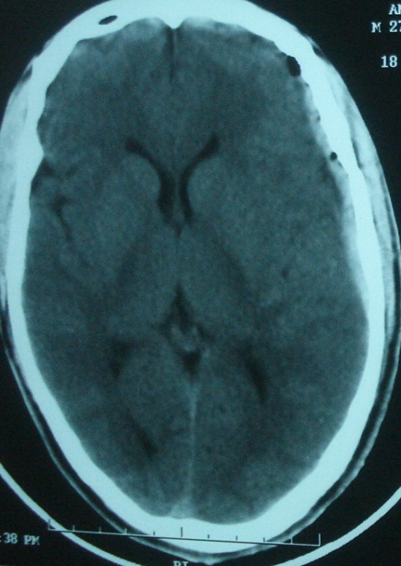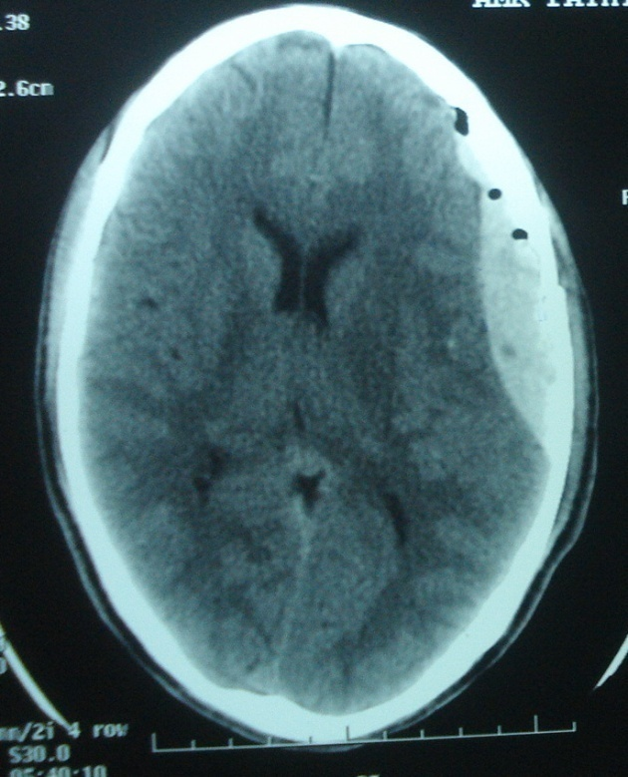
Figure 1: showing hematoma enlargement in the first follow up CT performed 8 hours after initial CT in one of our operated patients
Discussion:
Rapid diagnosis and surgery for EDH in a deteriorating head injury patient is one of the most urgent emergencies in medicine, with mortality and morbidity in EDH patients being used to judge neurosurgical services.¹⁷⁻²⁰ On the other hand, many authors have managed small asymptomatic or minimally symptomatic EDH non-operatively.^{5,6,8,21-27}
In spite of many articles discussing the conservative non-operative management of EDH, there has been no agreement on the factors determining which patients should be conservatively treated. Most authors focused on factors related to both the patients' clinical condition as well as the CT criteria of the hematoma and mass effect. Both the volume of EDH and the patient's neurological status have been reported to influence outcome following EDH,^{3,4,28-32} whereas other authors have found that the volume of EDH did not influence the outcome.^{2,33} The selection criteria were variable regarding GCS of the included patients, the impact of focal deficits, hematoma volume and thickness, as well as midline shift.^{5,6,8,14,21}
Chen and his co-workers ⁸ included 74 patients with GCS > 12 with no focal neurological deficits related to hematoma. Some of their patients had hematomas with thickness > 15 mm, volume > 30 cc, and MLS > 5 mm, however these patients tended to require surgery.
Bezircioglu and his group⁵ conducted a prospective study on the conservative management of patients with EDH including patients with GCS score greater than 8, with no neurological deficit, with hematoma thickness less than 2 cm, and volume less than 30 ml.
Dubey and his colleagues ²¹ reported that the factors influencing management strategy and outcome were the GCS, volume and location of EDH. They recommended that a patients having EDH should not be considered for non-operative management if volume exceeds 30 ml and GCS is 13 or less.
Bullock and his colleagues ⁶ included 12 patients with GCS 12 or more, with no focal deficits (apart from post-ictal deficits in 2 patients). They included patients with hematoma volume up to 40 cc and midline shift under 15 mm. They considered size threshold for conservative management of EDH to occur around 45 to 50 cc, although this might be affected by other factors such as patient's age and associated intradural lesions. The figure 50 cc was based on their previous series of 35 patients with chronic EDH,³⁴ as well as the work of Pang and his colleagues ²⁶ regarding the nonsurgical management of EDH in the pediatric group.
Our inclusion criteria followed the recent work of Bullock et al.¹⁴ regarding the guidelines for the surgical management of traumatic brain injury, including only patients with GCS > 8 without neurological deficits and hematoma volume and thickness less than 30 cc and 15 mm respectively, and with MLS < 5mm.
Close follow up of the patients' clinical condition particularly the conscious level is mandatory for early detection of any deterioration. Furthermore, one of the major goals during dealing with neurotrauma patients is detection before deterioration, allowing for early treatment of new mass lesions which require surgery. Thus, routine follow up CT was scheduled for all patients even if they show no clinical deterioration or even if their conscious level improves following admission.
We planned the first follow up CT within 12 hours (for patients with initial CT within 6 hours from onset of trauma) or within 24 hours (for patients with initial CT later than 6 hours from onset of trauma) from the initial CT. The subsequent CT scans were done one day later, then every other day. This overcautious plan coincides with various studies recommending early follow up CT, aiming not to miss any patient with enlarging hematoma. Bullock and his colleagues ¹⁴ recommended that the first follow-up CT scan in non-surgical patients should be obtained within 6 to 8 hours following trauma. Servadei and his colleagues ³⁵ strongly recommend that CT scans be repeated within 12 hours in patients with the first examination done within the first 3 hours after trauma, whereas Pozzati and Tognetti ²⁷ performed their first follow up CT 12 hours after the initial one in all of their patients irrespective of the time interval between trauma and initial CT. Chen and his colleagues ⁸ found higher incidence of hematoma enlargement in patients diagnosed within 6 hours than those diagnosed later than 6 hours after trauma. Sullivan and his coworkers ¹² suggested that CT monitoring of conservatively managed EDH patients is most appropriately timed in the first 36 hours after injury, with most cases of enlargement occurring by 8 hours after trauma. The longer intervals between the subsequent CT scans is based on that the longer an EDH is asymptomatic, the greater is the likelihood that it will remain so.³⁶
The number of follow up CTs in our series ranged between 4 and 7, with the majority of the patients having 5 follow up CTs before discharge. Complete resolution of the hematoma on the follow up CTs was not aimed as this may take between 3-15 weeks.^{6,26,27,37-39} In their series, Bullock et al. ⁶ had mean number of 3.5 scans for each patient, with mean period of 7.25 weeks for hematoma resolution, while Pozzati and Tognetti ²⁷ performed 3 to 4 CTs for each of the patients in their series.
Significant increase in the hematoma thickness reaching or exceeding 15 mm, and/or significant increase in hematoma volume reaching or exceeding 30 cc occurred in seven of our patients. This increase was detected on the first follow up CT in six patients, where the CT was done within 12 hours in 5 patients and within 24 hours in one patient. Only in one of our patients did the EDH volume exceed 30 cc on the follow up CT performed 4 days after trauma in a conscious patient complaining of occasional headache. Our results regarding the early enlargement of EDH in most of our patients agrees with the results of Sullivan and his coworkers ¹² who had mean interval of 8.2 hours between trauma and EDH enlargement, and 5.3 hours after initial CT. Enlargement occurred within 12 hours from initial CT in 95% of their patients, and within 24 hours following the initial CT scan in the rest, with no enlargement later than 36 hours from trauma. Chen and his colleagues ⁸ operated on 14 out of their patients within three days of trauma. On the other hand, Knuckey et al.¹³ had average interval of 2.7 days between admission and surgery in seven patients with EDH. Also, Pang and his colleagues ²⁶ operated on two of their patients 6 and 8 days following trauma based on gradual uncal herniation in these patients.
Only 10% of our patients needed surgical evacuation. Sullivan et al.¹² operated upon 16 out of their 160 patients (10%), Bezircioglu and his colleagues ⁵ operated on 5 out of their 80 patients (6%), while Chen and his colleagues ⁸ operated on 14 out of their 74 patients (19%). Pang and his colleagues ²⁶ operated on 2 out of their eleven patients (18%), whereas Balmer and his coworkers ²⁴ operated upon one patient (7%) with their other 13 patients successfully managed conservatively. Other authors had reported successful conservative management of all of their included patients, with none of their patients requiring surgical evacuation.^{6,22,23,27}
Our series included 27 patients with hematomas confined to or extending to the temporal region, with only 3 of these patients showing significant enlargement of their hematomas thus requiring surgery. Thus, the temporal location didn’t count for increased incidence of hematoma enlargement or need for surgery in our series. On the contrary, Bezircioglu et al. ⁵ found the only factor significantly associated with delayed surgical evacuation was the temporal site of hematoma, which was observed in all five surgical patients but only in 24% of the 75 patients managed without surgery. Also, Bullock et al. ¹⁴ stated that temporal location of an EDH is associated with failure of the conservative management and should lower the threshold for surgery. Dubey et al. ²¹ had increased rate of surgery for temporal EDH.
There is no firm consensus in the literature as regards the required length of conservative observation.⁴⁰ Complete hematoma resolution may take between 3-15 weeks.^{6,26,27,37-39} Chen et al.⁸ stated that the minimal hospital stay for their patients was 3 days, with average hospital stay of 6 or 7 days, and stressed that if this policy of hospital discharge is adopted, one should be aware of the possibility of delayed deterioration in such patients ⁴¹ and arrange for close follow-up. On the other hand, Bullock and his colleagues ⁶ allowed discharge only after 2 weeks of hospitalization; their mean hospital stay was 4.5 weeks. Although we kept our patients in the hospital for at least 6 days, we feel that this may not be necessary, and that patients can be discharged after 3 days (provided they have easy access to the hospital), with another follow up CT performed 6 days after trauma as outpatients.
The zero mortality in our patients is similar to the mortality rate reported in many other articles selecting patients with high GCS for conservative treatment.^{6,8,12,23,24,26} This is most likely attributable in great part to close clinical observation and urgent surgical evacuation of significant EDH enlargement.
Conclusion:
Safe management of patients with GCS > 8, without focal neurological deficits, having EDH less than 15 mm in thickness and less than 30 cc in volume, and with midline shift less than 5 mm; can be adopted with close observation of the conscious level and serial follow up CTs. A small group of these patients will show enlargement of their hematoma above 30 cc in volume and/or 15 mm in thickness, thus requiring surgical evacuation. Enlargement occurs within 24 hours from the initial CT in the majority of patients, however delayed enlargement may uncommonly occur in a small subset of these patients. Close clinical observation is the mainstay of this conservative management. We would recommend further study to determine the value of hospital stay longer than 3 days for patients who fail to show hematoma enlargement within the first 72 hours, and assess the need for further CT for these patients.
REFERENCES
- Bricolo AP, Pasut LM. Extradural hematoma: Toward zero mortality. A prospective study. Neurosurgery. 1984;14:8-12.

- Paterniti S, Falcone MF, Fiore P, Levita A, La Camera A. Is the size of an epidural haematoma related to outcome? Acta Neurochir (Wien). 1998;140:953-955.
- Rivas JJ, Lobato RD, Sarabia R, Cordobes F, Cabrera A, Gomez P. Extradural hematoma: analysis of factors influencing the courses of 161 patients. Neurosurgery. 1988;23:44-51.
- Lobato RD, Rivas JJ, Cordobes F, et al. Acute epidural hematoma: An analysis of factors influencing the outcome of patients undergoing surgery in coma. J Neurosurg. 1988;68:48-57.
- Bezircioglu H, Ersahin Y, Demircivi F, Yurt I, Donertas K, Tektas S. Nonoperative treatment of acute extradural hematomas: Analysis of 80 cases. J Trauma. 1996;41:696-698.
- Bullock R, Smith RM, van Dellen JR. Nonoperative management of extradural hematoma. Neurosurgery. 1985;16:602-606.
- Cook RJ, Dorsch NW, Fearnside MR, Chaseling R. Outcome prediction in extradural haematomas. Acta Neurochir (Wien). 1988;95:90-94.
- Chen TY, Wong CW, Chang CN, et al. The expectant treatment of "asymptomatic" supratentorial epidural hematomas. Neurosurgery. 1993;32:176-179.
- Wong CW. The CT criteria for conservative treatment-but under close clinical observation-of posterior fossa epidural haematomas. Acta Neurochir (Wien). 1994;126:124-127.
- Giordano C, Morello G, Rossano A, Chiloiro C, Boccuzzi F. The benign acute epidural haematoma. J Neurosurg Sci. 1985;29:313-316.
- Servadei F, Faccani G, Roccella P, et al. Asymptomatic extradural haematomas. Results of a multicenter study of 158 cases in minor head injury. Acta Neurochir (Wien). 1989;96:39-45.

- Sullivan T, Jarvik J, Cohen W. Follow-up of conservatively managed epidural hematomas: Implications for timing of repeat CT. AJNR Am J Neuroradiol. 1999;20:107-113.

- Knuckey N, Gelbard S, Epstein M. The management of "asymptomatic" epidural hematomas. A prospective study. J Neurosurg. 1989;70:392-396.

- Bullock MR, Chestnut R, Ghajar J, et al. Surgical management of acute epidural hematomas. Neurosurgery. 2006;58(3):S2-7-S2-15.

- Teasdale G, Jennett B. Assessment of coma and impaired consciousness. A practical scale. Lancet. 1974;2:81-84.

- Petersen OF, Espersen JO. Extradural hematomas: measurement of size by volume summation on CT scanning. Neuroradiology 1984;26:363-367.

- Cordobes F, Lobato RD, Rivas JJ. Observations on 82 patients with extradural hematoma: Comparison of results before and after the advent of computerized tomography. J Neurosurg. 1981;54:179-186.

- Gallagher JP, Browder EJ. Extradural hematoma – experience with 167 patients. J Neurosurg. 1968;29:1-12.

- Heiskanen E. Epidural hematoma. Surg Neurol. 1975;4:23-36.

- Jamieson KG, Yelland JDN. Extradural hematoma – report of 167 cases. J Neurosurg. 1968;29:13-23.

- Dubey A, Pillai SV, Kolluri SVR. Does volume of extradural hematoma influence management strategy and outcome? Neurol India. 2004;52(4):443-445.

- Cucciniello B, Martellotta N, Nigro D, Citro E. Conservative management of extradural hematomas. Acta Neurochir (Wien). 1993;120(1-2):47-52.

- Jamous MA, Abdel Aziz H, Al Kaisy F, Elogayli H, Azab M, Al-Jarrah M. Conservative management of acute epidural hematoma in a pediatric age group. Pediatr Neurosurg. 2009;45(3):181-184.

- Balmer B, Boltshauser E, Altermatt S, Gobet R. Conservative management of significant epidural hematomas in children. Childs Nerv Syst. 2006;22(4):363-367.

- Tuncer R, Kazan S, Ucar T, Acikbas C, Saveren M. Conservative management of epidural hematomas. Prospective study of 15 cases. Acta Neurochir (Wien). 1993;121(1-2):48-52.

- Pang D, Horton JA, Herron JM, Wilberger JE, Vries JK. Nonsurgical management of extradural hematomas in children. J Neurosurg. 1983;59(6):958-971.

- Pozzati E, Tognetti F. Spontaneous healing of acute extradural hematomas: Study of twenty-two cases. Neurosurgery. 1986;18(6):696-700.

- Heinzelmann M, Platz A, Imhof HG. Outcome after acute extradural haematoma, influence of additional injuries and neurological complications in the ICU. Injury. 1996;27:345-349.

- Kuday C, Uzan M, Hanci M. Statistical analysis of the factors affecting the outcome of extradural haematomas: 115 cases. Acta Neurochir (Wien). 1994;131:203-206.

- Lee EJ, Hung YC, Wang LC, Chung KC, Chen HH. Factors influencing the functional outcome of patients with acute epidural hematomas: analysis of 200 patients undergoing surgery. J Trauma. 1998;45:946-952.

- Mohanty A, Kolluri VR, Subbakrishna DK, Satish S, Mouli BA, Das BS. Prognosis of extradural haematomas in children. Pediatr Neurosurg. 1995;23:57-63.

- Servadei F. Prognostic factors in severely head injured adult patients with epidural haematomas. Acta Neurochir (Wien). 1997;139:273-278.

- van den Brink WA, Zwienenberg M, Zandee SM, van der Meer L, Maas AI, Avezaat CJ. The prognostic importance of the volume of traumatic epidural and subdural haematomas revisited. Acta Neurochir (Wien). 1999;141:509-514.

- Bullock MR, van Dellen JR. Chronic extradural hematoma. Surg Neurol. 1982;18:274-277.

- Servadei F, Nanni A, Nasi MT, et al. Evolving brain lesions in the first 12 hours after head injury: Analysis of 37 comatose patients. Neurosurgery. 1995;37(3):899-907.

- Sagher O, Ribas GC, Jane JA. In discussion of: Hamilton M, Wallace C. Nonoperative management of acute epidural hematoma diagnosed by CT: the neuroradiologist's role. AJNR AM J Neuroradiol. 1992;13:853-862.

- Handa J, Handa H, Nakano Y. Rim enhancement in computed tomography with chronic epidural hematoma. Surg Neurol. 1979;11:217-220.

- Illingworth R, Shawdon H. Conservative management of intracranial extradural haematoma presenting late. J Neurol Neurosurg Psychiatry. 1983;46:558-560.

- Tochio H, Waga S, Tashiro H, Takeuchi T, Miyazaki M. Spontaneous resolution of chronic epidural hematomas: Report of three cases. Neurosurgery. 1984;15:96-100.

- Hamilton M, Wallace C. Nonoperative management of acute epidural hematoma diagnosed by CT: the neuroradiologist's role. AJNR Am J Neuroradiol. 1992;13:853-859.

- Pozzati E, Staffa G, Nuzzo G, Frank F. Late recurrence of bleeding in a chronic extradural hematoma. J Trauma. 1987;27:579-580.

