Advanced ETL Operations

- Location table that is generated using an sql query because its source comes from 3 different tables

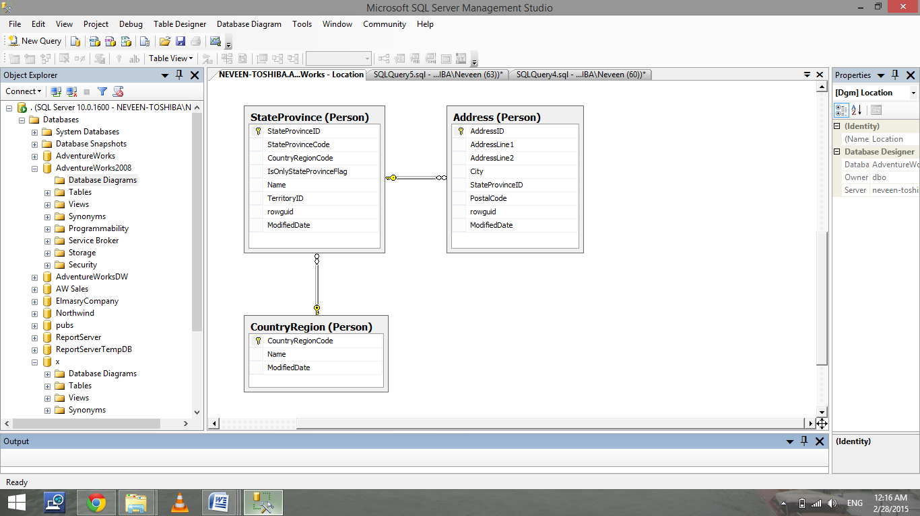

- the table needs to be created manually

Create table Location
(
LocationID int identity primary key,
City nvarchar(50),
State nvarchar(50),
Country nvarchar(50)
)

- Use the sql query below to load the table

select Person.Address.City, Person.StateProvince.Name as StateProvince ,Person.CountryRegion.Name AS CountryRegion
from Person.Address, Person.StateProvince, Person.countryRegion
where address.StateProvinceID = StateProvince.StateProvinceID
and StateProvince.CountryRegionCode = CountryRegion.CountryRegionCode
order by Person.CountryRegion.Name

- Choose destination table to be the previously created table LOCATION

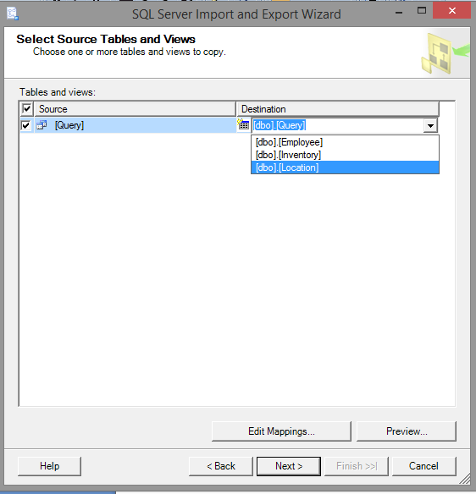

- Open Edit mapping to insure that each attribute was mapped to the proper destination

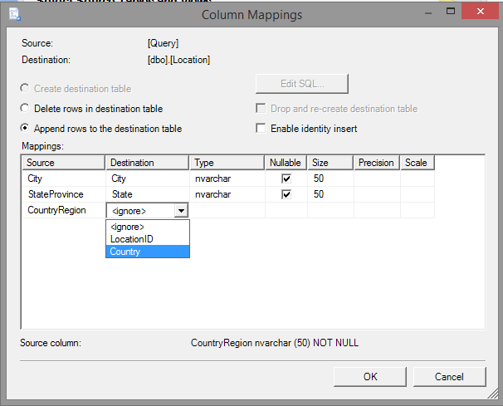

- Time Table that will be created using a query generated from one field in SalesOrderHeader the OrderDate field

- Create Time Table

Create table OrderTime
(
TimeID Datetime primary key,
[Day] int,
[Month] int,
[Year] int
)

- Transfer data using a query

Select distinct( Sales.SalesOrderHeader.OrderDate) As TimeID,day(Sales.SalesOrderHeader.OrderDate) As Day, month(Sales.SalesOrderHeader.OrderDate) as Month,year(Sales.SalesOrderHeader.OrderDate) as Year
from Sales.SalesOrderHeader
order by Sales.SalesOrderHeader.OrderDate

- Choose destination table
- Map Columns
- Notify students with extra options that are displayed because some data types mismatch.
