
Cairo University
Faculty of Computers and Information Information Systems Department Database Systems 1

Lab 1 (C# Tutorial 1)
Creating windows forms application using visual studio 2012:
Follow the following steps:
- Open Microsoft visual studio 2012 application.
- File > New Project > Visual C# > Windows >Windows Forms Application> and write down the project name.
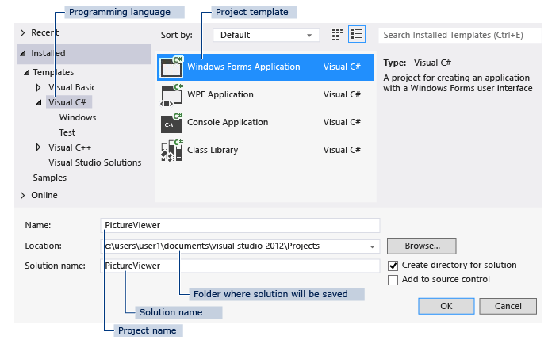
- Visual Studio creates a solution for your program. A solution acts as a container for all of the projects and files needed by your program.

- The following illustration shows what you should now see in the visual studio interface.

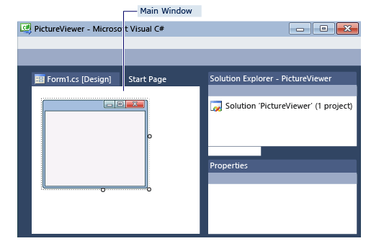

- The interface contains three windows: a main window, Solution Explorer and the Properties window.
- The illustration shows the following windows:

- Main window
In this window, you'll do most of your work, such as working with forms and editing code. In the illustration, the window shows a form in the Form Editor.

- Solution Explorer window
In this window, you can view and navigate to all items in your solution. If you choose a file, the contents of the Properties window changes.

- Properties window
In this window, you can change the properties of items that you choose in the other windows.

- Look at the Properties window, which should now be showing the properties for the
form.
- Forms have various properties. For example, you can set the foreground and background
color, title text that appears at the top of the form, size of the form, and other properties.
- For example, if you choose Form1, you can change its title by setting the Text property,
and you can change the background color by setting the Backcolor property.

- The project tree is on the right side of your screen, your application starting point is “Program.cs” which you could consider holding the “main” function as in your C++ project.

- The first form which will appear to you on running is “Form1”.

- To add more forms right click on your project > Add > Windows Form and write down the form name.

- To change the first form to appear go to “program.cs” and change “Form1” in this line “Application.Run(newForm1());” to your desired form name.

- To run your program, press F5.

- To resize the form, go back to Windows Forms Designer. Choose the form's lower-right drag handle, which is the small white square in the lower-right of the form and appears as follows.
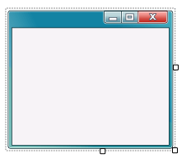

- Look at the Properties window, and notice that the Size property has changed.

- First task to implement is to create a form containing welcome text:
  - Click on “toolbox” drag “Label” and release on your form.

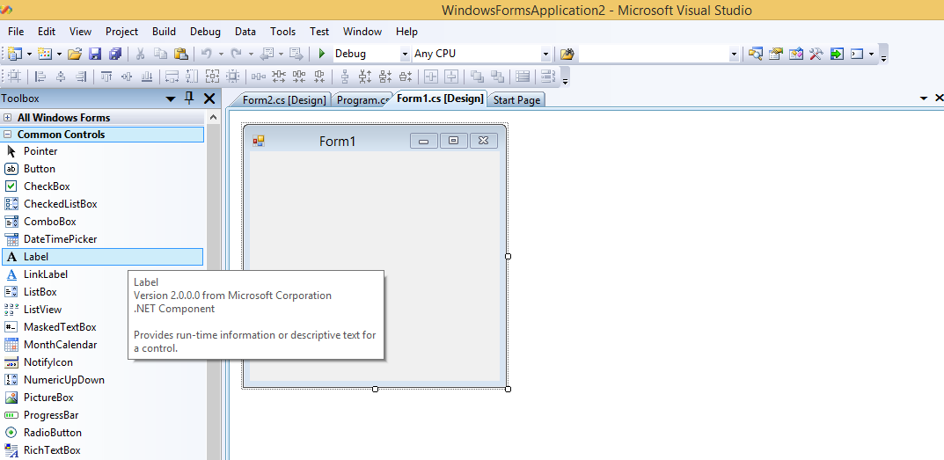

  - Click on the label and change its text from the properties window appearing.
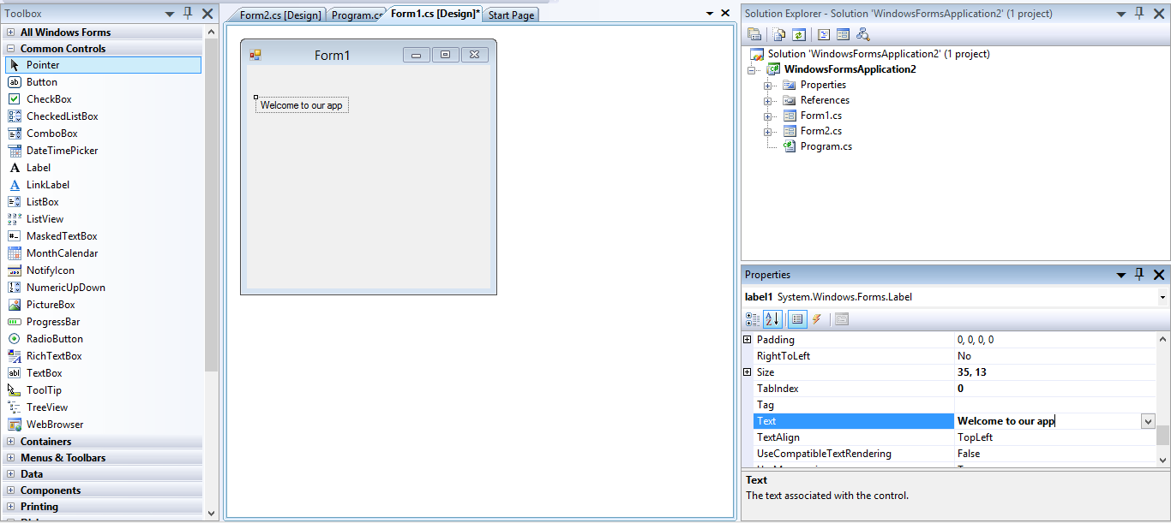
  - Try running now.

- Next task is to add a button and control its clicking action to display a message box by doing the following:
  - Click on “toolbox” drag “Button” and release on your form.
  - Click on the button and change its text from the properties window appearing.
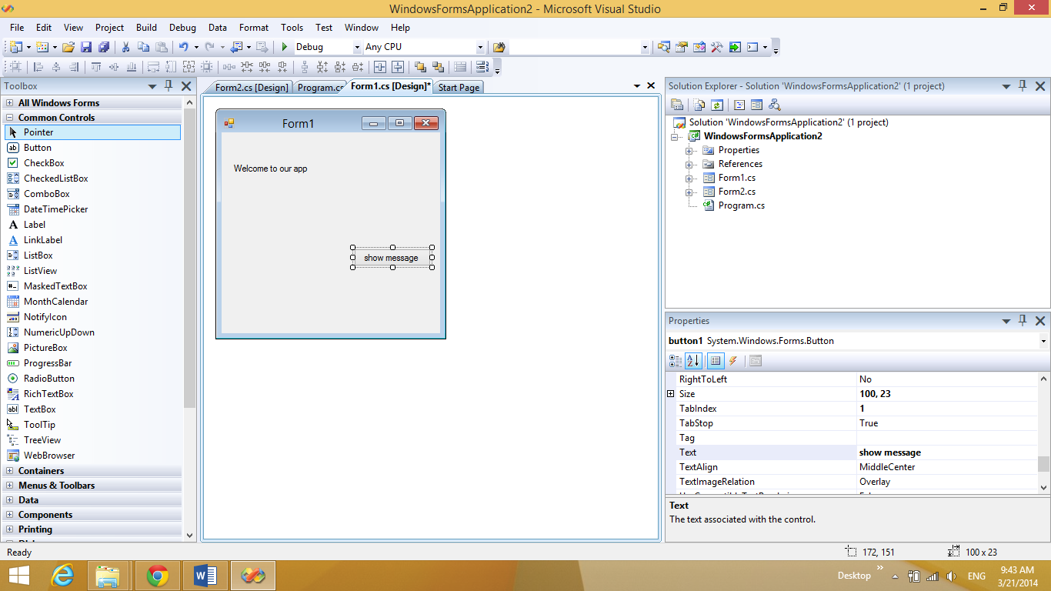
  - Now double click the button and the following window will appear.
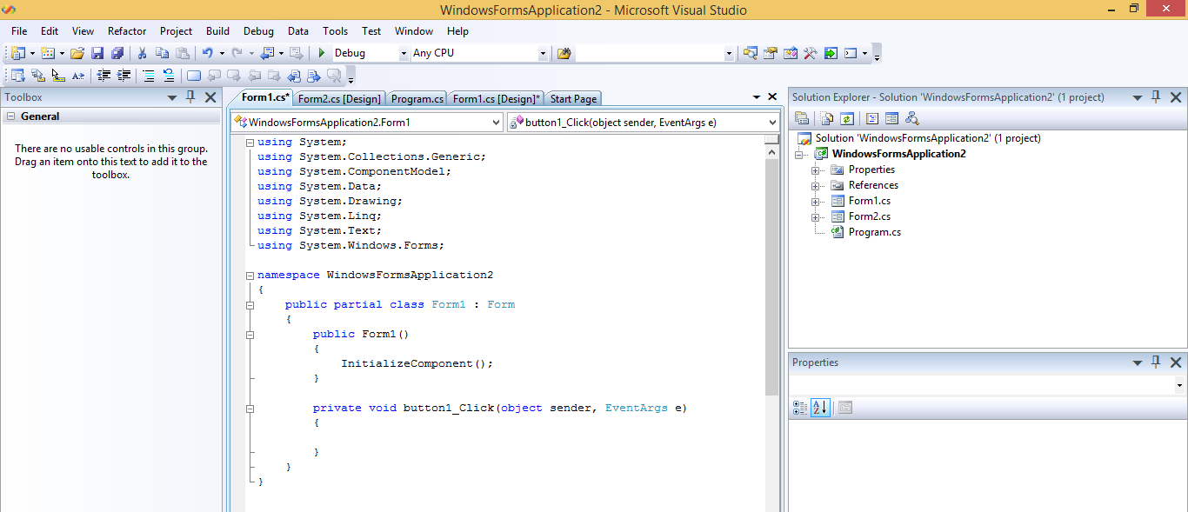
  - Write the following code snippet in order to show the message box”.
String message = "This is My first app";
MessageBox.Show(message);

  - Run now and test it.

- We now want to navigate from a form to another form:
  - Create a second form named Form2.
  - Create a button in Form1.
  - Write the following code snippet for the button in order to show the next form.
Form2 f2 = new Form2();
f2.Show();

  - Run now and test it.

- Final task will be creating a button on your final form of navigation to safely close the application by the following step:
Creating a button on your final form and write down the following snippet as its action”.
Application.Exit();

