Detailed Instructions of Installing MS SQL Server 2008 Enterprise Edition
- Installation Tab: New SQL server stand-alone or add features to an existing installation.
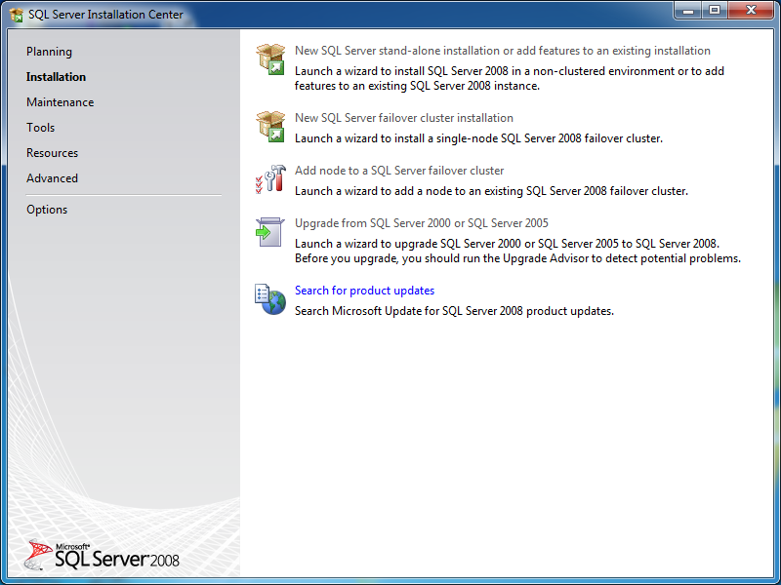
- Perform a new installation of SQL Server 2008
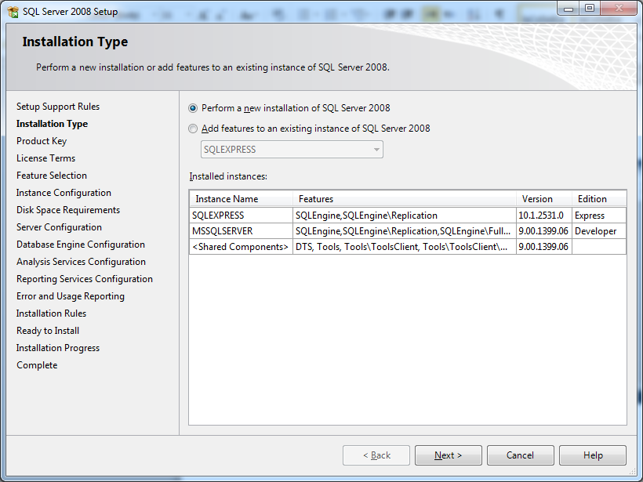
- Enter the product key: This should be stated, if you bought it from “مركز الحساب العلمي”.
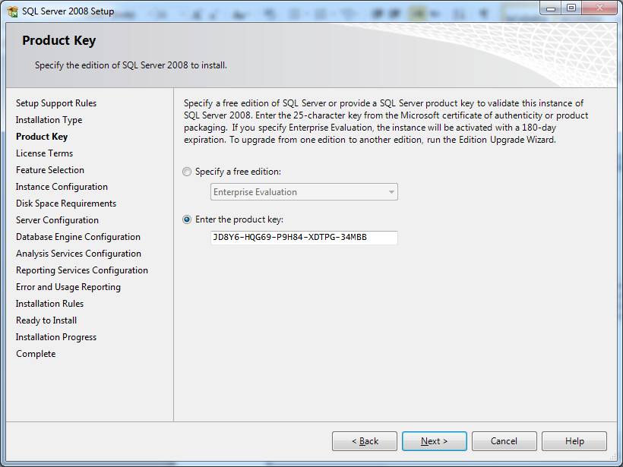
- Accept the license terms.
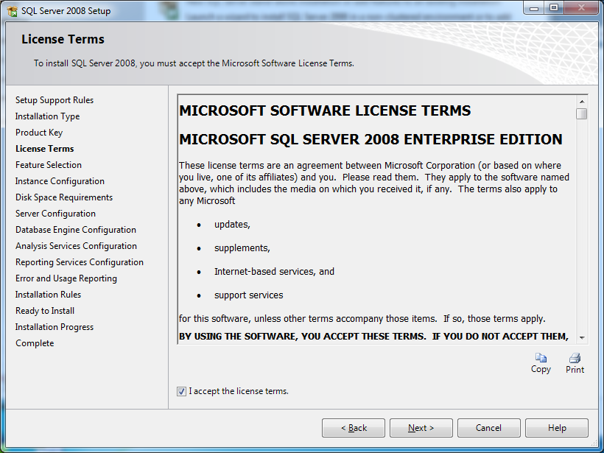

- Select all features, using “Select All” button.
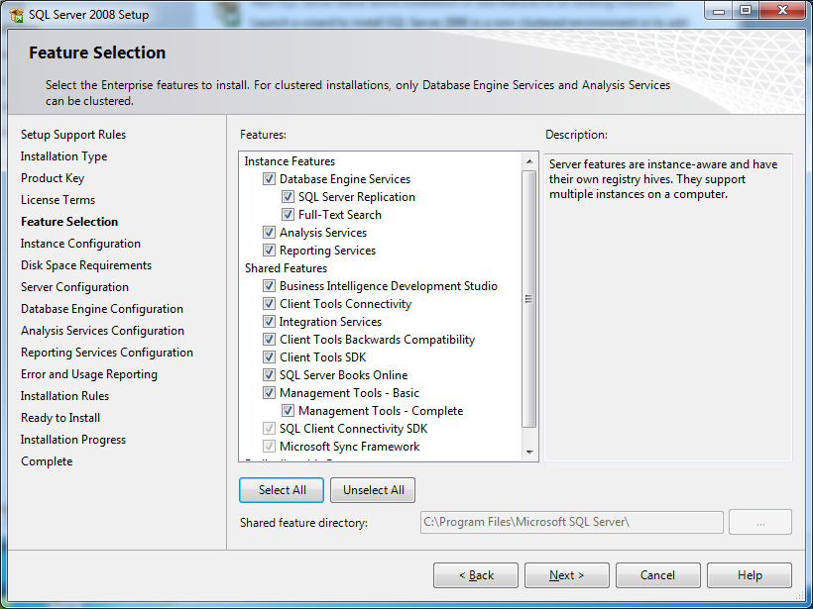
- Specify Named instance; please specify a fresh one that probably you never used or simply not currently installed on you computer.
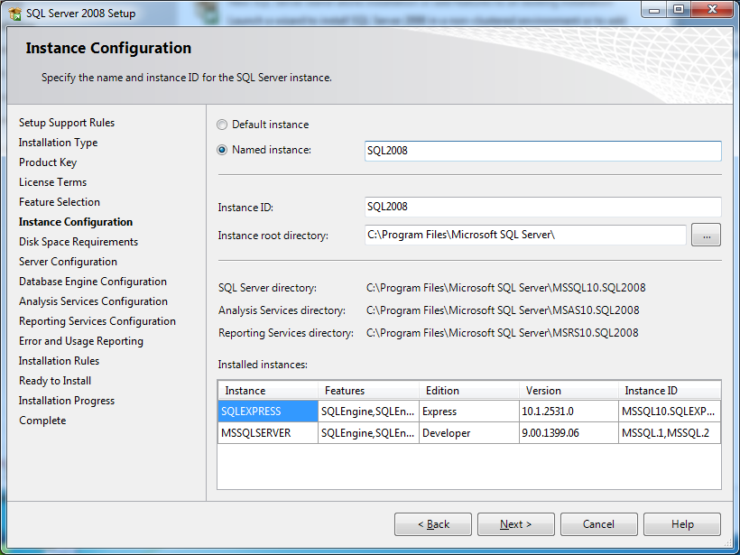

- Disk space requirements summary; Next.
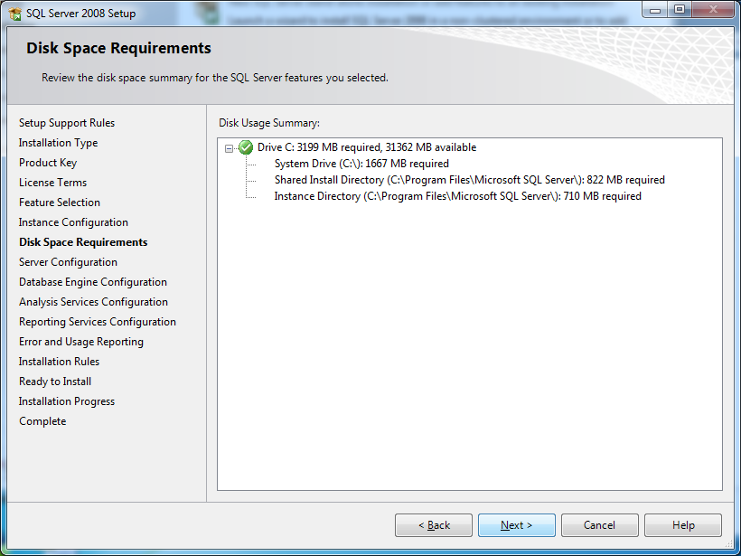
- In server configuration, you cannot simply press Next, you need to make sure that all servers’ startup type is “Automatic” except SQL server agent “Manual”. Then press button: “Use the same account for all SQL Server services”.
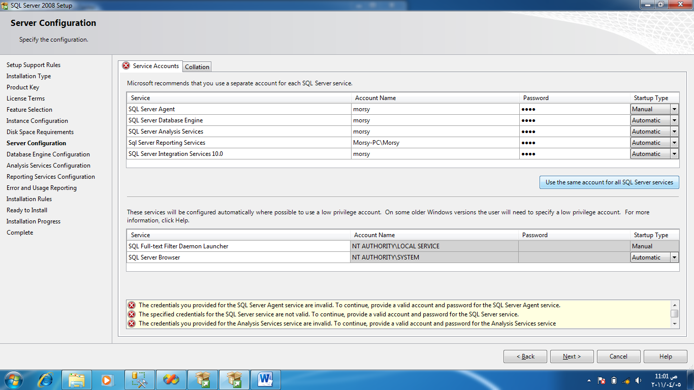

- It will display you to specify the account name, choose from the drop down list: “NT AUTHORITY\NETWORK SERVICE” and don’t specify password.
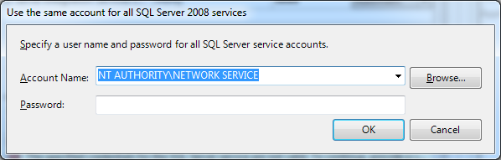
- Everything is now good; Next.
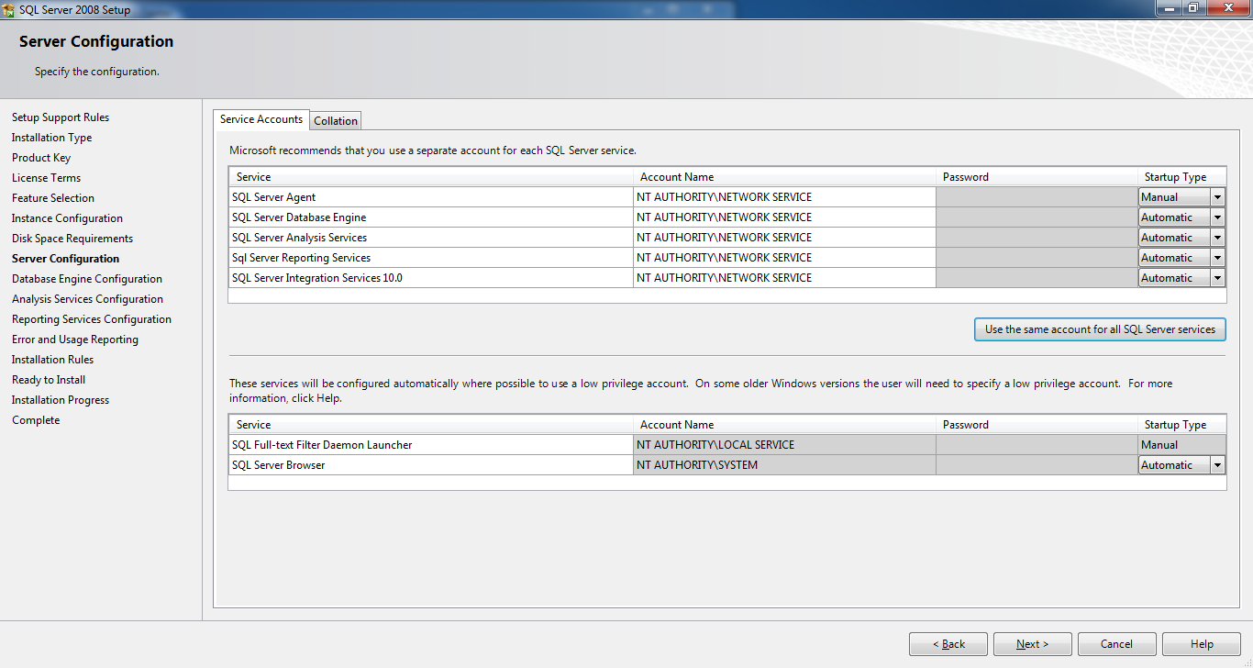
- Here choose Mixed Mode (SQL Server authentication and Windows authentication); specify your password and confirm it. Make it something simple and memorable like 1234. Then at specify system administrators; press button: “Add Current User”. Next.
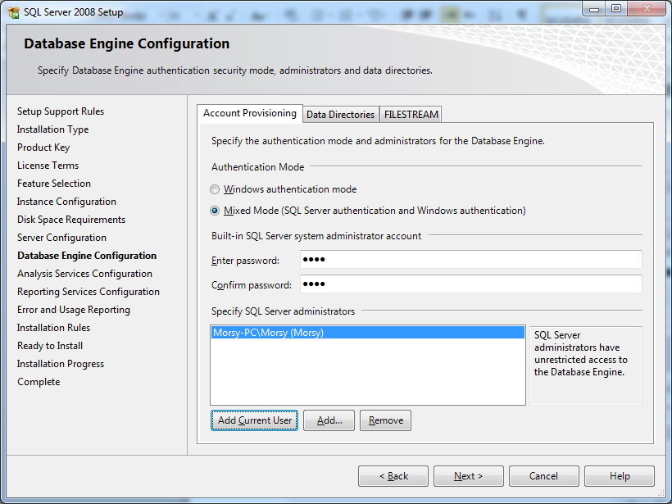
- Press button: “Add Current User” as administrator for Analysis Services.
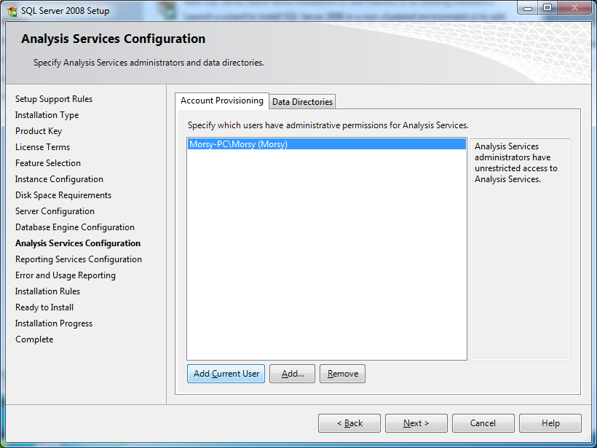
- Choose: “Install the native mode default configuration”. Next.
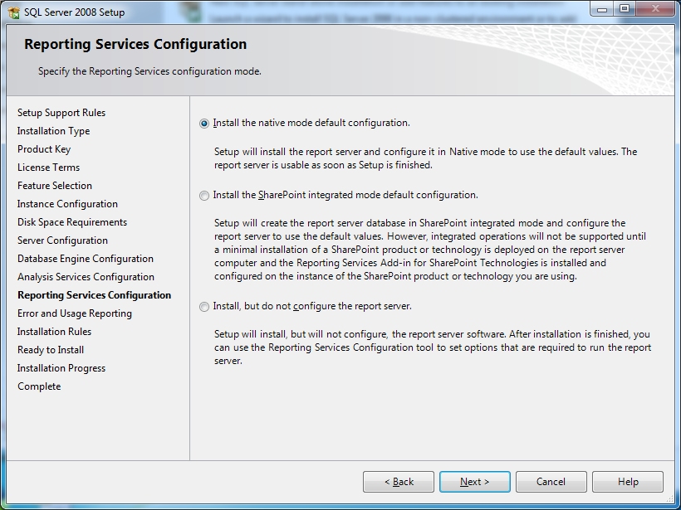

- Only if you want to report to Microsoft if you have any errors, it is completely optional and could be ignored. Next.
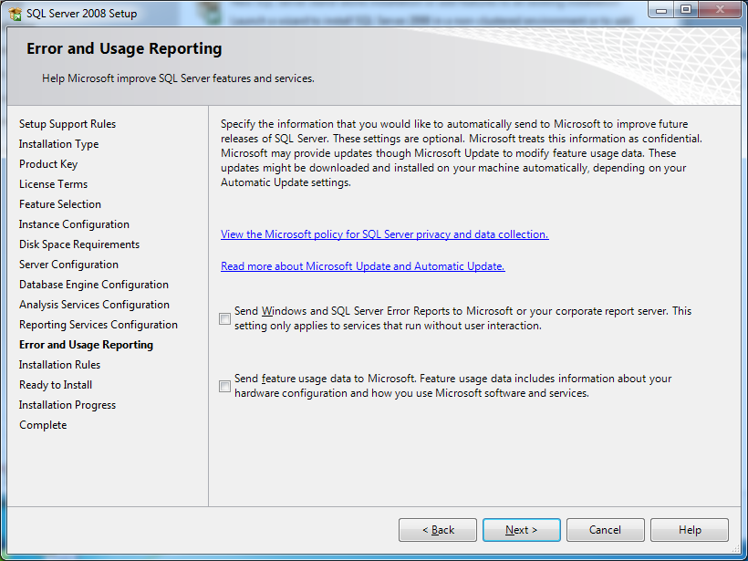
- It is checking installation rules, they should all pass without failure.
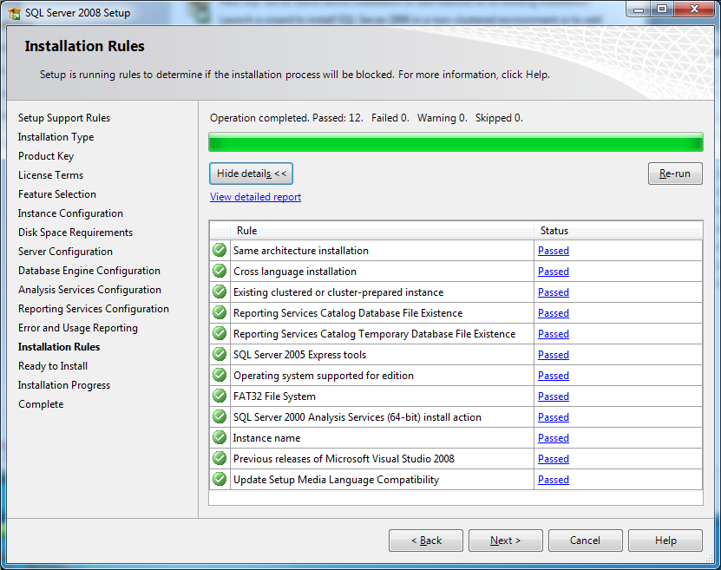

- Reviewing that you have chosen all required features of SQL, then press “Install”
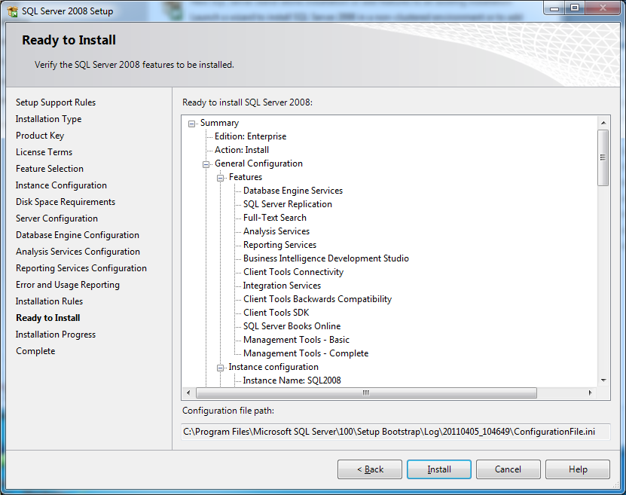
- Then installation will be processing. (It takes about 15 – 30 minutes depending on your PC and how much empty space in cache). So don’t worry.
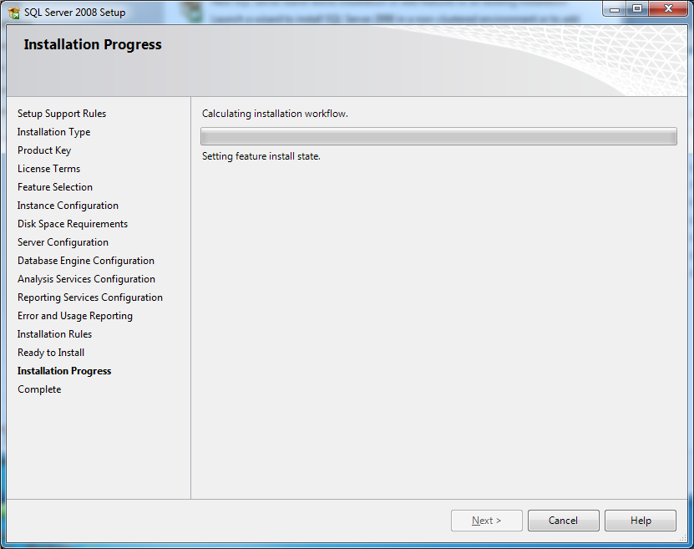
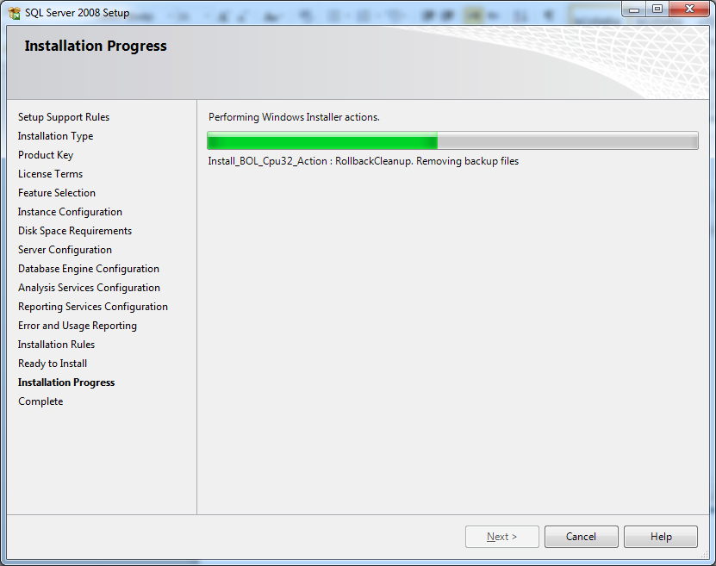
- Now we have finished installation, please restart your computer

I hope that this manual would be useful for you and wish you all good luck

