Determination of the best band combination in an image
Based on the Optimum index factor (OIF)
1- Open the image stack (contains bands 1,2,3,4,5,7)
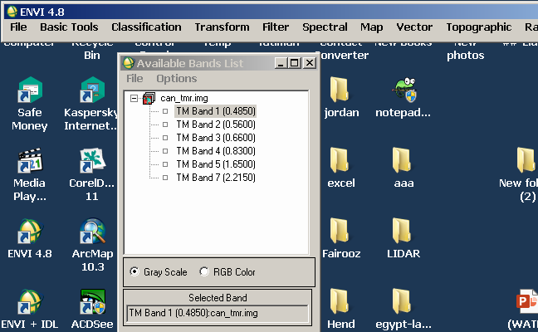

2- open (basic tools\statistics\compute statistics)
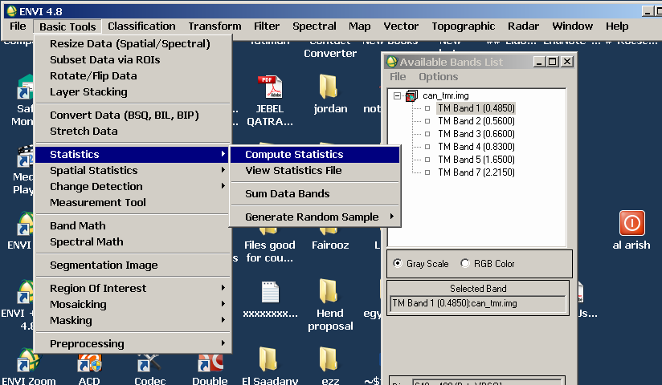

3- From the dropdown menu choose the image file (click on it) and press ok
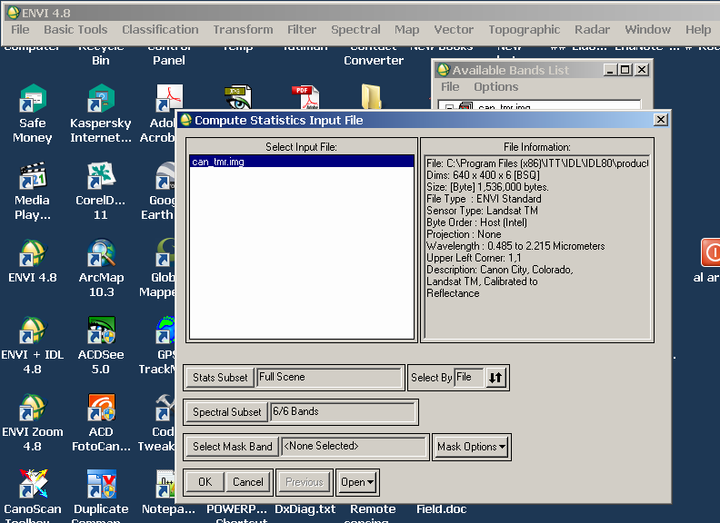

4- From the new dropdown menu check the (covariance box).
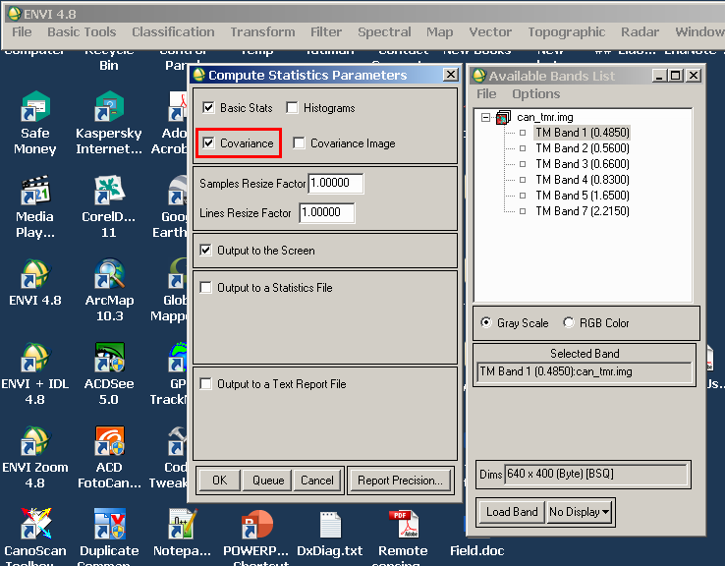

5- the statistics results will appear in a new window. To calculate the OIF, we need from the statistics tables:
- The basic stats table that contains the standard deviation (stdev).
- The table of correlation.
Copy he two tables into excel sheet. Copy both tables exactly as shown in the figures.
6- Continue as shown in the attached excel file.

