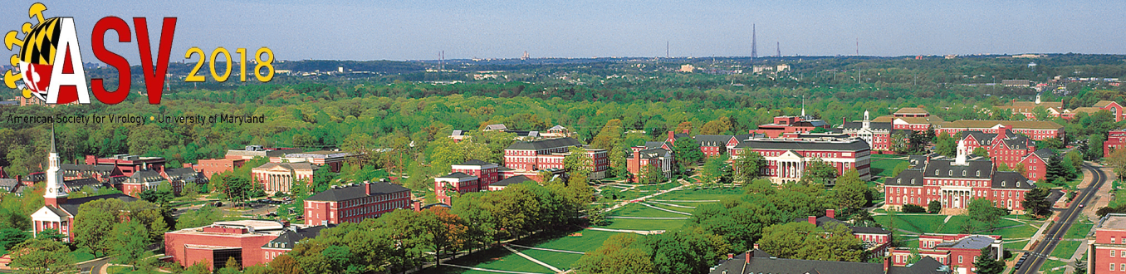

American Society for Virology
37th Annual Meeting
July 14-18, 2018
University of Maryland, College Park
Dear Colleague:
We are pleased to inform you that your abstract title Development of recombinant Newcastle disease virus-based vaccine expressing S protein of the Egyptian infectious bronchitis virus Ck/EG/CU/4/2014 has been accepted for a Poster Presentation in one of two sessions scheduled for Sunday and Monday at the 2018 ASV Annual Meeting. You will receive another email in the near future which will inform you of the session to which you have been assigned for your poster presentation.
Please remember that poster sessions are well attended and afford a special opportunity to present and discuss detailed data with a large number of meeting participants. You will be assigned poster board space for display of your text, graphs, charts, and tables. The maximum outside dimension of each poster, including the title, must not exceed 4 ft. x 4 ft. (120 cm x 120 cm). Information presented on posters should be readable at a distance of 3 ft. Poster board fasteners will be provided at the meeting. Authors must be present at their posters during the entire length of their assigned session from 4:00 pm to 6:00 pm.
Please remember to register for the meeting. The Early Registration rate will end on May 19th at 11:59 pm. Registration fees increase by $75 for all registrations received May 20th – July 13th, 2018 by 11:59 pm; and an additional $75 fee will be assessed beginning July 14th when all registrations are to be made on-site.
Additional information and online registration can be found on the ASV 2018 conference website: http://asv2018.umd.edu
We appreciate your participation in the 2018 ASV Annual Meeting and look forward to seeing you in July.
AMERICAN SOCIETY FOR VIROLOGY
asv@asv.org
www.asv.org

