Acknowledgement
First all and above of all, I would like to thank God, for giving me the ability to accomplish this work.
I am deeply and greatly thankful to Prof. Dr. Adel Abd El hamed Nossier, Prof. and Chairman of Physical Therapy Department for Surgery, Faculty of Physical Therapy, Cairo University, for his valuable supervision, continuous support, constructive criticism, useful advices and valuable guidance. Finally, words can't help me to express my deep thanks to all patients participated in this study.
I would like to express my deepest thanks to Prof. Dr. Hamed Abdala Hamed, Prof. of Dermatology, Faculty of Medicine, Cairo University, for his great help, support and valuable advice throughout this work.
Special thanks to all my colleagues in Physical Therapy Department for Surgery, Faculty of Physical Therapy, Cairo University, for their valuable advices and continuous help.

Abstract:
Efficacy of Narow Band Ultraviolet "B" versus Psolaren and Ultraviolet "A" in the treatment of Alopecia areata /Ereny Sobhy Wahba; Supervisors: Prof. Dr. Adel Abd El hamed Nossier; Prof. Dr. Hamed Abdala Hamed, Faculty of Physical Therapy, Cairo University, Department of Physical Therapy for Surgery, 2014.
Abstract
The purpose: This study was under taken to evaluate the efficacy of NB UVB versus PUVA in Treatment of Alopecia areata. Sixty patients males and females, age range from 20-40 years were randomly assigned into two groups of equal number complaining from Alopecia areata, were participated in this study: patients in group (A) (PUVA group) received PUVA three times per week for 3 months while patients in group (B) (NB UVB group) received NB UVB three times per week for 3 months. Assessment including photography follow up by digital camera, alopecia grading (SALT scoring system) and Global assessment. Result: indicating significant differences in improvement between the two groups. Conclusion: PUVA has variable success in the treatment of AA than NB UVB.
Keywords: (Alopecia areata, PUVA, NB UVB).

Contents
List of Tables | iii
List of Figures | v
List of Figures | vi
List of Figures | vii
List of Abbreviations | viii
Chapter I: Introduction | 1
Introduction | 1
Statement of the problem | 3
Purpose of the study | 3
Significance of the study | 4
Delimitations | 5
Limitations | 6
Basic assumption | 7
Hypothesis | 7
Definition of terms | 7
Chapter II: Review of Literature | 11
1. Alopecia areata: As chronic inflamtory disease | 11
2. Ultraviolet Radiation: Natuer and Application | 28
3. Therapeutic Efficacy of various form of UV on Alopecia Areata | 42
Chapter III: Subjects, Materials And Methods | 48
Chapter IV: Results | 62
Chapter V: Discussion | 120
Chapter VI: Summary, Conclusion and Recommendations | 132
References | 137
Arabic summary | 156

List of tables
 | A classification of skin photo types based on susceptibility to sunburn, together with indicative MEDs that might be expected following UV exposure on un acclimatized skin. | 34
 | Sources and Effects of Ultraviolet radiation: Federal Provincial Territorial Radiation Protection Committee | 37
 | The grades of SALT score. | 54
 | The grades of Global scale. | 55
 | Comparison of patients demographic data (age) in both groups of the study (groups A and B). | 64
 | The Percentages of males and females in both groups of the study(A and B). | 66
 | The median, range, maximum and minimum values of Alopecia grading (SALT scoring system) both groups of the study (groups A and B). | 73
 | The median values of alopecia grading of group A (PUVA). | 75
 | The median values of alopecia grading of group B (NB UVB). | 76
 | Comparison of pre values of alopecia grading between both groups of the study (A and B). | 78
 | Comparison of post₍₁₎ values of alopecia grading between both groups of the study (A and B). | 81
 | Comparison of post₍₂₎ values of alopecia grading between both groups of the study (A and B). | 84
 | Percentage of SALT scoring system of both groups of the study(groups A and B) | 92
 | The median, range, maximum and minimum values of Regrowth grading system(Global scale) both groups of the study (groups A and B). | 97
 | The median values of Regrowth grading system (Global scale) of group A (PUVA). | 99
 | The median values of Regrowth grading system (Global scale) of group B (NB UVB). | 100
 | Comparison of post₍₁₎ values of Regrowth grading system of both groups of the study (A and B). | 102
 | Comparison of post₍₂₎ values of Regrowth grading system of both groups of the study (A and B). | 105
 | Percentage of regrowth scoring system of both groups of the study (groups A and B). | 111
 | Correlation Analysis between the age and Regrowth scoring system after 18 sessions . | 113
 | Correlation Analysis between the age and Regrowth scoring system after 36 sessions. | 116

List of Figures
 | A model of immune privilege collapse in AA pathogenesis. Both a normal anagen (growing) hair follicle (A) and a hair follicle in AA (B) are shown. | 17
 | The electromagnetic spectrum. | 29
 | Ultraviolet (UV) region of the electromagnetic spectrum. | 30
 | Schematic diagram of the eye. | 35
 | Eye damage wavelengths. | 35
 | Sony cyber shot digital still camera. | 50
 | Semi-circular (PUVA 200). | 52
 | Closed and opened UV cabinet._{(a,b)} | 52
 | Opened UV cabinet (digital display unit)._{(c)} | 53
 | Lowering portion of UV cabinet._{(d)} | 53
 | 8-methoxypsoralen (8-MOP) (Ultramedanine) Psolaren. | 57
 | Psolaren plus ultraviolet A application procedures. | 57
 | UV Cabinet._{(a)} | 60
 | Step one: Prepare patient before UV cabinet switch on. _{(b,c)} | 60
 | Step two: Application of UV: Switch on UV cabinet, and then Switch off the cabinet and open the door. _{(d, e)} | 60
 | The Mean values of patients age of both groups of the study (A and B). | 65
 | The Percentages of males and females in group (A). | 67
 | The Percentages of males and females in group (B). | 68
 | The median values of alopecia grading of group A (PUVA). | 70
 | The median values of alopecia grading of group B (NB UVB). | 72
 | The median values of Alopecia grading (pre, post₍₁₎ and post₍₂₎) of both groups of the study (groups A and B). | 74
 | The median values of alopecia grading (SALT scoring) pre treatment between both groups of the study (groups A and B). | 79
 | The median values of alopecia grading post₍₁₎ between both groups of the study (groups A and B). | 82
 | The median values of alopecia grading post₍₂₎ between both groups of the study (groups A and B). | 85
 | Percentage of Alopecia grading pre values of both groups of the study (A and B). | 87
 | Percentage of Alopecia grading post₍₁₎ of both groups of the study (A and B). | 89
 | Percentage of Alopecia grading post ₍₂₎ values of both groups of the study (A and B). | 91
 | The median values of Regrowth grading system of group A (PUVA). | 94
 | The median values of Regrowth grading system of group B (NB UVB). | 96
 | The median values of Regrowth grading system (post ₍₁₎ and post ₍₂₎) of both groups of the (groups A and B). | 98
 | The median values of Regrowth grading system post₍₁₎ values between both groups of the study (groups A and B). | 103
 | The median values of Regrowth grading system post ₍₂₎ values between both groups of the study (groups A and B). | 106
 | Percentage of regrowth score system post₍₁₎ values of both groups of the study (A and B). | 108
 | Percentage of regrowth score system post₍₂₎ of both groups of the study (A and B). | 110
 | Correlation between age and Regrowth scoring system after 18 sessions. | 114
 | Correlation between age and Regrowth scoring system after 36 sessions. | 117
 | The photographic pictures for patient: A, pre treatment by PUVA, B post treatment by PUVA. | 118
 | The photographic pictures for patient: A, pre treatment by PUVA, B post treatment by PUVA | 118
 | The photographic pictures for patient: A, pre treatment by PUVA, B post treatment by PUVA. | 118
 | The photographic pictures for patient: A, pre treatment by NB UVB, B post treatment by NB UVB. | 119
 | The photographic pictures for patient: A, pre treatment by NB UVB, B post treatment by NB UVB. | 119
 | The photographic pictures for patient: A, pre treatment by NB UVB, B post treatment by NB UVB. | 119

List of abbreviations
5-MOP | 5 methoxypsoralen
AA | Alopecia Areata
ADTAFS | Acute and diffuse type alopecia of the female scalp
AT | Alopecia totalis
AU | Alopecia Univresalis
CGRP | calcitonin gene-related peptide
CHS | Contact hypersesitivity
CIE | Commission Internationale de l’Eclairage(International Commission on Illumination)
CsA | Cyclosporine
FAD | Food and drug association
Fig | Figure
GMCSF | Granulocyte-macrophage colony stimulating factor
ICAM-1 | Intercellular adhesion molecule-1
IL  Laser | interleukin  Light amplification by stimulated emission of radiation
IL2 | interleukin-2
MED | minimal erythema dose
MHC | major histocompatibility complex
NB UVB | Narrow band Ultraviolet-B
NK | natural killer
NTP | National Toxic Program
PUVA | Psolaren plus UVA
SADBE | Squaric acid dibutylester
SALT | Severity of Alopecia Tool
SED  SPF  8-MOP | Standard erythema dose  sun protection factor  8 methoxypsoralen
TGF-B  DPCP | Transforming growth factor-B  Diphencyprone
UVA | Ultraviolet-A
UVB | Ultraviolet-B
UVC | Ultraviolet-C
UVR | Ultraviolet radiation

CHAPTER I
INTRODUCTION
Alopecia areata is a complex genetic, immune mediated disease that targets anagen hair follicles, characterized by non scarring hair loss on the scalp or any hair bearing surface, it may be round or oval patches of hair loss, loss of all scalp hair (alopecia totalis AT; 10% of AA), loss of all body hair (alopecia universalis AU; 3% of AA), or ophiasis pattern hair loss (Alkhalifah et al., 2010).
Men and women are equally affected and the prevalence is almost the same for all ethnic groups(Epstein, 2001).It is a common disease and at any given time, about a 0.2% of people are involved with alopecia areata and 1.7% of the populations experience an episode of alopecia areata during their lifetime)Strober et al., 2005), affects both children and adults and hair of all colors although the disorder is uncommon in children under 3 years of age, most patients are relatively young: up to 66% are younger than 30 years of age, and only 20% are older than 40 years of age (Finner, 2011).
The etiology and pathogenesis of alopecia areata is still uncertain but many factors have been described in its pathogenesis genetic, family history, the atopic state, non-specific immune and organ specific autoimmune reaction, possible emotional stress, infectious agents and neurological factors) McDonagh and Tazi-Ahnini, 2002(
Alopecia areata (AA) is an organ-specific autoimmune condition characterized by T cell-mediated attack on the hair follicle (Gilhar et al., 2001). A dense per bulbar lymphocytic infiltrate and reproducible immunologic abnormalities are hallmark features of the condition. The cellular infiltrate primarily consists of activated T lymphocytes and antigen presenting Langerhans cells. T lymphocytes play a critical role in the pathogenesis of disease (Petukhova et al., 2010). About 20% of people with alopecia areata have a family history of the disease, indicating a genetic predisposition. Associations have been reported with a variety of genes, including major histocompatibility complex, cytokine and immunoglobulin genes, suggesting that the genetic predisposition is multifactorial in nature. The hair follicle lesion is probably mediated by T lymphocytes (McDonagh and Messenger, 1996).
Alopecia areata is associated with an increased overall risk of other autoimmune disorders (16%) (Chu et al., 2011), it is accompanied by lupus erythematous in 0.6% of patients (Goh et al., 2006), vitiligo in 4% (Kuchabal and Kuchabal, 2010), and autoimmune thyroid disease in 8 to 28 % (Kurtev and Iliev, 2005) alopecia areata may cause considerable psychological and emotional distress for affected individuals (Tang et al., 2003(. There is no “best” treatment for AA and at this time there is no FDA-approved drug for the treatment of AA (Epstein, 2001). It is believed that the available treatments at best only suppress the underlying process. Most of the published studies on the treatment of AA have focused on correlating therapy with clinical outcome as well as disease extent, disease duration, and historical factors such as previous treatment or history of atopy.
Treatment for AA also needs to be considered in light of the normal course of the disease. Addressing the impressive inflammatory process occurring in AA, corticosteroids have been the most popular treatment modality. Glucocorticoid treatment has an overarching anti-inflammatory effect (Shimmer and Parker, 2001). Several methods of corticosteroid administration have been used, notably intralesional injection, topical, and systemic therapy. Further attempts have been made at not only reducing inflammation, but to also stimulate hair growth, such as minoxidil. Also phototherapy is used such as Ultraviolet B (UVB), photo chemotherapy (PUVA), psoralen–UVB, Combinations of various therapeutics may be used .Currently, newer treatments targeting the immune system are being explored for use in AA which may be immunosuppressive or immunomodulatory in nature (Strober et al., 2005).
Statement of the Problem:-
Alopcia Areata is a benign disease and relatively common dermatosis of autoimmune pathogenesis and ultraviolet therapy is common effective methods in the treatment of alopecia areata.
The problem of the study was designed in a questionary form "Does the NB UVB is more effective than PUVA in the treatment of alopecia areata (AA)"?

The Purpose of the Study:
The main objectives of the present study were designed
1. To asses therapeutic efficacy of PUVA and NB UVB approaches in the treatment of alopecia areata.
2. To determine which one of these two methods is effective method and help in restoring the normal level of hair bearing area.
3. To assist in planning an ideal physical therapy rehabilitation program for these patient.

Significance of the Study:
Alopecia areata is a tissue-restricted autoimmune disease directed at the hair follicle, resulting in hair loss. Patients frequently suffer severe psychiatric consequences. This is especially true of girls and young women who become bald although alopecia can occur anywhere on the body; it is most distressing when it affects the scalp. Alopecia in women has been found to have significantly deleterious effects on self esteem, psychological well-being, and body image (Girman et al., 1999).
Hair loss can range from a small bare patch that is easily masked by hairstyling to a more diffuse and obvious pattern. Children and young adults are most frequently affected, and there is a positive family history. Among the many factors which appear to be implicated in at least a proportion of cases are the patient's genetic constitution, the atopic state, non-specific immune and organ-specific autoimmune reactions and possibly emotional stress. The most widely accepted hypothesis is that AA is a T-cell-mediated autoimmune condition that is most likely to occur in genetically predisposed individuals.
Treatment of AA is still a difficult task for every dermatologist. Current traditional therapies are predominantly immunomodulation modalities, including corticosteroids, topical sensitizers, anthralin, and photo chemotherapy (PUVA). At present, all treatment are palliative, only controlling the problem; they certainly do not cure the condition. No curative treatment is currently available. PUVA is a type of phototherapy used as an immunomodulatory treatment for severe and recalcitrant skin diseases such psoriasis, vitiligo as well as alopecia areata
Narrow band UVB has been found to be very efficient in reducing T-cells in the skin. Alopecia areata has been shown to be responsive to systemic PUVA therapy, presumably via its immunomodulatory effects. As narrow band UVB had previously been demonstrated to be effective for a number of other PUVA-responsive disorders including psoriasis, par psoriasis and vitiligo, a few research teams have endeavored to determine the efficacy of narrow-band UVB light therapy for extensive alopecia areata.The results of these studies indicate that the use of phototherapy
With ultraviolet B light has been useful in some patients with alopecia areata. The proposed mechanism of action is that Ultraviolet (UV) light induces biologic reactions in the skin’s cells that decrease the number of skin cells that grow too quickly and kills T cells in the skin. For this reasons this study may help to determine which one of these two methods is effective method and to provide a program of treatment to overcome this problem.
Delimitations:
This study was delimited in the following respects:

Subjects:
Sixty patients (48 males and 12 females) who had alopecia areata were participated in the study .The subjects had the following criteria.
- Patients were of both sexes
- Patients' age were ranged from 20-40 years.
- Patients entered the study after having given their informed consent.
- Patients with moderate to severe AA affecting more than 50% of the scalp.
- Patients with multiple patches of AA or alopecia totalis.
- Patients with no response to long term use of conventional therapy as corticosteroids.
- Patients were randomly divided into two equal groups in number:
- The first group (PUVA group) included 30 patients with AA who were subjected to treatment by PUVA3 times/week for 3 months or complete hair regrowth.
- The second group (NB UVB) included 30 patients with AA who were subjected to treatment by NB UVB 3 times/week for 3 months or complete hair regrowth.
- Patients were selected from Teaching Hospitals.
Equipment and tools:
A) Measurements equipment:
- Photography follows up by using digital camera
- Alopecia grading (SALT scoring system
- Global assessment
B) Therapeutic Equipments:-
- Ultraviolet A lamp
- VERRIE ETQUARTZ EMILY 98- ABRP64
Limitations:

This study was limited by following factors:
- Small sample size.
- Possible errors during the measurement.
- Individual variations.
- Psychological status of the patients may affect the treatment results.
Basic Assumption:-
It was assumed that:
- All patients didn't receive any kinds of medication that could interfere with the main objective of the study
- Psychological status might be stable all the period of the study
- All the patients told the truth about following the designed treatment plan for the topical application
- All patients were free from any disease that affects therapeutic outcomes.
- The clinical method of measurement was reliable and valid.
- All patients were free from any other impairment except alopecia areata
- All patients received the same kinds of medical care.
- First group received PUVA and second group received NB UVB
Hypothesis:
It was hypothesized that neither PUVA nor NB UVB affected in the treatment of alopecia areata
Definition of Terms:
The following terms were defined and explained for clear understanding of terminology used in this study:
1-Alopecia Areata:
It is a chronic inﬂammatory disease which affects the hair follicles and sometimes the nails .The onset may be at any age and there is no known race or sex preponderance. Alopecia areata usually presents as patches of hair loss on the scalp but any hair-bearing skin can be involved. The affected skin may be slightly reddened but otherwise appears normal (Draelos, 2007).
2- Androgenetic Alopecia:
This is caused by androgens in genetically susceptible women and men. Etiology is not clear but there has been an implication of 5 alpha reductance activity and increase in dihydrotestosterone (Price, 2003).
3-Interleukin:
Interleukins are a group of cytokines that were first seen to be expressed by white blood cells (leukocytes). The function of the immune system depends in a large part on interleukins, and rare deficiencies of a number of them have been described, all featuring autoimmune diseases or immune deficiency. The majority of interleukins are through monocytes, macrophages, and endothelial cells. They promote the development and differentiation of T and B lymphocytes, and hematopoietic cells. Interleukin receptors on astrocytes in the hippocampus are also known to be involved in the development of spatial memories in mice (Ben Menachem-Zidon et al., 2011).
4-Interleukin-2:
T-Lymphocytes regulate the growth and differentiation of T cells and certain B cells through the release of secreted protein factors. These factors, which include interleukin-2 (IL2), are secreted by lectin-or antigen-stimulated T-cells, and have various physiological effects. IL2 is a lymphokine that induces the proliferation of responsive T-cells. In addition, it acts on some B-cells, via receptor-specific binding, as a growth factor and antibody production stimulant. The protein is secreted as a single glycosylated polypeptide, and cleavage of a signal sequence is required for its activity (Driscoll et al., 1992).
5-Koilonychias:
Also known as spoon nails is a nail disease that can be a sign of hypo chromic anemia, especially iron deficiency anemia. Koilonychias literally means "spoon nails." It refers to abnormally thin nails (usually of the hand) which have lost their convexity, becoming flat or even concave in shape. In a sense, koilonychias is the opposite of nail clubbing (Kumar et al., 2005).
6-Photo Chemotherapy:
It is the treatment of skin diseases by exposure of UVR in combination with a photosensitizing agent (for example psoralen plus UVA exposure (Diffey and Farr, 2002).
7-Photo Therapy:
It is the treatment of skin disease by exposure to UVR and is often used in combination with agents applied topically (for example, Dithranol plus UVB phototherapy for psoriasis) (Diffey and Farr, 2002).
8-Twenty-Nail Dystrophy:
Also known as Trachonychia and Sandpapered nails, is a condition characterized by the rough linear ridges developed on many (although not necessarily all) of the twenty nails of the fingers and toes. The nails are opalescent and frequently are brittle and split at the free margin. There has been evidence of the condition as a cutaneous manifestation of lichen planus. It has also been associated with other diseases such as eczema, psoriasis, alopecia areata. It is more common in children and becomes less obvious with age (Rapini et al., 2007).
9-Ultraviolet Light:
It is a non-ionizing radiation, having a relatively high photon energy, which appears to lead to significant and diverse biological effects. It occupies that part of electromagnetic spectrum lying between the softest ionizing radiation (soft x-rays) and visible lights and has a wave length between (400-100) nm (Kitchen and Partridge, 1991).
11-Vellus Hair:
Vellus hair is short, fine, light-colored, and barely noticeable hair that develops on most of a person's body from his/her childhood Exceptions include the lips, the back of the ear, the palm of the hand, the sole of the foot, some external genital areas, the navel and scar tissue.
Vellus hair is differentiated from the more visible terminal or androgenic hair, which develops only during and after puberty, usually to a greater extent on men than it does on women (Marks et al., 2006).

CHAPTER II
REVIEW OF RELATED LITERATURES
In this part, the review of related researches and studies of these main concepts of this study had been presented and illustrated under the following heading:
1. Alopecia areata: As chronic inflammatory disease:
1.1 Introduction
Alopecia areata (AA) is the most frequent cause of inflammation induced hair loss, affecting an estimated 4.5 million people in the United States (Mc Michael et al., 2007). Depending on ethnic background and area of the world, the prevalence of alopecia areata is 0.1 to 0.2%; with a calculated lifetime risk of 2 % (Safavi, 1992).
Alopecia areata affects both children and adults and hair of all colors (Finer, 2011). Although the disorder is uncommon in children under 3 years of age, most patients are relatively young: up to 66% are younger than 30 years of age, and only 20% are older than 40 years of age. There is generally no sex predilection, but more men were found to be affected. Alopecia areata is associated with an increased overall risk of other autoimmune disorders (16%) (Chu et al., 2011). For example, it is accompanied by lupus erythematosus in 0.6% of patients (Goh et al., 2006), vitiligo in 4% (Kuchabal and Kuchabal, 2010) and autoimmune thyroid disease in 8 to 28% (Kurtev and Iliev, 2005).
1.2 Definition
Alopecia areata (AA) is a benign disease characterized by recurrent, nonscarring form of hair loss affecting any hair bearing area. It most commonly affects the scalp but can involve other areas too.
1.3 Types
Localized alopecia areata: Episodes of localized (<50% involvement) patchy alopecia areata usually are self limited. The pattern of hair loss observed in AA can vary considerably, including reticular patches of hair loss; ophiasis type, band-like hair loss in parieto-temporo occipital area ; ophiasis inversus (sisapho), very rare band like hair loss in the fronto-parieto-temporal area ; and a diffuse thinning over part or all of the scalp (Camacho, 1997).
Extensive alopecia areata: Extensive (>50% involvement) forms of alopecia areata are less common. Alopecia totalis or alopecia universalis are reported to occur at some point in 7% of patients; alopecia areata involving more than 40% hair loss is seen in 11% (Olsen et al., 2004).
1.4 Causes
About 20% of people with alopecia areata have a family history of the disease indicating a genetic predisposition (McDonagh and Messenger, 1996). Associations have been reported with a variety of genes, including major histocompatibility complex (MHC) and cytokine genes, suggesting that the genetic predisposition is multifactorial in nature. A genome-wide association study confirmed the link with the MHC genes and also identified associations with other genes involved in regulating immune and inflammatory responses, and with some genes expressed in the hair follicle (Petukhova et al., 2010).
The association between alopecia areata and other autoimmune diseases suggests that alopecia areata is itself an autoimmune disease although this is unproven. It has been proposed that the hair follicle is an immunologically ‘privileged tissue’ which is sheltered from immune surveillance by auto reactive T cells, and that failure of such immune privilege plays a key role in the pathogenesis of alopecia areata (Kang et al., 2010).
1.5 Histopathology issues
The early stage of AA is characterized by an increased number of the catagen and telogen follicles, the presence of inflammatory lymphocytic infiltrate in the peribulbar region “swarm of bees" and eosinophilsin the stellae( Loffreda, 2005).The hair matrix is infiltrated by lymphocytes and there is also pigment incontinence, matrix cell necrosis, and vacuolar damage. The inflammatory infiltrate is especially prominent in terminal hair follicles, the bulbs of which are located in the subcutaneous tissue. The infiltrate is composed of T lymphocytes (Ghersetich et al., 1996). Degeneration of the lower follicular keratinocytes, melanocytes, Langerhans cells, and dermal papillae can be seen (Hull et al., 1991).
Follicular lymphocytic infiltration is accompanied by progression to catagen and telogen phases. Following this, the follicle rapidly returns to anagen and the cycle repeats itself. Because of this continuous cycle and the accompanying inflammatory process, the follicle goes through two important morphological changes: trichomalacia characterized by short, incompletely keratined (pencil-point) hairs that are susceptible to trauma, and miniaturization of some anagen follicles (Restrepo et al., 2005). The late stage of the disease is characterized by numerous miniaturized hair follicles, and telogen follicles are present. There are non agen hairs that represent an intermediate stage between vellus and terminal anagen hair follicles. Inflammation may be absent in longstanding AA. Numerous stellae are present in the deep dermis and subcutaneous tissue, often accompanied by an inflammatory cell infiltrate and melanin pigment (Restrepo et al., 2005).
Incomplete recovery may demonstrate an abundance of diminutive anagen follicles, with a large percentage of them showing the typical peribulbar infiltrate. If these follicles are capable of developing hair shafts, they typically do so without pigment. The number of melanocytes and overall melanizationis decreased, most easily explained as partial or incomplete melanocyte activation in early anagen (Messenger and Bleehen, 1984).
1.6 Pathobiology issues
Improved pathobiologic concepts may ultimately pave the way to better management and outcomes in alopecia areata. It is important to note that this is a disorder of hair follicle cycling in a dual sense inflammatory cells attack only anagen hair follicles, which are then prematurely propelled into the catagen phase (Weedon, 2009). Because of inflammation induced dystrophy of the follicle, the hair shaft can no longer be firmly anchored in the hair canal and is rapidly shed (Whiting, 2003) however, the hair follicle retains its capacity to regenerate and continue cycling, since in alopecia areata unlike scarring alopecia's hair follicle stem cells are generally not destroyed. Thus, the loss of hairpin this disorder is, in principle, reversible. Like most other autoimmune diseases, alopecia areata is a chronically relapsing inflammatory disorder, which suggests a cyclic recurrence of disease promoting events. Also, in the absence of a perfollicular infiltrate, there is no hair loss (Gilhar et al., 2007).
The main therapeutic challenge, therefore, is to reduce the already established inflammatory infiltrates and to prevent both recurrence and spread to previously unaffected hair follicles. Alopecia areata may be considered an organ specific autoimmune disease, since it exclusively affects hair follicles, nails, and (in some patients) the retinal pigment epithelium (Alkhalifah et al., 2010).
Therefore, antigens or auto antigens that are preferentially or exclusively presented in these selected tissues could be important in the path biology of this disease. In addition, systemic interferon alfa therapy and tumor necrosis factor α antagonists, which are used to treat other autoimmune diseases, can trigger or aggravate alopecia areata suggesting that selected cytokines may also be important pathogenetic factors (Ferran et al., 2011).
1.7 Frequency
Prevalence in the general population is 0.1-0.2%. The life time risk of developing alopecia areata is estimated to be 1.7%. Alopecia areata is responsible for 0.7-3.8 % of patients seen by dermatologists (Tan et al., 2002).
1.8 Race, sex and age
All races are affected equally by alopecia areata; no increase in prevalence has been found in a particular ethnic group. Data concerning the sex ratio for alopecia areata vary slightly in the literature. In one study including 736 patients, a male-to-female ratio of 1:1 was reported (Wasserman et al., 2007). In another study on a smaller number of patients, a slight female preponderance was seen.
Alopecia areata can occur at any age from birth to the late decades of life. The disease prevalence peaks between the second and fourth decades of life (de Berker et al., 2004). Pediatric AA constitutes approximately 20% of AA cases (Nanda et al., 2002) and as many as 60% of patients with AA will present with their first patch before 20 years of age (Price, 1991).
1.9 Hypothetical Pathogenesis
It has been hypothesized that alopecia areata develops in a previously healthy hair follicle because its constitutive immune privilege collapses (Paus et al., 2005). According to this hypothesis, alopecia areata can occur in a genetically predisposed person only when proinflammatory signals (e.g., interferon-γ and substance P) (Peters et al., 2007). Known to up regulate ectopic major histocompatibility complex (MHC) class Ia expression in human hair follicle epithelium, expose previously “sequestered” follicle associated auto antigens to preexisting auto reactive CD8+ T cells. If co stimulatory signals and help from other cells, such as CD4+ T cells (Paus et al., 2005), and mast cells (Stelekati et al., 2009) are provided, the lymphocytic infiltrates could attack the hair follicle. Since only anagen hair follicles are attacked, the auto antigens in question may be generated and presented only during anagen (e.g., melanogenesis associated peptides)(Ito et al.,2008).
Genome wide association studies suggest that other proinflammatory factors and natural killer (NK) cell stimulating ligands may also be active at some stage during the development of alopecia areata (Ito et al., 2008).
1.9. _{(a)} Basic Immunopathology
The autoantibody response is heterogeneous and targets multiple structures of the anagen-phase hair follicle. The outer root sheath is the structure targeted most frequently, followed by the inner root sheath, the matrix, and the hair shaft. Although CD4+ T cells predominate numerically in the perifollicular infiltrates (Figure-1), CD8+ T cells appear to be the first lymphocytes to enter the proximal follicular epithelium (Cetin et al., 2009).In addition, the numbers of natural killer (NK) cells and mast cells are greatly increased in the perifollicular infiltrates, raising the question of whether these cells are also involved in the pathogenesis of alopecia areata (Ito et al., 2008).
Affected hair follicles terminate the anagen phase prematurely and regress via the induction of massive apoptosis of the lower portion of the follicle (catagen phase), resulting in a resting hair follicle (telogen phase). Hair follicles may then reenter the anagen phase, but in the presence of lymphocytic infiltrate, anagen is terminated prematurely, resulting in miniaturized hair follicles (Whiting, 2003).

Fig. (1): A model of immune privilege collapse in AA pathogenesis. Both a normal anagen (growing) hair follicle (A) and a hair follicle in AA (B) are shown.
1.9. _{(b)} Genetic Components
About 20% of people with alopecia areata have a family history of the disease indicating a genetic predisposition. Associations have been reported with a variety of genes, including major histocompatibility complex (MHC) and cytokine genes, suggesting that the genetic predisposition is multifactorial in nature. A genome-wide association study confirmed the link with the MHC genes and also identified associations with other genes involved in regulating immune and inflammatory responses, and with some genes expressed in the hair follicle (Petukhova et al., 2010).
The development of alopecia areata has a strong genetic component For example; many patients with a family history of alopecia areata also have a personal or family history of atopy, Down’s syndrome (Finner, 2011), autoimmune polyendocrinopathy candidias is ectodermal dystrophy syndrome (Kumar et al., 2011), other autoimmune diseases, or a combination of these disorders (Alkhalifah et al., 2010). Familial cases of alopecia areata, as compared with sporadic cases, are often characterized by a poorer prognosis, more rapid progression, more frequent relapses, and greater resistance to therapy (Goh et al., 2006). Relatives of affected family members are also at greatly increased risk for alopecia areata. Substantial ethnic variations in the incidence and relative risk of alopecia areata (Kumar et al., 2011), further underscore the prominent role of genetic factors in its pathogenesis.
1.9. _{(c)} Neuroendocrine-Immune hypothesis and stress:
Anecdotal reports have long suggested a connection between the triggering or aggravation of AA and acute or chronic psycho emotional stress (Wasserman et al., 2007). While this likely is of relevance only in a small minority of AA patients, increasing insight into the importance of the brain-skin connection, e.g., in the control of cutaneous neurogenic inflammation (Paus et al., 2006), encourages one to consider the potential impact of neuroendocrine factors on AA. The observation that lesional AA skin in human shows abnormalities in sensory peptidergic innervations (Peters et al., 2006) suggests that the neuroendocrine immune connection in AA, and its modulation by stress, deserves additional research.
1.9. _{(d)} Innervation and Vasculature
The fact that patients with alopecia areata occasionally report itching or pain on affected areas raises the possibility of alterations in the peripheral nervous system. Circulating levels of the neuropeptide calcitonin gene-related peptide (CGRP) has multiple effects on the immune system, including chemotaxis and inhibition of Langerhans cell antigen presentation and inhibition of mitogen stimulated T-lymphocyte proliferation.
1.9. _{(e)} Viral etiology
Other hypotheses have been proposed to explain the pathophysiology of alopecia areata, but more evidence is needed to support them. Alopecia areata was believed to possibly have an infectious origin, but no microbial agent has been isolated consistently in patients. Many efforts have been made to isolate cytomegalovirus, but most studies have been negative(Jackow et al., 1998).
1.10 Clinical Procedures
1.10 _{(a)} History
Patients with alopecia areata, 80% have only a single patch, 12.5% have 2 patches, and 7.7% have multiple patches. No correlation exists between the number of patches at onset and subsequent severity. The scalp is the most common site affected by AA (90%) however; it can affect any hair-bearing area. The beard is affected in 28%, eyebrows in 3.8%, and extremities in 1.3% of patients. More than one area can be affected at once (Tan et al., 2002).
1.10 _{(b)} Associated Conditions
Paralleling the increased frequency of auto antibodies in AA are reported associations with other autoimmune diseases such as thyroid disorders Thyroid disorders and vitiligo have the strongest relationship to AA. An incidence rate of 2.3% for thyroid disease has been reported in patients with AA (Tan et al., 2002). Vitiligo is seen with an incidence varying from 1.8-3% compared with 0.3% in control subjects (Hordinsky and Ericson, 2004). Others associations in some studies include pernicious anemia (Wang et al., 1994), myasthenia gravis, ulcerative colitis, lichen planus, lupus erythematosus (Werth et al., 1992),diabetes (Wang et al., 1994), autoimmune polyendocrine syndrome type I and Candida endocrinopathy syndrome. In one report, ophthalmologic findings such as asymptomatic lens opacities and fundus changes occurred in 51% and 41% of AA patients, respectively (Recupero et al., 1999).

1.10 _{(c)} Physical Skin Characteristics
The affected skin appears normal with no epidermal alteration grossly visible such as scaling or follicular abnormalities (Olsen, 2003). Characteristic hairs, known as “exclamation point hairs,” may be seen within or around the areas of alopecia. The hairs are tapered toward the scalp end with thickening at the distal end. Hair pull tests conducted at the periphery of the lesion may be positively correlated (six hairs or more) with disease activity. Thus, hair loss progresses in a circumferential pattern. Often, distinct patches merge to form larger patches. Upon regrowth, hairs will often initially lack pigment resulting in blonde or white hairs (Olsen, 2003).
1.11 Prognosis
The course of AA is unpredictable. Up to 50% of patients will recover within 1 year even without treatment (Shapiro and Madani, 1999).
However, most patients will have more than one episode of hair loss. The most important factors indicating a poor prognosis are the extent of hair loss presentation (extensive AA/AT/AU) (Tosti et al., 2006) or an ophiasis pattern of hair loss (Lew et al., 2009). Other factors associated with a poor prognosis include a long duration of hair loss (Lew et al., 2009), atopy, a positive family history, the presence of other autoimmune diseases, nail involvement, and young age of first onset (Mandani and Shapiro, 2000). In children, the disease may have a tendency towards worsening with time, even if the initial presentation was mild (Tosti et al., 2006).
1.12 Differential Diagnoses
Androgenetic Alopecia: is male-pattern baldness; it tends to occur in a typical pattern, and shedding is not prominent, pseudopelade, syphilis rarely is seen but should be suspected in patients at high risk or with other signs or symptoms, telogen effluviumis a form of non-scarring alopecia characterized by diffuse shedding (hair falling out by the root). Hair loss is generalized over the entire scalp as opposed to the usually patchy appearance of alopecia areata, anagen effluvium (drug-induced) may mimic diffuse alopecia areata and tinea Capitis is suggested by erythema, scaling, and crusting locally on the scalp (Mandani and Shapiro, 2000)
1.13 Investigations and methods of assessment
The investigation includes dermoscopy (Inui et al., 2010), blood examination and skin biopsy.
1.13 _{(a)} Dermoscopy
Dermoscopy is easy and useful to observe hair loss disease including AA, androgenetic alopecia, cicatricial alopecia and trichotillomania (Inui et al., 2010).
Characteristic dermoscopy features of AA are black dots, tapering hairs (exclamation mark hairs), broken hairs, yellow dots and short vellus hairs (Inui et al., 2008).
1.13 _{(b)} Blood examination
The symptom of hair loss can occur possibly because of collagen disease, thyroid disease, iron deficiency anemia, zinc deficiency and syphilis(Olsen et al., 1999).Therefore, the following items can be studied: antinuclear antibody; anti-deoxyribonucleic acid antibody; thyroid stimulating hormone; ant thyroid peroxidase antibody; serum iron; serum zinc; and serological tests for syphilis (Olsen et al., 1999).
1.13 _{(c)} Skin biopsy
In many cases of AA it is unnecessary to perform skin biopsy in order to make a diagnosis. However, some cases are difficult to distinguish between acute and diffuse type alopecia of the female scalp (ADTAFS) and telogen effluvium, and skin biopsy largely helps us to decide the diagnosis. In chronic lesions, lymphocytes are sparsely infiltrated in and around hair follicles, and these cases often show resistance against immunosuppressive therapies. Therefore, pathological assessments are important in deciding proper treatment. Namely, skin biopsy can be used for the diagnosis of AA and to suggest which treatment would be best (Sato-Kawamura et al., 2002).
1.14 Various lines therapies
No cure or preventive treatment for AA has been established, thus treatments are directed toward halting disease activity.

1.14.1 First-line therapies
1.14.1 _{(a)} Topical corticosteroids
Topical corticosteroids are widely used for the treatment of alopecia areata, even though their clinical efficacy is still controversial. It has been suggested that topical corticosteroids reduce the inflammatory response in AA. Super potent corticosteroid ointments with occlusive dressing have been documented to produce excellent results even though patient compliance is low (Tosti et al., 2003). Folliculitis is the most common side effect of this kind of treatment.
1.14.1 _{(b)} Intralesional corticosteroids
Depot corticosteroids injected intralesionally are preferred by many dermatologists in cases of alopecia areata involving less than 50% of the scalp. The basic concept of treatment is to maximize the corticosteroid effect on perifollicular inflammation by penetrating the epidermis barrier (Chang et al., 2009).
1.14.1 _{(c)} Topical immunotherapy
Diphencyprone (DPCP) represents a hallmark in AA treatment because its introduction produced reasonable aspirations for effective treatment of generalized AA (Buckley and Du Vivier, 2001). Even though topical immunotherapy with DPCP is considered as one of the most effective treatments of AA, success rates vary in different studies ranging from 4 to 85% (Sotiriadis et al., 2007). The sensitization and subsequent contact dermatitis results in recruitment of a different T cell subpopulation to the treated area, that has an impact on the putative follicular antigen, alters the expression of antifollicle antibodies (Tobin et al., 2002)or the excessive production of proinflammatory cytokines and growth factors (Pazoki-Toroudi et al., 2010).
Squaric acid dibutylester (SADBE) is proven to be a valid and suitable treatment for children, particularly those who are resistant to conventional therapies (Orecchia et al., 1994) but a rather high relapse rate occurs.
1.14.1 _{(d)} Minoxidil
Minoxidil is an antihypertensive vasodilator also known for its ability to slow or stop hair loss and promote hair regrowth. Topical minoxidil potentially shortens telogen phase, causing premature entry of resting hair follicles into anagen phase (Messenger and Rundegren, 2004). The effects of minoxidil include stimulation of cell proliferation, inhibition of collagen synthesis, stimulation of vascular endothelial growth factor and prostaglandin synthesis (Messenger and Rundegren, 2004).
1.14.1 _{(e)} Anthralin
Anthralin may generate free radicals, which have antiproliferative and immunosuppressive actions. Anthralin should produce a mild irritant reaction in order to be effective (MacDonald Hull et al., 2003). Side effects include severe irritation, folliculitis, regional lymphadenopathy, staining of skin, clothes, and fair hair (Sasmaz and Arican, 2005).
1.14.1 _{(f)} Topical cyclosporin
Cyclosporine (CsA) is a potent immunomodulatory agent whose mechanism involves inhibition of T-4 lymphocyte activation (Ferrando and Grimalt, 1999). The success rate with oral cyclosporine is 25%–76.6% (Kim et al., 2008). The use of oral cyclosporine in patients with alopecia areata is not generally favored due to its adverse event profile (nephrotoxicity, immune suppression, and hypertension) and a high relapse rate (up to 100%). Although hypertrichosis is a documented side effect of oral cyclosporine (Sternthal et al., 2008).
1.14.1 _{(g)} Bexarotene
In a randomized bilateral half-head study, hair regrowth of at least 50% on treated sites was noticed in only 26% of patients treated with 1% bexarotene gel (Talpur et al., 2009). Mild irritation is a common side effect.
1.14.1 _{(h)} Capsaicin
In a nonblinded randomized study, 9.5% of patients with alopecia areata showed cosmetically acceptable hair regrowth after 12 weeks of applying capsaicin ointment (Ehsani et al., 2009).
1.14.2 Second-line therapies
1.14.2 _{(a)} Sulfasalazine
Sulfasalazine has both immunomodulatory and immunosuppressive actions that include suppression of T cell proliferation and reducing the synthesis of cytokines, including interleukin (IL) 6, 1, and 12, tumor necrosis factor alpha, and antibody production (Ranganath and Furst, 2007). Side effects to sulfasalazine include gastrointestinal distress, dizziness, and headache (Rashidi and Mahd, 2008).
1.14.2 _{(b)} Photochemotherapy
The success rate for oral and topical psoralen plus ultraviolet A (PUVA) ranged from 15% to more than 70% (Mohamed et al., 2005). PUVA turban is a method of administering a dilute psoralen solution (8 methoxypsoralen 0.0001%) selectively to the scalp for 20 minutes using a cotton towel as a turban. The patient’s scalp is then exposed to ultraviolet A radiation (Broniarczyk-Dyla et al., 2006).
Treatment sessions are performed two or three times per week. PUVA turban has been shown to be effective in about 70% of treated patients. During a follow-up period of 15 months after PUVA turban therapy, recurrences of alopecia areata were observed in 26% of responders (Broniarczyk-Dyla et al., 2006).
PUVA turban therapy lacks the systemic side effects of oral PUVA and can be considered as alternative therapy for patients with alopecia areata. Although the erythema induced by UVB radiation is similar to that produced by other irritants, there is little evidence in the literature of the efficacy of this technique (MacDonald Hull et al., 2003).
1.14.2 _{(c)} Excimer laser
In a treatment of 42 alopecia areata patches with the 308 nm excimer laser, hair regrowth was observed in 41.5% of treated areas (Al- Mutairi, 2007). Hair regrowth was noticed to begin to appear during the second month of therapy. Laser therapy was administered twice a week for a maximum of 24 sessions. Apart from erythema at the treated sites, there were no significant adverse effects. Relapses of alopecia areata were observed in two patients with patchy alopecia areata of the scalp who had shown complete regrowth earlier. The use of excimer laser in children with alopecia areata has been reported to have a good success rate (Al-Mutairi, 2009).
1.14. 3 Third-line therapies
1. 14. 3 _{(a)} Systemic corticosteroids
Long-term therapy with oral corticosteroids may lead to hair regrowth in some patients. Indeed, the frequent relapses when tapering the dose, the need for prolonged treatment, and the associated side effects would seem to limit the use of these drugs (Mandani and Shapiro, 2000).
One way to minimize the side effects of systemic corticosteroids is to use them in the form of pulses; Intravenous methylprednisolone 250 mg administered twice a day in adults or 5 mg/kg twice a day in children for 3 consecutive days, once a month (Assouly et al., 2003) or oral dexamethasone 5 mg twice a week (Sharma and Gupta, 1999) or betamethasone 5 mg twice a week (0.1 mg/kg in children) (Agarwal et al., 2006).
1. 14. 3 _{(b)} Methotrexate
In a long-term follow-up study of methotrexate in 33 patients with alopecia areata, complete hair regrowth was achieved in 57% and 63% of patients who used methotrexate alone or with low doses of oral corticosteroids (prednisone 10–20 mg/day), respectively (Chartaux and Joly, 2010).In a retrospective trial of methotrexate in 14 children with alopecia areata, approximately one third of patients experienced a clinically relevant therapeutic response (Royer et al., 2011). Adverse effects to methotrexate include persistent nausea, transient elevation of hepatic enzymes, and leucopenia.
1. 14. 3 _{(c)} Cyclosporine
A recent study showed that a good response to oral cyclosporine can be predicted if the serum level of IL 18 is elevated and the level of soluble IL 2 receptor is low (Lee et al., 2010).
1. 14. 3 _{(d)} Azathioprine
Azathioprine, a thiopurine analog immunosuppressive drug, has been used to treat a vast array of autoimmune diseases. It inhibits DNA synthesis and thus decreases proliferation of cells, especially T and B lymphocytes. Azathioprine also decreases the number of Langerhans cells and other antigen-presenting cells in the skin. In a recent pilot study of 20 patients treated with azathioprine 2 mg/kg/day as monotherapy, mean hair regrowth was 52.3% ± 38.4% (Farshi et al., 2010).
1. 14. 3 _{(e)} Psychological support
Alopecia areata is considered to be an example of a psychosomatic disorder, leading to dramatic and devastating emotions which can negatively impact patient self-esteem, body image, and self-confidence. One important step that should not be overlooked during the course of management of alopecia areata is offering psychological support to foster increased self-esteem and adaptation to this disease. Helping patients with alopecia areata cope with depression and an unpredictable disease like alopecia areata can be achieved by several ways, including education of the patient about the nature of disease, psychotherapy, antidepressants, and support groups. Patients with extensive disease may wear scalp prostheses, such as wigs, hairpieces, or other scalp coverings (Cipriani et al., 2001).
2. Ultraviolet Radiation: Nature and Application
2.1. Introduction
Ultraviolet radiation, sometimes also called ultraviolet light, is invisible electromagnetic radiation of the same nature as visible light, but having shorter wavelengths and higher energies. In the electromagnetic spectrum as shown in (Figure 2), UVR extends between the blue end of the visible spectrum and low-energy X-rays, straddling the boundary between ionizing and non ionizing radiation (which is conventionally set at 100 nm). Ionizing radiation, such as X-rays and gamma-rays, has enough energy to ionize (i.e. break up) atoms and non-ionizing radiation, such as visible light, microwaves, or radio waves, do not (Diffy and Farr, 2002).
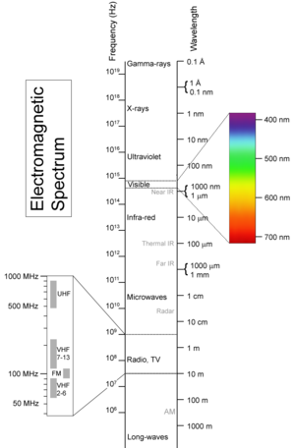
Fig. (2): The electromagnetic spectrum (Diffy and Farr, 2002).
2.2. Nature
Ultraviolet radiation spans the wave length region from 400 to 100 nm (Figure-3). Even in the Ultraviolet portion of the spectrum the biological effects of radiation vary enormously with wave length and, for this reason, the Ultraviolet spectrum in further subdivided into three regions. UV-A: 315 - 400 nm “Black light” UV-B: 280 - 315 nm “Erythemal UV” UV-C: 100 - 280 nm “Germicidal UV” (Diffy and Farr, 2002).
The division of UVB and UVC at 280 nm is because wave lengths from the sun shorter than 280 nm do not reach the earth’s surface as it is largely absorbed by atmospheric ozone layer. The division between UVB and UVA at 315 nm marks the upper wave length of the range that is strongly erythematogenic. Wave lengths between 200 and 280 nm are referred to UVC. These wavelengths are absorbed by DNA, RNA and proteins of cells and can lethal to organisms (Afag, 2011).
The UVC region of the spectrum is often called “germicidal radiation" .The waves shorter than 200nm is called vacuum ultraviolet. UVB (280-315 nm) is often referred to as mid UV or sunburn spectrum. Long wave UV, UVA (315-400nm) is sometimes referred as black light because it is not visible to the human eye and causes certain substances to emit visible fluorescence (Afag, 2011).
Fig. (3): Ultraviolet (UV) region of the electromagnetic spectrum
(Diffy and Farr, 2002)
2.3. Sources
2. 3. _{(a)} Solar radiation
The sun is the main source of exposure to UV for most individuals. Sunlight consists of visible light (400–700 nm), infrared radiation (>700 nm) and radiation. The quality (spectrum) and quantity (intensity) of sunlight are modified during its passage through the atmosphere. The stratosphere stops almost all UV radiation <290 nm (UVC) as well as a large proportion of UVB (70–90%).Therefore, at ground level, UV radiation represents about 5% of solar energy, and the radiation spectrum is between 290 and 400 nm (Afag, 2011).
2. 3. _{(b)} Artificial radiation
Ultraviolet radiation is produced artificially by the passage of an electric current through gas, usually vaporized mercury. For lamps containing mercury vapor at about atmospheric pressure (medium pressure mercury arc lamps) radiation is emitted with several different wavelengths in the UVC, UVB and UVA. The relative intensity of the different wavelengths in the spectrum depends upon the pressure of the mercury vapor (Low and Reed, 2000).
Another common way of producing Ultraviolet radiation is by fluorescent lamps, or tubes. A fluorescent lamp is a low – pressure mercury vapor lamp which has a phosphor coating applied to the inside of the glass tube (sometimes referred to as the envelope). Phosphors are available which produce their fluorescence radiation mainly in the visible region (for artificial lighting purposes), the UVA or UVB regions (Diffey and Farr. 2002).
2.4. Penetration of light and UV radiation through human skin
The penetration of UV radiation and light into human tissue is limited by scattering and absorption. The main action of UVB is believed to take place in the epidermis and in the basal cell layer, while UVA can also have a dermal effect. Numerous bimolecular in the skin act as radiation absorbents within the UVB range. These are mainly nucleic acids, aromatic amino acids, heme, quinones, flavins, porphyrins, carotenoids, 7 dehydrocholesterol, eumelanin and urocanic acid (Heck et al., 2004). UVA absorbing cellular molecules in the initiation of UVA induced photosensitization are still largely unknown, only Tran's urocanic acid and melanin have been reported (Trautinger, 2001).
Melanin plays the major role in penetration of UVB and UVA through the epidermis. Thus, the transmittance at 300 nm is 2-3 orders of magnitude larger for white epidermis than for the darkly pigmented epidermis. Furthermore, it disbelieved that this substance is a main chromospheres for UV effects on the immune system (Hussein, 2005).
Other macromolecules such as lipids and polysaccharides do not absorb in the UV region and thus do not undergo direct damage. Their disruption happens mainly via oxidative processes (Pattison and Davies, 2006).
2.5. General and physiological effects
Ultraviolet radiation in sunlight contributes to the synthesis of vitamin D and may have other beneficial health effects. Excessive exposure to UVR, however, has both acute and chronic adverse effects on the skin, eyes, and on the immune system.
2.5.1 Negative Effect
2.5.1 _{(a)} Acute Negative Effects:
2.5.1 _{(a1)} Effects on the Skin
Exposure of the skin to solar UVR (~ 295 – 400 nm) results in inflammation (erythema/sunburn) that is usually maximal about 24 hours later. This response is primarily induced by its UVB component (~295 315nm) and is associated with increased blood flow , increased sensitivity to thermal and mechanical stimuli (Harrison et al., 2004), a dermal inflammatory infiltrate and the presence of apoptotic keratinocytes know as sunburn cells (Sheehan and Young, 2002).
Individual sensitivity to erythema can be assessed by determining the minimal erythema dose (MED) that increases with skin type as shown in (Table 1) but MED is not predictive of skin type because there is considerable variation of MED within different white skin types (Harrison and Young, 2002).
Within a few days of exposure to solar UVR delayed melanogenesis (tanning) occurs that is dependent on skin type and like erythema is primarily caused by UVB. These results from the synthesis of melanin in melanocytes: specialized pigment producing cells in the epidermis that transfer melanin to keratinocytes. The UVA content of solar UVR makes a relatively small contribution to erythema and tanning. UVB tan is photo protective against erythema but the level of photo protection is modest and equivalent to a sunscreen with a sun protection factor (SPF) (Agar and Young, 2005).
Solar UVR exposure can aggravate certain (skin diseases) such as lupus erythematosus and pemphigus (Morison et al., 1999) and induce skin photosensitivity with commonly used UVR absorbing systemic drugs and topically encountered chemicals (Ferguson, 1999).
Exposure of the skin to UVR can (suppress cell-mediated immunity) when assessed with the sensitisation (Kelly et al., 2000) and the elicitation arms (Moyal and Fourtanier, 2003) of the contact hypersensitivity (CHS) response. Suppression of cell-mediated immunity is thought to play a role in UVR-induced skin cancer and infectious diseases, e.g. Herpes simplex infections.
§ The unit of erythemal radiation is the Standard Erythema Dose (SED), where 1 SED is equivalent to an erythemal effective radiant exposure of 100 Jm-2 (CIE 1998). It requires an exposure of about 3 SED to produce just minimal erythema in the un acclimatized white skin of the most common northern European skin types (Harrison and Young, 2002).

Table 1: A classification of skin photo types based on susceptibility to sunburn, together with indicative MEDs that might be expected following UV exposure on un acclimatized skin (Harrison and Young, 2002).
Skin Photo Type | Sunburn Susceptibility | Tanning Ability | Classes Of Individuals | No. in SED§ for 1minimal erythema dose (MED)
I | High | Noon | Melano-compromid | 1 – 3
II | High | Poor | Melano-compromid | 1 – 3
III | Moderate | Medium | Melano-competent | 3 – 7
IV | Low | Dark | Melano-competent | 3 – 7
V | Very low | Natural brown skin | Melano-protected | 7 >12
VI | Extremely low | Natural black skin | Melano-protected | 7 >12
2.5.1 _{(a2)} Effects on the Eye
The eye is a complex multi-layered organ that receives visible radiation on its retina. The various components of the eye, such as the eyelid, conjunctiva, cornea, lens and retina can be affected by UVR exposure (Figure-4).
The absorption of UVR by the various components of the eye depends upon wavelength. The intermediate layers attenuate UVR to different degrees and thereby protect the retina from UV photo damage. (Johnson, 2004).
Fig.(4):Schematic diagram of the eye. Fig. (5):Eye damage wavelengths. (Johnson, 2004).
The outermost cornea absorbs UVC and a substantial amount of UVB, which is further attenuated by the lens and the vitreous humor in front of the retina (Figure 5). UVA is less well attenuated by the cornea but is attenuated by the internal structures so it does not reach the retina The only acute clinical effect of UVR on the eye is photokeratitis that is also known as snow blindness or welder’s flash. This is a painful transient inflammatory condition caused by UVC and UVB-induced damage to the corneal epithelium (Johnson, 2004).
2.5.1 _{(b)} Chronic Negative Effects
2.5.1 _{(b1)} Skin Cancer
More importantly, chronic UVR exposure presents a carcinogenic risk for human skin as it induces DNA damage; subsequent mutation and carcinogenesis however the types of exposure necessary to cause the different types of skin cancer may vary. UVA induces a very similar spectrum of mutations as compared with UVB which requires further recommendations for UVA photo protection (Rünger, 2007).
2.5.1 _{(b2)} Photoageing
Photoaging includes a complex of biologic processes affecting various layers of the skin with the major damage seen in the cognitive tissue of the dermis (Scharffetter-Kochanek et al., 2000). This is the result of the chronic sun exposure. The clinical symptoms include dryness, wrinkling, elastics, telangiectasia, and anomalous pigmentation. Histological, the dermis is strikingly filled with on amorphous mass of deranged elastic fibers. Collagen fibers are disorganized. Blood vessels are dilated and tortuous. Dermal inflammatory cells are increased. Keratinocytes are irregular with loss of polarity. Melanocytes are abnormal and decreased in number (Pinnell, 2003).
Although UVB photons are much more energetic than UVA, they are essentially completely absorbed in the epidermis and are mostly responsible for sunburn, sun tanning and photo carcinogenesis. Thus UVA is suspected to play a substantial role in photo aging (Matsumura and Ananthaswamy, 2004).
2.5.1 _{(b3)} Effects on the Eye
Conditions linked to sub-chronic and chronic exposure to solar UV include pterygium affecting the cornea; cataract, affecting the ocular lens; and acute macular degeneration affecting the retina (Tomany et al., 2004). Risk for cortical cataract (opacity of the outer lens) is related to increasing cumulative UVB exposure, while risk for nuclear cataract (opacity of the central lens) has been shown to be significantly increased with increasing UV exposure in young adulthood, consistent with the successive laying down with age of outer lens fibers on the cortical layer exposed in earlier life (Neale et al., 2003).There is also epidemiological evidence that solar UVR exposure results in ocular melanoma, especially from a study in Australia (Vajdic et al, 2004) that showed that choroid and ciliary body melanoma were positively associated with time outdoors on weekdays. Unlike melanoma of the skin there is no latitude gradient for ocular melanoma (Vajdic et al, 2004), which may be because UVR dose tithe eye. The main harmful effects of sources in the different UVR bands are summarized in Table 2.
Table 2. Sources and Effects of Ultraviolet radiation: Federal Provincial Territorial Radiation Protection Committee (FPTRPC) Canada 1999.
UVC | UVB | UVA
Wavelength: 100-280 nm Higher energy per photon | Wavelength: 280-315 nm Intermediate energy per photon. | Wavelength: 315-400 nm Lower energy per photon
Sources:  - Sun (UV-C is absorbed by molecular oxygen, ozone and water vapor in the upper atmosphere)  - Germicidal lamps  - Arc welding equipment  - High intensity discharge lamps(HIDL) | Sources:  - Sun (5% of UVR at ground level, only wavelengths > 297 nm)  - Germicidal lamps  - Arc welding equipment  - HIDL  - Therapeutics lamps  - Medical and industrial lasers | Sources:  - Sun (95% of UVR at ground level)  - Black light lamps  - Germicidal lamps  - Arc welding equipment  - HIDL  - Therapeutics lamps  -Tanning devices (sun beds)
Penetration:  -Photons between 100 to 200 nm are absorbed in air.  Absorbed by keratin in the epidermis, does not penetrate to the dermis. | Penetration:  -Partially absorbed by ozone in the upper atmosphere  - Penetrates to the dermis | Penetration:  -Not absorbed by ozone  - Penetrates deeper into the skin than any other form of UVR.
Effects:  - DNA damage on unprotected cells: epithelium, cornea and bacteria. | Effects:  -Responsible for vitamin D3 production and delayed tanning.  - Most effective in causing acute and chronic harmful effects.  - Sunburn, immune suppression, cellular damage, skin cancer, solar urticaria and cataract | Effects:  - Causes immediate tanning.  - Can potentiate some carcinogenic effects of UVB.  - Thermal burns  - Sunburn, immune suppression, cellular damage, photo allergy, photo toxicity , photo aging, cataract and pterygium

2.5.2 Positive Effects of UVR
Exposure to solar UVB initiates the synthesis of vitamin D, in the skin, that is vital for musculoskeletal health (Vieth, 2005) and there is evidence that large numbers of people are vitamin D insufficient (Holick, 2005). There is also emerging evidence, as yet mainly ecologic (i.e. by association), that vitamin D is important in other aspects of health such the prevention of autoimmune disorders (Ponsonby et al., 2005) and several internal malignancies (Berwick and Kesler, 2005).
2.6. Ultraviolet Apparatus
2.6.1 Xenon arc lamps
This lamp has a smooth continuous spectrum in the UV region and various models of solar simulators are available with input power in the range 75W to 6kW and above, from companies that include Oriel Corporation, Solar Light, Spectral Energy Corporation, and Schoeffel Optical (Wilkinson et al., 1998). Optical filters and dichroic mirrors are used to shape the spectrum.
2.6.2 Fluorescent tubes
The output is determined by the nature of the phosphor coating. There are various lamp configurations, usually for whole body irradiation in vertical cabinets or horizontal beds. Vertical cabinets or irradiation is more efficient as the whole body can be exposed. This may pose little problem if the object is to irradiate small areas of skin. Because of this attention has turned to fluorescent lamp as sources of simulated UV (Brown et al., 2000).
2.6.3 The mercury arc lamps
Divided into two categories, low-pressure and high-pressure mercury arcs. Both consist of mercury (a heavy metal in a liquid state) contained in a quartz envelope (Robertson, 2006).
2.6.4 The Alpine sun lamp
These lamps are well suited for the treatment of smaller areas of tissue as leg or forearm (Robertson, 2006).

2.6.5 The Kromayer lamp
It is water cooled and so can be used in direct contact with body tissue. It is best suited for localized treatment involving small areas, such as a particular region of the skin, which has treatable lesions (Robertson, 2006).
2.7. Indications
- Large number of skin diseases. In addition to psoriasis, atopic dermatitis and vitiligo, various other skin diseases can be treated successfully with UV phototherapy, like parapsoriasis, initial mycosis fungoides, graft versus host disease and pruritus, as well as acquired perforating dermatosis, lichen planus, lichen simplex chronicus, lymphomatoid papulosis, generalized granuloma anulare, nummular dermatitis, pityriasis lichenoides chronica, pityriasis rosea, pityriasis rubra pilaris, pruritic folliculitis of pregnancy, seborrhoeic dermatitis, Schnitzler’s syndrome and Sneddon-Wilkinson disease (Samson et al., 2003).
- Vitamin D photosynthesis In general, sub erythemal doses of UV-B “light” have many bio-positive systemic effects on the human being, which can be used in prevention, in sports physiotherapy and in the rehabilitation of patients. Some of these effects are as follows: Vitamin-D synthesis in skin (prevention of rachitis, osteoporosis, etc.), enhancement of the metabolism in general, improvement of blood oxygen utilisation, enhanced phagocytic capacity of polymorphonuclear white blood cells (Holick, 1992).
- Prevention: rachitis, winter-fatigue, asthenic children and anemia
- Infectious diseases: lupus vulgaris, various types of eczema, bronchitis.
- Allergic diseases: neurodermatitis, asthma bronchial.
2.8. Precautions
- Avoid unnecessary exposure to sunlight on treatment days
- Patient should wear UV opaque eye protection during treatment (and for the remainder of the day in the case of PUVA)
- Ensure that the patient is not taking photosensitising medication.
2.9. Contraindications
The contraindication of UV radiation enumerate as the following (Michlovitz, 1996):
2.9.1 Absolute Contraindications
- xeroderma pigmentosum
- Gorlin’s syndrome
- Hereditary dysplastic naevus syndrome
- Systemic lupus erythematosus
- Dermatomyositis
- Trichothlodystrophy
- Bloom’s syndrome
- Cockayne’s syndrome
- Previous malignant melanoma
2.9.2 Relative contraindications – major
- Age less than 10 years
- Previous or current non-melanoma skin cancer
- Previous exposure to arsenic or ionising radiation
- Current premalignant skin lesions
- Concomitant immunosuppressive therapy
- Pregnancy (applies to PUVA treatments only)
- Some forms of porphyria
2.9.3 Relative contraindications – minor
- Age less than 16 years
- Cataracts (applies to PUVA treatments only)
- Bullous pamphigoid
- Pemphigus
- Previous or concomitant treatment with methotrexate
- Significant hepatic dysfunction (applies to PUVA treatments only)
3. Therapeutic efficacy of various forms of UV on Alopecia areata
Phototherapy is the use of UV radiation in the treatment of skin disease. Radiation within the UV spectrum can be divided by wavelength into UVC (200–280 nm), UVB (280–320 nm) and UVA (320–400 nm). Types of phototherapy include broadband UVB (BB-UVB, 290–320 nm, peaks at 313 nm), narrowband-UVB (NB UVB, 311–313 nm), UVA1 (340–400 nm, peaks at 365 nm), and combination therapy of psoralen plus UVA (PUVA photochemotherapy, 320–400 nm, peaks at 352 nm) (Maverakis et al., 2010).
3.1. PUVA and alopecia areata
3.1.1 Psoralen and ultraviolet A (PUVA)
The general principal is based on a succession of photochemical and/or photosensitized reactions and biochemical reactions caused by interaction between a photosensitizing molecule, psoralen, and an activating ultraviolet A light (Honigsmann et al., 2008).
3.1.2 Psoralen
Psoralens are isomers of the family of natural products known as furocoumarins, derived from condensation of a furan ring and coumarin. There are two classes of psoralens, i.e. linear psoralens (8-methoxypsoralen and 5-methoxypsoralen) and angular psoralens (isopsoralen or angelicin).The forms of psoralens currently used in PUVA therapy are linear psoralens:8 methoxypsoralen (8-MOP) or methoxalen or ammoidin, an extract of Ammi-majus Linn, is marketed under the name Meladinine and 5-methoxypsoralen (5-MOP) or bercapten, extracted from bergamot essential oil, is marketed under the name Psoraderm 5 (Sage and Lim, 2010).
The psoralen can be administered orally (5-MOP or 8-MOP) or topically, either in the form of ointment, cream or lotion, either as bath-PUVA (8-MOP, 5-MOP or 4, 5, 8-trimethoxypsoralen) (Honigsmann et al., 2008).
3.1.3 Photochemistry of psoralens
The skin is photosensitized by the intake of exogenous psoralens. Two major types of photochemical reactions are induced by activation of psoralens by light, i.e. photo additions to biological molecules, and photodynamic reactions. Photo additions: psoralens are capable of interacting in the dark with biological macromolecules, particularly DNA, with subsequent suppression of DNA synthesis and cell proliferation (Krutmann and Morita, 1999). Photodynamic reactions: in cells where psoralen is accumulated and that are exposed to UVA radiation, these reactions lead to the production of reactive oxygen species which damage DNA, cell membranes, proteins causes mitochondrial dysfunction and leads to apoptosis of Langerhans cells, keratinocytes and lymphocytes (Sage and Lim, 2010).
3.1.4 Application of PUVA
Psoralen application used in conjunction with ultraviolet (UVA) irradiation (PUVA) has been employed to treat alopecia areata. This modality appears to act via an immunomodulatory mechanism and was suggested to alter T lymphocyte function and perhaps suppress local immunological attack against the hair follicle by depleting Langerhans cells and that PUVA therapy can eradicate this inflammatory cell infiltrate (Behrens-Williams et al., 2001).
This drug has been administrated topically (1, 0% 8-MOP ointment or 0, 1% solution) or orally (0, 6 mg/kg 8-MOP) and followed in 1 or 2 hours, respectively, by UVA radiation. Treatments are given two to three times weekly with a gradual increase in UVA dosage. The success rate for oral and topical psoralen plus ultraviolet A (PUVA) ranged from 15% to more than 70% (Mohamed et al., 2005).
PUVA turbanis a method of administering a dilute psoralen solution (8-methoxypsoralen 0.0001%) selectively to the scalp for20 minutes using a cotton towel as a turban. The patient’s scalp is then exposed to ultraviolet A radiation. Treatment sessions are performed two or three times per week. The UVA dose was 6–20 J ⁄cm2 (average12 J) according to the skin photo type. The treatment continued with one exposure every 3months until hair regrowth. The number of regulatory T cells was increased after combination in peripheral blood nuclear cells and the lesions after the combination therapy (Broniarczyk-Dyla et al., 2006). PUVA turban has-been shown to be effective in about 70% of treated patients. PUVA turban therapy lacks the systemic side effects of oral PUVA and can be considered as alternative therapy for patients with alopecia areata (Behrens-Williams et al., 2001).
3.1.5 Short-Term Side Effects
Apart from its mediocre short effectiveness, PUVA can induce nausea, possible burning of the scalp, Stomachache, Swelling, Redness, Dry skin, Itching, Cold sores, Folliculitis, Photosensitivity, Dizziness, Parasthesia and Headache (Shapiro and Price, 1998).
3.1.6 Long-Term Side Effects
Pigmentary alterations, photoaging and squamous cell carcinoma, PUVA freckles, actinic keratoses, Cataract of eye (Shapiro and Price, 1998).
3.2. Ultraviolet B and alopecia areata
There are several types of UVB radiation in clinical use, namely, broad band UVB (BB-UVB 290-320nm), selective UVB phototherapy (SUP) (peaks at 305 and 325nm), and narrow band UVB (NB-UVB 311± 2 nm). NB-UVB therapies have been used for treatment of many skin disorders such as psoriasis (Kircik et al., 2008), vitiligo (Elmofty et al., 2006), chronic urticaria (Engin et al., 2008), lichen nitidus, pruritus, and inflammatory dermatoses. Few studies have been performed on the value of NB-UVB in treatment of Alopecia Areata AA (Jury et al., 2006). NB-UVB has been used in treatment of autoimmune diseases.
The immunosuppression that follows exposure to ultraviolet radiation is generated by complex multistep pathways. The process starts with cutaneous chromophores and most likely ends with the amplification of subsets of T regulatory cells. Roles of Langerhans cells, keratinocytes, dendritic cells, macrophages and mast cells have been identified (Norval et al., 2008). In a recent study, it was proved that NB-UVB suppresses contact hypersensitivity by inducing T-regulatory cells (Shintani et al., 2008).
Recently, it has been proven that mast cell migration from the skin to the draining lymph nodes upon ultraviolet irradiation represents a key step in the induction of immunosuppression. However, it has been recognized that mast cells can produce mediators known to be anti inflammatory such as IL-10 and transforming growth factor-β (TGF-β). Therefore, it has been proposed that they may possess anti inflammatory or immunosuppressive properties in some settings (Norval et al., 2008).The results of these studies indicate that the use of phototherapy with ultraviolet B light has been useful in some patients with alopecia areata. The proposed mechanism of action is that Ultraviolet (UV) light induces biologic reactions in the skin’s cells that decrease the number of skin cells that grow too quickly and kills T cells in the skin (Norval et al., 2008).
3.2.1 Frequency of treatments in NB-UVB phototherapy
Before starting UVB phototherapy, the minimal erythema dose (MED) should ideally be determined (erythema 24 h after exposure) (Sage and Lim, 2010). The erythemogenic effect of UV is measured by the minimal erytherna dose (MED), which is the lowest UV dose that results in a detectable erythema at 24 hours, for a defined UVB irradiation source. It is advised that the first treatment of NB-UVB equals 0.7 MED and that dose increments are made according to post irradiation erythema (Hönigsmann and Schwartz, 2008).
All patients were treated initially, three a week. Initial treatment dose was determined according to the skin photo type: 0.2 J/cm2 for skin photo type II and 0.3 J/cm2 for photo type III. Treatment continued with 20% dose increases at each subsequent session to a maximum of 1.8 J/cm2.The dose and frequency of treatments were gradually reduced once satisfactory clinical responses were achieved. The frequency was reduced to twice per week when terminal hair regrowth was seen with no further abnormal hair fall, then once per week, and finally terminated when regrowth was maintained (Dilek Bayramgürler et al., 2011)
3.2.2 Early side effects
Short-term adverse effects related to UVB phototherapy are mostly related to phototoxicity which includes burning, pruritus, xerosis, pain, and blistering, as well as increased susceptibility to cutaneous herpes simplex virus infections. Overaggressive treatment resulting in phototoxic reactions (i.e., erythema) can lead to koebnerization (Gonzaga, 2009).
3.2.3 Late side effects
Chronic exposure to UV radiation induces premature aging (photoaging) of the skin, showing typical clinical signs of leathery appearance, wrinkling, reduced recoil capacity and increased fragility of the skin (Berneburg et al., 2000). Long-term UVB exposure is associated with photodamage and is a carcinogen with the potential to increase long-term risk of malignancy (Gonzaga, 2009).
3.2.4 Contraindications of UVB
UVB phototherapy is contraindicated in patients with photosensitizing diseases such as systemic lupus erythematosus or polymorphous light eruption or in patients taking photosensitizng medications such as thiazide and certain antibiotics such as tetracycline.UVB phototherapy is also contraindicated in patients with lupus erythematosus, xeroderma pigmentosum, acute eczema, renal and hepatic insufficiencies, hyperthyroidism, advanced arteriosclerosis, active and progressive pulmonary tuberculosis, pellagra, sarcoidosis, acute psoriasis, herpes simplex and generalized dermatitis (Michlovitz, 1996).

CHAPTER III
SUBJECTS, MATERIALS AND METHODS
In this chapter, the materials and methods of the present study are presented under the following heading: subjects designed of the study, equipment used, procedures of the study and the statistical procedures.
1. Subjects:
This study was carried out on 60 patients (48 male and 12 female) with alopecia areata, their ages ranged from 20-40 years, they were free from any other diseases that might affect or influence the results and they were selected from the Dermatology Unit at Teaching Hospitals.
1.1. Groups Designed of the study
These patients were divided into two equal groups:-
- Group A: (PUVA group), this group was composed of 30 patients who had alopecia areata and were received PUVA, routine medical and nursing care through the treatment period.
- Group B: (NB UVB group), this group was composed of 30 patients who had alopecia areata and were received NB UVB, routine medical and nursing care through the treatment period.
1.2. Criteria for Patients Selection
The criteria for patients selection were classified into two various criteria:
1.2 _{(a)} Inclusive Criteria
These patients were selected under the following criteria:
- Patients were of both sexes.
- Their ages ranged from 20-40 years.
- Patients with no response to long term used of conventional therapy as corticosteroids.
- Patients entered the study after having their informed consent.
- Patients with moderate to severe AA affecting more than 50% of the scalp.
- Patients with multiple patches of AA or alopecia totalis.
- All patients were approximately the same age.
1.2 _{(b)} Exclusive Criteria:
All patients were assessed carefully by the dermatologist before the starting of the study procedures and the current study excluded the following patients:
- Patients under age of 14 years.
- Patients with personal or family history of malignant melanoma.
- Patients with evidence of light aggravated diseases, hepatic or renal impairment, cataract.
- Patients who took important drugs (chemotherapy).
- Pregnancy and lactation.
- Patients subjected to PUVA or NB-UVB for at least 6 months before this study
- Patients who had other types of illness linked to activation of cellular immunity such as infections, autoimmune
- Patients who had a history of frequent sunburns.
2. Equipments Used:
The study equipment was divided into measuring and therapeutic equipment:

2.1. Measuring Equipment and Materials:
2.1 _{(a)} Photography by using digital camera:
Sony cyber shot digital still camera S40.4 image pixels, zoom 3x optical zoom. Photographic picture was taken to every patient before the beginning of the treatment and after the end of treatment (Figure-6)
2.1 _{(b)} Alopecia grading (SALT scoring system):
The baseline assessment of alopecia grading was performed using a 6 point scale score was taken by the Severity of Alopecia Tool (SALT) scoring system: S0 = no hair loss, S1≤ 25% hair loss, S2 = 25–49% hair loss, S3 = 50–74% hair loss, S4 = 75–99% hair loss (a = 75–95%, b = 96–99%), S5 = 100% hair loss (Olsen et al., 2004).
2.1 _{(c)} Global assessment:
The extent and density of regrowth was taken by the Severity of Alopecia Tool (SALT) scoring system (Overall improvement). First note percent regrowth, then further categorizeby: A0 = no change or further loss, A1 = 1-24% regrowth, A2 = 25-49% regrowth, A3 = 50-74% regrowth, A4 = 75-99% regrowth, A5 = 100% regrowth (Olsen et al., 2004).
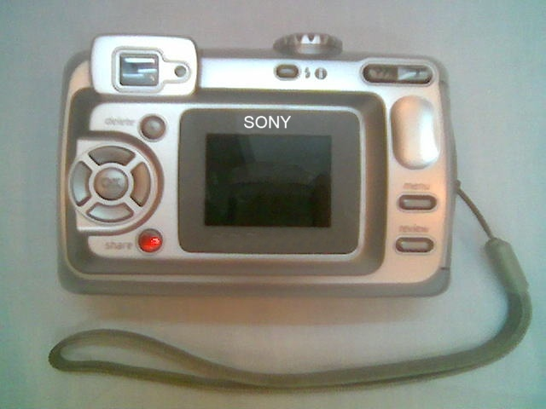
Fig.(6): Sony cyber shot digital still camera.

2.2. Therapeutic Equipment:
2.2 _{(a)} Ultraviolet A lamp. (Figure 7_{a, b})
Semi-circular (PUVA 200) base units can be combined to form a radiation system. This allows areas of the body for partial body irradiation (feet / lower legs arms) on both sides, are exposed around the same time. Radiation is emitted by fluorescent type tubes (low pressure). The treatment of the patient sitting. Combination therapy of psoralen plus UVA (PUVA photo chemotherapy, 320–400 nm, peaks at 352 nm).
Technical specification of UV 200 was:
Dimensions: approximately 273 x 489 x 331 mm
Weight: approximately 10, 6 kgs
Coating powder: similar to RAL 9010 (white)
Power consumption: 170 W cos φ 0, 59
Mains connection: 230 V / 50 Hz
Connection cable: 1 m with plug for non-heating appliances
Lamp types: 14 UV fluorescent lamps (PUVA) 8 Watts
Control unit: Illuminated LCD control for Joule or time input.
2.2 _{(b)} UV Cabinet (Figure 8)
This cabinet is a medical device intended for therapy of dermatological pathology under medical surveillance. Phototherapy is based on ultraviolet irradiation of patient (UVA for photo chemotherapy, UVB for phototherapy). The cabinet is fully body device allowing delivery of known quantity of UVA or UVB radiation. Radiation is emitted by fluorescent type tubes (low pressure). The radiation level set point is determined by the user, using a console for entry and display. In this study this cabinet was used to produce restricted wave length (311-313 nm) Narrowband UVB (NB UVB).
Two operational modes are available:
Energy controlled (dose): the prescription is given in the energy (J/cm2) and the time is automatically seated.
Time controlled: session duration is directly programmed by the user and the dose is automatically seated.
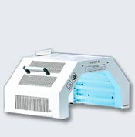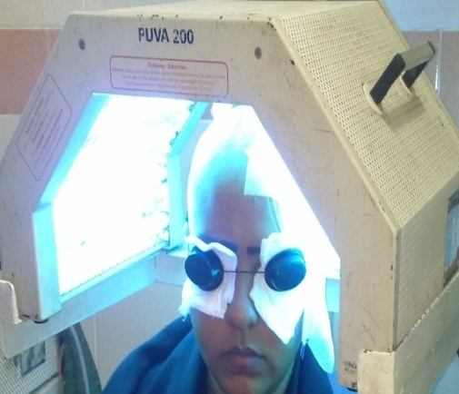
Fig.(7_{a, b}): Semi-circular (PUVA 200).
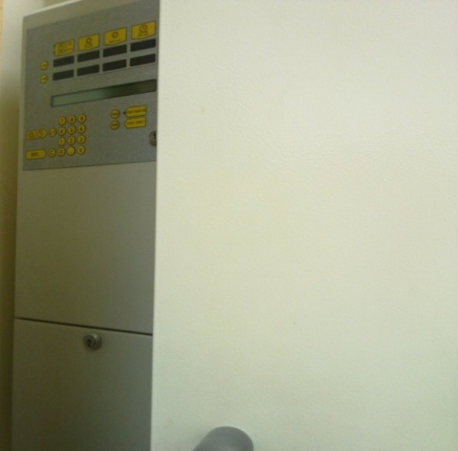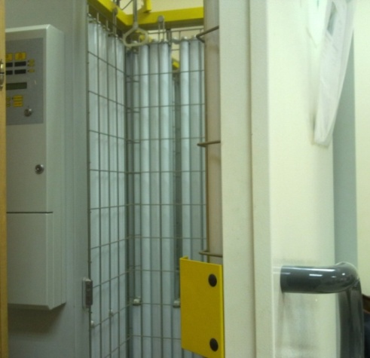
Fig.(8_{a, b}):Closed and opened UV cabinet.

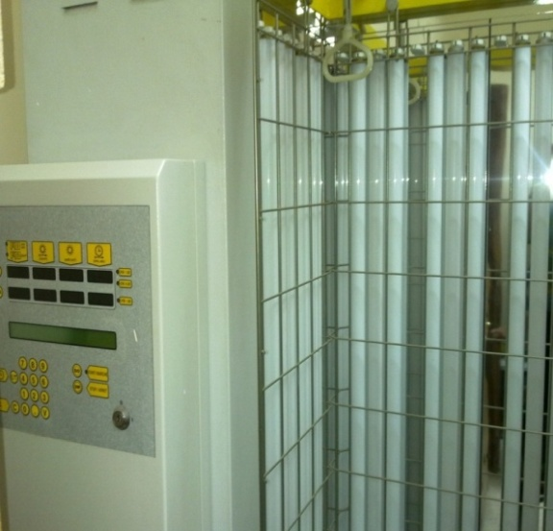
Fig. (8_{c}): Opened UV cabinet (digital display unit).
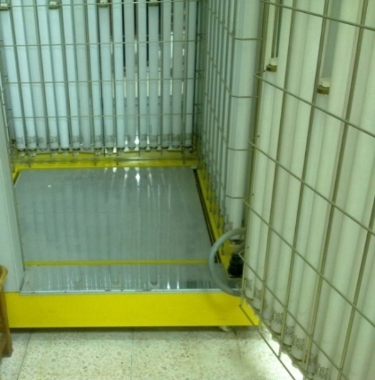
Fig. (8_{d}):Lowering portion of UV cabinet.
3. Procedures of the study:
The procedures of this study were classified into the following
3.1. Measurement procedures:
In this phase, the assessment procedures were conducted through the following technical measurements:
3.1 _{(a)} Photographic procedures by using digital camera:
- Sony cyber shot S40.4.Imega pixels, zoom 3x optical zoom.
- Photographic picture was taken to the affected area before the beginning of the treatment and after the end of it.
- The light of the room was good enough to obtain clear photo and the same intensity in follow up.
- The camera was holed vertical to the affected area.
- Photos were taken with dark background.
- The position of the patient, the distance of photographs, the illumination the magnification and the background were fixed for every patient.
3.1 _{(b)} Alopecia grading (SALT scoring system):
- The Severity of Alopecia Tool (SALT) scoring system scale was graded from no hair loss to total hair
- The SALT score assessment was done at the beginning of the study before starting of the treatment to determine grade of alopecia
- The SALT score was explained for every patient.
- The baseline assessment of alopecia grading was performed using
A 6 point SALT score as shown in table (3)
Table (3):- The grades of SALT score (Olsen et al., 2004).
Grade | Description
S0 | no hair loss
S1 | ≤ 25% hair loss
S2 | 25–49% hair loss
S3 | 50–74% hair loss
S4 | 75–99% hair loss (a = 75–95%, b = 96–99%)
S5 | 100% hair loss
3.1 _{(c)} Global assessment:
- The extent and density of regrowth was taken by the Severity of Alopecia Tool (SALT) scoring system (Overall improvement).
- Global assessment was graded from worse to clearance.
- The Global assessment was done through the treatment to determine the degree of the improvement
- The scale was explained for every patient.
- The Global assessment of extent and density of regrowth was first note percent regrowth, then further categorize by as shown in table (4).
Table (4):- The grades of Global scale (Olsen et al., 2004).
Grade | Description
A0 | no change or further loss
A1 | 1-24% regrowth,
A2 | 25-49% regrowth
A3 | 50-74% regrowth
A4 | 75-99% regrowth
A5 | 100% regrowth
3.2. Treatment procedures:
In this study treatment protocol was presented under the following heading:
3.2 _{(a)} Psoralen plus ultraviolet A application (PUVA) :( Figure-9_{a,b,c})
- The patient was checked carefully to make sure there were no contraindications.
- Before treatment all patients were given their written informed consent for UV treatment.
- The patient was placed in suitable position.
- The dose of UVA light was measured in joules per square centimeter, which was an amount of energy, and this was translated into a certain number of minutes of treatment. The output of the treatment units varied over time and different units emit different amounts of energy. Therefore, even if your dose of UVA light was constant, the time of treatment sessions varied from day to day.
- Starting therapy with8-methoxypsoralen (8-MOP) (Ultramedanine) topical. After 20 minutes of topical psoralen, the patients were instructed to sit under UVA lamp and he\she should wear goggles.
- The treatment given 3 times\week (every other day). First day of treatment was exposed for 3 minutes, and then increased to 6 minutes at the second session, 9 minutes at the third session, 12 minutes at the fourth session, then continue on 12 minutes for the rest of the session.
- The patient was asked to not look to the lamps and special safety glasses were worn by the patient during the treatment.
- Patient was asked to note the erythematic if marked or painful erythematic had occurred, therapy was stopped until erythematic relief, and then the session time was decreased to the previous level.
- The dose and frequency of treatments were gradually reduced once satisfactory clinical responses were achieved. The frequency were reduced to twice per week when terminal hair regrowth was seen with no further abnormal hair fall, then once per week, and ﬁnally terminated when regrowth was maintained.
- The interval between topical psolaren and being exposed to light
was also held constant because peak levels of psoralen in the skin.
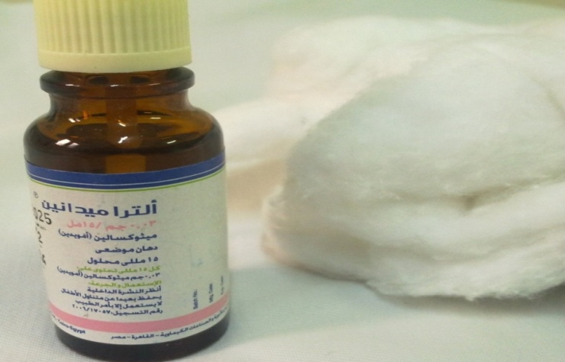
Fig.(9_{a}):8-methoxypsoralen (8-MOP) (Ultramedanine) Psolaren.
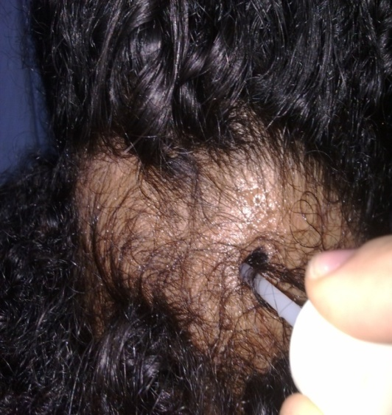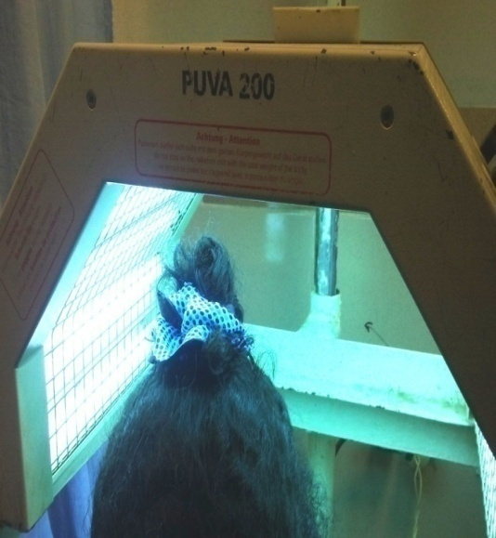
Fig.(9_{b,c}): Psolaren plus ultraviolet A application procedures.

3.2 _{(b)} NB UVB Application:
VERRIE ETQUARTZ EMILY 98 ABRP 64 (UV cabinet) (Figure-10)
- Before the beginning of the treatment, the device safety measures were checked and the device was checked to be switched off.
- Then the appropriate time was selected (started by 3 minutes/session and increased the time gradually with the treatment progress depending on how the patient tolerated the last treatment).
- Before treatment all patients were given their written informed consent for UV treatment
- The patient was checked carefully to make sure there were no contraindication
- The non treated areas were protected from UVR exposure.
- The patient was placed in suitable position.
- The patient was asked to not look to the lamps and special safety glasses were worn by the patient during the treatment.
- The cabinet door was closed and the patient was asked to pull both grips inside the device.
- Switch on the device.
- Programming NB UVB session was done through:
- Selection the programming mode (the time mode) was done through pressing the E/T key one time.
- Selection of type of tube used was done through pressing UVB key then (V) key was pressed to confirm the selection of this type of tube.
- Set point entry was done by entering the desired time (starting time was 3 minutes/session) then (V) key was pressed to confirm the selection of set point entry. The time was increased gradually with the progression of the treatment according to the patient tolerance.
- First day of treatment was exposed for 3 minutes, and then increased to 6 minutes at the second session, 9 minutes at the third session, 12 minutes at the fourth session, then continue on 12 minutes for the rest of the session.
- Start key was pressed to begin the session.
- After the end of the treatment, the device was switched off, and the patient was allowed to come out and then the treated area was checked.
- Patient was asked to note the erythematic if marked or painful erythematic had occurred, therapy was stopped until erythematic relief, and then the session time was decreased to the previous level.
- The dose and frequency of treatments were 3 times/week and then gradually reduced once satisfactory clinical responses were achieved. The frequency were reduced to twice per week when terminal hair regrowth was seen with no further abnormal hair fall, then once per week, and ﬁnally terminated when regrowth was maintained.

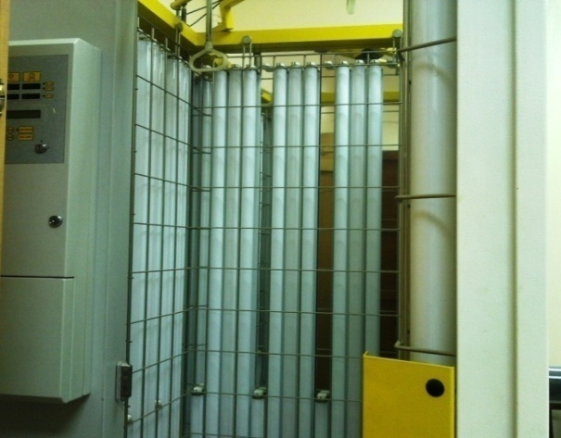
Fig.(10_{a}):UV Cabinet.
NB UVB application procedure (preparatory and application phases).
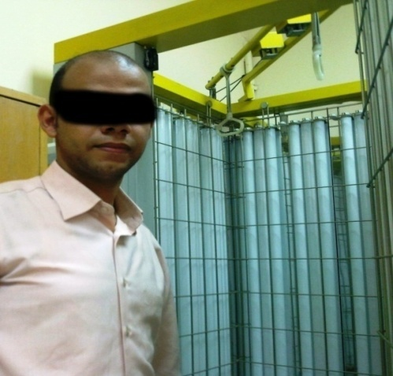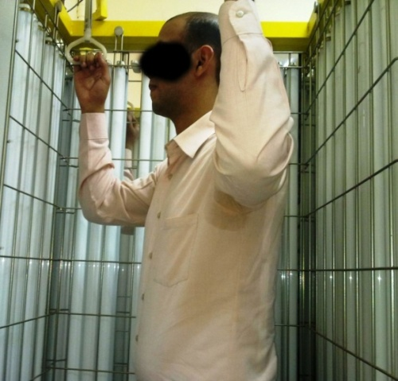
Fig.(10_{b,c}): Step one: Prepare patient before UV cabinet switch on.
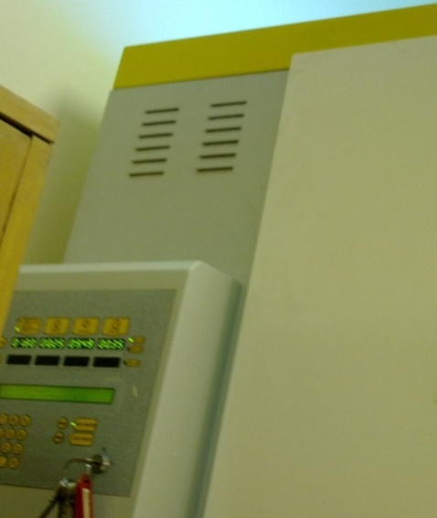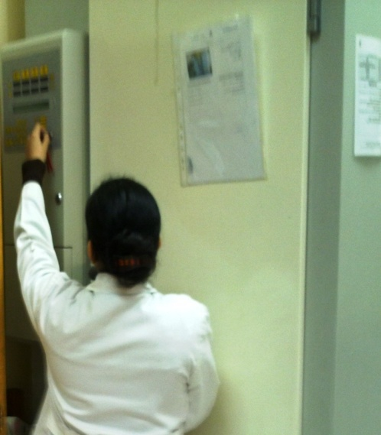
Fig.(10_{d, e}): Step two: Application of UV: Switch on UV cabinet, and then Switch off the cabinet and open the door.

4. Statistical procedures:
In this study, the clinical data were recorded on the evaluate sheet. These data were transferred with statistical program to obtain the following statistical tools:
4.1. Descriptive statistical tools
- In this study, the mean, the standard deviation and the standard error were calculated for all patients (2 groups of the study) after the detected time of the time of the study. The mean, the standard deviation and range were used as a primary source of connecting facts about each parameter to measure central tendency.
4.2. Analytical statistical tools
- Friedman Test: (Non parametric Repeated Measures ANOVA) to compare the variable within each group to detect level of significance in each group.
- Wilcoxon signed ranks test: To compare the variable between groups was used to detect significance level between two groups (comparison).
N.B. Both the descriptive and the analytic statistical were used to examine, describe and analyze the collected data in order to detect if there was any inter group differences before and after treatment application. The statistical package for social science (SPSS) was utilized for data analysis and the level of significance was set at the 0.05 level (Pipkin, 1984).

CHAPTER IV
RESULTS

The purpose of this study was to investigate the efficacy of narrow band ultraviolet B (NB UVB) versus psolaren ultraviolet A (PUVA) on the treatment of patients with Alopecia areata. Sixty patients participated in this study. Patients were randomly subdivided into two matched groups, each group consisted of 30 patients, the first group was received PUVA treatment, and the second group was received NB UVB
This chapter was intended to present the collected data (SALT scoring system and Global scale) that were assessed before application of treatment (pre-treatment), and after one and half month or 18 sessions of treatment application (post-treatment one) and after three months or 36 sessions of treatment application (post-treatment two) for each patient in both groups of the study (Group A + Group B).
The units of this chapter are presented as follows:
1. The Statistical analysis and results of patient demographic data
1.1. Age:
- As observed in table (5), the mean value of age of group A was 28.66±6.07 years, with maximum value of 40 years and minimum value of 20 years. While that of group B was 28.3±6.17 years, with maximum value of 40 years and minimum value of 20 years.
- It is clear from table (5) that there was non significant difference in the mean values of age between both groups of the study (group A and group B) (P= 0.81).
- Figure (11) showed the mean values of age between both groups of the study (group A and group B).
1.2. Percentage of males and females
The data in table (6) represented the percentage of males and females in each group of the study. In group (A) the number of males was 23 patients with a percent of 76.67% and the numbers of females was 7 patients with a percent of 23.33%. In group (B), the number of males was 25 patients with a percent of 83.33% and the numbers of females was 5 patients with a percent of 16.67%.
- As shown in table (6) there was no significant difference between both groups of the study (in the percentage of males and females) as reflected by the Chi-square test where (p- value = 0.74).
- Figure (12) showed the percentage of males and females in group A.
- Figure (13) showed the percentage of males and females in group B.

Table (5): Comparison of patients demographic data (age) in both groups of the study (groups A and B).
Item | Age (years)
Item | Group (A) | Group (B)
 | 28.66 | 28.3
SD± | 6.07 | 6.17
Max. value | 40 | 39
Range | 20 | 19
Min. value | 20 | 20
t-value | 0.23 | 0.23
p-value | 0.81 | 0.81
Level of significance | NS | NS
*NS: no significance. P value: Probability Level, SD±: Standard deviation and = Mean

Fig. (11): The Mean values of patients age of both groups of the study (A and B).

Table (6):The Percentages of males and females in both groups of the study(A and B).
Sex | Group A |  | Group B |  | Chi-square value | p-  value | Level  of significant
Sex | Number | Percentage | Number | Percentage | Chi-square value | p-  value | Level  of significant
Males | 23 | 76.67% | 25 | 83.33% | 0.41 | 0.74 | NS
Females | 7 | 23.33% | 5 | 16.67% | 0.41 | 0.74 | NS
*NS: no significance and P value: Probability Level.

Fig.(12): The Percentages of males and females in group (A).

Fig. (13): The Percentages of males and females in group (B).

2. Results and statistical analysis of Alopecia grading (SALT scoring system):
2.1. Alopecia grading of group A
The statistical analysis of the median value of SALT scoring system before application of treatment (pre treatment), after one month and half (18 sessions) (post ₍₁₎) and after three months of treatment application (36 sessions) (post ₍₂₎ ) of PUVA (group A) was discussed as follows:
- As reflected from table (8) the median value of SALT scoring (Alopecia grading) pre treatment was 3 with a maximum and minimum values of 5 and 1 respectively. While the median value of SALT scoring of group (A) after 18 sessions of treatment application was 2 with a maximum and minimum values of 4 and 0 respectively and the median value of SALT scoring after 36 sessions of treament application was 1 with a maximum and minimum values of 4 and 0 respectively.
- As shown also in table (8) there were a significant difference in Alopecia grading of group (A) after 18 sessions (post ₍₁₎ ) and 36 sessions (post ₍₂₎ ) when compared with the corresponding value of before treatment application (pre treatment) respectively as the Friedman statistic value was 57.82 and p-value was (0.0001).
- Figure (14) showed the median values of alopecia grading of group A (PUVA).

Fig (14): The median values of alopecia grading of group A (PUVA).

2.2. Alopecia grading of group B
The statistical analysis of the median value of SALT scoring system before application of treatment (pre treatment), after one month and half (18 sessions) (post ₍₁₎) and after three months of treatment application (36 sessions) (post ₍₂₎ ) of NB UVB (group B) was discussed as follows:
- As reflected from table (9) the median value of SALT scoring (Alopecia grading) pre treatment was 3.5 with maximum and minimum values of 4 and 1 respectively. While the median value of SALT scoring of group (B) after 18 sessions of treatment application was 2 with maximum and minimum values of 4 and 0 respectively and the median value of SALT scoring after 36 sessions of treatment application was 1 with maximum and minimum values of 4 and 0 respectively.
- As reflected also from table (9) there were a significant difference in Alopecia grading of group (B) after 18 sessions (post ₍₁₎ ) and 36 sessions (post ₍₂₎ ) when compared with the corresponding value of before treatment application (pre treatment) respectively as the Friedman statistic value was 57 and p-value was (0.0001).
- Figure (15) showed the median values of alopecia grading of group B (NB UVB).

Fig (15): The median values of alopecia grading of group B (NB UVB).

Table (7): The median, range, maximum and minimum values of Alopecia grading (SALT scoring system) in both groups of the study (groups A and B).
 | Alopecia grading (SALT scoring system)
 | Group A |  |  | Group B
 | pre | post₍₁₎ | post₍₂₎ | pre | post₍₁₎ | post₍₂₎
Median | 3 | 2 | 1 | 3.5 | 2 | 1
Range | 3 | 3 | 1 | 3 | 3 | 1
Max. values | 5 | 4 | 4 | 4 | 4 | 4
Min. values | 1 | 0 | 0 | 1 | 0 | 0
Pre treatment = before treatment, Post ₍₁₎ = After 18 sessions of treatment, Post ₍₂₎ = After 36 sessions of treatment, Max. values = Maximum values and Min. values = Minimum values.

Fig. (16): The median values of Alopecia grading (pre, post ₍₁₎ and post ₍₂₎) of both groups of the study (groups A and B).

Table (8): The median values of alopecia grading of group A (PUVA).
SALT scoring system |  |  |  | χ² |  | p- value |  | Level of significant
Median
Pre | Post₍₁₎ | Post₍₂₎
3 | 2 | 1 |  | 57.82 |  | 0.0001 |  | S
Wilcoxon Signed Ranks Test
 |  |  | pre |  | post₍₁₎ |  | pre |  | post₍₂₎ | post₍₁₎ | post₍₂₎
Z-value |  |  | 4.98 |  |  |  | 4.88 |  |  | 4.77
p- value |  |  | 0.0001 |  |  |  | 0.0001 |  |  | 0.0001
Level of significance |  |  | S |  |  |  | S |  |  | S
χ² = Friedman statistic value, Z – value = Wilcoxon Signed Ranks Test., P- value = Prbability level and S = Significant.

Table (9): The median values of alopecia grading of group B (NB UVB).
SALT scoring system |  |  |  | χ² |  | p- value |  | Level of significance
Median
Pre | Post₍₁₎ | Post₍₂₎
3.5 | 2 | 1 |  | 57 |  | 0.0001 |  | S
Wilcoxon Signed Ranks Test
 |  |  | pre |  | post₍₁₎ |  | pre |  | post₍₂₎ | post₍₁₎ | post₍₂₎
Z-value |  |  | 4.91 |  |  |  | 4.9 |  |  | 4.86
p- value |  |  | 0.0001 |  |  |  | 0.0001 |  |  | 0.0001
Level of significance |  |  | S |  |  |  | S |  |  | S
χ² = Friedman statistic value, Z – value = Wilcoxon Signed Ranks Test, P- value = Prbability level and S = Significant.

2.3. Comparison of the statistical analysis results of Alopecia grading between both groups of the study(A and B):

2.3_{(a)} Comparison of pre values (A and B)
- As shown in table (10) there was no significant difference in the median values of alopecia grading pre treatment between both groups of the study (groups A and B) (p=0.55).
- Figure (17) showed the median values of alopecia grading pre treatment between both groups of the study (groups A and B).

Table (10):Comparison of pre values of alopecia grading between both groups of the study (A and B).
Item | Alopecia Grading
Item | Group A | Group B
Median | 3 | 3.5
Range | 3 | 3
U-value | 412.5
P-value | 0.55
Level of significance | NS
U-value: Mann-Whitney test value, P- value: Probability level and N.S: Non significant.

Fig. (17): The median values of alopecia grading (SALT scoring) pre treatment between both groups of the study (groups A and B).

2.3_{(b)}Comparison of post₍₁₎values (A and B)
- As shown in table (11) there was a significant difference in the median values of alopecia grading post₍₁₎ between both groups of the study (groups A and B) with group (A) showed better improvement than group (B) ( p = 0.01).

- Figure (18) showed the median values of alopecia grading post₍₁₎ between both groups of the study (groups A and B).

Table (11): Comparison of post₍₁₎ values of alopecia grading between both groups of the study (A and B).
Item | Alopecia Grading
Item | Group A | Group B
Median | 2 | 2
Range | 3 | 3
U-value | 304.0
P-value | 0.01
Level of significance | S
U-value: Mann-Whitney test value, P- value: Probability level and S: significant.

Fig. (18): The median values of alopecia grading post ₍₁₎ between both groups of the study (groups A and B).

2.3_{(c)} Comparison of post₍₂₎values (A and B)
- As shown in table (12) there was a significant difference in the median values of alopecia grading post₍₂₎ between both groups of the study (groups A and B) with group (A) showed better improvement than group (B) ( p = 0.01).
- Figure (19) showed the median values of alopecia grading post ₍₂₎ between both groups of the study (groups A and B).

Table (12): Comparison of post₍₂₎ values of alopecia grading between both groups of the study (A and B).
Item | Alopecia Grading
Item | Group A | Group B
Median | 1 | 1
Range | 1 | 1
U-value | 330.0
P-value | 0.01
Level of significance | S
U-value: Mann-Whitney test value, P- value: Probability level and S: Significant.

Fig. (19): The median values of alopecia grading post ₍₂₎ between both groups of the study (groups A and B).

2.4. Percentage of Alopecia grading (SALT scoring system):
2.4_{(a)} Percentage of Alopecia grading pre values (A and B):
- Table (13) showed that There was no significant difference in percentage of Alopecia grading system pre treatment between both groups of the study (groups A and B ) as reflected by Chi-square test where p-value was (0.74).
- Figure (20) showed the percentage of Alopecia grading (pre treatment) of both groups of the study (groups A and B).

Fig. (20): Percentage of Alopecia grading pre values of both groups of the study (A and B).

2.4_{(b)} Percentage of Alopecia grading post₍₁₎ values (A and B):
- Table (13) showed that There was a significant difference in percentage of Alopecia grading system after 18 sessions (post₍₁₎) between both groups of the study (groups A and B ) as reflected by Chi-square test where p-value was (0.04).
- Figure (21) showed the percentage of Alopecia grading (post ₍₁₎ ) of both groups of the study(groups A and B).

Fig.(21): Percentage of Alopecia grading post₍₁₎ values of both groups of the study (A and B).

2.4_{(c)} Percentage of Alopecia grading post₍₂₎ values (A and B):
- Table (13) showed that There was a significant difference in percentage of Alopecia grading system after 36 sessions (post₍₂₎) between both groups of the study (groups A and B ) as reflected by Chi-square test where p-value was (0.03).
- Figure (22) showed the percentage of Alopecia grading (post₍₂₎ ) of both groups of the study(groups A and B).

Fig.(22): Percentage of Alopecia grading post₍₂₎ values of both groups of the study (A and B).

Table (13): Percentage of SALT scoring system of both groups of the study (groups A and B)
Time of measurement |  | SALT scoring system |  |  |  |  |  |  |  |  |  |  |  | Chi-square value | p-value | S
 |  | Grade (0) |  | Grade (1) |  | Grade (2) |  | Grade (3) |  | Grade (4) |  | Grade (5) |  | Chi-square value | p-value | S
 |  | N | % | N | % | N | % | N | % | N | % | N | % | Chi-square value | p-value | S
Before treatment | Group(A) | - |  | - | - | 4 | 13.3% | 14 | 46.7% | 9 | 30% | 3 | 10% | 1.22 | 0.74 | NS
Before treatment | Group (B) | - | - | - | - | 3 | 10% | 12 | 40% | 13 | 43.3% | 2 | 6.7% | 1.22 | 0.74 | NS
Post₍₁₎ | Group (A) | - | - | 5 | 16.7% | 20 | 66.7% | 4 | 13.3% | 1 | 3.3% | - | - | 5.11 | 0.04 | S
Post₍₁₎ | Group (B) | - | - | 1 | 3.3% | 16 | 53.3% | 12 | 40% | 1 | 3.3% | - | - | 5.11 | 0.04 | S
Post₍₂₎ | Group (A) | - | - | 27 | 90% | 3 | 10% | - | - | - | - | - | - | 5.96 | 0.03 | S
Post₍₂₎ | Group (B) | - | - | 19 | 63.3% | 11 | 36.7% | - | - | - | - | - | - | 5.96 | 0.03 | S

3. Results and statistical analysis Regrowth grading system (Global scale):
3.1.Regrowth grading system of group A
The statistical analysis of the median differences of Regrowth grading system after one month and half (18 sessions) (post ₍₁₎) and after three months of treatment application (36 sessions) (post ₍₂₎ ) of PUVA (group A) was discussed as follows:
- As shown in table (15) the median values of Regrowth grading system of group (A) after 18 sessions (post₍₁₎) of treatment application was 3 with a maximum and minimum values of 4 and 0 respectively. While the median values of Regrowth grading system after 36 sessions (post ₍₂₎) of treatment application was 4 with a maximum and minimum values of 4 and 0 respectively.
- As shown also in table (15) there was significant difference in the median values of Regrowth grading system of group (A) after 18 sessions (post₍₁₎) and 36 sessions (post ₍₂₎ ) where P-value was (0.0001).
- Figure (23) shows the median values of Regrowth grading system of group A (PUVA).

Fig. (23): The median values of Regrowth grading system of group A (PUVA).

3.2. Regrowth grading system of group B
The statistical analysis of the median values of Regrowth grading system after one month and half (18 sessions) (post ₍₁₎) and after three months of treatment application (36 sessions) (post ₍₂₎ ) of NB UVB (group B) was discussed as follows:
- As reflected from table (16) the median values of Regrowth grading system of group (B) after 18 sessions (post ₍₁₎) of treatment application was 2 with a maximum and minimum values of 4 and 0 respectively. While the median values of Regrowth grading system after 36 sessions (post ₍₂₎) of treatment application was 4 with a maximum and minimum values of 4 and 0 respectively.
- As shown also in table (16) there were significant difference in the median values of group (A) after 18 sessions (post ₍₁₎ ) and 36 sessions (post ₍₂₎ ) where P-value was (0.0001).
- Figure (24) showed the median values of Regrowth grading system of group B (NB UVB).

Fig. (24): The median values of Regrowth grading system of group B (NB UVB).

Table (14): The median, range, maximum and minimum values of Regrowth grading system(Global scale) both groups of the study (groups A and B).
 | Regrowth grading system(Global scale)
 | Group A |  | Group B
 | post₍₁₎ | post₍₂₎ | post₍₁₎ | post₍₂₎
Median | 3 | 4 | 2 | 4
Range | 2 | 1 | 2 | 1
Max. values | 4 | 4 | 4 | 4
Min. values | 0 | 0 | 0 | 0
Post ₍₁₎: After 18 sessions of treatment, Post ₍₂₎: After 36 sessions of treatment, Max. values: Maximum values and Min. values: Minimum values.

Fig.(25): The median values of Regrowth grading system(post₍₁₎ and post₍₂₎) of both groups of the (groups A and B).

Table (15): The median values of Regrowth grading system (Global scale) of group A (PUVA).
Item | Regrowth grading system
Item | Post₍₁₎ | Post₍₂₎
Median | 3 | 4
Range | 2 | 1
Z-value | 5.01
P-value | 0.0001
Level of significance | S
Z – value: Wilcoxon Signed Ranks Test, P- value: Probability level and S: Significant.

Table (16): The median values of Regrowth grading system (Global scale) of group B (NB UVB).
Item | Regrowth grading system (Global scale)
Item | Post₍₁₎ | Post₍₂₎
Median | 2 | 4
Range | 2 | 1
Z-value | 5.03
P-value | 0.0001
Level of significance | S
Z – value: Wilcoxon Signed Ranks Test, P- value: Probability level and S: Significant.

3.3.Comparison of the statistical analysis results of Regrowth grading system (Global scale) between both groups of the study(A and B):

3.3_{(a)} Comparison of post₍₁₎ values (A and B)
- As shown in table (17) there was a significant difference in the median values of Regrowth grading system post₍₁₎ between both groups of the study (groups A and B) with group (A) showed better improvement than group (B) (p= 0.02).
- Figure (26) showed the median values of Regrowth grading system post ₍₁₎ between both groups of the study (groups A and B).

Table (17):Comparison of post₍₁₎ values of Regrowth grading system of both groups of the study (A and B).
Item | Regrowth grading system
Item | Group A | Group B
Median | 3 | 2
Range | 2 | 2
U-value | 314.5
P-value | 0.02
Level of significant | S
U value: Mann-Whitney test, P- value: Probability level and S: Significant.

Fig. (26): The median values of Regrowth grading system post ₍₁₎ values between both groups of the study (groups A and B).

3.3_{(b)} Comparison of post₍₂₎ values (A and B)
- As shown in table (18) there was a significant difference in the median values of Regrowth grading system post₍₂₎ between both groups of the study (groups A and B) with group (A) showed better improvement than group (B) (p= 0.01).
- Figure (27) showed the median values of Regrowth grading system post₍₂₎ between both groups of the study (groups A and B).

Table (18):Comparison of post₍₂₎ values of Regrowth grading system of both groups of the study (A and B).
Item | Regrowth grading system
Item | Group A | Group B
Median | 4 | 4
Range | 1 | 1
U-value | 330.0
P-value | 0.01
Level of significant | S
U value = Mann-Whitney test, P- value = Probability level and S = Significant.

Fig.(27): The median values of Regrowth grading system post₍₂₎ values between both groups of the study (groups A and B).

3.4 Percentage of Regrowth scoring system (Global scale):
3.4_{(a)} Percentage of Regrowth scoring system post₍₁₎ values (A and B):
Table (19) showed that There was a significant difference in percentage of regrowth score system after 18 sessions (post₍₁₎) between both groups of the study (groups A and B ) as reflected by Chi-square test where p-value was (0.03) with group (A) showed better improvement than group (B).
Figure (28) showed the percentage of regrowth score system (post₍₁₎ ) of both groups of the study(groups A and B).

Fig.(28): Percentage of regrowth score system post₍₁₎ values of both groups of the study (A and B).

3.4_{(b)} Percentage of Regrowth scoring system post₍₂₎ values (A and B):
Table (19) showed that There was a significant difference in percentage of regrowth score system after 36 sessions (post₍₂₎) between both groups of the study (groups A and B ) as reflected by Chi-square test where p-value was (0.03) with group (A) showed better improvement than group (B).
Figure (29) showed the percentage of regrowth score system (post₍₂₎ ) of both groups of the study(groups A and B).

Fig.(29): Percentage of regrowth score system post₍₂₎ of both groups of the study (A and B).

Table (19 ): Percentage of regrowth scoring system of both groups of the study (groups A and B).
 |  | Regrowth scoring system (Global scale) |  |  |  |  |  |  |  |  |  |  |  | Chi-square value | p-  value | S
 |  | Grade (0) |  | Grade (1) |  | Grade (2) |  | Grade (3) |  | Grade (4) |  | Grade (5) |  | Chi-square value | p-  value | S
 |  | N | % | N | % | N | % | N | % | N | % | N | % | Chi-square value | p-  value | S
Post₍₁₎ | Group (A) | - | - | - | - | 9 | 30% | 20 | 66.7% | 1 | 3.3% | - | - | 5.94 | 0.03 | S
Post₍₁₎ | Group (B) | - | - | 2 | 6.7% | 15 | 50% | 13 | 43.3% | - | - | - | - | 5.94 | 0.03 | S
Post₍₂₎ | Group (A) | - | - | - | - | - | - | 3 | 10% | 27 | 90% | - | - | 5.96 | 0.03 | S
Post₍₂₎ | Group (B) | - | - | - | - | - | - | 11 | 36.7% | 19 | 63.3% | - | - | 5.96 | 0.03 | S
*S: Significance, NS: no significance.

3.5. Correlation between age and Regrowth scoring system after treatment application:
3.5_{(a)} Correlation between age and Regrowth scoring system after 18 sessions of treatment:
The statistical analysis of the correlation between age and Regrowth scoring system after one month and half (18 sessions) (post ₍₁₎) was discussed as follows:
- As shown in table (20) there was a significant inverse correlation between age and Regrowth scoring system after 18 sessions where the r value equals (-0.68) and p-value was (0.0001).
- Figure (30) shows the Correlation between age and Regrowth scoring system after 18 sessions.

Table (20): Correlation Analysis between the age and Regrowth scoring system after 18 sessions.
Correlation coefficient
R-value | -0.68
P-value | 0.0001
Level of significance | S
R-value = correlation coefficient, P-value = probability and S = significant.

Fig. (30): Correlation between age and Regrowth scoring system after 18 sessions.

3.5_{(b)} Correlation between age and Regrowth scoring system after 36 sessions of treatment :
The statistical analysis of the correlation between age and Regrowth scoring system after three months (36 sessions) (post ₍₂₎) was discussed as follows:
- As shown in table (21) there was a significant inverse correlation between age and Regrowth scoring system after 36 sessions where the r value equals (-0.66) and p-value was (0.0001).
- Figure (31) shows the Correlation between age and Regrowth scoring system after 36 sessions.

Table (21): Correlation Analysis between the age and Regrowth scoring system after 36 sessions.
Correlation coefficient
R-value | -0.66
P-value | 0.0001
Level of significance | S
R-value = correlation coefficient, P-value = probability and S = significant.

Fig. (31): Correlation between age and Regrowth scoring system after 36 sessions.

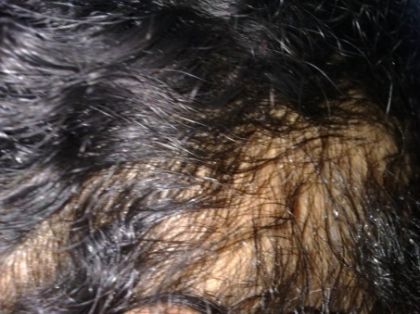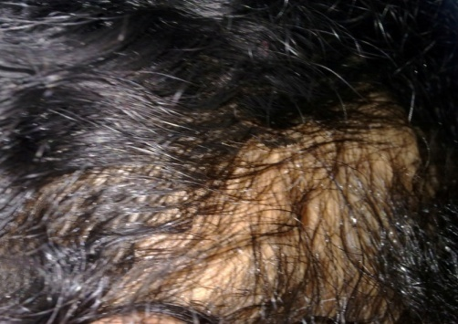
A B
Fig. (32): The photographic pictures for patient: A,pre treatement by PUVA, B post treatement by PUVA.
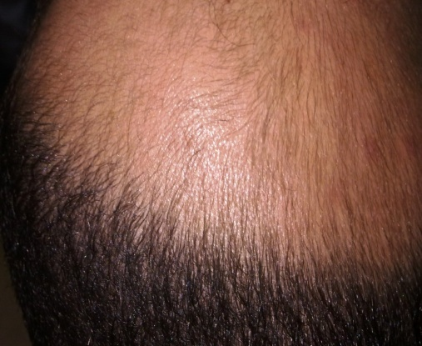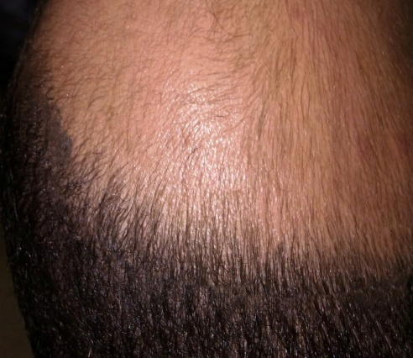
A B
Fig. (33): The photographic pictures for patient: A,pre treatement by PUVA, B post treatement by PUVA.
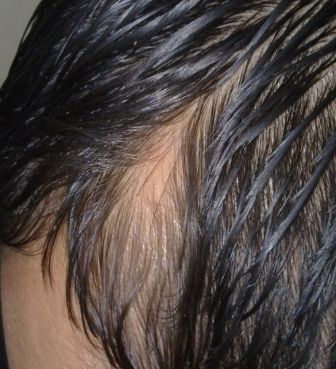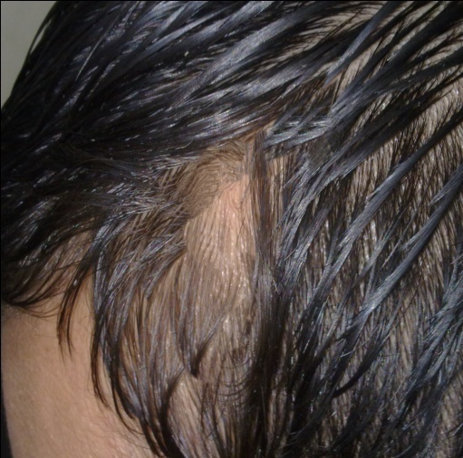
A B
Fig. (34): The photographic pictures for patient: A, pre treatement by PUVA, B post treatement by PUVA.
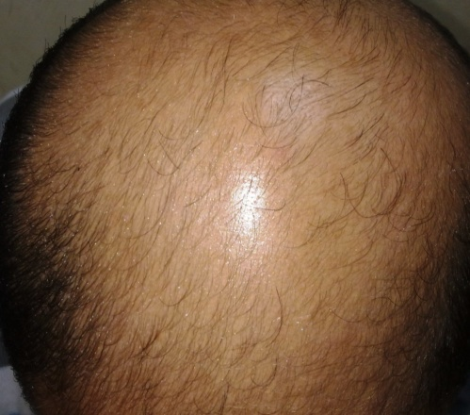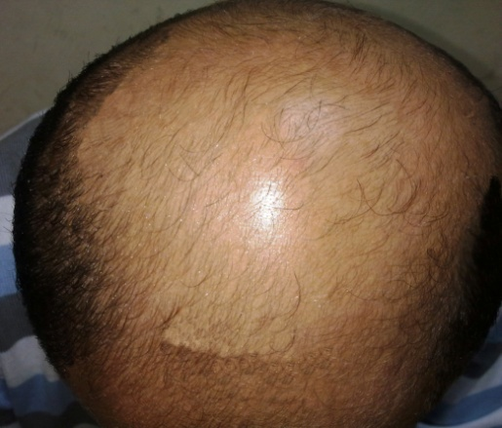
A B
Fig. (35): The photographic pictures for patient: A,pre treatement by NB UVB, B post treatement by NB UVB.
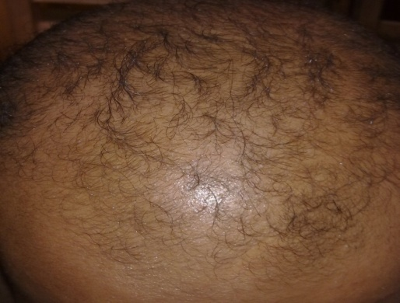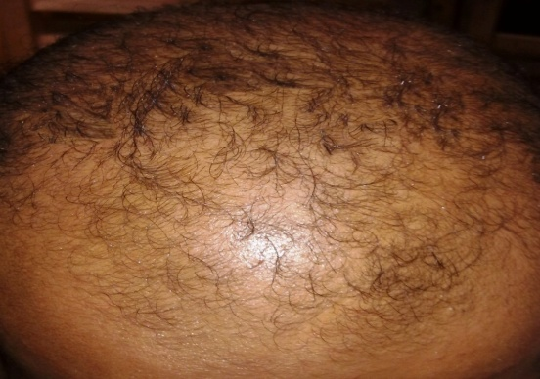
A B
Figure (36) The photographic pictures for patient: A,pre treatement by NB UVB, B post treatement by NB UVB.
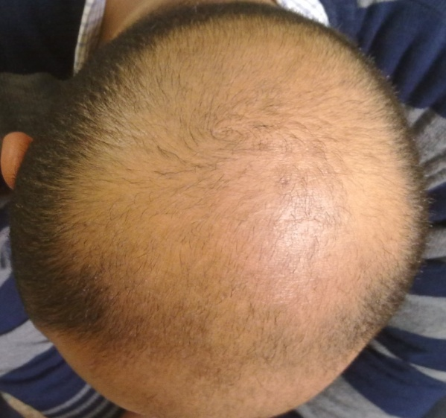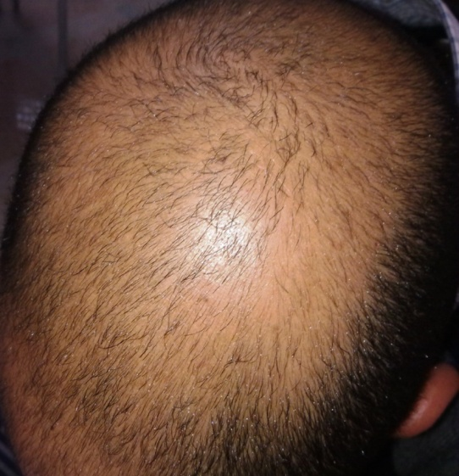
A B
Fig. (37): The photographic pictures for patient: A, pre treatement by NB UVB, B post treatement by NB UVB.
CHAPTER V
DISCUSSION
- The present study was designed to determine whether physical therapy intervention in a form of PUVA or NB UVB improve in restoring the normal level of hair bearing area in cases of alopecia areata.
- The parameters investigated in this study involved (SALT scoring system and Global scale). The SALT scoring system (alopecia grading): The Severity of Alopecia Tool (SALT) was graded from no hair loss to total hair loss. It was done at the beginning of the study (pre treatment) before starting of the treatment to determine grade of alopecia for both groups of the study. The baseline assessment of alopecia grading was performed using a 6 point scale score: S0 = no hair loss, S1≤ 25% hair loss, S2 = 25–49% hair loss, S3 = 50–74% hair loss, S4 = 75–99% hair loss (a = 75–95%, b = 96–99%), S5 = 100% hair loss (Olsen et al., 2004).
- Global scale: (Overall improvement) the extent and density of regrowth was taken by overall improvement. Global assessment was graded from worse to clearance. It was done through the treatment to determine the degree of the improvement (post₍₁₎) after one month and half or 18 sessions and (post₍₂₎) after three months or 36 sessions. First note percent regrowth, then further categorize by: A0 = no change or further loss, A1 = 1-24% regrowth, A2 = 25-49% regrowth, A3 = 50-74% regrowth, A4 = 75-99% regrowth, A5 = 100% regrowth (Olsen et al., 2004).

- The units of this chapter are summarized as following titles:
- Alopecia areata (AA) is an organ-specific autoimmune condition characterized by T cell mediated attack on the hair follicle (Gilhar et al., 2001). A dense per bulbar lymphocytic infiltrate and reproducible immunologic abnormalities are hallmark features of the condition. The cellular infiltrate primarily consists of activated T lymphocytes and antigen presenting Langerhans cells. T lymphocytes play a critical role in the pathogenesis of disease (Petukhova et al., 2010). Alopecia areata has a prevalence of about 0.1 to 0.2%, with a lifetime risk of 1.7%. There is no racial or sexual difference in incidence. Late-onset alopecia areata is characterized by marked female predominance and milder disease activity with increasing age (Wu et al., 2012).
- Alopecia areata has been shown to be responsive to systemic PUVA therapy, presumably via its immunomodulatory effects. As narrow band UVB had previously been demonstrated to be effective for a number of other PUVA-responsive disorders including psoriasis, par psoriasis and vitiligo, a few research teams have endeavored to determine the efficacy of narrow-band UVB light therapy for alopecia areata.
- This study has dealt with 60 patients with alopecia areata. They were randomly divided into two equal groups, PUVA group (group A) and NB UVB group (group B).
- This study was conducted to evaluate the efficacy of narrow band ultraviolet B (NB UVB) versus psolaren and ultraviolet A (PUVA) intervention on the treatment of patients with Alopecia areata.
- There was significant difference in Alopecia grading (SALT score) and Global scale between the PUVA group (group A) compared to the NB UVB group (group B).
- The finding of this study indicated a considerable difference in measuring in Alopecia grading (SALT score) and Global scale between pre-treatment and post₍₁₎, pre treatment and post₍₂₎, and post₍₁₎ and post₍₂₎ between both groups of the study(A and B).

- PUVA is a useful modality in controlling alopecia areata:
- PUVA can be used in the treatment of alopecia areata. Several researches and studies have reported significant effects of PUVA on regrowthing mechanism of hair loss.
- This concept of the results of this study concerning the effect of PUVA in treatment of alopecia areata confirm the observations of Mohammad et al.,(2010), Ito et al., (2009), Broniarczyk-Dyla et al., (2006), Whitmont and Cooper, (2003), Sahin et al., (1998), Behrens-Williams et al., (2001), Taylor and Hawk, (1995) and Happle, (1991)

(Mohammad et al., 2010) PUVA has been used with variable success in the treatment of AA. PUVA may be an effective treatment through its photo-immunologic effect on T cells. The immunosuppression induced by PUVA therapy can be attributed to different mechanisms: The disappearance of epidermal Langerhans cells and their decreased antigen-presenting capacity induces apoptosis (programmed self death) in T lymphocytes. PUVA has been shown to influence the release of cytokines. Because dendrite cells are thought to play an important role in the initiation of AA, PUVA might exert an inhibitory effect on the development of this form of hair loss. PUVA has been sown to stimulate the Dopa-negative melanocytes in the outer root sheath to divide and proliferate.
(Ito et al., 2009) used oral psolaren and ultraviolet A (PUVA) therapy plus oral prednisolone fr alopecia areata. They concluded that at 3 months, seven patients had greatly increased terminal hair growth on the whole scalp, and the remaining two (both with alopecia universalis) had moderately increased hair growth. The control group had significantly lower scores (P<0.01). Hair was maintained in all but two patients, both of whom relapsed 6 months after treatments were stopped.
(Broniarczyk-Dyla et al., 2006) PUVA-turban is a method of administering a dilute psoralen solution (8-methoxypsoralen 0.0001%) selectively to the scalp for 20 minutes using a cotton towel as a turban. The patient’s scalp is then exposed to ultraviolet A radiation. Treatment sessions are performed two or three times per week. PUVA-turban has been shown to be effective in about 70% of treated patients.
(Broniarczyk-Dyla et al., 2006) founded that during a follow up period of 15 months after PUVA-turban therapy, recurrences of alopecia areata were observed in 26% of responders. PUVA-turban therapy lacks the systemic side effects of oral PUVA and can be considered as alternative therapy for patients with alopecia areata.
(Whitmont and Cooper, 2003) have demonstrated complete hair regrowth in patients with AA totalis (53%) and AA universalis (55%) and a low relapse rate among these patients (21%) within a long period of follow up (means 5.2 years).
(Behrens-Williams et al., 2001) reported hair regrowth in 6 patients with AA refractory to other treatments after applying a 0.0001% solution (1 g/L) of 8-methoxypsoralen (8-MOP) at 37ºC to the scalp for 20 minutes with subsequent exposure to UVA radiation (PUVA-turban). They recommended that a large number of recurrences (between 30% and 50% of successfully treated patients) after initial hair regrowth, which strongly decreased the efficacy of PUVA treatment for AA. Because of an increased risk for skin malignancies after long-term therapy, PUVA cannot be recommended for AA, even if technical improvements such as a UVA-comb should ultimately prove to be effective.
(Sahin et al., 1998) showed that good results with cosmetically acceptable hair re-growth in 40% to 55% of treated patients, but there are no controls in any of the studies and, therefore, the claimed response-rate includes an unknown number of cases showing spontaneous re-growth and they claimed success rates of up to 56%, but the treatment required was extensive and included whole body irradiation.
(Taylor and Hawk, 1995) have examined treatment of AA with PUVA using either oral 8-methoxypsoralen (8-MOP) with ultraviolet A radiation (UVA) on the scalp or the whole body, or topical application of 8-MOP and UVA radiation on the scalp, including one study with topical application of psoralen via the PUVA-turban. They found the success rate to be, at best, 6.3% for partial alopecia areata and 12.5% for alopecia totalis and alopecia universalis. They concluded that PUVA generally is not an effective long-term treatment for alopecia areata. PUVA is a relatively safe treatment modality; adverse effects include burning and, possibly, an increased risk of skin cancer.
(Happle, 1991) the use of PUVA (psoralen plus ultraviolet light A) is based on the concept that the mononuclear cells and Langerhans cells that surround the affected hair follicles may play a direct pathogenic role and that PUVA therapy can eradicate this inflammatory cell infiltrate.

- Therapeutic results of the significant outcomes of PUVA are summarized as follow:
- PUVA has photo-immunologic effect on T cells.
- Decreased antigen presenting capacity induces apoptosis (programmed self death) in T lymphocytes.
- Influence the release of cytokines.
- Inhibitory effect on dendrite cells that play an important role in the initiation of AA.
- Stimulate the Dopa-negative melanocytes in the outer root sheath to divide and proliferate.
- PUVA therapy can eradicate the mononuclear cells and Langerhans cells that surround the affected hair follicles which play a direct pathogenic role.
- Anti inflammatory effect on cell infiltrate.

- NB UVB has a positive effects in the treatment of alopecia areata:

- Several studies have reported that the use of phototherapy with ultraviolet B light has been useful results in some patients with alopecia areata. The proposed mechanism of the action is dependent upon ultraviolet light induces biologic reactions in the skin cells which improve hair follicle growth.
- These finding of the present study are in agreement with the previous studies and past literatures conducted by Dilek Bayramgürler et al., (2011), Kircik et al., (2008), Engin et al., (2008), El Mofty et al., (2006), Jury et al., (2006), Weichenthal and Schwarz, (2005), and Friedli et al., (1993).

Narrow band UVB therapies have been used for treatment of many skin disorders such as psoriasis (Kircik et al., 2008), chronic urticaria (Engin et al., 2008), vitiligo (El Mofty et al., 2006), lichen nitidus, pruritus, and inflammatory dermatoses. Few studies have been performed on the value of NB-UVB in treatment of Alopecia Areata (Jury et al., 2006).
(Dilek Bayramgürler et al., 2011) used NB UVB therapy with 25 AA patients. Patients were divided into four groups according to extent of the disease. Four patients (22.2%) with extensive patchy hair loss and two patients (20%) with total entire scalp hair loss achieved excellent response. Four of six excellent responders also received concomitant corticosteroid injections. Although erythema induced by UVB is similar to other skin irritants used in the treatment, there is little evidence of efficacy. However, it is known that immunomodulatory effects of NB UVB are very important in the treatment of many skin diseases. It is also known that UVB is absorbed in the upper dermis, whereas UVA penetrates to the deeper dermis. Early pathological changes in AA show lymphocytic infiltration around the hair follicle; NB UVB cannot reach that depth. In this study group, most of their excellent responders were treated with combination therapy; therefore, the role of NB UVB in AA is questionable. In this retrospective, uncontrolled study, they have demonstrated that NB UVB is not an effective treatment with nearly 20% excellent treatment responses. Although response rates with NB UVB obtained in their study is comparable with some response rates of PUVA reported earlier (Alkhalifah et al., 2010), randomized controlled trials comparing the two methods are needed.
(Jury et al., 2006) used NB UVB with six AA patients with a median number of 20 sessions. Poor response rate was reported; 83% of the patients were recorded to be ‘no better’ by the end of the treatment.
(Weichenthal and Schwarz, 2005) founded that Narrow band UVB have been used in treatment of autoimmune diseases as PUVA. NB UVB is also decrease production and/or secretion of interleukin 1, interleukin 2 and monocyte chemotactic factor and decrease Langerhans cell members as well as Langerhans cell dependent T-lymphocyte activation. However, it is known that immunomodulatory effects of NB UVB are very important in the treatment of many skin diseases. It is also known that UVB is absorbed in the upper dermis, whereas UVA penetrates to the deeper dermis. Early pathological changes in AA show lymphocytic infiltration around the hair follicle; NB UVB cannot reach that depth.

(Friedli et al., 1993) indicated that the use of phototherapy with ultraviolet B light has been useful in some patients with alopecia areata. The proposed mechanism of action is that Ultraviolet (UV) light induces biologic reactions in the skin’s cells that decrease the number of skin cells that grow too quickly and kills T cells in the skin.
- Therapeutic benefits of NB UVB are summarized:
- Decrease production and/or secretion of interleukin 1, interleukin 2 and monocyte chemotactic factor.
- Decrease Langerhans cell members as well as Langerhans cell-dependent T-lymphocyte activation.
- NB UVB has immunomodulatory effects.
- Induces biologic reactions in the skin’s cells that decrease the number of skin cells that grow too quickly and kills T cells in the skin.

The finding of the present study showed non significant difference in the pre treatment of the Alopecia grading (SALT scoring system) and Regrowth grading system (Global scale) between the median values of Group A (PUVA application) and Group B (NB UVB application) (P>0.05). But, showed a significant decrease in the (SALT scoring system) and significant increase in Regrowth grading system between the median values of the Group A (after 18 sessions of PUVA application) and Group B (after 18 sessions of NB UVB application) (P<0.0001). Also showed significant decrease in (SALT scoring system) and significant increase in Regrowth grading system between the median values of Group A (after after 36 sessions of PUVA application) and Group B (after 36 sessions of NB UVB application) (P<0.0001).
Moreover, the results of this study showed significant decrease in the median values of (SALT scoring system) and significant increase in the median values of Regrowth grading system in group A after 18 sessions of PUVA application compared with the median values of the pre-application of PUVA of (SALT scoring system) and Regrowth grading system (P<0.0001).
The results of this study showed significant decrease in the median values of (SALT scoring system) and significant increase in the median values of Regrowth grading system in group A after 36 sessions of PUVA application compared with the median values of the pre-application of PUVA of (SALT scoring system) and Regrowth grading system (P<0.0001).
Moreover, the results of this study showed significant decrease in the median values of (SALT scoring system) and significant increase in the median values of Regrowth grading system in group A after 36 sessions of PUVA application compared with the median values of after 18 sessions of PUVA application of (SALT scoring system) and Regrowth grading system (P<0.0001).
Moreover, the results of this study showed significant decrease in the median values of (SALT scoring system) and significant increase in the median values of Regrowth grading system in group B after 18 sessions of NB UVB application compared with the median values of the pre-application of NB UVB of (SALT scoring system) and Regrowth grading system (P<0.0001).
The results of this study showed significant decrease in the median values of (SALT scoring system) and significant increase in the median values of Regrowth grading system in group B after 36 sessions of NB UVB application compared with the median values of the pre-application of NB UVB of (SALT scoring system) and Regrowth grading system (P<0.0001).
Moreover, the results of this study showed significant decrease in the median values of (SALT scoring system) and significant increase in the median values of Regrowth grading system in group B after 36 sessions of NB UVB application compared with the median values of after 18 sessions of NB UVB application of (SALT scoring system) and Regrowth grading system (P<0.0001).
The median values of the (SALT scoring system) pre-application, after 18 sessions of PUVA application and after 36 sessions of PUVA application in group A were 3, 2 and 1 respectively, while those of the group B pre- application, after 18 sessions of NB UVB application and after 36 sessions of NB UVB application were 3.5, 2 and 1 respectively.
The median values of (Regrowth grading system) after 18 sessions of PUVA application and after 36 sessions of PUVA application in group A were 3and 4 respectively, while those of the group B after 18 sessions of NB UVB application and after 36 sessions of NB UVB application were 2 and 4 respectively.
The results of this study indicated that there was significant decrease in the median values of the (SALT scoring system) and significant increase in the medain values of the (Regrowth grading system) after 18 sessions of PUVA application in group A compared with that of group B after 18 sessions of NB UVB application (P<0.0001).
Also the results of this study indicated that there was significant decrease in the median values of the (SALT scoring system) and significant increase in the median values of the (Regrowth grading system) after 36 sessions of PUVA application in group A compared with that of group B after 36 sessions of NB UVB application (P<0.0001).
The results of this study indicated that there was a significant inverse correlation between age and Regrowth scoring system after 18 sessions and after 36 sessions in both groups where the r value equals (-0.68) and (-0.66) respectively and p-value was (0.0001).
To avoid the possible implication of the placebo effect, results of the pre-treatment records for both the PUVA and NB UVB groups were compared with each other and showed non- significant differences between mean values of the (SALT scoring system) and (Regrowth grading system).
- Final finding:
Eventually, from the previous discussion of these results and according to reports of the researches in fields related to this study, it could be claimed that the application of both PUVA and NB UVB had a valuable effects on Alopecia areata as evidenced by the significant decreases in the (SALT scoring system) and the significant increases in the (Regrowth grading system). But PUVA application was more fruitful than NB UVB application.

CHAPTER VI
SUMMARY, CONCLUSION and RECOMMENDATIONS

SUMMARY
Alopecia areata is a complex genetic, immunemediated disease that targets anagen hair follicles, characterized by non scarring hair loss on the scalp or any hair bearing surface. Men and women are equally affected and the prevalence is almost the same for all ethnic groups. It is a common disease and at any given time, about a 0.2% of people are involved with alopecia areata and 1.7% of the populations experience an episode of alopecia areata during their lifetime, affects both children and adults. The etiology and pathogenesis of alopecia areata is still uncertain but many factors have been described in its pathogenesis genetic, family history, the atopic state, non-specific immune and organ specific autoimmune reaction, possible emotional stress, infectious agents and neurological factors.
The efficacy of NB UVB and PUVA for treating patients with alopecia areata was the subject of this study.
The purpose of the current study was to investigate the efficacy of NB UVB versus PUVA in the treatment of Alopecia areata.
Sixty patients (male and female) with Alopecia areata were recruited in this study, their ages ranged from 20-40 years; they were free from any other diseases that might affect or influence the results. The mean age of the group (A) or PUVA group was (28.66±6.07) years while the mean value of the group (B) or NB UVB group was (28.3±6.17) years.
The patients were divided randomly into two equal groups: Group (A)(PUVA group) included 30 patients with AA who were subjected to treatment by PUVA 3 times/week for 3 months or complete hair regrowth. Group (B) (NB UVB) included 30 patients with AA who were subjected to treatment by NB UVB 3 times/week for 3 months or complete hair regrowth.
All patients were evaluated before the treatment and after18 sessions and after 36 sessions of application of PUVA and NB UVB by using Alopecia grading (SALT scoring system) and Regrowth grading system Global assessment).
The finding of the present study showed non significant difference in the pre treatment of the Alopecia grading (SALT scoring system) and Regrowth grading system (Global scale) between the mean values of Group A (PUVA application) and Group B (NB UVB application) (P>0.05).
The finding of the present study showed a significant decrease in the (SALT scoring system) and significant increase in Regrowth grading system between the mean values of the Group A (after 18 sessions of PUVA application) and Group B (after 18 sessions of NB UVB application) (P<0.0001).
Also showed significant decrease in (SALT scoring system) and significant increase in (Regrowth grading system) between the mean values of Group A (after after 36 sessions of PUVA application) and Group B (after 36 sessions of NB UVB application) (P<0.0001).
The results of this study indicated that there was significant decrease in the mean values of the (SALT scoring system) and significant increase in the mean values of the (Regrowth grading system) after 18 sessions and after 36 sessions of application of PUVA in group A compared with that of group B after application of NB UVB (P<0.0001).
It was concluded that PUVA was beneficial therapeutic modality in the treatment of patients with Alopecia areata than NB UVB, that in expression of decrease the Alopecia grading (SALT scoring system) and improving of Regrowth grading (Global scale).

CONCLUSIONS
The findings of this study suggested the following outcomes:
- PUVA is a useful approach in controlling alopecia areata; PUVA treatment induces apoptosis (programmed self-death) in T-lymphocytes, influence the release of cytokines and PUVA therapy may be important to a successful clinical response.
- NB UVB is decrease production and/or secretion of interleukin 1, interleukin 2 and monocyte chemotactic factor and decrease Langerhans cell members as well as Langerhans cell-dependent T-lymphocyte activation
- PUVA is effective, easy to apply, painless and inexpensive therapy.
- The immunomodulatory effects of NB UVB are very important in the treatment of many skin diseases.
- UVB is absorbed in the upper dermis, whereas UVA penetrates to the deeper dermis.Early pathological changes in AA show lymphocytic infiltration around the hair follicle; NB UVB can not reach that depth.
- Measurement of improvement by (SALT scoring system), Regrowth grading (Global scale) are qualitative approach to measure the rate of improvement and photographic documentation method is quantitative approach to measure the rate of improvement.
- Early intervention of PUVA or NB UVB is crucial, and most patients can be offered hope and support to help them cope with the months of treatment usually needed to achieve reduction in disease symptoms.

RECOMMENDATIONS
- The results of this study considered the following recommendations:

- PUVA and NB UVB need long time to produce good result.
- Further researches should be undertaken to evaluate the data obtained after applying different lines of treatment to treat alopecia.
- Further researches should be done to use other objective findings to measure the degree of improvement.
- A similar study should be undertaken to large number of patients providing better statistical analysis of data.
- A similar study should be undertaken to study the effect of UV radiation on patients with alopecia (over years).
- To investigate long term evaluation after long period of treatment.
- Further researches should be done to investigate long term evaluation after long period of treatment.
- It is recommended to add both PUVA and NB UVB with different approaches and various lines of treatment of alopecia areata.
- Similar studies should be conducted on patients with other types of Alopecia.
- Follow up studies of various treatment duration would be of great interest.

REFERENCES
Afag F. (2011); Natural agents: Cellular and molecular mechanisms of photoprotection. Archives of Biochemistry and Biophysics, Vol.508, pp. 144-151, ISSN 0003-986.
Agar N and Young AR. (2005); Melanogenesis: A photo protective response to DNA damage? Mutat. Res. 571:121-132.
Agarwal A, Nath J and Barna KN. (2006); Twice weekly 5 mg betamethasone oral pulse therapy in the treatment of alopecia areata. JEADV.20:1375-6.
Akron. (2009); The Chemical database. The Department of Chemistry at the University of Akron. http://ull. Chemistry. Uakron.edu/erd and search on CAS number. Last accessed: 7/7/09.
Alkhalifah A, Alsantali A, Wang E, Mc Elwee KJ and Shapiro J. (2010); Alopecia areata update: part II. Treatment. J Am Acad Dermatol 62: 191–202, quiz 203-194.
Alkhalifah A, Alsantali A, Wang E, Mc Elwee KJ and Shapiro J. (2010); Alopecia areata update: part I. Clinical picture, histopathology, and pathogenesis. J Am AcadDermatol. 62:177-88.
Al-Mutairi N. (2007); 308-nm excimer laser for the treatment of alopecia areata. Dermatol Surg. 33(12):1483–1487.
Al-Mutairi N. (2009); 308-nm excimer laser for the treatment of alopecia areata in children. Pediatr Dermatol. 26(5):547–550.
Assouly P, Reygagne P, Jouanique C, Matard B, Marechal E and Reynert P, et al. (2003); Intravenous pulse methylprednisolone therapy for severe alopecia areata: An open study of 66 patients. Ann Dermatol Venereol. 130:326-30.
Behrens-Williams SC, Leiter U, Schiener R, Weidmann M, Peter RU and Kerscher M. (2001); The PUVA-turban as a new option of applying a dilute psoralen solution selectively to the scalp of patients with alopecia areata. J Am AcadDermatol. 44(2):248-52.
Berneburg M, Plettenberg H and Krutmann J. (2000); Photoaging of human skin. Photodermatol Photoimmunol Photomed. 16: 239–244.
Berwick M and Kesler D. (2005); Ultraviolet radiation exposure, vitamin D, and cancer. Photochem. Photobiol. vol. 18, n° 6, pp. 1262-1266
Broniarczyk-Dyla G, Wawrzycka-Kaflik A, Dubla-Berner M and Prusinska Bratos M. (2006); Effects of psoralen-UV-A-Turban in alopecia areata. Skinmed. 5(2):64–68.
Brown DB, Peritz AE, Mitchell DL, Chiarello S, Uitto J and Gasparro FP. (2000);Photochemical. Photobiological. 72:340–344.
Buckley DA and Du Vivier AWP. (2001);The therapeutic use of topical contact sensitizers in benign dermatoses. Br. J. Dermatol. 145, 385–405.
Cetin ED, Savk E, Uslu M, Eskin M, and Karul A. (2009); Investigation of the inflammatory mechanisms in alopecia areata. Am J Dermatopathol. 31:53-60.
Chang KH, Rojhirunsakool S and Goldberg LJ. (2009); Treatment of severe alopecia areata with intralesional steroid injections. J DrugsDermatol. Oct 8(10):909-12.
Chartaux E and Joly P. (2010); Long-term follow-up of the efficacy of methotrexate alone or in combination with low doses of oral corticosteroids in the treatment of alopecia areatatotalis or universalis. Ann DermatolVenereol. 137(8–9):507–513. French.
Chu SY, Chen YJ and Tseng WC, et al. (2011); Comorbidity profiles among patients with alopecia areata: The importance of onset age, a nationwide population-based study. J Am AcadDermatol. 65:949-56.
CIE Standard. (1998); Erythema reference action spectrum and standard erythema dose. CIE S 007/E- 1998. Vienna: Commission Internationale de l’Éclairage, 1998
Cipriani R, Perini GI and Rampinelli S. (2001); Paroxetine in alopecia areata. Int J Dermatol. 40(9):600–601.
Commission Internationale de l’Eclairage(International Commission on Illumination) (1987);Vocabulaire International de l’Eclairage[International Lighting Vocabulary] (CIE Publication No. 17.4), 4th ed., Geneva, Bureau Central de la Commission Electro technique international, p. 3.
de Berker DAR, Messenger AG and Sinclair RD. (2004); Disorders of hair. In: Burns DA, Breathnach SM, Cox N, Griffiths CE, editors. Rook’s textbook of dermatology. Vol. 4. 7th ed Oxford: Wiley- Blackwell. p. 63.1-63.120
Diffey B and Farr P. (2002); “Ultraviolet therapy in electrotherapy: Evidence – based practice”; (Eds) Kitchen, S and Bazin, S; 11^{th,} Churchill. Livingstone Comp; London; pp 192-207.
Dilek Bayramgürler, Evren Odyakmaz Demirsoy, Aysun S¸ikar Aktürk and Rebiay Kıran. (2011); Narrowband ultraviolet B phototherapy for alopecia areata. Photodermatology, Photoimmunology & Photomedicine. 27, 325–327.
Draelos ZD. (2007); Alopecia areata MedicineNet.com. Retrieved on December.
Driscoll PC, Campbell ID, Mott HR, Boyd J, Cooke RM and Weir MP. (1992); Secondary structure of human interleukin 2 from 3D heteronuclear NMR experiments. Biochemistry31 (33): 7741–7744.
Ehsani AH, Toosi S and Seirafi H, et al. (2009);Capsaicin vsclobetasol for the treatment of localized alopecia areata. J EurAcadDermatolVenereol. 23(12):1451–1453.
El Mofty M, Mostafa W, Esmat S, Youssef R, Azzam O, Hunter N, El Hanafi G and Fawzi M. (2006); Narrow band ultraviolet B 311 nm in the treatment of vitiligo: Two right-left comparison studies. Photodermatol Photoimmunol Photomed; 22:6-11.
Engin B, Ozdemir M, Balevi A and Mevlitoğlu I. (2008); Treatment of chronic urticaria with narrowband ultraviolet B phototherapy: A randomized controlled trial. ActaDermVenereol. 88:247-51.
Epstein E. (2001); Evidence based treatment of alopecia areata.J AmAcadDermatol. 45:640-2.
Farshi S, Mansouri P, Safar F and Khiabanloo SR. (2010); Could azathioprine be considered as a therapeutic alternative in the treatment of alopecia areata? A pilot study. Int J Dermatol.49 (10):1188–1193.
Ferguson J. (1999); Drug and chemical photosensitivity. In photo dermatology, Hawk JLM (ed) London: Arnold, pp. 155-169.
Ferran M, Calvet J, Almirall M, Pujol RM and Maymó J.(2011); Alopecia areata as another immunemediated disease developed in patients treated with tumor necrosis factor-α blocker agents: report of five cases and review of the literature. J Eur Acad Dermatol Venereol. 25:479-84.
Ferrando J and Grimalt R. (1999); Partial response of severe alopecia areata to cyclosporine A. Dermatology. 199: 67-69.
Finner AM. (2011); Alopecia areata: Clinical presentation, diagnosis, and unusual cases. Dermatol Ther. 24:348-54.
Food and Drug Association (FDA). (2009); The electronic orange book. U.S. food and drug administration. http://www.fda.gov/cder/ob/ default.htm and select Search by Active Ingredient and search on methoxsalen. Last accessed: 10/22/09.
Friedli A, Hunziker T, Finkel B and Braathen LR. (1993); Effects of acute, low-dose UVB radiation on the induction of contact hypersensitivity to diphenylcyclopropenone in man. Arch Dermatol Res285(1-2):1-5. PMID: 7682397.
Ghersetich I, Campanile G and Loti T. (1996);Alopecia areata: immune histochemistry and ultrastructure of infiltrate and identification of adhesion molecule receptors. Int JDermatol. 35: 28–33.
Gilhar A, Landau M, Assy B, Shalaginov R, Serafimovich S and Kalish RS. (2001); Melanocyte-associated T cell epitopes can function as autoantigens for transfer of alopecia areata to human scalp explants on Prkdc (scid)mice. J Invest Dermatol. 117: 1357–1362.
Gilhar A, Paus R and Kalish RS. (2007);Lymphocytes, neuropeptides, and genes involved in alopecia areata. J Clin Invest. 117: 2019-27.
Girman CJ, Hartmaier S, Roberts J, Bergfeld W and WaldstreicherJ. (1999);Patient-perceived importance of negative effects of androgenetic alopecia in women. J Womens Health Gend Based Med. 8:1091-5.
Gloor M and Scherotzke A. (2002);Age dependence of ultraviolet light-induced erythema following narrow-band UVB exposure. Photodermatol Photo immunol Photomed. 18: 121–126.
Goh C, Finkel M, Christos PJ and Sinha AA. (2006);Profile of 513 patients with alopecia areata: Associations of disease subtypes with atopy, autoimmune disease and positive family history. J EurAcadDermatolVenereol. 20:1055-60.
Gonzaga ER. (2009); Role of UV light in photodamage, skin aging, and skin cancer: Importance of photoprotection. Am J ClinDermatol 10 Suppl 1: 19-24.
Happle R. (1991); Topical immunotherapy in alopecia areata. J Invest Dermatol. 96: 71S–72S.
Harrison GI and Young AR. (2002); Ultraviolet radiation-induced erythema in human skin. Methods 28:14-19.
Harrison GI, Young AR and McMahon SB. (2004); Ultraviolet radiation-induced inflammation as a model for cutaneous hyperalgesia. J. Invest Dermatol. 122:183-189.
Heck DE, Gerecke DR, Vetrano AM and Laskin JD. (2004); Solar ultraviolet radiation as a trigger of cell signal transduction. ToxicolApplPharmacol 195, 288–97.
Holick MF. (2005);The vitamin d epidemic and its health consequences. J. Nutr. 135:2739S-2748S.
Hönigsmann H and Schwartz T. (2008);Ultraviolet therapy. In: Bolognia: Dermatology 2nd Edition. Elsevier Inc., Amsterdam, the Netherlands.
Hönigsmann H, Szeimies RR and Knobler R. (2008);Photochemotherapy and photodinamic therapy. In: Fitzpatrick Dermatology in General Medicine. McGraw-Hill Professional, New York, NY, USA, 2249–2262.
Hordinsky M and Ericson M. (2004);Autoimmunity: Alopecia areata. J Investing DermatolSymp Proc. 9:73-8.
Hull SM, Nutbrown M and Pepall L, et al. (1991);Immunohistologic and ultrastructural comparison of the dermal papilla and hair follicle bulb from “active” and “normal” areas of alopecia areata. J Invest Dermatol 1991; 96: 673–681.
Hussein MR. (2005); Ultraviolet radiation and skin cancer: Molecular mechanisms. J CutanPathol 32, 191–205.
Inui S, Nakajima T and Itami S. (2010); Coudability hairs: A revisited sign of alopecia areata assessed by trichoscopy. ClinExpDermatol. 35: 361–365.
Inui S, Nakajima T, Nakagawa K and Itami S. (2008); Clinical significance of dermoscopy in alopecia areata: Analysis of 300 cases. Int J Dermatol. 47: 688–693
Ito T, Aoshima M and Ito N, et al. (2009); Combination therapy with oral PUVA and corticosteroid for recalcitrant alopecia areata. Arch Dermatol Res. 301:373–80.
Ito T, Ito N and Saathoff M, et al. (2008); Maintenance of hair follicle immune privilege is linked to prevention of NK cell attack. J Invest Dermatol. 128:1196-206.
Jackow C, Puffer N, Hordinsky M, Nelson J, Tarrand J and Duvic M. (1998); Alopecia areata and cytomegalo virus infection in twins: Genes versus environment. J Am AcadDermatol. 38(3):418-25.
Johnson GJ. (2004); The environment and the eye. Eye 18:1235-1250.
Jury CS, McHenry P, Burden AD, Lever R and Bilsland D. (2006); Narrowband ultraviolet B (UVB) Phototherapy in Children. Clinical ExpDermatology; 31:196-9.Outcomes. J Drugs Dermatology; 7:245-53.
Kelly DA, Young AR, McGregor JM, Seed PT, Potten CS and Walker SL. (2000); Sensitivity to sunburn is associated with susceptibility to ultraviolet radiation-induced suppression of cutaneous cell-mediated immunity. J. Exp. Med. 191:561-566.
Kim BJ, Min SU and Park KY, et al. (2008); Combination therapy of cyclosporine and methylprednisolone on severe alopecia areata. J Dermatolog Treat.19 (4):216–220.
Kircik L, Bagel J, Korman N, Menter A, Elmets CA, Koo J, Yang YC, Chiou CF, Dann F, and Stevens SR. (2008); Unit study group utilization of narrow-band ultraviolet light B therapy and etanercept for the treatment of psoriasis (UNITE): Efficacy, safety, and patient-reported outcomes. J Drugs Dermatol; 7:245-53.
Kitchen SS and Partridge CJ. (1991); A review of ultraviolet radiation therapy. Phys.ther. (77): pp 423-432.
Krutmann J and Morita A. (1999); Mechanisms of ultraviolet (UVB) and UVA phototherapy. J. Invest. Dermatol. Symp. Proc.4 (1), 70–72.
Krutmann J, Honigsmann H, Elmets CA and Bergstresser PR. (2001); Dermatological Phototherapy and Photodiagnostic Methods. Berlin Springer 56-59.
Kuchabal SD and Kuchabal DS. (2010);Alopecia areata associated with localized vitiligo. Case Rep Dermatol. 2:27-31.
Kumar V, Pedroza LA and Mace EM, et al. (2011);The autoimmune regulator (AIRE), which is defective in autoimmune polyendocrinopathy candidias is ectodermal dystrophy patients, is expressed in human epidermal and follicular keratinocytes and associates with the intermediate filament protein cytokeratin 17. Am J Pathol. 178:983-8.
Kumar, Robbins and Cotran. (2005); Pathologic basis of disease, 7th (ed). Saunders.
Kurtev A and Iliev E. (2005); Thyroid autoimmunity in children and adolescents with alopecia areata. Int J Dermatol. 44:457- 61.
Lee D, Hong SK and Park SW, et al. (2010);Serum levels of IL-18 and sIL-2R in patients with alopecia areata receiving combined therapy with oral cyclosporine and steroids. ExpDermatol. 19(2):145–147.
Lew BL, Shin MK and Sim WY. (2009);Acute diffuse and total alopecia: a new subtype of alopecia areata with a favorable prognosis. J Am AcadDermatol. 60:85-93.
Loffreda M. (2005); Inflammatory diseases of hair follicles sweat glands and cartilage. In: Elden D, Elantsas R, Bernett J, et al. eds. Lever’s Histopathology of the Skin, 9th edn. Philadelphia: Lippincott Williams & Wilkins. 483–485.
Low J and Reed A. (2000); “Ultraviolet Radiation” In Electrotherapy Explained principles and practice; 3rd (ed); Butteworth Heinemann Comp, Oxford; pp.331-371.
MacDonald Hull SP, Wood ML, Hutchinson PE, Sladden M and Messenger AG. (2003); British Association of Dermatologists. Guidelines for the management of alopecia areata. Br J Dermatol. 149:692-9.
Man I, Dawe RS, Ferguson J and Ibbotson SH. (2003); An intraindividual study of the characteristics of erythema induced by bath and oral methoxsalen photochemotherapy and narrowband ultraviolet B. Photochem Photobiol.78: 55–60.
Mandani S and Shapiro J. (2000); Alopecia areata update. J Am AcadDermatol. 42:549–566.
Marks, James G, Miller, and Jeffery (2006); Look in gbill and Marks' Principles of Dermatology (4th Ed.).
Matsumura Y and Ananthaswamy HN. (2004); Toxic effects of ultraviolet radiation on the skin. Toxicol Appl Pharmacol. 195, 298–308.
Maverakis E, Miyamura Y, Bowen MP, Correa G, Ono Y and Goodarzi H. (2010); Light, including ultraviolet. J. Autoimmun.34 (3), J247–J257.
Mc-Donagh AJ and Tazi-Ahnini R. (2002); Epidemiology and genetics of alopecia areata. ClinExpDermotal. 27:405-9.
Mc-Donagh AJG and Messenger AG. (1996); The pathogenesis of alopecia areata. DermatolClin. 14: 661–70.
Mc-Michael AJ, Pearce DJ and Wasserman D, et al. (2007); Alopecia in the United States: Outpatient utilization and common prescribing pattern. J Am AcadDermatol. 57: Suppl: S49-S51.
Messenger AG and Bleehen SS. (1984);Alopecia areata. Light and electron microscopic pathology of the regrowing white hair. Br J Dermatol. 110: 155–162.
Messenger AG and Rundegren J. (2004); Minoxidil: Mechanisms of action on hair growth. Br. J. Dermatol. 150, 186–194.
Michlovitz S. (1996); Ultraviolet radiation in thermal agents in rehabilitation; 3rdEd; Davis Comp. London; pp 269-272.
Mohamed Z, Bhouri A, Jallouli A, Fazaa B, Kamoun MR and Mokhtar I. (2005); Alopecia areata treatment with a phototoxic dose of UVA and topical 8-methoxypsoralen. J EurAcadDermatolVenereol. 19(5): 552–555.
Mohammad S. N AL-Mashhadani, Wisam S. Najam, Rafal K and Farhan. (2010); Topical Psoralen And Ultraviolet A Radiation Treatment For Alopecia Areata Dept. of Medicine, Dept. of Microbiology, College of Medicine, Tikrit University. Tikrit Medical Journal 16(2):67-70.
Morison WL, Towne LE and Honig B. (1999);The photo aggravated dermatoses. In: Photo dermatology, Hawk JLM (ed) (London: Arnold, pp. 199-212.
Moyal DD and Fourtanier AM. (2003); Efficacy of broad-spectrum sunscreens against the suppression of elicitation of delayed-type hypersensitivity responses in humans depends on the level of ultraviolet A protection. Exp. Dermatol. 12:153-159.
Nanda A, Al-Fouzan AS and Al-Hasawi F. (2002); Alopecia areata in children: A clinical profile. PediatrDermatol. 19:482-5.
Neale RE, Purdie JL, Hirst LW and Green AC (2003); Sun exposure as a risk factor for nuclear cataract. Epidemiology, 14:707–712.
Norval M, Malley R and Woods GM. (2008); What’s new in photoimmunology? Photodermatol Photoimmunol Photomed. 24: 334-6.
Ntional Toxic Program (NTP). (1989); Toxicology and carcinogenesis studies of 8-methoxypsoralen (CAS No. 298-81-7) in F344/N Rats (Gavage Studies). Technical report series no. 359. Research triangle park, NC: National toxicology program. 134 pp.
Olsen E, Hordinsky M and McDonald-Hull S, et al. (1999); Alopecia areata investigational assessment guidelines. National Alopecia Areata Foundation. J Am AcadDermatol. 40: 242–246.
Olsen EA, Hordinsky MK and Price VH, et al. (2004); Alopecia areata investigational assessment guidelines – Part II. J Am AcadDermatol. 51: 440–447.
Orecchia G, Malagoli N and Santagostino L. (1994); Treatment of severe alopecia areata with squaric acid dibutylester in pediatric patients. Pediatr. Dermatol. 11, 65–68.
Pattison DI and Davies MJ. (2006); Actions of ultraviolet light on cellular structures. EXS 96, 131–57.
Paus R, Ito N, Takigawa M, and Ito T. (2003); The Hair Follicle and Immune Privilege. J InvestigDermatol Symp Proc. 8 (2): 188-94.
Paus R, Nickoloff BJ and Ito T. (2005); A ‘hairy’ privilege. Trends Immunol. 26:32- 40.
Paus R, Theoharides TC, and Arck PC. (2006);Neuroimmunoendocrine circuitry of the ‘brainskin connection’. Trends Immunol. 27:32–39.
Pazoki-Toroudi H, Ajami M and Babakoohi S, et al. (2010); Effects of diphencyprone on expression of Bcl-2 protein in patients with alopecia areata. Immunopharmacol. Immunotoxicol. 32, 422–425.
Peters EM, et al. (2006);Neuropeptide control mechanisms in cutaneous biology: physiologicaland clinical significance. J. Invest. Dermatol.126:1937–1947.
Peters EM, Liotiri S and Bodó E, et al. (2007); Probes the effects of stress mediators on the human hair follicle: Substance p holds central position. Am J Pathol. 171: 1872-86.
Petukhova L, Duvic M and Hordinsky M, et al. (2010); Genome-wide association study in alopecia areata implicates both innate and adaptive immunity. Nature. 466:113–17.
Pinnell SR. (2003);Cutaneous photo damage, oxidative stress, and topical antioxidant protection. J Am AcadDermatol 48, 1–19.
Pipkin FB. (1984); Medical statistics made easy. Edinburgh London. Melbourn and New York.
Ponsonby AL, Lucas RM and vand M. (2005);A potential role for UVR and Vitamin D in the induction of Multiple Sclerosis, Type 1 Diabetes, Rheumatoid Arthritis. Photochem. Photobiol.
Price VH. (1991); Alopecia areata: Clinical aspects. J Invest Dermatol. 96:68S.
Price VH. (2003); Androgenetic alopecia in women. J. Investig. DermatolSymp Proc. 8 (1): 24-7
Puavilai S, Puavilai G, Charuwichitratana S, Sakuntabhai A and Sriprachya-Anunt S. (1994); Prevalence of thyroid diseases in patients with alopecia areata. Int J Dermatol.33 (9):632- 3.
Ranganath VK and Furst DE. (2007); Disease-modifying anti rheumatic drug use in the elderly rheumatoid arthritis patient. Rheum Dis Clin North Am. 33(1):197–217.
Rapini, Ronald P, Bolognia, Jean L, Jorizzo, and Joseph L. (2007); Dermatology: 2-Volume Set. St. Louis: Mosby. 1-4160-2999-0.
Rashidi T and Mahd AA. (2008); Treatment of persistent alopecia areata with sulfasalazine. Int J Dermatol. 47(8):850–852.
Recupero SM, Abdolrahimzadeh S, De Dominicis M, Mollo R, Carboni I and Rota L, et al. (1999); Ocular alterations in alopecia areata. Eye 13(pt 5):643-6.
Restrepo R, MckeePh and Calonje E. (2005); Diseases of the hair. In: MckeePh, Calonje E, Granter SR, eds. Pathology of the skin with clinical correlations. 3th ed. Philadelphia: Elsevier Mosby, 1073–1079.
Robert SS, Elissa JL and Liisa V. (1998); Oral Psoralen and ultraviolet-A light (PUVA) treatment of psoriasis and persistent risk of nonmelanoma skin cancer. Oxford journals medicine JNCI J Natl cancer Inst 90(17): 1278-1284.
Robertson V, Ward A, Low J and Reed A. (2006); “Electrotherapy explained: Principles and practice” chapter 17: Ultraviolet radiation. Edinburg London New York Oxford Philadelphia St Louis Sydney Toronto.
Royer M, Bodemer C and Vabres P, et al. (2011); Efficacy and tolerability of methotrexate in severe childhood alopecia areata. Br J Dermatol. [Epub ahead of print].
Rünger TM. (2007); How different wavelengths of the ultraviolet spectrum contribute to skin carcinogenesis: The role of cellular damage responses. J InvestDermatol. 127: 2103-5.
Safavi K. (1992); Prevalence of alopecia areata in the first national health and nutrition examination survey. Arch Dermatol. 128:702.
Sage RJ and Lim HW. (2010); UV-based therapy and vitamin D. Dermatol. Ther. 23(1), 72–81.
Sahin S, Yalcin B and Karaduman A. (1998); PUVA treatment for alopecia areata. Experience in a Turkish population. Dermatology. 197(3):245-7.
Sasmaz S and AricanO. (2005); Comparison of azelaic acid and anthralin for the therapy of patchy alopecia areata: A pilot study. Am J ClinDermatol 2005: 6: 403–406.
Sato-Kawamura M, Aiba S and Tagami H. (2002);Acute diffuse and total alopecia of the female scalp. A new subtype of diffuse alopecia areata that has a favorable prognosis. Dermatology. 205: 367–373.
Scharffetter-Kochanek K, Brenneisen P, Wenk J, Herrmann G, MaW, Kuhr L, Meewes C and Wlaschek M. (2000);Photoaging of the skin: From phenotype to mechanisms. ExpGeront 35, 307–16
Shapiro J and Madani S. (1999); Alopecia areata: Diagnosis and management. Int J Dermatol. 38(suppl 1):19-24.
Shapiro J and Price VH. (1998); Hair regrowth: Therapeutic agents. DermatolClin. 16: 341-356.
Sharma VK and Gupta S. (1999);Twice weekly 5 mg dexamethasone oral pulse in the treatment of extensive alopecia areata. J Dermatol. 26:562-5.
Sheehan JM and Young AR. (2002); The sunburn cell revisited: An update on mechanistic aspects. Photochem. Photobiol. Sci. 1:365-377.
Shimmer BP and Parker KL. (2001); Goodman’s and Gillman’s: The Pharmacological basis of therapeutics. New York: McGraw-Hill, 1661–1663.
Shintani Y, Yasuda Y, Kobayashi K, Maeda A and Morita A. (2008); Narrowband ultraviolet B radiation suppresses contact hypersensitivity. Photodermatol Photoimmunol Photomed. 24: 32-7.
Sotiriadis D, Patsatsi A, Lazaridou E, Kastanis A, Vakirlis E and Chrysomallis F. (2007);Topical immunotherapy with diphenylcyclopropenone in the treatment of chronic extensive alopecia areata. Clin. Exp. Dermatol. 32, 48–51.
Stelekati E, Bahri R and D’Orlando O, et al. (2009);Mast cell-mediated antigen presentation regulates CD8+ T cell effector functions. Immunity 31:665-76.
Sternthal MB, Murphy SJ, George J, Kornbluth A, Lichtiger S and Present DH. (2008); Adverse events associated with the use of cyclosporine in patients with inflammatory bowel disease. Am J Gastro enterol.103(4):937–943.
Strober BE, Siu K, Alexis AF, Kim G, Washenik K and Sinha A, et al.(2005); Etanercept does not effectively treat moderate to severe alopecia areata; An open-lable study. J Am Acad Dermatol. 52:1082-4.
Talpur R, Vu J, Bassett R, Stevens V and Duvic M. (2009);Phase I/II randomized bilateral half-head comparison of topical bexarotene 1% gel for alopecia areata. J Am Acad Dermatol. 61(4):592. e591–e599.
Tan E, Tay YK, Goh CL and Chin Giam Y. (2002); The pattern and profile of alopecia areata in Singapore—a study of 219 Asians. Int J Dermatol. 41:748-53.
Tang L, Lui H, Sundberg JP, Bissonnette R, McLeanDI and Shapiro J. (2003); Restoration of hair growth with topical diphencyprone in mouse and rat models of alopecia areata. J Am AcadDermatol. 49:1013-9.
Taylor CR, Hawk JLM (1995); PUVA treatment of alopecia areata partialis, totalis and universalis: Audit of 10 years’experience at St John’s Institute of Dermatology. Br J Dermatol. 133:914-918.
Tobin DJ, Gardner SH, Lindsey NJ, Hoffmann R, Happle R and Freyschmidt-Paul P. (2002);Diphencyprone immunotherapy alters anti-hair follicle antibody status in patients with alopecia areata. Eur. J. Dermatol. 12, 327–334.
Tomany SC, Cruickshanks KJ and Klein R, et al. (2004);Sunlight and the 10-year incidence of age-related maculopathy: the Beaver Dam Eye Study. Arch Ophthalmol, 122:750–757. Erratum in: Arch Ophthalmol, 123:362.
Tosti A, Bellavista S and Iorizzo M. (2006); Alopecia areata: a long term follow-up study of 191 patients. J Am AcadDermatol. 55:438-41.
Tosti A, Piraccini BM, Pazzaglia M and Vincenzi C. (2003);Clobetasol propionate 0.05% under occlusion in the treatment of alopecia totalis/universalis. J. Am. Acad. Dermatol. 49, 96–98.
Trautinger F. (2001); Mechanisms of photodamage of the skin and its functional consequences for skin agening. ClinExpDermatol. 26, 573–7.
Vajdic CM, Kricker A, Giblin M, McKenzie J, Aitken JF, Giles GG and Armstrong BK. (2004);Artificial ultraviolet radiation and ocular melanoma in Australia.Int J Cancer 112:896-900.
Vieth R. (2005);The role of vitamin D in the prevention of osteoporosis. Ann. Med. 37:278-285.
Wang SJ, Shohat T, Vadheim C, Shellow W, Edwards J and Rotter JI. (1994); Increased risk for type I (insulin-dependent) diabetes in relatives of patients with alopecia areata (AA). Am J Med Genet. 51(3):234-9.
Wasserman D, Guzman-Sanchez DA, Scott K and McMichael A. (2007); Alopecia areata. Int J Dermatol. 46:121-31.
Weedon D. (2009);The dermis and the subcutis. In: Weedon’s skin pathology Vol. I. 3rd ed. London: Churchill Livingstone/ Elsevier, 422-4
Weichenthal M and Schwarz T. (2005); Phototherapy: How does UV work? photodermatol photoimmunol photomed 21(5): 260-266.
Werth VP, White WL, Sanchez MR and Franks AG. (1992); Incidence of alopecia areata in lupus erythematosus. Arch Dermatol.128 (3):368-71.
Whiting DA. (2003);Histopathologic features of alopecia areata: a new look. Arch Dermatol. 139:1555-9.
Whitmont K and Cooper A. (2003); PUVA treatment of alopecia areata totalis and universalis: a retrospective study. Australas J Dermatol. 44: 106–109.
Wilkinson F, Matthes R and Sliney D. (1998); Measurements of optical radiation hazards, international commission on nonionizing radiation protection. 653–684.
Wu MC, Yang CC and Tsai RY, et al. (2012); Late-onset alopecia areata: A retrospective study of 73 patients from Taiwan. J Eur Acad Dermatol Venereol. Feb 20. doi: 10.1111/j.1468-3083.2012.04467.
Wyatt EL, Sutter SH, and Drake LA. (2001); Dermatological pharmacology. In goodman and gillman’s the pharmacological basis of therapeutics. Hardman JG, Limbird LE, Eds. New York: McGraw Hill. pp. 1795-1818.

الملخص العربي
فاعلية الآشعة فوق البنفسجية المتوسطة الموجة "ب" مقابل
سولارين والآشعة فوق البنفسجيه "أ" في علاج الثعلبه
الهدف من البحث:
تهدف هذه الرساله لاستكشاف مدى فاعلية الآشعة فوق البنفسجية المتوسطة الموجة "ب" مقابل سولارين والآشعة فوق البنفسجيه"أ" في علاج الثعلبه مستخدما فى ذلك عدة طرق للقياس لاستخلاص التأثير العلاجي لكل وسيله.
مواد وأساليب البحث:
أجريت هذه الدراسة على ستين مريضا ممن يعانون من الثعلبه و قد تراوحت أعمارهم ما بين20-40 سنه و قد تم تقسيمهم عشوائيا إلى مجموعتين متساويتين فى العدد :-
المجموعة الأولي (مجموعةPUVA):
مجموعة السولارين والاشعه فوق البنفسيجيه"أ" وتضم ثلاثين مريض ممن يخضعون إلى العلاج باستخدام السولارين والاشعه فوق البنفسيجيه"أ" وأستمرالعلاج لمدة ثلاثة اشهر بواقع ثلاث مرات أسبوعيا.
المجموعة الثانية(المجموعهNB UVB):
مجموعة الآشعة فوق البنفسجية متوسطة الموجة "ب" وتضم ثلاثين مريض ممن يخضعون إلى العلاج باستخدام الآشعة فوق البنفسجية المتوسطة الموجه "ب" وأستمرالعلاج لمدة ثلاثة اشهر بواقع ثلاث مرات أسبوعيا.

طرق القياس
وقد تم التقييم باستخدام:
- التصوير الفوتوغرافى قبل العلاج وبعده
- حساب مساحه المنطقه المصابه عن طريق نظام التسجيل لشده الاصابه بالثعلبه وهو ما يعرف (SALT Scoring) ويقسم الي سته درجات S0: لا يوجد فقدان للشعر ,S1 : فقدان للشعر يعادل 1الي24%, S2 : فقدان للشعر يعادل ما بين 25% الي 49%, S3 : فقدان للشعر يعادل مابين 50% الي 74%, S4 : فقدان للشعر يعادل مابين 75% الي 95% و يعادل ايضا ما بين 96% الي 99%, S5 : فقدان للشعر يعادل 100% .
- حساب نسبه التحسن بواسطه(Global Scale) ويقسم الي سته درجات ايضا الي A0: لا يوجد تحسن او مزيد من فقدان للشعر,A1 :التحسن يعادل من 1 الي 24%, A2 : التحسن يعادل من 25% الي 49%, A3 : التحسن يعادل من 50% الي 74%, A4 : التحسن يعادل من 75% الي 99% ,S5: التحسن يعادل يعادل 100% .
النتائج
لقد أظهرت النتائج الآتى :
- أن هناك نقص ذو دلاله إحصائية في مساحة المنطقه المصابه و درجة تحسن المرضى بعد ثماني عشر جلسه و سته وثلاثون جلسه من بداية العلاج فى مجموعة السولارين والاشعه فوق البنفسيجيه "أ" (المجموعة العلاجية الأولى)
- أن هناك تحسن ملحوظ فى مظهر المنطقة المصابة بعد ثلاثه اشهر من العلاج لمعظم المرضى فى مجموعة الاولى.
- لم تكن هناك فروق ذات دلالة احصائية في مساحة المناطق المصابة و درجة تحسن المرضى بعد ثماني عشر جلسه و سته وثلاثون جلسه من بداية العلاج فى مجموعة الاشعه فوق البنفسيجيه متوسطه الموجه "ب" (المجموعة العلاجية الثانيه).
- ان هناك تحسن طفيف فى مظهر المنطقة المصابة بعد ثلاثه اشهر من العلاج لبعض المرضى فى المجموعة الثانيه.
الاستنتاجات
وعليه يمكن استنباط التالي: أن سولارين و الاشعه فوق البنفسيجيه "أ" ذات قوة علاجية افضل فى علاج الثعلبه عن الاشعه فوق البنفسيجيه متوسطه الموجه"ب" و ذلك عن طريق تأثيرها فى تقليل مساحه المنطقه المصابه و تحسين مظهر المنطقة المصابة.

فاعلية الاشعه فوق البنفسيجيه المتوسطه الموجه "ب" مقابل سولارين والاشعه فوق البنفسيجيه "أ" في علاج الثعلبه/ ايريني صبحي وهبه خليل المدرس المساعد بقسم العلاج الطبيعي للجراحه- كليه العلاج الطبيعي جامعه القاهره
إشراف:ا. د/ عادل عبد الحميد نصير استاذ ورئيس قسم العلاج الطبيعي للجراحه- كليه العلاج الطبيعي جامعه القاهره، ا. د/ حامد عبدالله حامد استاذ الجلديه والتناسليه - كليه الطب جامعه القاهره. جامعة القاهرة ، قسم العلاج الطبيعي للجراحة، درجة الدكتوراه ،2014

المستخلص العــــــــــــــــــــــــــــربي
كان الهدف من البحث أستكشاف مدى فاعلية الاشعه فوق البنفسيجيه المتوسطه الموجه"ب" مقابل سولارين والاشعه فوق البنفسيجيه"أ" في علاج الثعلبه .اشترك في هذه الدراسة:
- ستون مريض ممن يعانون من مرض الثعلبه و تتراوح أعمارهم بين20-40 سنة وتم تقسيمهم عشوائيا إلي مجموعتين متساويتين:
- المجموعة الأولى و تتضم30 مريضا ممن تلقين سولارين والاشعه فوق البنفسيجيه"أ".
- المجموعة الثانية و تتضم30 مريضا ممن تلقين الاشعه فوق البنفسيجيه المتوسطه الموجه"ب" و لقد أظهرت النتائج فروق ذات دلاله إحصائية بين المجموعتين (المجموعةالاولى و المجموعةالثانيه).و كانت أفضل النتائج بالنسبة لمساحة المنطقه المصابه و على مقياس درجة التحسن و أفضل النتائج بالنسبة لتحسن المظهر في المجموعة الاولى.
الكلمات الداله: (الثعلبه, الاشعه فوق البنفسيجيه متوسطه الموجه"ب", سولارين والاشعه فوق البنفسيجيه"أ").

فاعلية الآشعة فوق البنفسجية المتوسطة الموجة "ب" مقابل سولارين والآشعة فوق البنفسجيه "أ" في علاج الثعلبه

مقدمة من
ايريني صبحي وهبه
ماجيستير العلاج الطبيعي

رسالة مقدمة توطئة للحصول على درجة الدكتوراه في العلاج الطبيعي

كلية العلاج الطبيعي
جامعة القاهرة
2014

