RESEARCH ARTICLE

Ultrastuctural Intestinal Pathology Induced by Human Blastocystis in Experimentally Infected Mice
Naglaa S. M. El-Gebaly, Mayssa M. Zaki
Medical Parasitology Department, Faculty of Medicine, Cairo University Egypt
Received: January, 2012 | Accepted: April, 2012

ABSTRACT
Background: Blastocystis spp. is a single-celled anaerobic enteric parasite that inhabits the lower gastrointestinal tract of humans and many animals. This emerging parasite with a worldwide distribution is often identified as the most common eukaryotic organism reported in human fecal samples that showed a dramatic increase in recent years; however its pathogenicity still shows many contradictions.
Aim of the work: To evaluate the histological and ultrastructural pathological changes induced by human Blastocystis isolates in the intestine of experimental infected mice.
Methodology: Fecal samples positive for Blastocystis were collected from patients, and processed for culture using Jones' medium. Cultured samples were subjected to examination by light and transmission electron microscopy. Blastocystis cyst stages were isolated and orally fed to immunocompetent BALB/c mice. Mice were sacrificed 2 weeks post infection. Semi-thin and ultra-thin sections prepared from their intestine were examined by both light and transmission electron microscopy (TEM), respectively.
Results: Blastocystis showed different forms: vacuolar, granular, amoeboid and cysts within 24 hours in culture. Histological examination of infected intestine showed vacuolar, granular and amoeboid forms in the caecum, but only cyst forms were observed in the colon. Intense inflammatory cell infiltration, edematous lamina propria, and villous atrophy were noticed. Ultrastructure of Blastocystis hominis by TEM revealed the surface coat with outer fibrillar layer, nuclei with multiple chromatin masses, and mitochondria with some pathological tubular changes. Atrophy and sloughing of microvilli of infected intestine was noticed in comparison to the mucosa of control non-infected mice that showed normal brush border and microvilli.
Conclusion: Infection with Blastocystis may be self limited in some hosts however it may cause considerable pathological changes such as enterocytes invasion and intestinal mucosal atrophy of infected mice. Blastocystis Mitochondrial vaculations were detected within intestine of infected mice compared to culture forms. Thus, apparently B. hominis is capable of causing pathogenicity.
Key words: Blastocystis hominis, Culture, Transmission Electron Microscopy, Ultrastuctural Changes, Experimental Study.
Corresponding author: Mayssa M. Zaki, mayssaabcd@gmail.com
INTRODUCTION
Blastocystis hominis is a unicellular protozoan found in the large intestine of humans as well as many species of animals. The distribution of this parasite is very wide, especially in underdeveloped nations^{(1,2)}, with up to 60% incidences reported in the tropical, subtropical and developing countries^{(3,4)}. Most subtypes exhibit low host specificity, which may contribute to its zoonotic potential, especially as it has been noticed to be more prevalent in animal handlers^{(3,5,6)}.
Recent research has identified Blastocystis in some species of Australian wildlife but pathogenicity remains undetermined⁽⁷⁾. The pathogenic potential of B. hominis in the human intestine is controversial⁽⁸⁾. Several investigators reported the presence of the parasite in symptomatic and asymptomatic patients^{(4,8,9)}; and many studies have reported higher incidence of Blastocystis infection in irritable bowel syndrome (IBS)^{(2,9,10)}. In a study conducted in 2009, Dogruman et al.⁽¹¹⁾ showed an association between some Blastocystis species and IBS, inflammatory bowel diseases (IBD) diagnosed by endoscopy, and chronic diarrhea. Stark et al.⁽⁹⁾ proposed that low grade inflammation through persistent antigenic exposure in a chronic Blastocystis infection might be a possible mechanism. In addition, cases of B. hominis-induced enteritis⁽¹²⁾ and terminal ileitis⁽¹³⁾ were also reported.
However, it was noted that B. hominis is often found along with other organisms that are more likely to be the cause of diarrhea and therefore it was believed relevant to exclude infection with other parasites, bacteria or viruses⁽¹⁴⁾. It was advised that physicians, as well as diagnostic parasitologists, should be aware of the potential clinical significance of B. hominis, especially when more than five organisms per high power field are found⁽¹⁴⁾; while, positive findings with fewer numbers should be considered as carriers and followed up for any ill effect⁽¹⁵⁾. The number of symptomless infections has probably been grossly underestimated, because not all forms of B. hominis have been recognized in diagnosis, and many studies rely on the principal of detecting five or more organisms per oil immersion field⁽¹⁶⁾.
In addition to the three commonly recognized morphological forms of B. hominis; vacuolar, granular and ameboid, later studies described several additional forms; cystic, avacuolar and multivacuolar^{(15,17)}. Sukthana⁽¹⁴⁾ noted that the vacuolated form is the most common and that the cyst form has a very thick surface coat, often up to 0.5 µm, surrounding the cells. The author considered this gelatinous capsule a contributing factor to the survival of the organism in laboratory culture, probably also acting as a mechanical and chemical protective barrier against host responses⁽¹⁴⁾.
This work aims at better understanding of the ultrastrctural changes induced by Blastocystis isolates from human patients, as a trial to explain the conflicting reports regarding its pathogenicity by experimental infection in a mouse model.
MATERIAL AND METHODS
Type of the study: Experimental study.
The study was conducted in the period from January 2011 to November 2011 in the Parasitology department, Faculty of Medicine, Cairo University and in the electron microscopy department, Faculty of Science, Ain Shams University.
Materials
Fecal samples: Patients were selected from wards of Tropical Medicine Department, Cairo University, and those attending outpatient clinics. All patients with other parasitic infections were excluded by serial stool samples. All stool samples were collected in clean sterile cups and immediately subjected to direct parasitological examination by wet mount, iodine-stained and Geimsa-stained preparations and examined for presence of Blastocystis spp. or other parasites. From each patient, three successive stool samples were examined before exclusion from the study. Only 12 Blastocystis isolates obtained from sixty samples were employed for culture in the present study.
Experimental animals: Fifteen immunocompetent BALB/c mice nearly of the same age were obtained from experimental house, Faculty of Medicine, Cairo University. Stool samples of mice were subjected to direct parasitological examination by wet mount and iodine-staining to exclude the presence of Blastocystis spp. or other parasites. Twelve of them were inoculated with B. hominis cysts obtained from each culture separately, and three mice were kept at the same nutritional and environmental conditions as controls for histological sections and TEM study. At 10 days before the start of the experiment, each mouse was kept in a separate cage and the stools were checked by light microscopy on alternate days⁽¹⁸⁾.
Methods
Culture of B. hominis: Fecal samples were cultured in Jones' medium⁽¹⁹⁾, supplemented with 10% horse serum (Invitrogen, Groningen, The Netherlands), 100 UI/ml penicillin and 100 μg/ml streptomycin (Sigma-Aldrich, St. Louis, MO, USA) at 37°C for 2-3 days. The cultures were screened for Blastocystis by standard light microscopy every 12 hours and sub-cultured for an additional 2-3 days in fresh medium.
Transmission electron microscopic study: Contents from day 5 culture were washed three times using PBS (pH 7.4) and centrifuged at 500×g for 5 min. The pelleted cells were resuspended overnight in 4% glutaraldehyde in 0.1 M sodium cacodylate buffer (pH 7.3) at 4°C, washed thoroughly with cacodylate buffer, and postfixed for 30 min in 1% osmium tetroxide in cacodylate buffer. The fixed cells were dehydrated in ascending series of ethanols and embedded in epoxy resin. Semithin sections were stained with toluidine blue. Ultrathin sections were cut using an ultramicrotome, contrasted with uranyl acetate and lead citrate^{(18,20)} and viewed using a TEM (JEOL JEM.1400) at the electron microscopy department, Faculty of Science, Ain Shams University.
Preparation of Blastocystis inoculum for experimental infection: Cysts were isolated by the Ficoll-Paque concentration technique^{(21,22)} from the collected fecal samples. The cysts were filtered through a 3-ml filter membrane (Nucleopore), and extracted from the filters by washing with sterile saline⁽¹⁸⁾.
Oral inoculation of cysts: Isolated cysts were enumerated with a hemocytometer, re-cultured in Jones' medium at 37 °C for 3 days to check their viability (being viable if organisms increase exponentially in culture medium) and reexamined. Fixed doses of cysts in sterile saline (2 x 10⁶ cysts/100 µl), taken from each culture separately, were inoculated orally into each mouse using a 100 µl micropipette (Ultipette, Barky Instruments, UK) with a capillary tip⁽²²⁾.
Evaluation of B. hominis infection in experimentally infected mice: Feces from all mice were examined microscopically. Infected and control mice were euthanized 2 weeks post infection. The contents of the small intestine, caecum and colon were examined by TEM. Both ends of the caecum were tied with threads to prevent mixing of the caecal and intestinal contents. Contents from the small intestine, caecum and colon were fixed with 4% glutaraldehyde and processed for TEM (JEOL JEM.1400) as previously described^{(18,20,23)}. Tissue samples from walls of small intestine, caecum and colon were fixed in 10% formalin, embedded in paraffin, sectioned, stained with hematoxylin-eosin (H&E), and examined under the light microscope⁽¹⁸⁾.
Ethical considerations: All procedures in the present work were performed in accordance with the regulations and guidelines of experimental animal studies.
RESULTS
By light microscopy, Blastocystis vacuolar form was the one most commonly detected in the patients' stool samples. Granular and cyst forms were also detected, and amoeboid was the least detected form. Cultured fecal samples developed vacuolar, granular and amoeboid forms of Blastocystis within 24 h (Figure 1). The total number of cells generally remained unchanged from 0 to 12 h and then doubled at 24 h. From 24 to 48 h the cell number increased to about 16 times the original number. Vacuolar forms were the most common ones seen (Figure 2). Light microscopic examination of colonic histopathological sections of mice showed B. hominis and inflammatory cells dispersed throughout mucosal layer in 10 out of the 12 (83.3%) infected mice (Figure 3).
Transmission electron microscopy of Blastocystis from culture revealed a vacuolar form surrounded by a thin fibrillar layer, containing nuclei and electron-dense mitochondria with cristae (Figure 4). Compared with normal intestinal mucosa of mice (Figure 5a), the infected intestine showed a tiny mucosal layer with sloughed villi and minute ulcerations at site of the sloughed sites (Figure 5b). Two Blastocystis cells infiltrating an enterocyte demonstrated vacuolated mitochondria and abnormal tubulation of the mitochondrial christae (Figure 5b). Cystic forms detected in the colon had a distinct outer fibrillar layer, mitochondria and multiple intranuclear chromatin masses in each nucleus (Figure 7).

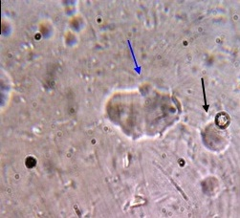 | 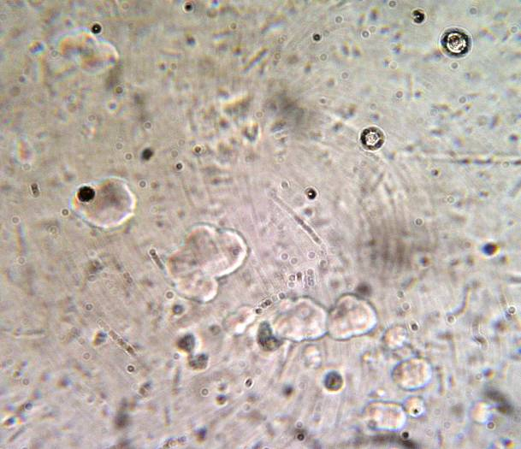
(a) | (b)
Figure (1, a-b): Light microscopy micrograph of Blastocystis in 24 hour culture (X400). Some amoeboid Blastocystis cells are seen dividing by binary fission (blue arrows), vacuolar forms (red arrows) and cyst forms (black arrow) can be seen.
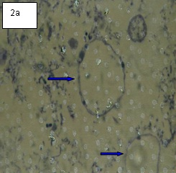 |  |  | 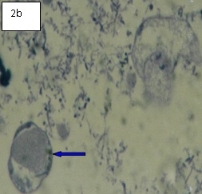
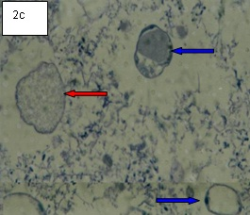 |  |  | 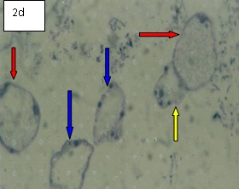
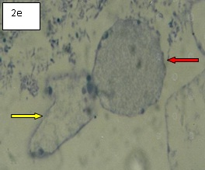 |  |  | 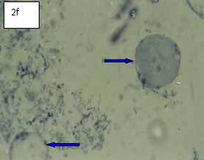
Figure (2 a-f): Light microscopy micrograph of different forms of B. hominis in culture (X1000): vacuolar (blue arrows), granular (red arrows) and amoeboid (yellow arrows).
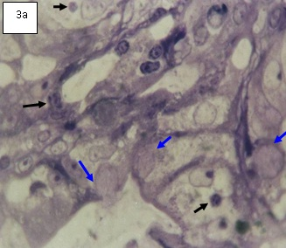 |  |  | 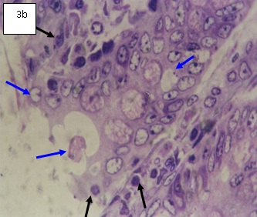
Figure (3 a-b): Histopathological section of colon of infected mice (X1000) showing B. hominis (blue arrows) and inflammatory cell infiltrations (black arrows).
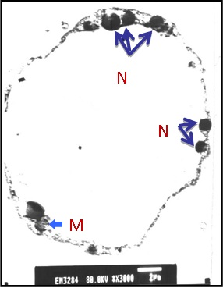 |  |  | 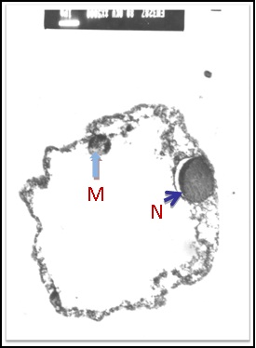
Figure (4): TEM (X3000) of B. hominis in culture: vacuolar form containing many nuclei (N), mitochondria (M), and surrounded by outer fibrillar layer (FL).

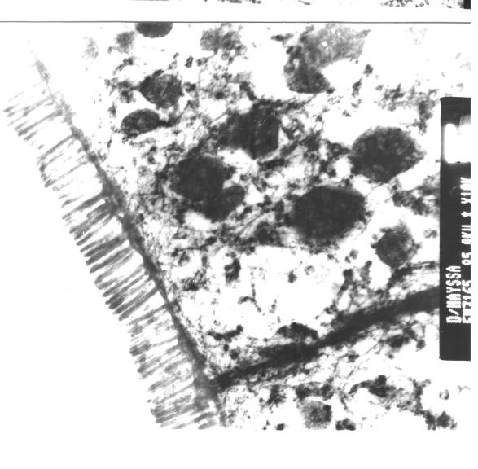 |  |  |  | 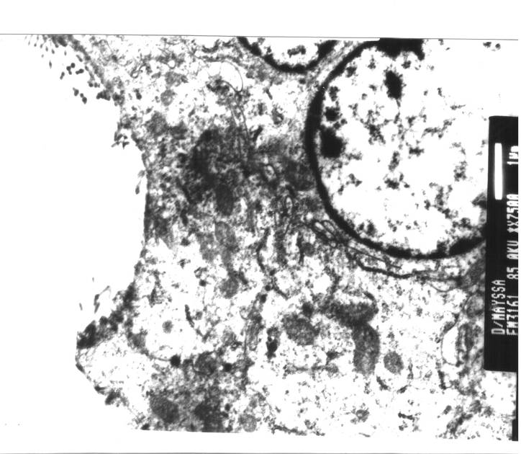
5a |  |  |  | 5b
Figure (5a): TEM (X75000) of large intestine of non-infected mice. Mucosa of non infected mice showed normal brush border and microvilli.
Figure (5b): TEM (X75000) of an infected enterecyte in large intestine of Blastocystis-infected mice. Yellow arrows: sloughed villi; Red arrows: 2 Blastocystis cells; Blue arrows: mitochondria within the Blastocystis with pathological changes in the form of vacuolations and tubulation of the mitochondrial cristea; Green arrow: enterocyte nucleus.

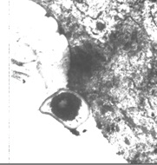 |  | 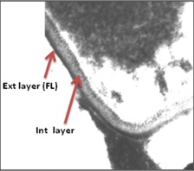
6a |  | 6b
Figure (6a): TEM (X4000) of vacuolar form of B. hominis in caecum with a large homogeneous central body.
Figure (6b): TEM (X15000), magnification of figure (6a) showing thin external fibrillar layer (FL), an electron dense surface coat and an electron lucent internal layer of the surface coat.
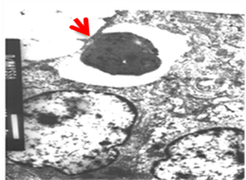  7a |  | 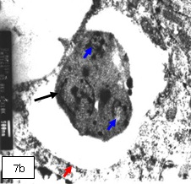
Figure (7): TEM of cystic form of B. hominis in colon. Red arrow: Outer fibrillar layer; Blue arrows: Two nuclei with multiple chromatin masses; Black arrows: Mitochondria. 7a: X4000, and 7b: X10000.
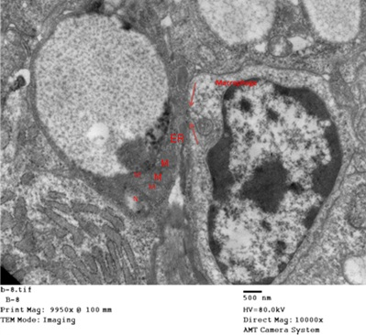 |  |  |  |  | Figure (8): TEM of B. hominis with nuclei (N), mitochondria (M) and endoplasmic reticulum (ER). A macrophage with prominent phagosome (red arrows on pseudopodia) is seen opposite B. hominis (X10000).

DISCUSSION
In the present study, experimental infection of mice by oral inoculation of cultured B. hominis cysts confirms that the cyst stage is responsible for transmission of infection and that the oral route is the mode of transmission. This is supported by a previous study⁽²²⁾ that reported that cysts of B. hominis are the source of external transmission via the fecal-oral route.
Parasites were found only in the caecum and colon of 10 mice and in the whole intestine of 2 mice. The later observation was also reported by Yao et al.⁽²⁴⁾ who found Blastocystis in the whole GIT of experimentally infected mice. Severe edema, hyperemia and congestion were observed in the tissues of jejunum, ileum, caecum and colon. However their study was done on immunocompromised mice⁽²⁴⁾.
In the present work, different forms of Blastocystis were found in the caecum and small intestine; vacuolar forms (with a rounded central body), granular forms (granules in the central vacuole) and amoeboid forms (with multiple extended pseudopodia and multiple indentations). Whereas, in the colon only small sized cysts with thick cyst wall and multiple vacuoles were seen. It can be postulated that the vacuolar, granular and amoeboid forms developed from the inoculated cysts, which are the most resistant forms able to withstand gastric digestion. This was also seen in vitro culture, where all non-cyst forms arose from cysts within 24±48 h. On the other hand, cysts seen in the colon were probably due to earlier encystation of some forms in the caecum and small intestine. Results of a similar previous study⁽⁴⁾ is in accordance with our recorded changes observed as trophic forms mainly in the caecum and cysts in the colon. The report added that the decrease in trophic forms was accompanied by an increase in cyst forms while going distally in the intestine. In another study done by Suresh et al.⁽²³⁾, the amoeboid form found mainly in the caecum was considered an intermediate stage between the vacuolar and cyst forms.
In the present study, after inoculation with in vitro cultured cyst forms, 8 infected mice (66.7%) showed variable clinical presentations of bloated caecum, weight loss and lethargy, however histological examination of caecum and colon of 10 (83.3%) showed villous atrophy with mucosal sloughing, and intense edematous lamina propria with inflammatory cellular infiltration by neutrophils and lymphocytes. Thus, histopathological findings found in larger number of mice 10/12, while the gross pathological picture noted only in 8 mice is more evident for Blastocystis induced pathology that is seen as microscopic changes before affecting the gross pathology of intestine. These histopathological findings showed that Blastocystis has pathogenic potential. In a similar study done on guinea pigs histopathological sections showed that B. hominis invaded the intestinal surface causing mucosal and submucosal inflammation of the host's intestine⁽²²⁾.
The TEM examination conducted to provide detailed ultrastructural description of Blastocystis and the infected tissue showed the parasite located in the enteric cavity and on the surface of the ileocecal and colonic mucosa. Some parasites also invaded into the mucosa and its folds. Partial destruction of mucosal microvilli was observed. Blastocystis infilterating the enterocytes showed pathological changes, seen mainly as mitochondrial vaculation and tabulation of christae, compared to normal E/M picture of Blastocystis in culture. These findings were supported by Zhang et al.⁽²⁵⁾, who recorded reduction of microvilli array on the surface of absorptive cells, in addition to mitochondrial edema, rough endoplasmic reticulum dilatation and degranulation of absorptive cells and goblet cells. Lymphocyte infiltration was found in the intercellular stroma. The authors also reported that B. hominis were dispersed on the mucosal surface of the colon mainly and to lesser extent on ileum mucosa, in addition to individual parasites found in submucosa. In another more recent study, done in 2010⁽²⁶⁾, the investigators reported that vacuolar forms of Blastocystis may invade the lamina propria, submucosa and even the muscle layer of the intestine; however they specified that large a number of Blastocystis is essential for oral infection.
Regarding Blastocystis infection in human, many researchers^{(7,10)} reported that clinical symptoms are variable as some patients are asymptomatic while others display severe abdominal cramps, diarrhea and fatigue. Researchers also linked Blastocystis with IBS^{(2,9,10)}. Others concluded that a clear understanding of the parasite pathogenicity still requires further studies^{(8,27)}. Al-Tawil et al.⁽²⁸⁾ described the case of a 4-year-old girl with mucosal ulcers, rectal bleeding and protein-losing enteropathy in which B. hominis was the only causal organism found. Histopathological examination of intestinal biopsy of this case showed that B. hominis was infiltrating the superficial lamina propria and glandular spaces and was associated with ulceration with prominent inflammatory cellular infiltration.
Other researchers recorded that protein-losing enteropathy may accompany Blastocystis infections and may be related to increased intestinal permeability reported to occur in some Blastocystis infections⁽²⁹⁾.
A study conducted on Blastocystis ratti referred its pathogenicity to interaction between parasite products (e.g. cysteine protease) and enterocytes that influence host inflammatory and immunological responses. They also reported that Blastocystis induced cell apoptosis, led to production of pro-inflammatory mediators, including IL-8, regulated upon activation normal T-cell expressed and secreted (RANTES) chemokines, and transforming-growth-factor TGF-β resulting in mucosal inflammation⁽³⁰⁾.
Recent research advocated that Blastocystis causes intestinal disease in human and although it infects a wide variety of hosts, its pathogenicity remains undetermined. The authors concluded that future researches should focus on the ability of Blastocystis to cause various degrees of pathogenicity⁽⁷⁾.
In conclusion, the ultrastructural pathological observations reported in this work represented mainly by mucosal damages, sloughing of villi and Blastocystis invasion of enterocytes can be considered an evidence of a moderate degree of pathogenicity caused by this parasite or its products and the interaction with enterocytes. Being previously recorded by some researchers to be non-pathogenic it would be relevant to re-assay using isolates from non complaining carriers.
Author contribution: MM Zaki designed the experiment, collected the samples, and shared NSM El-Gebaly in performing the culture, experimental infection, histological and EM examination and writing the manuscript.
Acknowledgements: Special thanks to the staff members of the Department of Electron microscopy, Faculty of Science, Ain Shams University for their help in preparation and examination of electron microscopic samples. Sincere thanks to the staff members of the Histology Department, Faculty of Medicine, Cairo University for their help in examination of histological sections by both light and electron microscopy.
REFERENCES
- Sohail M, Fischer PR. Blastocystis hominis and travelers. Travel Med Infect Dis; 2005, 3:33–8.
- Stensvold CR, Lewis HC, Hammerum AM et al. Blastocystis: Unraveling potential risk factors and clinical significance of a common but neglected parasite. Epidemiol infect; 2009, 137:1655-63.
- Tan KS. Blastocystis in humans and animals: New insights using modern methodologies. Vet Parasitol; 2004, 126:121-44.
- Tan KS. New insights on classification, identification and clinical relevance of Blastocystis spp. Clin Microbiol Rev; 2008, 21: 639-65.
- Abe N. Molecular and phylogenetic analysis of Blastocystis isolates from various hosts. Vet. Parasitol; 2004, 120, 235-42.
- Parkar U, Traub RJ, Vitali S et al. Molecular characterization of Blastocystis isolates from zoo animals and their animal-keepers. Vet. Parasitol; 2010, 169, 8-17.
- Australian Wildlife Health Network. Australian Wildlife Health Network Fact Sheets Blastocystis in Australian wildlife; 2011, 1-4.
- Yakoob J, Jafri W, Jafri N et al. Irritable bowel syndrome in search of etiology: Roles of Blastocystis hominis. Am Soc Trop Med Hyg; 2004, 70, 383-5.
- Stark D, Hal SV, Marriott D, Ellis J, Harkness J. Irritable bowel syndrome: A review on the role of intestinal protozoa and the importance of their detection and diagnosis. Int J Parasitol; 2007, 37:11–20.
- Boorom KF, Smith H, Nimri I, Viscogliosi E, Spanakos G, Parkar U. Oh my aching gut: Irritable bowel syndrome, Blastocystis and asymptomatic infection. Parasite Vectors; 2008, 1:40.
- Dogruman FAI, Kustimur S, Yoshikawa H et al. Blastocystis subtypes in irritable bowel syndrome and inflammatory bowel disease in Ankara, Turkey. Mem Inst Oswaldo Cruz; 2009, 104:724-7.
- Gallagher PG, Venglarcik JS. Blastocystis hominis enteritis. Pediatr Infect Dis; 1985, 4: 556-7.
- Tsang TK, Levin BS, Morse SR. Terminal ileitis associated with Blastocystis hominis infection. Am J Gastroenterol; 1989, 84: 798-9.
- Sukthana Y. Is Blastocystis hominis a Human Pathogenic Protozoan? J Trop Med Parasitol; 2001, 24:16-22.
- Vdovenko AA. Blastocystis hominis: Origin and significance of vacuolar and granular forms. Parasitol Res; 2000, 86:8-10.
- Sadek Y, El-Fakahany AF, Lashin AH, El-Salam FA. Intestinal parasites among food-handlers in Qualyobia Governorate, with reference to the pathogenic parasite Blastocystis hominis. J Egypt Soc Parasitol; 1997, 27:471-8.
- Singh M, Suresh K, Ho LC, Ng GC, Yap EH. Elucidation of the life cycle of the intestinal protozoan Blastocystis hominis. Parasitol Res; 1995, 81:446-50.
- Moe KT, Singh M, Howe J et al. Experimental Blastocystis hominis infection in laboratory mice. Parasitol Res; 1997, 83:319-25.
- Jones WR. The experimental infection of rats with Entamoeba histolytica with a method for evaluating the anti-amoebic properties of new compounds. Ann Trop Med Parasitol; 1946, 40:130-40.
- Tan TC, Suresh KG. Amoeboid form of Blastocystis hominis: A detailed ultrastructural insight. Parasitol Res; 2006, 99(6):737-42.
- Zaman V, Khan KZ. A comparison of direct microscopy with culture for the diagnosis of Blastocystis. Southeast Asian J Trop Med Public Health; 1994, 25:792-3.
- Moe KT, Singh M, Howe J et al. Observations on the ultrastructure and viability of the cystic stage of Blastocystis hominis from human feces. Parasitol Res; 1996, 82: 439-44.
- Suresh K, Howe J, Chong SY et al. Ultrastructural changes during in vitro encystment of Blastocystis hominis. Parasitol Res; 1994, 80: 327-35.
- Yao FR, QiaoJY, Zhao Y, Yang JH, Li XQ. Experimental infection of mice with Blastocystis hominis. Chin J Parasitol Parasit Dis; 2005, 23(26):444-8.
- Zhang HM, Li W, Yan QY, He LJ, Su YP. Impact of Blastocystis hominis infection on ultrastructure of intestinal mucosa in mice. Chin J Parasitol Parasit Dis; 2006, 24(3):187–191.
- Elwakil HS, Hewedi IH. Pathogenic potential of Blastocystis hominis in laboratory mice. Parasitol Res; 2010, 107:685-9.
- Giacometti A, Cironi O, Fiorentini A, Fortuna M. Irritable bowel syndrome in patients with Blastocystis hominis infection. Eur J Clin Microbiol Infect Dis; 1999, 18, 436-9.
- Al-Tawil YS, Gilger MA, Gopalakrishna GS, Langston C, Bommer KE. Invasive Blastocystis hominis infection in a child. Arch Pediatr Adolesc Med; 1994, 148(8):882-5.
- Dogruman ALF, Hokelek M. Blastocystis hominis is an opportunistic pathogen. Turk J Parasitol; 2007, 31 (1): 28-36.
- Puthia MK, Lu J, Tan KS. Blastocystis ratti contains cysteine proteases that mediate interleukin-8 response from human intestinal epithelial cells in an NF-kappa B-dependent manner. Eukaryot Cell; 2008, 7(3):435-443.

التغيرات المجهرية (بالمجهر الإلكترونى) بأمعاء الفئران المصابة بالمتبرعمة الكيسية (البلاستوسيستيس)
نجلاء سعد محمود الجبالى، مايسة محمد زكى
قسم الطفيليات الطبية، كلية الطب، جامعة القاهرة
مقدمة: المتبرعمة الكيسية هو طفيل معوى، وحيد الخلية، لاهوائي يسكن الجزء السفلى من الجهاز الهضمى للانسان وكثير من الحيوانات. وهذا الطفيل الناشئ والمنتشر فى جميع أنحاء العالم قد تم تحديده كأكثر الكائنات الحية حقيقية النواة شيوعا فى عينات البراز البشرى، كما أنه قد تبين زيادته زيادة كبيرة فى السنوات الأخيرة، ومع ذلك لا يزال هناك العديد من التناقضات فى حالات الإصابة بهذا الطفيل.
الهدف من البحث: دراسة التغيرات المجهرية لطفيل المتبرعمة الكيسية على أمعاء الفئران المصابة تجريبيا بهذا الطفيل والذى تم عزله من الانسان.
طرق البحث: تم جمع عينات البراز للمتبرعمة الكيسية من المرضى ثم تم زراعتها باستخدام وسيط جونز وفحصها بالمجهرالضوئى والالكترونى التشريحى. كما تم عزل المراحل المتحوصلة من مزرعة المتبرعمة الكيسية ثم لقحت الفئران ذوى الكفاءة المناعية عن طريق الفم . بعد أسبوعين من العدوى تم تشريح الفئران وأعدت مقاطع مختلفة من الأمعاء لفحصها بكل من المجهر الضوئى و الالكترونى التشريحى.
نتائج البحث: أظهرت المتبرعمة أشكالا مختلفة: الفجوىة، الحبيبية، والأميبية فى خلال 24 ساعة فى المزرعة. وقد كان الشكل المتحوصل فى البراز هو المسؤول عن العدوى عن طريق الفم. كما أظهر الفحص النسيجى لأمعاء الفئران المصابة الأشكال الفجوىة والحبيبية والأميبىة على حد سواء في الأعور، ولكن لوحظ الشكال المتحوصل فقط في القولون. ولقد لوحظت أيضا التهابات كثيفة وتسلل خلوى، تورم الصفيحة المخصوصة من جدار الأمعاء، وضمور فى زغيبات الأمعاء. و بذا كان من الواضح أن وباء المتبرعمة قادر على التسبب فـى الأعراض المرضية فى الفئران المصابة. أيضا أمكن ملاحظة التركيب التشريحى للمتبرعمة بواسطة المجهرالإلكتروني فقد تم مشاهدة كل من طبقة السطح الخارجي اللييفية، النوى مع كتل الكروماتين المتعددة، الميتوكوندريا مع بعض التغييرات الأنبوبية المرضية . وقد لوحظ ضمور وتمزق من الزغيبات الصغيرة من الأمعاء المصابة بالمقارنة مع غشاء الأمعاء المخاطي للفئران غير المصابة والتي أظهرت البطانة المعوية والزغيبات الصغيرة طبيعية.
الخلاصة: العدوى بطفيل المتبرعمة يكون محدود الأعراض في بعض المصابين، ومع ذلك فإنه قد يسبب تغييرات مرضية كبيرة واجتياح الغشاء المخاطي من الأمعاء في حالات أخرى.

