A Program Based on Artistic and Musical Activities to Acquire Educational Concepts for Children with Learning Difficulties
Ahmed Amin Mousa, Huda Mazeed, Eman Saad
Abstract—The study aims to identify the extent of effectiveness of the artistic formation program using some types of pastes to reduce the hyperactivity of the kindergarten children with learning difficulties. The researchers have discussed the aforesaid topic, where the research sample included 120 children of ages between 5 to 6 years, from five schools for special needs, learning disability section, Cairo Governorate. The study used the quasi-empirical method, which depends on designing one group using the pre& post application measurements for the group to validate both, hypothesis and effectiveness of the program. The variables of the study were specified as follows; artistic formation program using Paper Mache as an independent variable, and its effect on the skills of kindergarten child with learning disabilities, as a dependent variable. The researchers utilized the application of an artistic formation program consisting of artistic and musical skills for kindergarten children with learning disabilities. The tools of the study, designed by the researchers, included: observation card used for recording the culling paper using pulp molding skills for kindergarten children with learning difficulties during practicing the artistic formation activity. Additionally, there was a program utilizing Artistic and Musical Activities for kindergarten children with learning disabilities to acquire educational concepts. The study was composed of 20 lessons for fine art activities and 20 lessons for musical activities, with obligation of giving the musical lesson with art lesson in one session to cast on the kindergarten child some educational concepts.

Keywords—Musical activities, developing skills, early childhood, educational concepts, learning difficulties.
- Introduction
S
INCE the dawn of history, man has been able to express his emotions and feelings through fine arts, beginning from his early drawings and primitive sketches on the walls of the caves, to his sophisticated and complex creations, within the galleries of major cities and capitals, through the artworks left by successive civilizations throughout the ages. Art has a significant impact on human senses.
Art has been used as a common language to communicate with other people of whatever language and generation. Moreover, it can be used to express the lifestyle, confront fears and confirm identity. The importance of art through the history of humankind explains why it should be considered as a means of self-expression for children [1].
Many philosophers and scholars have alluded to the purifying and therapeutic values of the arts, where the fine arts have been utilized in the treatment of mental disorders, as an integrated means within the rehabilitation and educational programs in the institutions for the care of children with disabilities. The fine art activities such as painting, photography and three-dimensional modeling, have been utilized to enable the children to show their feelings and emotions, and positing their internal experiences through optional or targeted activities [2], [3].
Kindergarten stage is concerned with the development of various competencies and skills by children. The required competencies not only include social skills, cultural awareness and communication but also extend to aesthetics and creativity [4]. Nowadays, after the current information revolution, the need to creative individuals increases. The world is in need to individuals with developed aesthetic judgment because they view problems from multiple perspectives. In addition, they are highly sensitive to the surrounding objects in terms of beauty and ugliness. Art education is regarded as powerful means for improving the children’s skills. Art instruction, which is a necessary element in this education, is used for evolving the aesthetic sensitivity of children. Furthermore, it helps them realize their full potential and develop their creative and constructive capabilities. In fact, art can give children the opportunity for sharing materials, cooperating and expressing their feelings [5]. Therefore, art instruction has a significant impact on children education. Several studies [6]-[11] have utilized art activities for developing the aesthetic and cognitive aspects of children. Moreover, it can be regarded as an efficient tool for creating and communicating ideas with others, as well as understanding others. Besides, it can be used for acquiring different skills, for example; indulging in teamwork, problem-solving, critical thinking and self-discipline. On the other side, art can be employed to be part in promoting the everyday life skills such as mathematical calculations, writing and reading. It provides a learning opportunity and simplifies their intellectual, emotional, and physical development [6].
Art is a universal language which offers the opportunity to children to respect others with different perspectives. Therefore, it facilitates developing children personality and maintaining their psychological balance. Art also provides children with a convenient environment to express themselves. It offers them the potential for risk-taking and qualifies them to explore different solutions. Using art, children can express their experiences and perceptions without fear [7], [8].
Art projects often begin with discussions about themes and colors. After the discussion, it is time to prepare and give the children the materials they need (scissors, paper, paint, crayons, etc.). Then, they talk about their creations as the project progresses as they work individually or in small groups. When the project is complete, the kids will clean and make sure everything is in place.
There are some art advices and activities that we, as parents, can do with the children, for example:
- Travel is a learning experience for you and your children. Let your child realize that both of you are learning something new.
- Facts about the history of impressionism do not educate or add to the child. He pushes himself to experience painting. Tell him what you know in detail. Write down his thoughts and consider discussing them later.
- If you feel uncomfortable in an art gallery and are talking about art, consider joining the art museum's parent class. Most of these classes are free.
- The Art of Preschool Curriculum
The term kindergarten was coined by the German Friedrich Frobel, who had an impact on early childhood education worldwide. Today, the term is used in many countries to describe different educational institutions and learning spaces for children aged 2 to 7 based on different teaching methods such as art and music.
The needs of preschool children usually vary, in accordance with specialists. Their aspects on their primary needs are generally the same. It is important to identify those needs, and it is hard to say that children can be educated without meeting their needs. These needs of a preschool child can be identified as: love, care, nutrition, affection, physical activity, adult support, freedom, friendship and playing games with other children.
Since children react to other people through their senses, the curricula should involve art content that worthily triggers their senses. The curriculum of self-renewal instructional requires that art education should follow this purpose. In addition, it should have an influential developing in response to conditions changing. Besides, developing children integrally imposes the existence of an adaptive art curriculum.
The use of fine arts with kindergarten children with learning disabilities has multiple objectives. While acknowledging the variation of these goals according to the different needs of these children, they meet as a whole about coping with the mental and behavioral disorders caused by the abuse they are exposed to, and help them replace painful experiences with fruitful ones of value, thus, helping to introduce them to the social adjustment. The plastic art may be divided into fine arts and applied arts, so that visual arts are called also by the term visual plastic arts or plastic arts [9].
Building an art education curriculum requires four major components: aesthetic values, aesthetic perception, creative expression and cultural heritage, where these components have to be integrated into production, observation, and discussion of art. In addition to these components, the art curriculum should consider other issues such as the inclusion of a wide range of art resources and materials. The presented arts should have a balance among different cultures and ethnicities. Moreover, it should include interdisciplinary sciences such as literature, architecture, mathematics, and science. This variety gives children the opportunity to experience communication, discovery, and exploration. Children in this age should be able to make contributions using simple elements such as color, value, texture and line. There should be a variety in the styles of activity involving two- and three-dimensional activities with different materials and techniques [10].
Playing for the child is the heart of his life and his thinking, and is the effective means of developing his abilities, especially intelligence and innovative thinking, but not only that, it develops the child physically, motor wise, cognition wise and emotionally. There are a variety of forms of play such as directed play, free play, impulsive play and artistic play, where there are games through utilizing paper pulp, used in the creation of models and forms of different three-dimensional bodies [11], [12].
Preschool children need to learn about place, sharing, and assembly of materials, rituals and cleaning routines. These elements should be taken into account while designing the art education curriculum to allow children to acquire these competencies. Art education curriculum aims to train children to be adaptive and creative. It is necessary to help children that are innovative and open to experimentation rather than adopting obtaining information directly, without working out to acquire them [13].
Art education curriculum should develop the artistic intelligence which is not necessarily obtained with maturation. Such development needs qualified teachers as well as an enhanced curriculum [14]. Thus, in order to improve the quality of these curricula, it is required to establish collaboration with artists. Some research has discussed the role of artistic participation in enhancing children’s curricula [15]. Through the last two decades, the connection between art education curriculs and professional artists has been distinctly increased in the United States and Europe. In addition, it is realized that children should interact with various art environments such as museums and galleries [16], [17]. In fact, many countries consider artists as a valuable resource and involve them in the art education curriculums. Teachers involve artistic activities in the educational process. Moreover, they organize regular visits to artists’ workshops to provide children with knowledge of how artists work and shape their thoughts [18].
Teachers, parents, school administrators, and policymakers should pay attention to the importance of art in reinforcement of the education process. All of them should play a role in enabling children to receive a high qualified art education [19].
Above all, arts education curriculum should include a planned assessment dimension. The assessment of children art work should include approaches such as observation, individual interviews, self-evaluation, performance-based assessment, and art exhibition [20].
- Method
- Study Problem
The problem of research was identified by lack of mechanisms and determination of the skills utilized for the formation of paper-shaped three-dimensional bodies for children with learning disabilities. To address this problem, the research seeks to answer the following questions:
- What are the mechanisms and determination of the skills used for the holographic formation of paper pulp for children with learning disabilities?
- What is the effectiveness of using mechanisms, and the determination of the skills utilized for the holographic formation of paper pulp for children with learning disabilities?
Thus, the problem of the study was crystallized in; what is the effectiveness of a program for the development of fine art skills using paper paste for kindergarten child with learning disabilities?
- Study Importance
The importance of the study can be summarized in the following points:
- To draw the attention of kindergarten teachers to the importance of artistic formation activities using paper paste to develop the skills of the kindergarten child with learning difficulties.
- To provide kindergarten teachers with an artistic program using some paper pastes to develop the skills of the kindergarten child with learning difficulties.
- To utilize, form and employ paper materials in making a variety of stereogram to help kindergarten children with learning disabilities to develop their abilities.
- To raise the level of kindergarten child with learning disabilities towards the development of their cognitive, emotional and muscular skills through the use of holographic fine arts by the utilization of paper pastes.
- To help the kindergarten teacher in identifying the abilities of the children with learning difficulties through the daily artistic activity provided to the kindergarten child with learning disabilities.
The applied importance of the study may be posited as:
- To cast on kindergarten children with learning difficulties skills of artistic formation using some pastes.
- To improve the children kinetic abilities through the formation of paper materials.
- Study Objectives
- Designing a program utilizing paper pulp to develop the skills of the kindergarten child with learning disabilities.
- Development of new methods in using holographic formation, by utilizing paper pulp to develop the fine art abilities of kindergarten children with learning disabilities.
- Development of the ability of children with learning disabilities to use the paper material in the formation of many paper toys and models.
- Identification of the most important fine art skills using paper pulp to be developed by the kindergarten child with learning disabilities in light of national standards and the new curriculum through the production of some paper games.
- Development of some of the plastic abilities in the field of paper works, such as: folding, bending, two- and three-dimensional paper configuration for kindergarten children with learning disabilities.
- Exploiting the energy of kindergarten children in the implementation of the activities of artistic composition in pastes.
- Study Limits
Human limits: The study sample consists of 120 children with learning difficulties, 67 males, 53 females, ranging between 5-6 years of age, from the second level of kindergarten (KG2). However, some sample children have quitted during the application of the program interviews, therefore, post-measurement was applied to only 18 children in the study sample, in one experimental group, they are selected in a deliberate manner.
Spatial limits: The study was selected from children enrolled in the kindergarten attached to Al-Bashaer International School (Cairo governorate).
Time limits: The proposed program, which is based on the use of the artistic configuration in paper pulp, was applied over a period of three months at a rate of twice a week, with two hours per interview. The application was implemented from 12/1/2017 to 20/3/2017.
Objective limits: The study is limited to the identification of the artistic skills of kindergarten children with learning difficulties through a program of artistic formation utilizing some paper pulp, using a number of fine art activities with some paper pastes, planned and organized by the researcher as stated in the program presented through interviews with the children with learning disabilities. The research is limited to the use of some types of paper materials (newsprint and cardboard).
The composition of paper in this research is limited to the application of the following techniques (folding, kneading, discharging, embossing).
- Methodology and Procedures
The researchers followed the experimental approach, due to the adequacy of such approach to the nature of the research in order to determine the effectiveness of using the method of three-dimensional formations in paperwork area to develop fine art abilities of kindergarten children with learning disabilities.
The variables of the study can be determined as follows: A program of artistic formation using paper pulp as an independent variable and its effect on the development of fine art skills of kindergarten child as a dependent variable.
- Study Tools
- Observation cards of the child performance including the themes of the pre-, during-, post-program (prepared by the researcher)
- Art Skills Scale of kindergarten child with learning disabilities (prepared by the researcher)
- Diagnostic battery for developmental learning difficulties.
- Evaluation form of an artistic product (prepared by the researcher).
- Study Hypotheses
There are statistically significant differences between pre- and post-test measurements, where the research experiment is applied to a sample of children with learning difficulties in the kindergarten stage, averaging between 5-6 years of age, where these differences are in favor of the post-test measurement.
- Study Terms
Kindergarten Stage
It is the stage that receives children between 4-6 years of age, and precedes the primary stage. The study duration is two years. It aims to achieve the comprehensive integrated development of the child, taking into account individual differences in capacity, preparedness and developmental levels [21].
Researches dealt with several tracks about artistic activities. These activities were used with children and employed to gain some educational concepts, including artistic activities [22], [23].
Some researches indicated how to apply artistic and musical activities and how to measure them with the kindergarten child [24]. There are many researches [6], [8], [9], [11] to provide the child with some advanced educational concepts, and it was through the use of robots in education [25], in addition to contributions that appeared to employ educational concepts in field training with children [26].
- Study Procedures
- Access to the literature and research related to the skills of stereoscopic fine arts suitable for kindergarten children with learning disabilities.
- Identify the skills of fine arts to be developed for kindergarten children with learning disabilities.
- Develop a list of the skills of stereoscopic fine arts using paper pulp to be developed by kindergarten child with learning disabilities.
- Present the list of skills of stereoscopic fine arts using paper paste by the kindergarten child with learning disabilities to a group of art education and kindergarten experts to ensure the relevance and importance of such list to the children with learning disabilities.
- Prepare some holographic paperwork for the development of fine art skills in kindergarten children with learning disabilities, including goals, content, strategies (educational methods) and evaluation.
- Present the activities to a group of art education and kindergarten experts to ascertain their suitability and importance to kindergarten children with learning disabilities.
- Prepare an observation card including the performances of the child (pre-, during, post) artistic activities.
- Prepare an artistic product evaluation form for kindergarten children with learning disabilities.
- Ensure the validity and stability of the study tools.
- Select the study sample.
- Apply pre-standards (observation card, artistic product evaluation form).
- Apply artistic activities on the study sample.
- Apply post standards (observation card, list of developmental learning disabilities for kindergarten children, artistic product evaluation form).
- Analyze and interpret results.
- Make recommendations and proposals.
- Results
TABLE I
The Result of Applying the Program
Variables | Average before applying the program | Average after  applying the program | Development percentage
Oral expression | 3.50 | 7.10 | 50.7%
Visual discrimination | 3.90 | 7.20 | 45.8%
Visual memory | 3.50 | 7.00 | 50%
Audio discrimination | 3.80 | 7.30 | 47.9%
Audio memory | 3.20 | 7.20 | 55.5%
Audiovisual discrimination | 3.10 | 7.00 | 55.7%

Fig. 1 shows samples of children's work during the pre and post evaluation.

Pre-evaluation samples | Post-evaluation samples | Pre-evaluation samples | Post-evaluation samples
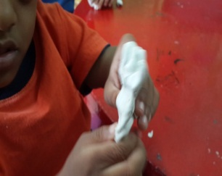 | 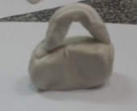 | 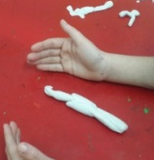 | 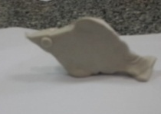
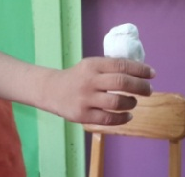 | 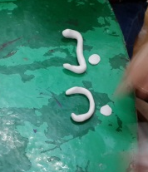 | 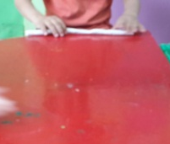 | 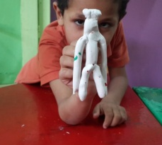
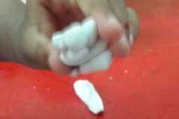 | 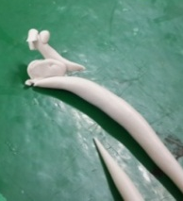 | 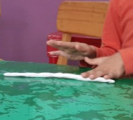 | 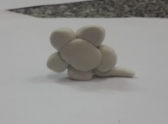
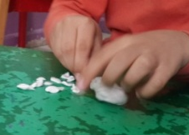 | 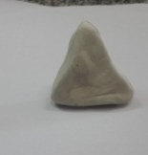 | 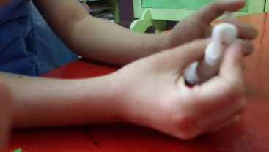 | 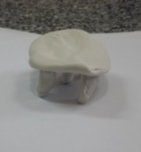
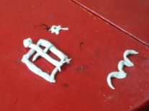 | 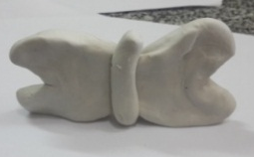 | 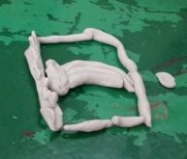 | 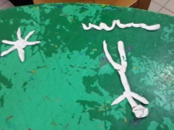
Fig. 1 Samples of children's work during the pre and post evaluation

References
- Nutbrown, C., 2013. Conceptualizing arts-based learning in the early years. Research Papers in Education, 28(2), pp.239-263.
- Lowenstein, L., 2011. Favorite therapeutic activities for children, adolescents, and families: Practitioners share their most effective interventions.
- Machida, C. A. ed., 2012. Art therapy and health care. Guilford Press.
- Acer, D., 2015. The arts in Turkish preschool education. Arts Education Policy Review, 116(1), pp.43-50.
- Kaimal, G. and Blank, C. A. L., 2015. Program evaluation: a doorway to research in the creative arts therapies. Art therapy, 32(2), pp.89-92.
- Clarke, A., Sharp, K. and Tai, M., 2017. Technology-enabled curriculum for transnational education in art history and theory. International Journal of Education & the Arts, 18(40).
- Marshall, J., 2016. A systems view: The role of art in education. Art Education, 69(3), pp.12-19.
- Spodek, B. and Saracho, O. N., 2014. Handbook of research on the education of young children. Routledge.
- Flynn, A., Matthews, H. and Hollins, S., 2002. Validity of the diagnosis of personality disorder in adults with learning disability and severe behavioural problems: Preliminary study. The British Journal of Psychiatry, 180(6), pp.543-546.
- Brown, N. C., 2017. Art education curriculum praxis: a time for collaboration. In Studies in Philosophical Realism in Art, Design and Education (pp. 79-93). Springer, Cham.
- Courtman, S. P. and Mumby, D., 2008. Children with learning disabilities. Pediatric Anesthesia, 18(3), pp.198-207.
- Hallahan, D. P., Kauffman, J. M. and Pullen, P. C., 2012. Current practices for meeting the needs of exceptional learners. Exceptional learners: An introduction to special education, pp.24-41.
- Burkitt, E., Jolley, R. and Rose, S., 2010. sThe attitudes and practices that shape children's drawing experience at home and at school. International Journal of Art & Design Education, 29(3), pp.257-270.
- Efland, A., 2004. The arts and the creation of mind: Eisner's contributions to the arts in education. Journal of Aesthetic Education, 38(4), pp.71-80.
- Brown, E. D., Benedetti, B. and Armistead, M. E., 2010. Arts enrichment and school readiness for children at risk. Early Childhood Research Quarterly, 25(1), pp.112-124.
- Sanderson, P. and Savva, A., 2004. Artists in Cypriot primary schools: the pupils' perspective. Music Education Research, 6(1), pp.5-22.
- Hancock, R. and Cox, A., 2002. 'I Would Have Worried About Her Being a Nuisance': workshops for children under three and their parents at Tate Britain. Early Years: An International Journal of Research and Development, 22(2), pp.105-118.
- Horn, S., 2006. Inspiration into installation: An exploration of contemporary experience through art. International Journal of Art & Design Education, 25(2), pp.134-146.
- Gratto, S. D., 2002. Arts education in alternative school formats. Arts Education Policy Review, 103(5), pp.17-24.
- Hopper, G. (2007). Assessment in art and design in the primary school.
- Mousa, A. A. and Abd El Salam, M., 2016. A Proposed Program for Postgraduates in Egypt to Acquire the Skills and Techniques for Producing Concept Cartoons for Kindergarten Children. International Journal of Social, Behavioral, Educational, Economic, Business and Industrial Engineering, 10(7), pp.2208-2212.
- Mousa, A. A. and Yacoub, M., 2020. The Impact of Scientific Content of National Geographic Channel on Drawing Style of Kindergarten Children. International Journal of Educational and Pedagogical Sciences, 14(4), pp.280-285.
- Yacoub, M. and Mousa, A. A., 2020. Developing Artistic Concepts for Kindergarten Children in Egypt Using Graphic Activities. International Journal of Educational and Pedagogical Sciences, 14(4), pp.252-255.
- Mousa, A. A. and Azam, G., 2017. An Electronic and Performance Test for the Applicants to Faculty of Education for Early Childhood in Egypt for Measuring the Skills of Teacher Students. International Journal of Educational and Pedagogical Sciences, 11(7), pp.1903-1906.
- Mousa, A. A., Ismail, T. M. and Abd El Salam, M., 2017. A robotic cube to preschool children for acquiring the mathematical and colours concepts. children, 5, p.7.
- Mousa, A. A. and El-Salam, M. A., 2016. Employing QR code as an effective educational tool for quick access to sources of kindergarten concepts. World Academy of Science, Engineering and Technology, International Journal of Social, Behavioral, Educational, Economic, Business and Industrial Engineering, 10(7), pp.2367-2370.

Ahmed Mousa is with the Educational and Pedagogical Sciences, Egypt (e-mail: dr_ahmed_mousa@cu.edu.eg).

