Evaluation of the feasibility of thoracic surgery without general anesthesia and tracheal intubation
Date submitted: 4/12/2012
Date accepted: 18/2/2013

Somaya M.Elshaikh¹*, Jehan M.Kamal¹, Dina Nabil¹, Abeer A.Sherif², AbdElRahman A.AbdElRahman³
¹Department of Anesthesia, Intensive Care and Pain Relief, National Cancer Institute, Cairo University, Egypt.
² Department of Anesthesia, Menofiya University, Egypt.
³ Department of Thoracic surgical oncology, National Cancer Institute, Cairo University, Egypt.
*Corresponding author. Address: National Cancer Institute, Cairo University, Kasr El-Aini St., Fom El – Khalig, Cairo, Egypt. T: 002-01271126511
E-mail address: somayaelshaikh@in.com (S. ElShaikh).
Abstract:
Background: This study evaluated the safety and feasibility of awake thoracic surgery under thoracic epidural anesthesia (TEA) vs. a traditional thoracic surgery under general aneasthesia (GA).
Methods: Thirty patients scheduled for thoracic surgery were randomly assigned to receive either sole TEA at any level between T4–T6 with sedation (awake group [AG], n=15) or receive GA with one lung ventilation (OLV) and thoracic epidural analgesia (control group [CG], n=15). Evaluated variables included the technical feasibility, patient satisfaction, perioperative arterial oxygen tension to fraction of inspired oxygen (PaO₂/FiO₂), arterial carbon dioxide tension (PaCO₂), heart rate (HR) and mean arterial pressure (MAP). Anesthesia, surgery, recovery, and total operating room times were recorded as well as all anesthesia-related costs for both techniques.
Results: The study groups were comparable as regards technical feasibility, anesthesia satisfaction, PaO₂/FiO₂ and PaCO₂.The operating room workflow was better in the AG group when compared with the CG [anesthesia time, 14 (3) vs. 33 (6) min, P <0.001; global operating room time 59 (15) vs 89 (21) min, P<0.001, respectively; time to Aldrete score > 8, 21 (13) min in CG]. The ICU stay was 18 (5.3) h in the AG vs 29 (11) h in the CG, P=0.002).The anesthetic costs were significantly reduced in the AG (L.E. 213 (33) vs. L.E. 709 (25) in CG, P<0.001).
Conclusions: Awake thoracic surgery under TEA in highly selected patients and procedures is safe, satisfactory, and technically feasible, with less cost, shorter global operating room time than the same procedures performed under GA.
Key Words: Thoracic surgery; thoracic epidural anesthesia; metastatectomy; video-assisted thoracoscopic surgery; cost-effectiveness.

Introduction:
Thoracic surgery is routinely performed under GA, with OLV to assure adequate ventilation and is usually combined with thoracic epidural analgesia. However, GA with OLV may have adverse effects including peri-intubational hypoxia, trauma to the upper airway, mechanical ventilation-induced injuries, impaired cardiac performance, neuromuscular problems, increased risk of pneumonia, and release of proinflammatory mediators.₁ ₂ ₃ Recently, TEA has been used alone without GA in thoracic surgery.₄ ₅ ₆ The results achieved in these early studies have been encouraging. TEA may eventually provide an alternative method to GA for thoracic surgery in selected patients and procedures that would not only eliminate the need for OLV but also facilitate both surgical reconstruction and eventually patient recovery. Multiple studies evaluated the safety of intravenous ketamine/propofol combination for sedation and analgesia and there is evidence that this technique is both safe and effective.₇
The primary end point of this study is to test the hypothesis that thoracotomy could be safely and satisfactorily done in selected cancer patients and procedures solely under TEA with sedation. The secondary aim of this research is to study the total operating room time, incidence of complications and cost-effectiveness of wake thoracotomy compared with conventional GA with OLV.
Patients and Methods:
This randomized controlled study was conducted at the National Cancer Institute (NCI), Cairo, Egypt, during the period from March 2011 to April 2012. After obtaining approval from the institutional Medical Ethics Committee and obtaining written informed consent, 30 cancer patients were recruited. Inclusion criteria for open surgery were operable solitary central or multiple lung metastases not more than three by CT. For (VATS), lung or pleural biopsies, solitary pulmonary metastases less than 3 cm in the peripheral one-third of the lung by follow up CT. Age range between 18 and 60 years, ASA score equal to or less than III, the absence of severe emphysema or clinical signs of active infectious disease, and the procedure is predicted to be completed within two hours.

Exclusion criteria were major lung resections, Patients with poor cardiac function; with ejection fraction less than 50%, patients with bad PFT, and patients with absolute contraindication to TEA such as patient refusal, allergy to local anesthetics, coagulopathy, active neurologic disorders, skin infection at insertion site, uncooperative patients, uncontrolled cough, or unfavorable anatomy for thoracic epidural. Preoperatively, patients in the AG group were counseled for awake thoracic surgery under sedation. Details of the procedures with the potential to cause discomfort (e.g., pleura opening) were discussed.
Patients were randomized using a computer-generated random list prepared using Graph Pad Stat Mate© version 1.01i (Graph Pad Software Inc., San Diego, CA) to receive either sole TEA at any level between T4–T6 with sedation (awake group [AG], n=15) or to receive GA with OLV and thoracic epidural analgesia (control group [CG], n=15). Preoperative radiologic study included chest X-ray and computed tomography (CT), arterial blood gases (ABG), pulmonary function tests (PFT) and routine laboratory work were done.
Evaluated variables included the technical feasibility as scored by the surgeon using the following 4-point scale: 1 = unsatisfactory; 2 = satisfactory; 3 = good; 4 = excellent. Patient satisfaction was scored using the same scale after complete recovery and 12 hours thereafter. Perioperative PaO₂/FiO₂ , PaCO₂, HR, and MAP were collected before induction of anesthesia, 30 min after skin incision, and 2h postoperatively. Anesthesia time (the time required for anesthesia in operating room until ready for surgical preparation).), operative time (the time from skin incision to skin closure), and recovery time (time to reach an Aldrete score₈ of > 8) were recorded. Total operating room time (the anesthesia time, operative time and recovery time) and anesthesia-related costs were recorded for both techniques.
Anesthetic technique
After application of standard monitoring (pulse oximetry, ECG, and non-invasive arterial pressure), an infusion of 500 ml of lactated ringer’s solution was initiated in both groups followed by a continuous infusion of 4-8 ml kg⁻¹ h⁻¹ until the end of the surgery. All patients were premedicated with 2-5 mg of midazolam and 0.01 mg kg⁻¹ atropine intravenously in the holding area, patients in both groups were placed in the lateral position with the operation side down to enhance gravitational distribution of local anesthetics, an epidural catheter was inserted at any level between T4-T6 intervertebral spaces using loss of resistance technique, an epidural catheter was introduced cephalic 5-6 cm, and a test dose of 3 ml of lidocaine 2% with 1:200,000 epinephrine was administered. In the AG group 10–12 ml of bupivacaine 0.5% with 100 µg of fentanyl was given in a fractionated dose every 5 minutes to achieve sensory and motor block between C7 and T8 levels to maintain diaphragmatic function. The sensory dermatomal block was mapped with ice then patients were placed in the supine position. If the anesthesia level was insufficient, a further dose of 3 ml of 2% lidocaine was given. Additional doses of 5ml of bupivacaine 0.5% and fentanyl were eventually given 1 hour thereafter if necessary. Patients were sedated with low doses of propofol (0.3-0.6mg kg⁻¹ h⁻¹) and ketamine (0.3-0.6mg kg⁻¹ h⁻¹) in a ratio of 1:1. Level of sedation was assessed using the modified Wilson scale which is as follows:
1 = Oriented, eyes may be closed but can respond; 2 = Drowsy, eyes may be closed, arousable only to command; 3 = Arousable to mild physical stimulation (ear lobe tug); 4 = Unarousable to mild physical stimulation, ₉ and patients were kept sedated but responsive (grade1or 2) most of the time. Additional doses of propofol and ketamine combination was given if necessary. Forty% to 50% oxygen was administered through face mask with nebulizer using 2% lidocaine to suppress the cough reflex.
In the operating room (OR) the patient was placed in lateral position with the surgical side up. The surgical procedure started when full sensory and motor blockade were obtained and the patient was sedated and responsive. When the chest wall was opened during thoracotomy or after insertion of the trocar in VATS, spontaneous pneumothorax and lung collapse occurred, if oxygen saturation was less than 90%, suction tube was inserted into the pleural cavity to counteract the pneumothorax and improve oxygen saturation by expanding the nonventilated lung and keeping it expanded until the cause of desaturation could be managed. We used oxygen through Ventimask or mask with reservoir bag to deliver 100% oxygen when needed.
All patients of the CG were given GA following thoracic epidural insertion and activation with 10–12 ml of bupivacaine 0.25% with 100 µg of fentanyl given in a fractionated dose every 5 minutes. After preoxygenation, GA was induced with sodium pentothal 5–7 mg kg⁻¹ and fentany l-2 µg kg⁻¹, intubation of the trachea with adouble-lumen endobronchial tube was facilitated with atracurium 0.6 mg kg⁻¹, and position of the tube was confirmed by auscultation and fibreoptic examination. Anesthesia was maintained with isoflurane with 65%-100% oxygen in air, using closed circuit ventilation, and neuromuscular blockade was maintained using atracurium. Patients were placed in the lateral position.
Surgical technique
During open approach, serratus sparing posterolateral thoracotomy was used in all patients and excision of the metastases was performed by wedge resection for periphery located lesions and coring with safety margin for central lesion. VATS was performed in a full lateral position, lung or pleural biopsies were taken, or stapled metastatectomy was done. Chest tubes and water seal were inserted if needed and removed when no air leak and complete lung re-expansion was confirmed by chest X-ray. Vasopressor was given if blood pressure dropped more than 20% of baseline. All patients in the control group were extubated in the operating room. After surgery all patients were shifted to the ICU and received an epidural infusion containing fentanyl 5 µg ml⁻¹ in bupivacaine 0.125%, infused at 0.1 ml kg⁻¹ h⁻¹ and non steroidal anti-inflammatory drugs if needed to keep the visual analog scale VAS less than 3 (on 10 cm line VAS, where 0= no pain and 10= worst pain.) in the postoperative period till discharged from the ICU. Pulmonary function tests in the form of forced expiratory volume in 1 second (FEV₁%), and forced vital capacity (FVC%) were done pre-operatively as baseline, and 4 hours after recovery in the ICU. Postoperatively, patients were allowed to take fluids and semisolids as tolerated, and were fully mobilized if they could. ICU stay, and any complications or morbidities were recorded. After 18 to 36 hours, patients were transferred to the normal ward, and a standard protocol for pain management was implemented. The cost of all anesthetic disposables and drugs was recorded to evaluate the anesthesia-related cost-effectiveness for both groups.
Study Design and Statistical Methods
The required sample size was calculated using G*Power© software version 3.1.0 (Institut für ExperimentellePsychologie, Heinrich Heine Universität, Düsseldorf, Germany). The primary outcome measure was the difference in the patient satisfaction and the technical feasibility scores in both groups. Since both variables were on an ordinal scale we expected the data to be skewed. Therefore we used the two-tailed Wilcoxon-Mann Whitney test to estimate our sample size. A previous study ₄ reported that the median (interquartile range) for the patient satisfaction and technical feasibility scores in the general anesthesia group versus awake group were 3 (3 – 4) and 4 (3.5 – 4), respectively. Thus, assuming a two-tailed α-error of 0.05, a β-error of 0.2, we estimated that a sample size of 15 patients in either group would have a power of 80% to detect an effect size (d) of 1.1.
Data were analyzed on a personal computer using the Statistical Package for Social Sciences (SPSS®, SPSS® Inc., Ch icago, IL). Normality of quantitative data distribution was tested using the one-sample Kolmogorov-Smirnov goodness-of-fit test. Normally distributed quantitative data were presented as mean (standard deviation) and between-group differences were compared parametrically using the independent samples Student t test. Repeated measures were compared using repeated measures analysis of variance (ANOVA) with Bonferroni correction for multiple comparisons. Non-normally distributed quantitative data were presented as median (interquartile range) and inter-group differences were compared non-parametrically using the Mann-Whitney U test. Categorical data were presented as number (percentage) and intergroup differences were compared using the Pearson χ²-test with application of Fisher’s exact test when appropriate.
All P values are two-tailed. P values < 0.05 were considered statistically significant. Graphical presentations of data were plotted using GraphPad Prism© version 5 (Graph Pad Software Inc., San Diego, CA).

Results:
Thirty patients were enrolled in this randomized controlled study. The flow of the study is depicted in Figure 1; forty eight patients only fulfilled eligibility criteria of which 37.5% refused awake procedure and randomization. Table 1 shows the demographic and preoperative data of both groups. There were no statistically significant differences between the two groups as regards patient satisfaction and technical feasibility (Table 2). Awake thoracotomy was successfully completed in 14 patients. In the AG, technical feasibility was excellent in 9 (60%) patients, good in 4 (26.7%) and satisfactory in one (6.7%) patient, while conversion to GA was considered only in one (6.7%) patient due to unexpected deep multiple lesions (Figure 2). There was no statistically significant difference between both groups regarding the PaO₂/FiO₂, or PaCO₂ at any time. both groups had intraoperative significant decrease in PaO₂/FiO₂ (p<0.05) although remained satisfactory (fig. 3) accompanied with significant increase in PaCO₂ compared to base line values which returned to base line values 2 hour postoperatively (fig. 4) . Only one patient (6.7%) in the AG group developed hypercarbia PaCO₂ (56 mmHg ) at the end of surgery from excessive sedation due to prolonged surgery. This was readily reversed by stopping the ketamine/propofol infusion.
There were no significant differences between both groups in HR, MAP.
Conversely, total operating room time, anesthesia and recovery times were significantly longer in the CG (Table 3).
The time to drinking water and to walking was significantly shorter, and postoperative PFT were significantly higher in the AG group compared with the CG group. The ICU length of stay was significantly shorter in the AG (p < 0.05) (Table4). The incidence of complications were minimal, (table 5); In the AG group, five (33.3%) patients required vasopressor. No patient had spinal complications related to the epidural catheter, there was no operative mortality. In the CG group, two (13.3%) patients had difficult intubation with repeated attempts, 9 (60%) patients had sore throat and 3 (20%) patients required vasopressor drugs. After 12 hrs in ICU, chest X-ray showed complete lung re-expansion in 12 (80%) patients in the CG, and 13 (86.7%) patients in the AG but nearly complete with minimal pleural obliteration in 3 (20%) patients in control group and 2 (13.3%) patients in AG. The total anesthetic costs per case were significantly less in the AG group compared with the CG group [L.E. 213(19) vs L.E. 709 (25), respectively].L.E (Egyptian pound).

Discussion:
This was the first randomized control study done in awake thoracic surgery at the NCI, Cairo, Egypt. We proved that awake thoracic surgery could be safely performed and was well tolerated in highly selected group of cancer patients. Patient satisfaction and technical feasibility associated with awake thoracotomy was comparable to GA with less cost, shorter global operating room time and ICU stay. The advantages of awake thoracotomy have already been reported in many studies in order to avoid the adverse effects of GA. High TEA has been used for VATS,₁₀ in coronary artery bypass,₁₁ lung volume reduction,₅ excision of solitary lung metastases and pulmonary nodules,₄ ₁₂management of pneumothorax,₁₃₋₁₅ and trans-sternal thymectomy.₆ ₁₆ Our present study proved that with effective TEA, it was safely possible to perform thoracotomy and VATS in 93.3% of awake spontaneously breathing patients with no mortality or serious complications. The results also contradict the concept that lung surgery necessitates one-lung ventilation under GA, and support the previous studies as they proved that awake thoracotomy, and VATS were easily
feasible ₄ ₆ ₁₅ ₁₇₋₁₉.
Moreover, the idea that operating on spontaneously breathing tubeless patient might be technically difficult, dangerous or intolerable was reversed by our experience as we noticed that the open pneumothorax created to perform the procedure produced a satisfactory lung collapse which facilitated the surgical maneuvers and was reversed rapidly after closure of chest wall as seen in blood gases and chest X-ray results. These results corroborate and support previous studies in awake thoracic surgery.₄ ₆ ₁₂ ₁₉
Both groups showed mild and transient hypoxaemia as PaO₂/FiO₂ decreased significantly although remaining satisfactory. This was accompanied with mild hypercapnia where PaCO₂ increased intraoperatively but returned to baseline within two hours after surgery. During OLV under GA, the expansion of the dependent lung is limited by the pressure of the mediastinum weight, and cephalad displacement of the paralyzed diaphragm by abdominal organs leading to atelectasis which activates hypoxic pulmonary vasoconstriction with concomitant increase in dependent lung volume during control ventilation. This may hamper perfusion of the ventilated lung leading to ventilation-perfusion mismatch and increased shunt fraction with resultant hypoxemia₂₀. However, in the AG group, respiratory function remained satisfactory in spite of complete intercostal muscle paralysis. This may be explained by preservation of diaphragmatic function that counteracted the pressure effect of the abdominal organ on the dependent lung due to diaphragmatic paralysis under GA. These hypotheses are supported by the recent finding in other studies in awake lung-volume reduction surgery₅ and awake thoracoscopic bullaplasty ₁₉ which demonstrated that respiratory compromise in the awake group was limited due to better synchronization of rib cage–abdominal motion. Furthermore, the global operating time was significantly shorter in the AG due to decrease anaesthesia and recovery time, thus, optimizing OR utilization by decreasing turnover times. These results support the findings of previous studies by Pompeo et al. as they proved that awake VATS for spontaneous pneumothorax, bullectomy with pleural abrasion and resection of solitary pulmonary nodule were feasible , resulted in reduced procedure-related costs and better patient satisfaction to equivalent procedures performed by GA.₄ ₁₂ ₁₅ ₁₉
At early postoperative time, conscious level was better in the AG group compared with the CG as they were able to drink and walk earlier due to better neurocognitive function. The pulmonary function tests were better in the AG four hours after surgery. Accordingly, the length of the ICU stay was significantly shorter in the AG group compared with the CG group. This has been proved by other studies which reported that TEA without general anesthesia resulted in immediate recovery with a faster return to daily life activities and reduction in hospital stay.₄ ₁₅ ₂₁₋₂₃
We sedated our patients in the AG with ketamine/propofol to provide the maximum comfort and safety. In other studies they reported that ketamine/propofol sedation was effective and safe with minor haemodynamic and respiratory events.₇
Potential complications of TEA may reduce acceptance for this technique, even though many studies and wide retrospective analysis stated that thoracic epidural catheter is safe and they found that an incidence for adverse events is rare. ₁₂ ₂₄ An additional potential risk of high TEA is phrenic nerve palsy caused by accidently high anesthetic levels which was prevented by carful titration of local anesthetics. In our study, the incidence of complications of TEA were minimal, mainly hypotension which was managed effectively with vasopressor medication. No patient had spinal complications related to the epidural catheter. Overall, awake thoracotomy not only provides excellent anesthesia and analgesia but also reduces the adverse effect of OLV.As reduced release of stress hormone in awake VATS for non-malignant lung conditions has also been demonstrated by Pompeo E, Mineo D,₂₅ which could improve the patient defense against tumor cell spread in cancer patients.
In current times, increasing health care costs makes economic aspects an important issue in surgical practice. In our study, we saved financial resources as we did not use double lumen tube or GA; also, total OR and ICU time were reduced. As a result, awake thoracotomy might eventually improve the cost-effectiveness of this procedure. This hypotheses is supported by the a recent study published in 2011as Pompeo E, ,et al reported that awake non-resectional lung volume reduction surgery was preferred by the most of patients, with better perioperative outcome, shorter hospital stay, and lower costs than the same procedures performed under GA.₅

Conclusion:

From the implemented research it was concluded that awake thoracic surgery in highly selected cancer patients and procedures is safely feasible. It resulted in comparable patient satisfaction, technical feasibility with less cost, shorter global OR time and ICU stay than the same procedures performed under GA. Such innovation with excellent patient acceptance and the lowest cost for our institute may lead to a new standard for ambulatory thoracic surgery and play future role for protocols in oncologic surgery.

Limitation
The inclusion criteria are the main limitation of our study. We assess feasibility and outcome in highly selected cancer patients and procedures as this was the first study done in awake thoracic surgery at the NCI Egypt. Therefore, we recommended larger studies recruiting larger numbers of patients and procedures in high risk patients to determine the validity of our findings.

References:
- Tokics L, Hedenstierna G, SvenssonL,et al. V/Q distribution and correlation to atelectasis in anesthetize paralyzed humans. J Appl Physiol 1996;81:1822-1833
- Tommaso CM. Epidural anesthesia in awake thoracic surgery. Eur J Cardiothorac Surg 2007;32:13-19
- Whitehead T, Slutsky AS. The pulmonary physician in critical care. 7: ventilator induced lung injury. Thorax 2002;57:635-642

4- Pompeo E, Mineo D, Rogliani P, Sabato AF, Mineo TC. Feasibility and results of awake thoracoscopic resection of solitary pulmonary nodules. Ann Thorac Surg 2004; 78:1761-1768

5- Pompeo E, Tacconi F, Mineo TC. Comparative results of non-resectional lung volume reduction performed by awake or non-awake anesthesia. Eur J Cardiothorac Surg 2011; 39(4): e51-e58.

6- Al-Abdullatief M, Wahood A, Al-ShirawiN,et al. Awake anaesthesia for major thoracic surgical procedures: an observational study. Eur J Cardiothorac Surg 2007; 32:346-350
- Samar A. Abdou, Hany A. Shehab, Enas M. Samir, Ehab M. Eissa. Preliminary evaluation of ketofol-based sedation for awake craniotomy procedure. Egyptian Journal of Anaesthesia 2010 ; 26 (4) : 293-297
- Aldrete JA, Kroulik D. A postanesthetic recovery score. Anesth Analg1970;49: 924-34

9- Höhener D, Blumenthal S,Borgeat A. Sedation and regional anaesthesia in the adult patient. Br. J. Anaesth 2008; 100 (1): 8-16

10- Tseng Y, Cheng Y, Hung M , Chen K, , Chen J. Nonintubated Needlescopic Video-Assisted Thoracic Surgery for Management of Peripheral Lung Nodules. Ann Thorac Surg 2012;93:1049-1054

11- Meininger D, Neidhart G, Bremerich DH, et al. Coronary artery bypass grafting via sternotomy in conscious patients. World J Surg 2003; 27:534-538

12- Pompeo E, Mineo TC. Awake pulmonary metastasectomy. J Thorac Cardiovasc Surg 2007; 133:960-966

13- Mukaida T, Andou A, Date H, Aoe M, Shimizu N. Thoracoscopic operation for secondary pneumothorax under local and epidural anesthesia in high-risk patients. Ann Thorac Surg 1998; 65:924-926

14- Sugimoto S, Date H, Sugimoto R, et al. Thoracoscopic operation with local and epidural anesthesia in the treatment of penumothorax after lung transplantation. J Thorac Cardiovasc Surg 2005; 130:1219-1220

15- Pompeo E, Tacconi F, Mineo D, Mineo TC. The role of awake video-assisted thoracoscopic surgery in spontaneous pneumothorax. J Thorac Cardiovasc Surg 2007; 133:786-790

16- Tsunezuka Y, Oda M, Matsumoto I, Tamura M, Watanabe G. Extended thymectomy in patients with myasthenia gravis with high thoracic epidural anesthesia alone. World J Surg 2004; 28:962-965

17- Tacconi F, Pompeo E, Fabbi E and Mineo T C. Awake video-assisted pleural decortication for empyema thoracis. Eur J Cardiothorac Surg 2010; 37(3): 594-601

18- Piccioni F, Langer M, Fumagalli L, Haeusler E, Conti B, Previtali P. Thoracic paravertebral anaesthesia for awake video-assisted thoracoscopic surgery daily. Anaesthesia 2010; 65: 1221–1224

19- Pompeo E, Tacconi F, Frasca L, Mineo TC. Awake thoracoscopic bullaplasty. Eur J Cardiothorac Surg 2011; 39:1012-1017

20- Karzai W, Schwarzkopf K. Hypoxemia during One-lung Ventilation Prediction, Prevention, and Treatment. Anesthesiology 2009; 110:140211

21- Aybek T, Kessler P, DoganS,et al. Awake coronary artery bypass grafting: utopia or reality? Ann Thorac Surg 2003; 75:1165-1170

22- Pompeo E, Mineo TC. Awake operative video thoracoscopic pulmonary resections. Thorac Surg Clin. 2008; 18(3):311-20

23- Tomita S, Watanabe G. Awake off-pump CABG using high thoracic epidural anesthesia: effect on postoperative neuro-cognitive function. Eur J Cardiothorac Surg 2011; 40(4): 788-793

24-FreiseH, Van Aken HK. Risks and benefits of thoracic epidural anaesthesia. Br. J. Anaesth 2011; 107 (6):859-868

25- Tacconi F, PompeoE, Sellitri F ,MineoTC. Surgical stress hormones response is reduced after awake video thoracoscopy. Interact Cardio Vasc Thorac Surg 2010; 10 (5): 666-671

Table 1: Demographic and preoperative data of both groups.
Values are expressed as mean (standard deviation), ratio or number (percentage)
Variable | Awake group (n=15) | Control group (n=15)
Age (years) | 19-55(37) | 20-52(36)
Sex (M/F) | 6/9 | 8/7
Height (cm) | 145 (19) | 156 (13)
Weight (kg) | 61 (12) | 59 (16)
Right/left (ratio) | 8/7 | 9/6
ASA physical status (II/III) | 10/5 | 11/4
Preoperative FEV1, % predicted | 72 (9) | 73 (10)
FVC, % predicted | 78(12) | 81 (14)
PreoperativePaO2/FiO2(mm Hg) | 354(65) | 367 (37)
Preoperative PaCO2 (mm Hg) | 36(4.3) | 35(4.9)
Preoperative heart rate (Beat/min) | 82 (12) | 79 (14)
Preoperative mean arterial pressure (mmHg) | 75 (15) | 77 (16)
Previous metastatectomy | 10/5 | 11/4
Chemotherapy Medication (yes/no) | 9/6 | 10/5
Type of Surgery
Metastatectomy | 5 (33.3%) | 6 (40%)
Biopsy | 6 (40%) | 6 (40%)
VATS | 4 (26.7%) | 3 (20%)

Table 2: Technical feasibility and patient satisfaction scores
Data are presented as median (interquartile range) or number (percentage)
Variable | Awake group (n=15) | Control Group (n=15) | P value
Technical feasibility score | 4 (3 – 4) | 4 (4 – 4) | 0.187
Patient satisfaction score | 3 (3 – 4) | 3 (3 – 4) | 0.775
Table 3: Intraoperative data
Values are expressed as mean (standard deviation)
Variable | Awake group (n=15) | Control group (n=15) | P value
Anesthesia time (min) | 14 (3) | 33 (6) | <0.001
Operating time (min) | 49 (25) | 54 (24) | 0.501
Time to Aldrete score > 8 (min) | NA | 21 (13) | NA
Total operating room time (min) | 59 (15) | 89 (21) | <0.001
Intraoperative oxygen saturation SaO₂ (%) | 94 (5) | 95 (4) | 0.550
Intraoperative PaO2/FiO₂(mm Hg) | 311(32) | 301(14) | 0.277
Intraoperative end tidal CO₂(mm Hg) | 41(4.2) | 42(6) | 0.601
Intraoperative PaCO₂ (mm Hg) | 45(4.4) | 47(6.4) | 0.327
Intraoperative heart rate (bpm) | 81 (6) | 77(8) | 0.133
Intraoperative mean arterial pressure (mmHg) | 59 (14) | 66 (15) | 0.197
NA, not applicable.

Table 4: Postoperative data
Values are expressed as mean (standard deviation)
Variable | Awake group (n=15 ) | Control group (n=15) | P value
Postoperative PaO₂/FiO₂ (mm Hg) | 343 (34) | 332 (56) | 0.521
Postoperative PaCO₂ (mm Hg) | 35(4.2) | 36 ( 5) | 0.558
Time to drinking (min) | 65 (32) | 178(42) | <0.001
Time to walking (h) | 3.2 (1.5) | 5.3 (2.1) | 0.004
Time to discharge from ICU (h) | 18 (5.3) | 29 (11) | 0.002
FEV₁ (% of predicted) | 79 (7) | 73 (8) | 0.037
FVC (% of predicted) | 87 (7) | 79 (5) | 0.005
Anesthesia cost (L.E.) | 213 (19) | 709 (25) | <0.001
Postoperative heart rate (bpm) | 73 (11) | 72 (14) | 0.829
Postoperative mean arterial pressure (mmHg) | 71 (16) | 77 (23) | 0.414

Table 5: Incidence of complications
Data are presented as number (percentage)
 | Awake group (n=15 ) | Control group (n=15 ) | P-value
Hypotension | 5 (33.3%) | 3 (20%) | 0.682
Bradycardia | 3 (20%) | 2 (13.3%) | 1.000
Difficult intubation | NA | 2 (12%) | NA
Sore throat (number) | 0 | 9 (60%) | 0.002
NA, not applicable.

Figures legends
Figure 1. Flowchart showing patient enrolment, allocation to treatment groups, follow-up, and analysis.
Figure 2. Feasibility score in the two study groups.
Figure 3. Change in mean PaO2/FiO2 during the perioperative period in the two study groups.
Figure 4. Change in mean PaCO2 during the perioperative period in the two study groups

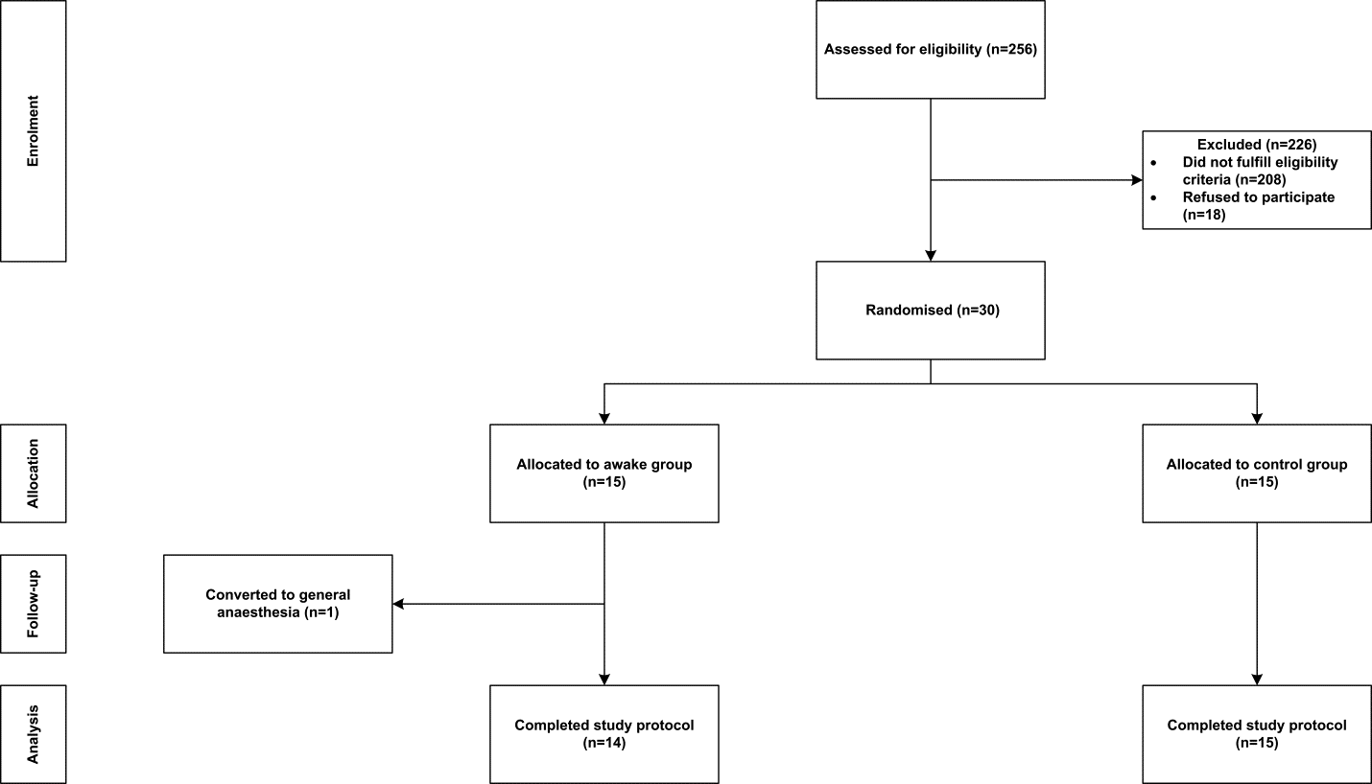
Figure 1. Flowchart showing patient enrolment, allocation to treatment groups, follow-up, and analysis.

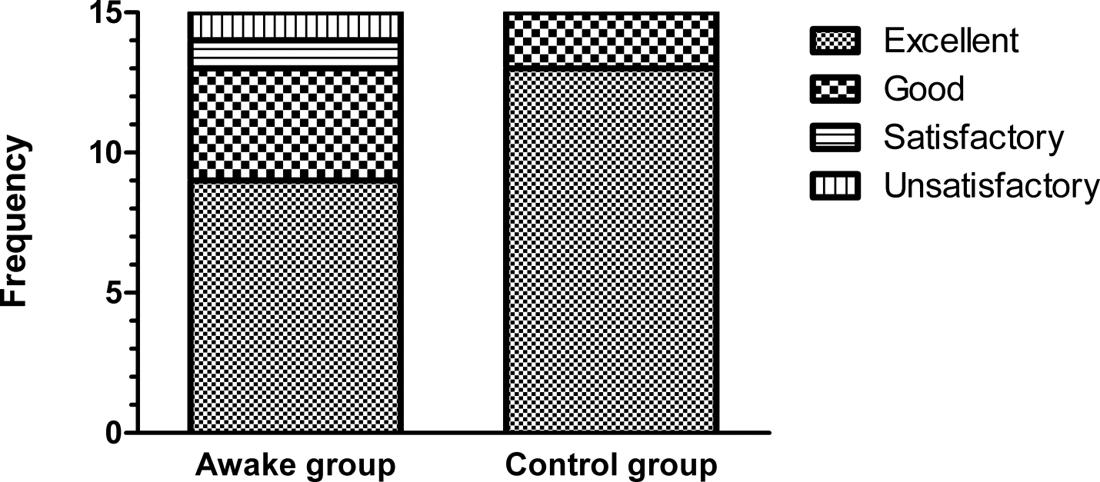
Figure 2. Feasibility score in the two study groups.

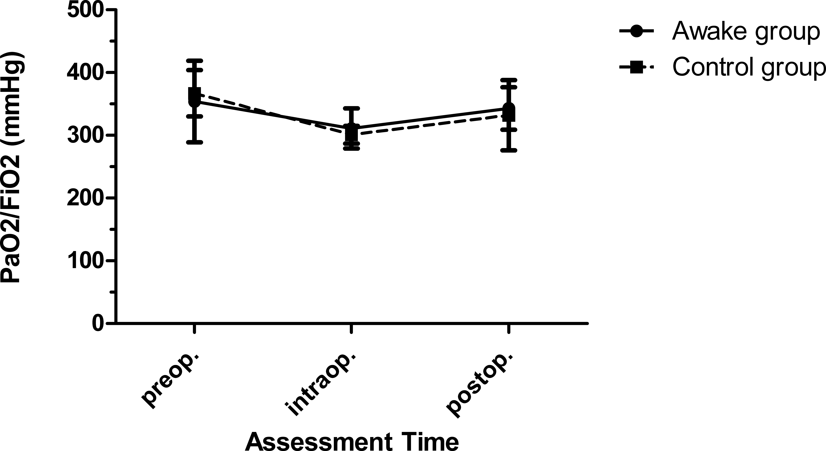

Figure 3. Change in mean PaO2/FiO2 during the perioperative period in the two study groups. Error bars represent SD. preop. = preoperative; intraop. = intraoperative; postop. = postoperative.

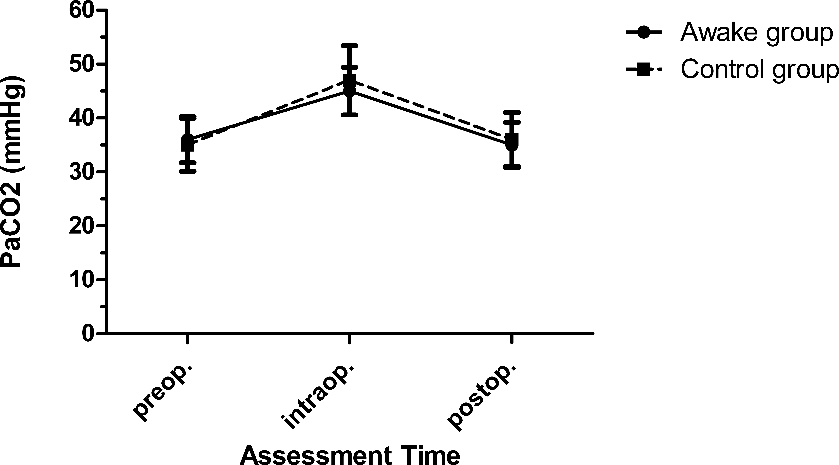
Figure 4. Change in mean PaCO2 during the perioperative period in the two study groups. Error bars represent SD. preop. = preoperative; intraop. = intraoperative; postop. = postoperative.

